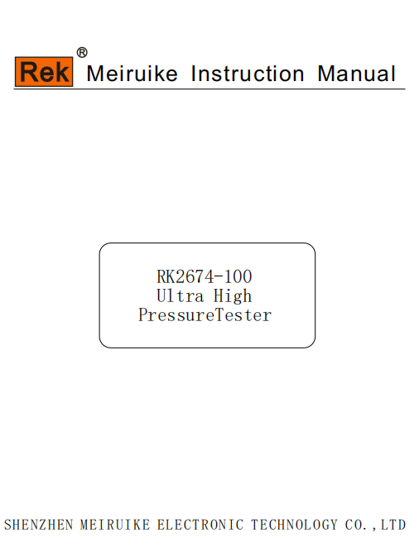

Ultra high voltage tester Shenzhen Meiruike Electronic Technology Co.,Ltd

**One.Summary**

This model is composed of a light high voltage test transformer and a console matched.It has the advantages of superior performance,multiple functions,reliable,beautiful appearance,convenient operation and maintenance.

**Two.Technical parameter**

Capacity****:10KVA Input voltage:200V Input current:50A

Output voltage:0-100KV Output current:0-100mA

**Three:Layout diagram of structure and faceplate**

The device is a desktop structure,the shell is cold rolled steel plate structure,the faceplate use of Aluminum alloy sandblasting process,the faceplate elements arranged as follows：



Ultra high voltage tester Shenzhen Meiruike Electronic Technology Co.,Ltd



The alarm device has the advantages of simple circuit and reliable performance.With timing, sound and light alarm function.

**Four.Using methods**

1. According to the test requirements,connecting the operating table,transformer and the test object well.
2. Plug in the power,the green lamp(-HG) light,turn the voltage regulator handle to zero,yellow lamp(-HY) light,indicating that the test can be carried out.
3. In accordance with the current and withstand time which the normal test required, select the corresponding setting current,set the action value of flow relay(-KA) and time relay(-KT).Overcurrent action value=Flow relay dial reading*mutual inductor variable ratio(such as flow relay dial reading is 1A,and the mutual inductor variable ratio to 10,then the overcurrent action value=1*10=10A),the maximum value of normal overcurrent action can only be setted to 1/3,otherwise the overcurrent will damage the tested product or equipment.That it can send electrical operation after all of the above work is completed.Press the start button(-ST),once the main circuit(- KM1)actuation,the voltage regulator is electric.Rotating regulator handle clockwise,the regulator boost.The zero lamp light-off(-HY),power transmission indicator lamp(-HR) light-on.Pay close attention to the voltmeter(-PV) instructions, when reach the withstand value of product to be tested,press the timer button(-ST2) and pay attention to the situation of the tested object.
4. When the withstand time’up,the operating table sound and light alarm automatically.You should be immediately rotating the regulator handle to zero clockwise,press the stop button(-SP)and timing button(-ST2),red lamp light-off, yellow lamp light-on.Test is completed.
5. In the process of boosting or withstanding voltage,if short circuit,flashover and breakdown and other overcurrent occured,the overcurrent relay(-KA)action,and cut off the main circuit.Now the regulator should be rotated to zero counterclockwise.

**Five.Using conditions**

1. Temperature: 0 ~ 40℃
2. Altitude: ＜1000m
3. Relative temperature:＜85%
4. The workplace shall have no serious gases,vapors,chemical dust and other explosive and aggressive media influence on the insulation.

Schematic diagram of the conventional ultrahigh voltage tester:

Ultra high voltage tester Shenzhen Meiruike Electronic Technology Co.,Ltd





High voltage tail

Output 100KV

Reliable grounding

Input

Meter

Output

Meter

Operation box(set)

**Six.Matters needing attention**

1. You should check whether there is damage or bad contact before testing,and check the electrical components well,especially the regulator carbon brush contact well.

According to the test requirements,the operating table,transformer,and the tested products are connected properly.

1. The maximum overcurrent action value can be setted to 1/3 of the rated current normally,or the over current will damage the test object or equipment.
2. When the withstand time’s up,the operation table sound-light alarm automatically,you should rotating the regulator handle to zero counterclockwise immediately(please adjust the handle lightly prevent carbon brush arm damaged the petite zero position that bring inconvenience to your work!).Press the stop button (-SP) and timing buttons(-ST2),the red lamp light-on and the yellow lamp light-off.The test is completed.Don’t press the stop button directly or cause the induction anti-pressure by cut off the power in the high voltage condition.
3. The workplace shall have no serious gases,vapors,chemical dust and other explosive and aggressive media influence on the insulation.Equipment should be placed in normal temperature dry dust-free environment when non use period.
4. In the process of transportation,please adjust the regulator carbon brush arm far away from zero position.To prevent carbon brush arm damaged the petite zero position that bring inconvenience to your work!

Ultra high voltage tester Shenzhen Meiruike Electronic Technology Co.,Ltd

**Seven.Electrical schematic**



**Eight.Packing list**

1. Operating table one set
2. Withstand tester host(10KVA/100KV) one set
3. Manual one copy
4. Product certificate one copy

