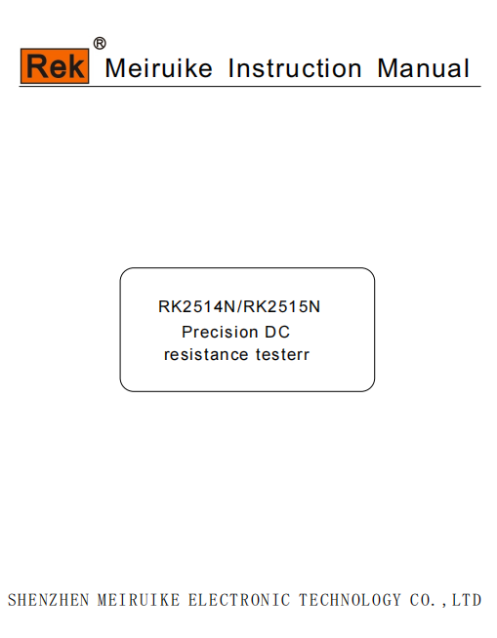

Foreword
Thank you for purchasing the products of Shenzhen Meiruike Electronic Technology Co., Ltd. Please read this manual carefully before use.
In this chapter you will learn about the following:
- Safety instructions
- Company description
- Security Information
- Limited warranty and scope of responsibility

Safety instructions
This manual describes the information and precautions required to operate the instrument safelyand maintain the safe state of the instrument.Please read carefully before proceeding. Please read the following safety-related items carefully to ensure safe and optimized use.
Disclaimer: Please read the following safety information carefully before starting to use the instrument.Rek Electronic Technology Co.,Ltdwill not assume any responsibility for personal safety and property losses caused by failure to comply with the following terms.

Caveat | The instrument has been designed and tested safely before leaving the factory and shipped in a safe state.If the measurement method was incorrect, it may lead to personal accidents and instrument malfunction.Please read the instructions carefully and operate after fully understanding the content.In the event of an accident, we will not be responsible except for the reasons of our products.

Warning  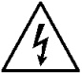Danger | When you find that the following abnormal conditions have occurred, please immediately terminate the operation and disconnect the power cord.Immediately contact Rek Electronic Technology Co., Ltd. Sales Department for maintenance.Otherwise, it may cause fire or potential electric shock hazard to the operator.

- The instrument is operating abnormally.
- The instrument produces abnormal noise, odor, smoke or flash during operation.
- During operation, the instrument generates high temperatures or electric shocks.
- The power cord, power switch, or power outlet is damaged.
- Impurities or liquids flow into the instrument.
Caveat: | This instrument strictly forbidslive testing of the tested piece!

Security Information

Symbol on the instrument
 | Indicates attention and danger.When the symbol or display is on the instrument, please refer to the corresponding position of the manual.
 | Indicates alternating current (ac)
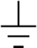 | Indicates earth (ground) terminal
 | Indicating fuse
Safety symbol: The precautions in this manual are marked as follows according to their importance.
Caveat | Indicates attention and danger.
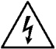Danger | Indicates an extremely high risk of death or serious injury to the user if an operational error or misuse occurs.
Note | The product may cause damage to the product itself or other products under certain circumstances or in actual application.
 | Indicates prohibited behavior
Symbols related to standards:
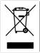 | Marking of laws and regulations on the abandonment of electrical and electronic equipment
Other symbols:
 | Details: indicates tips, details
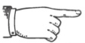 | Convention: indicates the agreement
Or | Reference: indicates where the reference content or reference is located
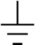 | Indicates earth (ground) terminal
 | Indicates direct current (dc)
 | Indicates alternating current (ac)
 | Indicates that the power is "on"
 | Indicates that the power is "off"

Limited warranty and scope of responsibility
Shenzhen Meiruike Electronic Technology Co., Ltd. guarantees that every RK2514N/RK2515N instrument you purchase is completely qualified in quality and measurement.This warranty does not include fuses.
Rek promises that the instrument mainframe and accessories produced by Rek will not have any defects in material and process defects during the warranty period. During the warranty period, if the product proves to be defective, Rek will repair or replace it for free.
From the date of shipment, Rek promises to guarantee the warranty of its product’s mainframe for two years and other accessories for one year.For hardware and software failures caused by the quality of the product itself during the warranty period, please present the product warranty card and maintenance registration card, and the product will be repaired free of charge by Rek Maintenance Department or Rek authorized maintenance point.For products that exceed the warranty period, Rek will perform paid repairs for the user.
For products that are repaired free of charge (no special problems), Rek promises to repair and return to the user within five working days after receiving the instrument, and bear the transportation cost of the return journey.
Rek will not carry out free repairs if one of the following conditions occurs:
- Accidental damage caused during transportation.
- Instrument malfunction or damage caused by incorrect installation or use in a non-product specified working environment.
- The appearance of the product is artificially damaged (such as surface scratches, deformation, etc.).
- Unauthorized dis-assembly of the machine for repair, modification, replacement of parts and tearing of the product warranty seal.
- Failure or damage caused by irresistible factors such as lightning strikes.
- Direct or indirect damage caused by improper user operation.
If the instrument is inaccurate or cannot be measured due to improper operation of the user, the instrument itself has no problem, and the return cost is borne by the user.
Guangdong Province, China
Shenzhen Meiruike Electronic Technology Co., Ltd

Company description
Note | The descriptions in this manual may not be all the contents of the instrument. The information contained in the manual has been corrected before printing. However, as Rek Electronic Technology Co., Ltd. continuously improves the products, it reserves the right to modify the product specifications, characteristics, internal structure, appearance, accessories,packaging and maintenance procedures of the produces in the future. Therefore, the contents may be changed without prior notice.The confusion caused by inconsistency between the instructions manual and the instrument can be contacted with our company by the address on the back cover of the manual; the latest news and content can also be found on the company website.

Table of contents
Foreword 2
Safety instructions 2
Security Information 2
Symbol on the instrument 3
Limited warranty and scope of responsibility 4
Company description 4
Chapter 1 Usage Precautions 7
Packing content confirmation 7
Precautions for use 7
Instrument Upgrade instructions: 11
Chapter 2 Product Overview 12
2.1 Product Overview and Model Description 12
2.2 Technical specifications, features, main functions 12
2.3 Product introduction (name and function of each part) 13
2.3.1 Positive description 13
2.3.4 Rear panel brief introduction 19
2.3.5 Support of device seat 20
Chapter 3. Preparation Before Measurement 21
3.1 Preparation procedure 22
3.2 Connection of power supply cable 22
3.3 Connection of testing cable and test piece 22
3.4 Connection of temp probe 24
3.5 Connection of external interface cable 25
3.6 Power on/off 25
3.7 Device parameter setting 26
3.8 Clear 26
3.9 Start test 28
Chapter IV Test parameter setting and operation 29
1.1 Confirm the test object 29
4.2 Methods to set parameters and input values 29
4.3 Introduction and parameter setting of measurement setting page 30
Chapter 5 System setting and file management 36
5.1 System setting interface 36
5.2 File system interface 39
5.3 File System Description (Storage/Recall Function) 41
Chapter 6 Sorting Comparator 43
6.1 Sorting Settings Interface 43
6.2 Ring 44
6.3 PASS/FAIL Light 45
6.3 Comparison Process 45
Chapter 7 Remote Control 46
7.1 RS232 / 485 communication method 46
7.2 Communication Protocol 47
7.3 Handler communication method 54
7.4 USB communication method 56
Chapter 8 Maintenance and Service 58
8.1 About correction 58
8.2 Packaging and Transportation 58
8.3 Storage 58
8.4 Warranty 58
8.5 Cleaning 59
8.6 About discarding 59
Appendix A: Specifications 60
Appendix B: Selection Table 62

Chapter 1 Usage Precautions
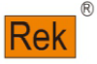 | In this chapter you will learn about the following：  - Packing content confirmation  - Precautions for use  - Instrument upgrade instructions

Packing content confirmation
Please confirm before use: When the instrument is delivered to your hand, please check and confirm:
- Please check the appearance of the product for damage or scratches.
- Check the instrument accessories for any omissions according to the following table:
Table 1-1 Instrument Accessories
Seri | Name | Specification | Qty | Unit | Remarks
1 | instrument | RK2514(2515)/N | 1 | set | Standard
2 | Four-terminal Kelvin test | RK2514(2515)/N | 1 | set | Standard
3 | Three-phase power cord(220V50Hz) | RK2514(2515)/N | 1 | piece | Standard
4 | Fuse(0.5A slow blow) | RK2514(2515)/N | 2 | piece | Standard
5 | RS232 communication cable | RK2514(2515)/N | 1 | piece | Standard
6 | USB communication cable | RK2514(2515)/N | 1 | piece | Standard
7 | Temperature probe | RK2514(2515)/N | 1 | piece | Standard
8 | HANDLER junction box | RK2514(2515)/N | 1 | piece | Standard
9 | user's manual |  | 1 | piece | Standard
10 | Verification report |  | 1 | piece | Standard
11 | Product certification |  | 1 | piece | Standard
12 | Warranty |  | 1 | piece | Standard
If there is any damage or insufficient accessories, please contact the sales department or distributor of Shenzhen Meiruike Electronic Technology Co., Ltd. immediately.Whentransporting this instrument, please use the packaging materials at the time of delivery.
Table 1-2 Optional Accessories
Seri | Name | Specification | Quan | Unit | 备注
1 | RS485 communication cable | RK2514(2515)/N | 1 | piece | Optional
2 | Data acquisition software | RK2514(2515)/N | 1 | piece | Optional
3 | Multimeter pen test clip | RK2514(2515)/N | 1 | piece | Optional
4 | Smd Kelvin test cable | RK2514(2515)/N | 1 | piece | Optional
5 | Equipment test cable (common） | RK2514(2515)/N | 1 | piece | Optional
Customers can choose according to their own requirements. If there is any damage or not matching with their own selection, please contact the sales department or distributor of Shenzhen Meiruike Electronic Technology Co., Ltd. immediately.

Precautions for use
In order to use the instrument safely and to make full use of its functions, please observe the following precautions.
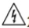Dangers | In order to prevent electric shock accidents, please do not remove the shell of the host; Internal high voltage and high temperature part.
Caveat | Please do not modify, disassemble or repair.Failure to do so may result in an accident or personal injury.  Do not let the instrument get wet or use wet hands to measure.Failure to do so may result in electric shock.
Note | To prevent damage to the instrument, avoid vibration and collision during handling and use.Payattention to failures caused by falling.When transporting the instrument, please use the packaging materials at the time of delivery.

- About the placement and environmental conditions of the instrument
- Environmental conditions
The RK2514(2515)N must be used under the following environmental conditions:
- Temperature and humidity range: Temperature: 0 ~ 40 °C, Humidity: 80% RH below (no condensation)
- Temperature and humidity range with guaranteed accuracy: 23 ± 5 °C, 80% RH or less (no condensation)
- In order to ensure good ventilation, do not block the ventilation holes.
- The instrument, especially the test leads connected to the device under test, should be kept away from strong electromagnetic fields to avoid interference with the measurement.

Caveat | Please do not place the instrument in the following places, otherwise it will cause malfunction or accident of the instrument.  - Direct sunlight or high temperature places  - a place where corrosive gas or explosive gas is generated  - Places where strong electromagnetic waves are generated or near charged objects  - a place where mechanical vibration is frequent  - Wet, dew condensation  - Dustplace  - Near induction heating device (high frequency induction heating device, IH induction cooker, etc.)  - A place affected by water, oil, chemicals, solvents, etc.
Note | Do not use near noise-generating devices.If the noise affects the test object, it may cause the measured value to be unstable.

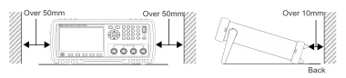
- Placement method:
- To prevent the temperature of the instrument from rising, be sure to keep a specified distance from the surroundings when placing it.
- Place the bottom side down.This instrument can be used when the stand is raised.

Note | - The method of cutting off the power supply of the instrument can be to unplug the power cord; in case of emergency, the plug of the power cord can be unplugged to immediately power off; therefore, please ensure that there is no room for sufficient operation.  - Do not place on unstable pedestals or in inclined places.Otherwise it may fall or turn over and cause personal injury or host failure
- Power requirements:
The RK2514(RK2515)/N can only be used under the following power conditions:
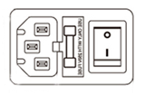
- Supply voltage range: 220V±10% AC Power supply frequency: 50Hz/60Hz (47.5~52.5Hz) Power supply range: ≤30VA
- The power input phase line l, neutral line n, and ground line e should be the same as the power plug of the instrument.
- This instrument has been carefully designed to reduce clutter interference from the ac power supply input. However, it should be used in a low noise environment. If it is unavoidable, install a power filter.
Danger | - To prevent electric shock, connect the power ground to the ground reliably.  - If the user replaces the power cord, make sure that the ground of the power cord is securely connected.

Caveat | - Check the outer skin of the power cord, test leads, etc. for damage or metal exposure before use.Since these damages may cause an electric shock, please replace it with the model specified by the company.  - Before turning on the power, please confirm that the power supply voltage listed on the power connection part of the instrument is consistent with the power supply voltage you are using. If the power supply voltage outside the specified range is used, it may cause damage to the instrument or electrical accident.  - To prevent electric shock and to ensure the safety of this instrument, please connect the power cord to the three-phase socket.
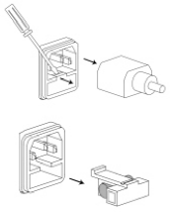
- Fuse
- The instrument is equipped with a fuse at the factory, and the user should use the fuse provided by the company.
- Replace the instrument fuse.Open the fuse box on the rear panel power outlet for replacement.

Caveat | To avoid personal injury, turn off the power before replacing the fuse.
- Measurement considerations
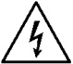  Danger | Do not short-circuit the top of the test leads and the lines with voltage.That is, the instrument is strictly prohibited from being tested with the test piece!
- About the use of power cords, test cables, and wires
Please use our company's power cord, test fixture or test cable. User-made or other company test fixtures or test cables may result in incorrect measurement results.The instrument test fixture or test cable should be kept clean and the pins of the tested device should be kept clean to ensure good contact between the device under test and the fixture.
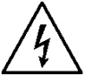  Danger | To avoid electric shock or short-circuit accidents, disconnect the power to the test object before connecting the test cable.

Note | - In order not to damage the wires and test cables, do not step on or pinch the wires or test the cables.  - To prevent malfunction due to wire breakage, do not bend or pull the wire or cable connection.  - To prevent disconnection, when pulling the power cord out of the socket or the instrument, hold the plug part (outside the power cord) and pull it out.  - To prevent disconnection, when pulling out the connector, hold the insertion part (outside the cable) and pull it out.  - The tip of the needle test line is pointed and very dangerous.Please pay full attention when using it to avoid injury.  - If the wire is melted, the metal part will be exposed, which is very dangerous. Do not touch the hot part.  - The temperature probe is precision machined. Do not apply excessive voltage pulses or static electricity to avoid damage.  - Do not subject the temperature probe to excessive collisions or force the wires to be damaged.
- Before measurement
In order to achieve the test accuracy, the instrument should be warmed up for more than 30 minutes.
Note | - To avoid damage to the instrument, do not input voltage or current to the measurement terminals.  - Do not measure the part to which the voltage is applied.Especially after the transformer or motor temperature rise test or the withstand voltage test, if measured immediately, the voltage or residual charge will be induced and the instrument will be damaged.  - The measurement of the internal resistance of the battery cannot be performed, otherwise the instrument may be damaged.When measuring the internal resistance of the battery, use the battery internal resistance tester.  - Please use the packing material when transporting the instrument
- Please do not remodel. Do not allow non-repair technicians to disassemble or repair either.
- RK2514 RK2515) /N On the rear panel(TRIG)、 (LAN) are empty boards. To avoid electric shock, do not remove the empty board.
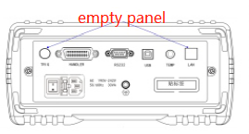
- This figure shows the RK2514(RK2515)N instrument rear panel, empty panel part.

Instrument Upgrade instructions:
Upgrade the instrument as follows：
- Copy the relevant upgrade files to the root directory of the U disk (no more than 4G), and insert them into the USB interface of the instrument
- Press set key to start the machine, and "U disk read success" appears on the screen
- Press the < OK > key to upgrade. The upgrade is completed when the instrument white screen or jump to the boot interface. Restart to complete the upgrade。
Note | Please use the company's corresponding upgrade software, and under the guidance of the company's technical personnel, otherwise it will cause the failure or accident of the instrument。

Chapter 2 Product Overview
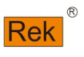 | In this chapter you will learn about the following:  - Product summary and model description  - Technical specifications, features, main functions  - product description

2.1 Product Overview and Model Description
product Overview
RK2514(RK2515)N DC resistance tester features high-precision, wide-range and performance. It adopts the current mainstream 32bits CPU and high-density SMD placement technology, 24-bit color 4.3-inch color LCD screen and rotary encoder. The interface is intuitive and refreshing. Easy to operate.The instrument has high anti-interference; the range is: 0.1uΩ∽110MΩ；the display digit is five and half. the test speed is up to 15 times/second; the test accuracy is up to 0.01; the temperature compensation can eliminate the ambient temperature test. The instrument provides a variety of interface functions to facilitate data communication and remote control with PC. It has professional sorting function, 10 sets of data storage, multiple sorting signal settings, and matching Handler interface. It can be used in automatic sorting system to complete automatic pipeline testing. It can also be equipped with RS232 interface (or converted to IEEE485 interface) for remote control and data acquisition and analysis.
The instrument is compact, compact and fully functional.Through the four-terminal test method, high-speed, high-precision measurement of various high, medium and low value resistors; various switch contact resistance; connector contact resistance; relay line package and contact resistance; transformer, inductor, motor, Deflection coil winding resistance; wire resistance; metal riveting resistance of cars, boats, airplanes; DC low resistance of fuses, resistors, DC resistance of conductive rubber, printed circuit board lines and hole resistance.Since the instrument is equipped with a temperature compensation function, it is suitable for measuring the object whose resistance value changes due to temperature.The instrument is widely used in research and development, production lines, feed inspection and other places.
Model Description
In order to meet the requirements of different users, the RK2514(RK2515)/N has 2 models to choose from.
Model | Measuring range | Accuracy
RK2515(RK2515)/N | 0.1uΩ-110MΩ | 0.01%
RK2514(RK2515)AN | 1uΩ-20MΩ | 0.01%

See | See Appendix B for the complete version of the DC Resistance Tester.
Agreement | The complete set of all versions is described in this manual.

2.2 Technical specifications, features, main functions
The RK2514(RK2515)N specifications contain the basic technical specifications of the instrument and the range allowed by the instrument test.These specifications are all achievable when the instrument is shipped from the factory.
See | The complete technical specifications are detailed in Appendix A.

- Easy to view display / intuitive operability: high brightness, super clear 4.3 inch color LCD display; easy to learn and intuitive to use；
- The basic setting is easy to operate, with direct reading, percentage error and sorting results; multiple parameters are displayed at the same time.
- The comparator judgment light is directly displayed, without looking at the screen, the operation efficiency can be improved.
- Rich interfaces, including handler interface, RS232 interface, RS485 interface (optional), USB host, USB device
- High precision temperature test function: temperature can be tested by temperature sensor.
- Reliable contact detection function, can automatically detect whether the test end is well connected to avoid misjudgment
- Low voltage test function, effective range: 2 Ω, 20 Ω. Maximum test voltage ≤ 60mV.
- Calibration function: full range short circuit zero clearing function。
- Comparator (sorting) function: built in 12 sorting data, which can judge the hi / low of the measured parts.
- Thermoelectric potential elimination: it can eliminate the thermoelectric potential, minimize the influence of thermoelectric potential, and improve the measurement accuracy of small resistance.
- Ultra high speed and high precision measurement can improve the production efficiency. Test speed: fast: 100 times / second; medium speed: 25 times / second; slow speed: 10 times / second; precision test: 4 times / second
- Reliable 4-terminal measurement.
- The allowable value of wiring resistance in low resistance range is 1.5 Ω; even in the measuring current range of 1a, the test cable can be easily extended.

2.3 Product introduction (name and function of each part)

2.3.1 Positive description
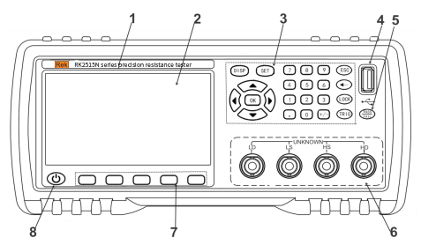

Figure 2-1 Front panel
- 1、Trademark and model——Brand and model of instrument.
2、LCD display——480 × 272 pixels, color TFT LCD screen, used to set test conditions and display measurement results.
3、Key area 2——一A group of multi-functional keys, including digital keys, direction keys, ESC keys, etc.
See | For details, see 2.3.2 "key area"
4、USB DEVICE——USB DEVICE interface. It is used to save test data on USB flash disk and upgrade firmware.
5、PASS/FALL indicator light——Sorting qualified indicator light. The green light indicates that the test data is qualified, and the red light indicates that the test data is unqualified.
6、Test end (input end)——Four end test end. It is used to connect the four terminal test cable and measure the tested parts.
See | For details, see 3.3 "connection of test end".
7、Soft key area——Used to select the function corresponding to the lower side of LCD screen.
See | For details, see 2.3.2 "key area"
8、Power standby key——Long press the standby key, the instrument is in standby mode, and the standby key is displayed in red.
Press and hold the standby key for a long time to turn to the working state, the instrument turns to the working state, and the standby key displays green,
You can turn off the power switch at the back of the chassis if you need to turn off the power during standby.

2.3.2 Key Area
1、Key area 1：May Function Soft Key
Used to select the function on the right side of the LCD screen.See the image to the above.
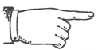Agreement | The four wordless "dark gray" keys on the button are the keypad one, the main function key.The function of one or four keys in the keypad is “soft”, that is, their functions are not fixed, they have different functions on different display pages, and their current functions are correspondingly displayed in the “soft keys” under the LCD screen. Display area.
2、 Key area 2: number key, direction (up, down, left, right) key, OK key, ESC key, backspace (←), lock key, trig key, set key and disp key.
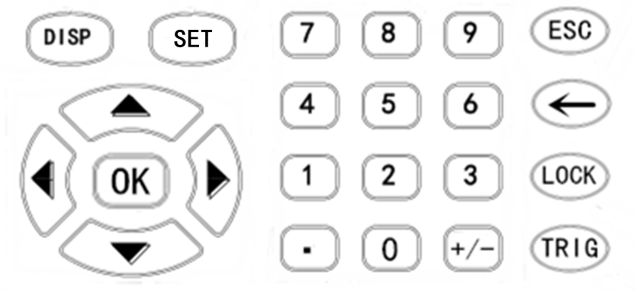

Figure 2-2 Key Area2
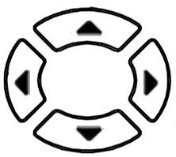
1）、Direction key
Up,down,left and right direction keys are used to move the cursor and select setting parameters.
- 、OK key
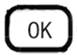
Used for confirmation after setting parameters such as values.
3）、DISP key
Press the [disp] key to enter the "MEAS DISP" interface.
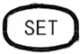
4）、SET key
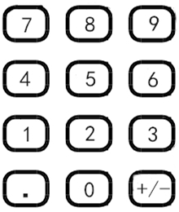
Press the [disp] key to enter the "SYS SET" interface .
5）、Number key
“0～9”、 “.”、“+/-”，used to type in the value. See 4.1 for the input method of the specific value.
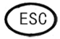
6）、ESC key
No function.
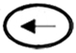
7）、←key
Backspace key for numeric input.
8）、LOCK key
Key lock key. Press and hold for about 2 seconds, the key is locked, and the key lock light is on; press and hold for 2 seconds again, the key is unlocked, and the key lock light is off.
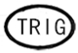
9）、TRIG key
Trigger key. When the trigger is set to manual trigger, press the trigger key once to test the instrument. If the start signal is valid during external triggering, this key flashes once, indicating that the instrument receives a start signal and tests once.
2.3.3 MEAS DIS interface - main interface (definition of display area)
The instrument uses 480*272 LCD screen.
The instrument has the following interfaces: measurement display interface, measurement display reset interface, measurement setting interface, COMP setting interface, internal file system interface, external file system interface, system setting interface.
Note | Do not use sharp objects and fingernails to touch the screen, which may cause damage to the LCD screen. We will not be responsible for the damage caused.
1、Measurement display interface(BoostDis ON)
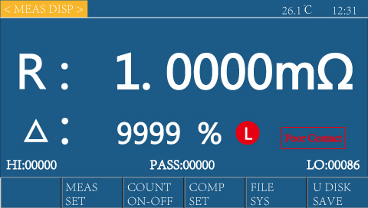
Operation：If BoostDis is "on" in the system setting interface, it will automatically enter the measurement display amplification interface after power on; at this time, press the [disp] menu key, and the < measurement display magnification > page will also be displayed on the screen. As shown in the figure on the right:
The status bar display area, measurement result display area, measurement status display area, sorting statistics display area and function soft key display area refer to "measurement display page".
See | For details, see 2.3.3 "Item 2 measurement display interface""
2、Measurement display interface
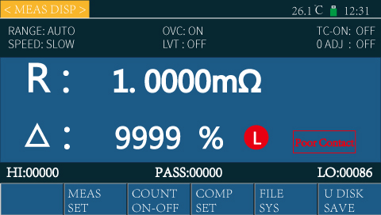
Operation：If "off" is displayed in the system setting interface, it will automatically enter the measurement display interface after power on; at this time, if you press the [disp] menu key, the < measurement display > page will also be displayed on the screen. As shown in the figure on the right:
1）、Status bar display area
This area indicates the name of the current display page, current ambient temperature (need to insert temperature sensor and open temperature compensation), U disk prompt and time. As shown in the figure on the right:
2）、Measurement parameter display area
This area indicates the function and measurement parameters of the current display setting instrument.
As shown in the figure above: these measurement parameters can be set in the "measurement setting interface".
See | For details, See "4.3.3 measurement setting interface"
3）、The results show that the measurement area
This area displays the direct reading resistance measurement results of the instrument (both direct reading and percentage ratio are displayed)
As shown in the right figure: R: measured resistance value
Δ: the relative deviation of the measured resistance relative to the nominal value。
Note | If the measurement is near 0 Ω, the measured value may become negative. In other cases, when the measured value becomes negative, please check whether the test line is connected in reverse
4）Measurement status display area
This area is divided into file (sorting)display area and part of poor contact status.
As shown in the figure on the right:
Display area of file (sorting):
Among them, H stands for super high and P stands for qualified
L -- represents lower super F -- represents separation failure
Poor contact display: detect the poor contact between the tested object and the probe or the broken status of the test cable.
Caution | If "Poor Contact" function is used in the measurement of objects with variable characters by implementing voltage onto the object to be measured, please note.
5）Sorting statistics display area
This area displays the number of HIGHER/LOWER/PASS
As shown in the figure on the right:
Refer | Please refer to "4.3 Measurement interface setting" for details Please refer to "4.3 Measurement interface setting" for details.
- Functional soft key display area
This area is used to display the function menu corresponding to the cursor area. The functions below can be realized by the corresponding soft keys on this interface. As shown in the figure on the right:
- Measurement setting(Enter the measurement setting interface)
Press corresponding functional soft keys under "Measurement setting" to enter the measurement setting interface.
Refer | Please refer to "4.3.3 Measurement interface setting" for details"
- Counting switch(ON/Off of sorting counting)
Press corresponding functional soft keys under “Sorting counting” and enter the corresponding digit in the sorting counting area of this area to start or end the counting
As shown in the figure on the right:
Is is mainly used in the statistics of measurement data.
With this function turned on, each time the sorting comparator outputs, the device will count each test according to the sorting output result to judge whether the test test result is higher (H) than upper limit, or lower (L) than lower limit, or pass a certain grade P(1-12).
The statistics are displayed in the quantity menu bar.
With this function turned off, "Counting off" will be displayed at the bottom of the grade counting interface, which means that this function is turned off.
Counting clear:Press again the counting switch to cleat the counting and the HIPASSLO values in the display area will be cleared and reset as zero.
Statistical parameter description:Hi(num):count the number of times the measurement result is higher than the upper limit.
Lo(num):count the number of times the measurement result is lower than the lower limit.
PASS(num):count the number of passed measurement results.
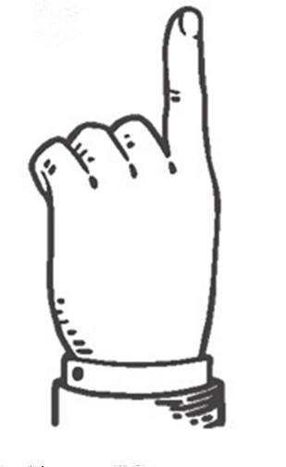  Tips | - Each measurement result of the sample. Data are stored in device cache.  - Hi is applicable to the upper limit of the comparison  - Lo is applicable to the lower limit of the comparison
- Sorting setting (Enter sorting setting page)
Press corresponding soft keys under “Sorting setting” to enter sorting setting interface.
Refer | Refer to “6.1 sorting setting interface” for details.
- File system(Enter internal file setting page)
Press corresponding soft keys under “File system” to enter file system setting interface。
Refer | Refer to “5.2 file system interface” for details.
- U disc record
Press corresponding soft keys under “ U disc record” to save current measurement data into U disc.
If no U disc is inserted by user, the data won’t be save. If a U disc is inserted and recognized by device (i.e., U disc letter is displayed in device status bar), data will be saved.
After a USB disc is inserted, a red USB disc letter indicates that the "USB disc switch" is off;
After a USB disc is inserted, a green USB disc letter indicates that the "USB disc switch" is on;
When no U disk is inserted, no U disk letter will be displayed, which indicates that the USB disc is not inserted.
Refer | Refer to “5.2 file system interface” for details.

2.3.4 Rear panel brief introduction
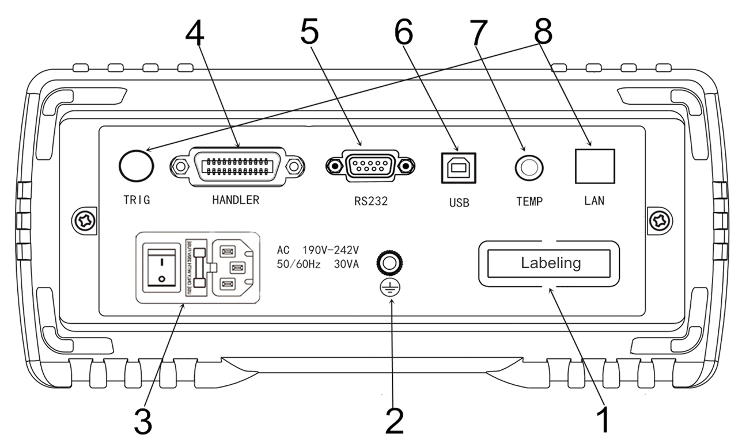
Fig.2-4 Rear panel
- Nameplate——Indicates specific model and numbers of device
- Grounding pole——this wiring terminal connects to the metal outer enclosure of device to protect or shield the grounding wire.
- Power supply socket fuse and power supply switch——Socket is for AC input with fuse holder on it (to receive a fuse to protect the device)
Power supply switch is used to turn on/off the power supply. When switch is at “I”, power is on, when switch is at “O”, power is off.
Refer: | Refer to "Use precautions" and "3.5 Power on/off" for details.
- HANDLER interface—— Via HANDLER interface, automatic test system can be easily integrated to realize automatic test
Device outputs sorting comparison result signal and end signal through the interface, and obtains "Start" signal via this interface.
Refer: | Refer to "HANDLER interface instructions" fro details.
- RS232（or RS485）interface——Connect by DB-9 cable to realize 232/485 serial communication with upper monitor (computer)
Refer: | Refer to “RS232485 interface instructions” for details.
- USB HOST interface——Use square -head USD cable for the connection of USB HOST interface。
- TEMP DETECTOR interface——Connect to the HD temp sensor to measure the external environment temp.
Refer: | Refer to “3.4 Connection of temp probe” for details.
- Blank panel——Spare. Please do not remove the blank panel prevent electric shock accident.

2.3.5 Support of device seat
The handle of the device can be adjusted. Hold both sides of the handle with both hands at the same time, gently pull both sides of the box, and then rotate the handle.
The handle close to the front can be propped up; When adjusting the handle, pull the handle outward and fold up the device handle. The handle of the device can be positioned at 4 places as shown in the figure below.
The handle can be removed so that ti can be installed on the equipment rack.
Caution | Do not apply pressures from the top when the placing support is standing.

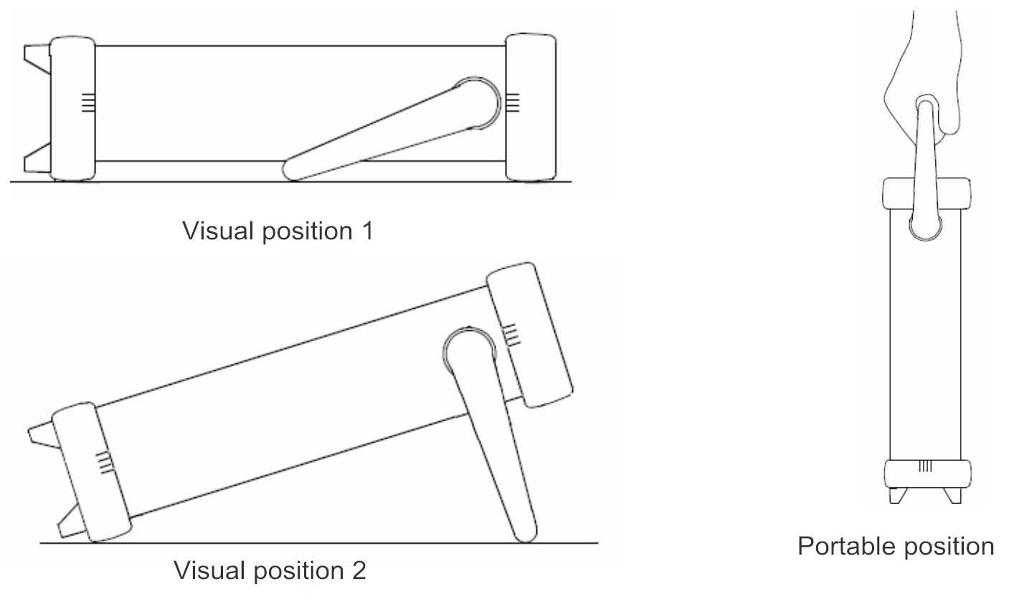

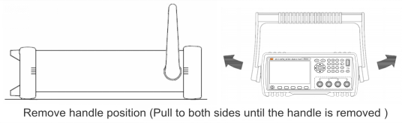

Chapter 3. Preparation Before Measurement
In this chapter, you will learn:
- Preparation procedure
- Connection of power supply cable
- Connection of testing cable
- Connection of external interface cable
- Power on/off
- Device parameter setting
- Clear
- Connect test piece
- Start the test

3.1 Preparation procedure
- Checks before measurement
Before use, please confirm that no fault caused by storage or transportation exists, and do not use it until the checks and operation confirmation are finished. For any confirmed fault, please contact the sales or Rek device.
Please read the precautions before use.

3.2 Connection of power supply cable
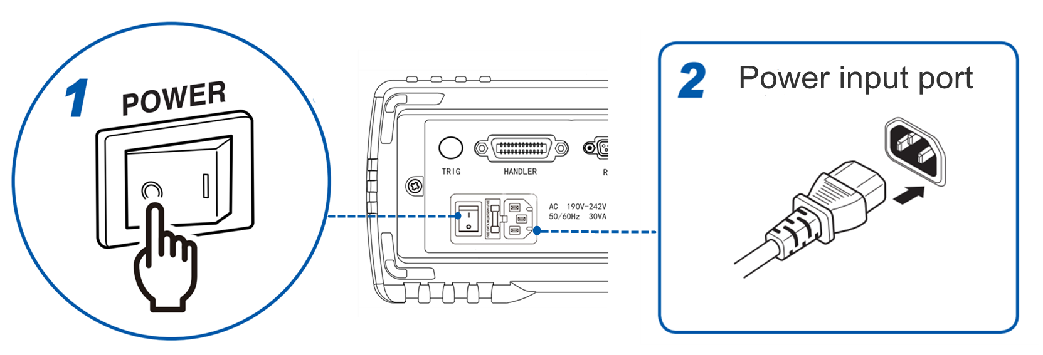
1 Ensure the power supply switch is off
2 Confirm that the voltage of power supply and this device is consistent, and connect power supply cables to power supply inlets at the back.
3 Plug the power supply cable plug into power supply socket.
Refer | Refer to “Chapter 1 Use precautions” for details

3.3 Connection of testing cable and test piece
- Connect the measuring probe or test fixture to the measuring terminal
Please use the test cables or cables for test produced by Rek (optional)
Caution | - Do not apply voltage to the measuring terminals. Otherwise, the device may be damaged.  - Ensure to unlock the lockout before hold and pull out the probe-type BNC connector.  - Do not bent or pull the connecting part of the probe to prevent the faults caused by the break up of the cable.
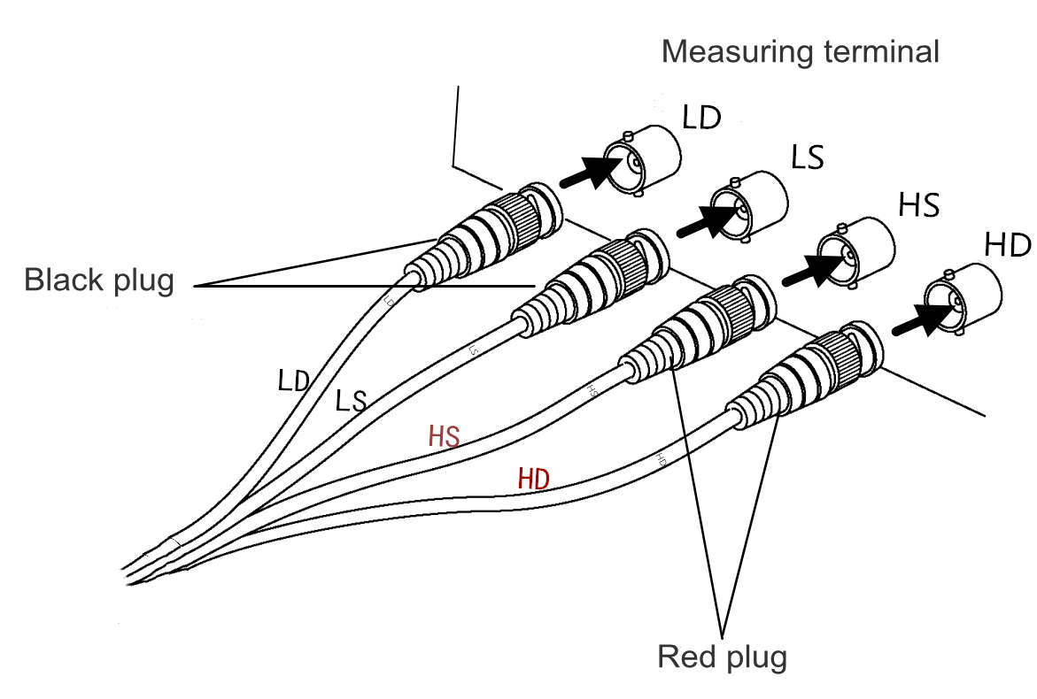
- Connect red (marked by HD) plug to HD terminal, red (marked by HS) plug to HS terminal. Connect black (marked by LD) plug to LD terminal, black (marked by LS) plug to LS terminal.
4 measuring terminals compose the measuring terminal set of this device.

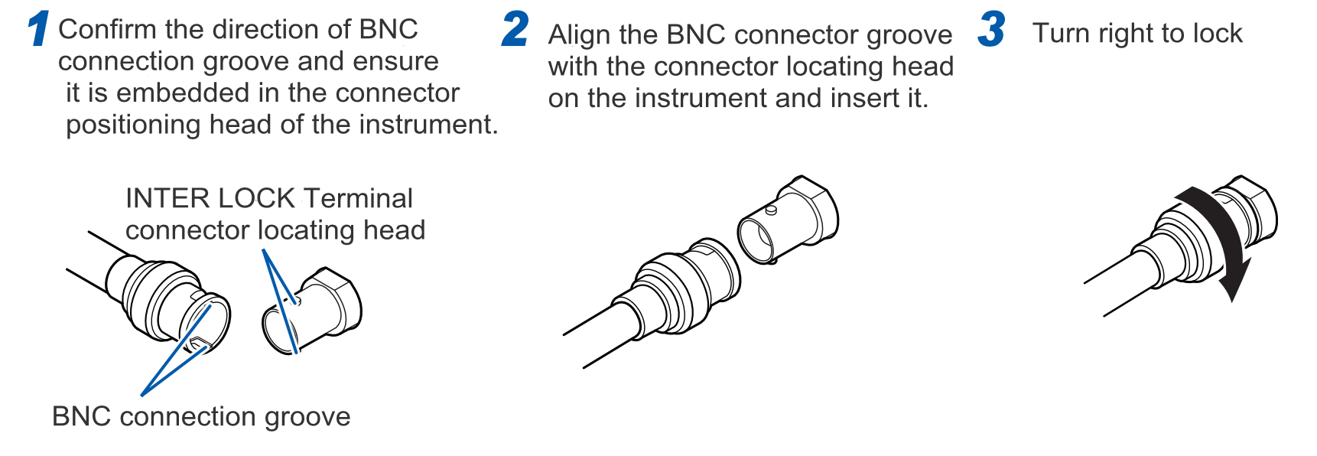
2) Point the grove of BNC connector to the positioning head of testing end connector of this device, and rotate to clockwise to fasten
3) To remove, rotate anticlockwise to unlock and then pull out
- Test cables produced by our company are available
Refer | Refer to “ Optional fittings” of “Chapter 1 Use precautions” for details.
- Connect to test piece（Connection of test piece (DUT)）
- Connection method（Connection of test piece (DUT)）
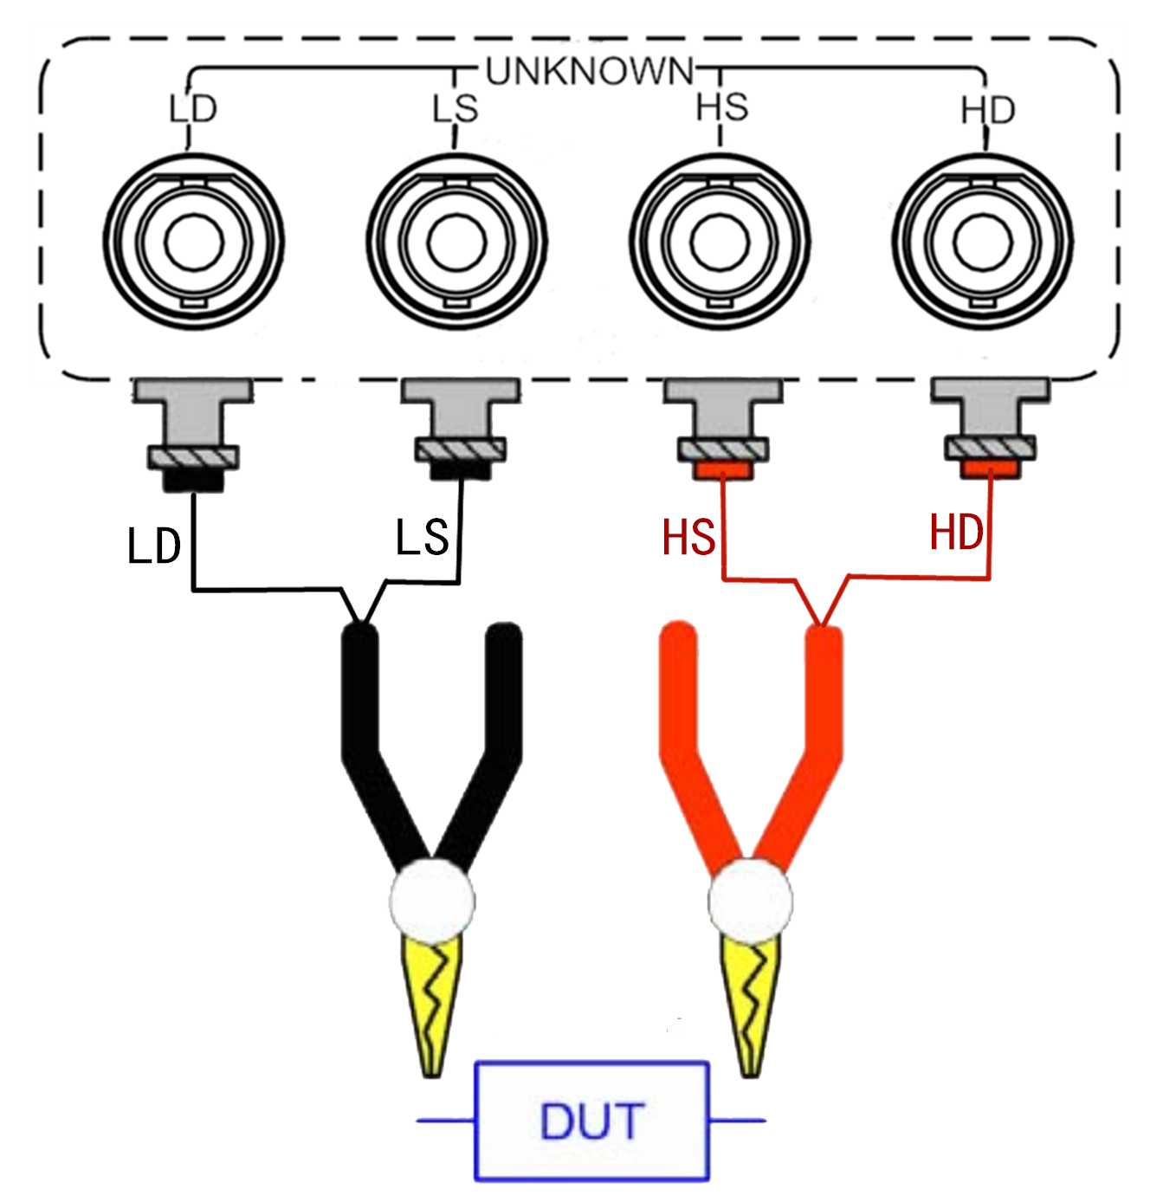
is shown in the figure below
Please use “Kelvin” test fixture attached to the device for the measurement:
Connect the test piece as the figure on the right before the test:
The test ends are:
LD: Current excitation low end;
LS:Voltage sampling low end;
HS:Voltage sampling high end.
HD:Current excitation high end;

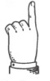  Detail | Use GND terminal as shield in high resistance (higher than 1M) measurement

Warning | - Do not apply voltage to the measuring terminals. Otherwise, the device may be damaged.  - Do not connect the current source directly to the test terminal. Otherwise, the device may be damaged.  - The energy storage element cannot be connected to the test terminal unless being discharged. Otherwise, the device may be damaged。  - To remove the test terminals, unlock first and then pull out

3.4 Connection of temp probe
1 Connection of temp interface（When TC is used; follow the demand）
For temp input, PT1000 platinum resistance temp sensor is available.
- Before the connection of temp probe
Note | - To prevent device or temp sensor fault, please cut the device power supply before connecting.  - Please wipe the socket of temp probe if it’s dirty..  - Do not let water and other liquids in if the structure of temp probe is not waterproof.  - Temp probe will collect the induced noise when it’s seized in hand, which may lead to unstable measured values.
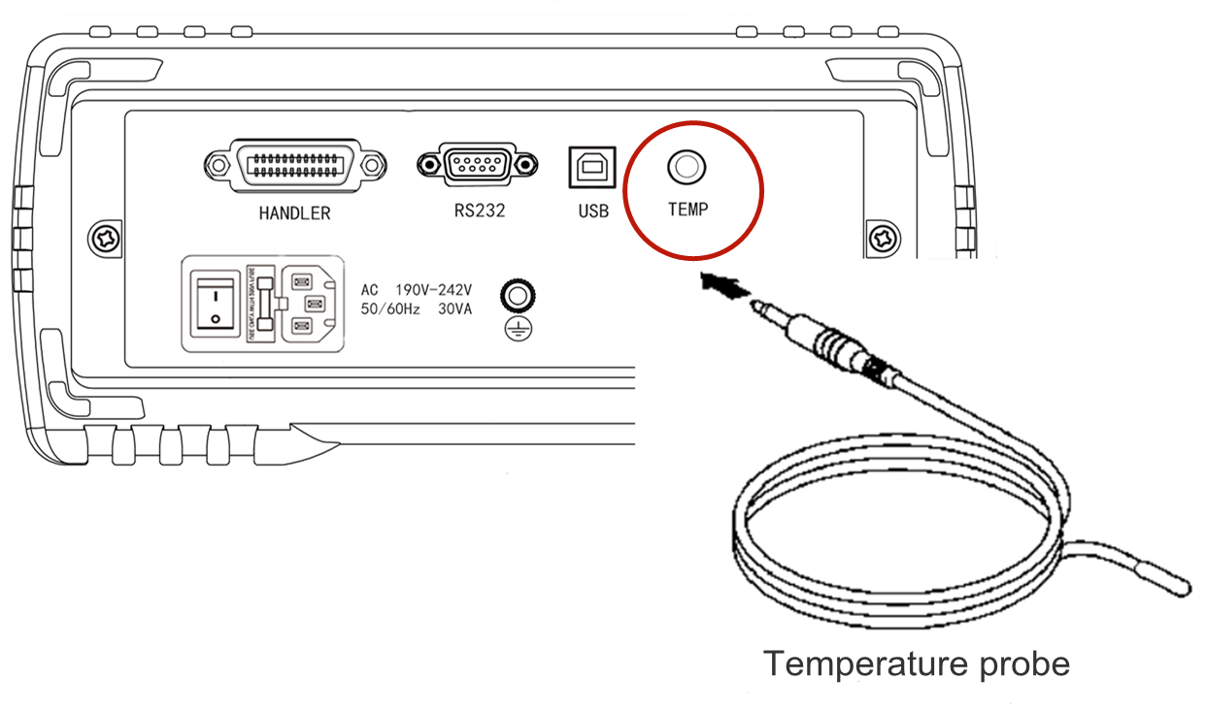
- Connection of temp sensor
- Confirm that power supply of device is off
- Connect the sensor to “TEMP” terminal at back of the device. Please fix it well. Please plug it firmly to the deep end.
- Please place the top of the temp sensor nearby the test piece.
Warning | Temp probe is precisely processe, it may be damaged if high voltage pulse or static electricity is applied.

- When using the temp probe

Caution | - Enough pre-heat time (30 min in general) of the device shall be ensured before measurement.  - Please measure after the test piece asking for compensation and the temp probe are fully adapted to the environment. Otherwise, a large error will occur.  - Induced noise will appear once temp probe is seized by naked hand, which may cause instability of the measured value.  - Temp sensor shall be placed around the test piece close as possible without actual contact. Wait for the measured value to stabilize before reading.

Refer | Refer to “ Use of temp” of “Chapter 7 Remote control” for details

3.5 Connection of external interface cable
- Connection of RS232 communication cable（as demand）
Refer | Refer to "Chapter 7 Remote control" for details
- Connection of RS485 communication cable（optional）
Refer | Refer to "Chapter 7 Remote control" for details
- Connection of USB communication cable（as demand）
Refer | Refer to "Chapter 7 Remote control" for details
- Connection of HANDLER（as demand）
Refer | Refer to "Chapter 7 Remote control" for details
- U disc storage（as demand）
If test data need to be stored, user may insert the U disc to the USD DEVICE interface on the front panel of the device. Only USB 2.0 is supported so far.
Refer | Refer to "5.2 File system instructions" for details

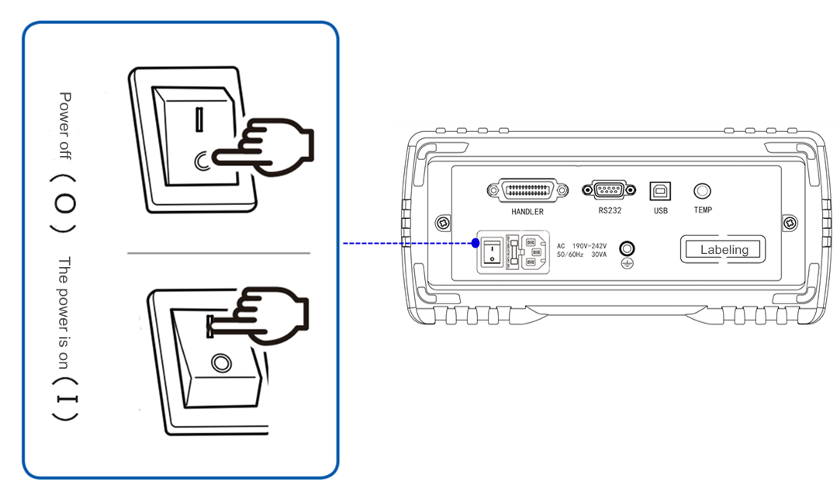
3.6 Power on/off
- Power on: The key marked on the lower left ( see figure on the right) is the power switch
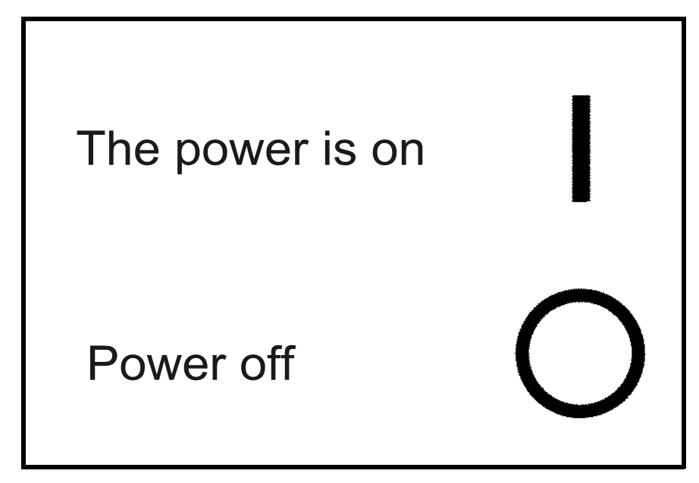

- STANDBY key: Below the LCD screen on the front panel
(see the figure on the right)
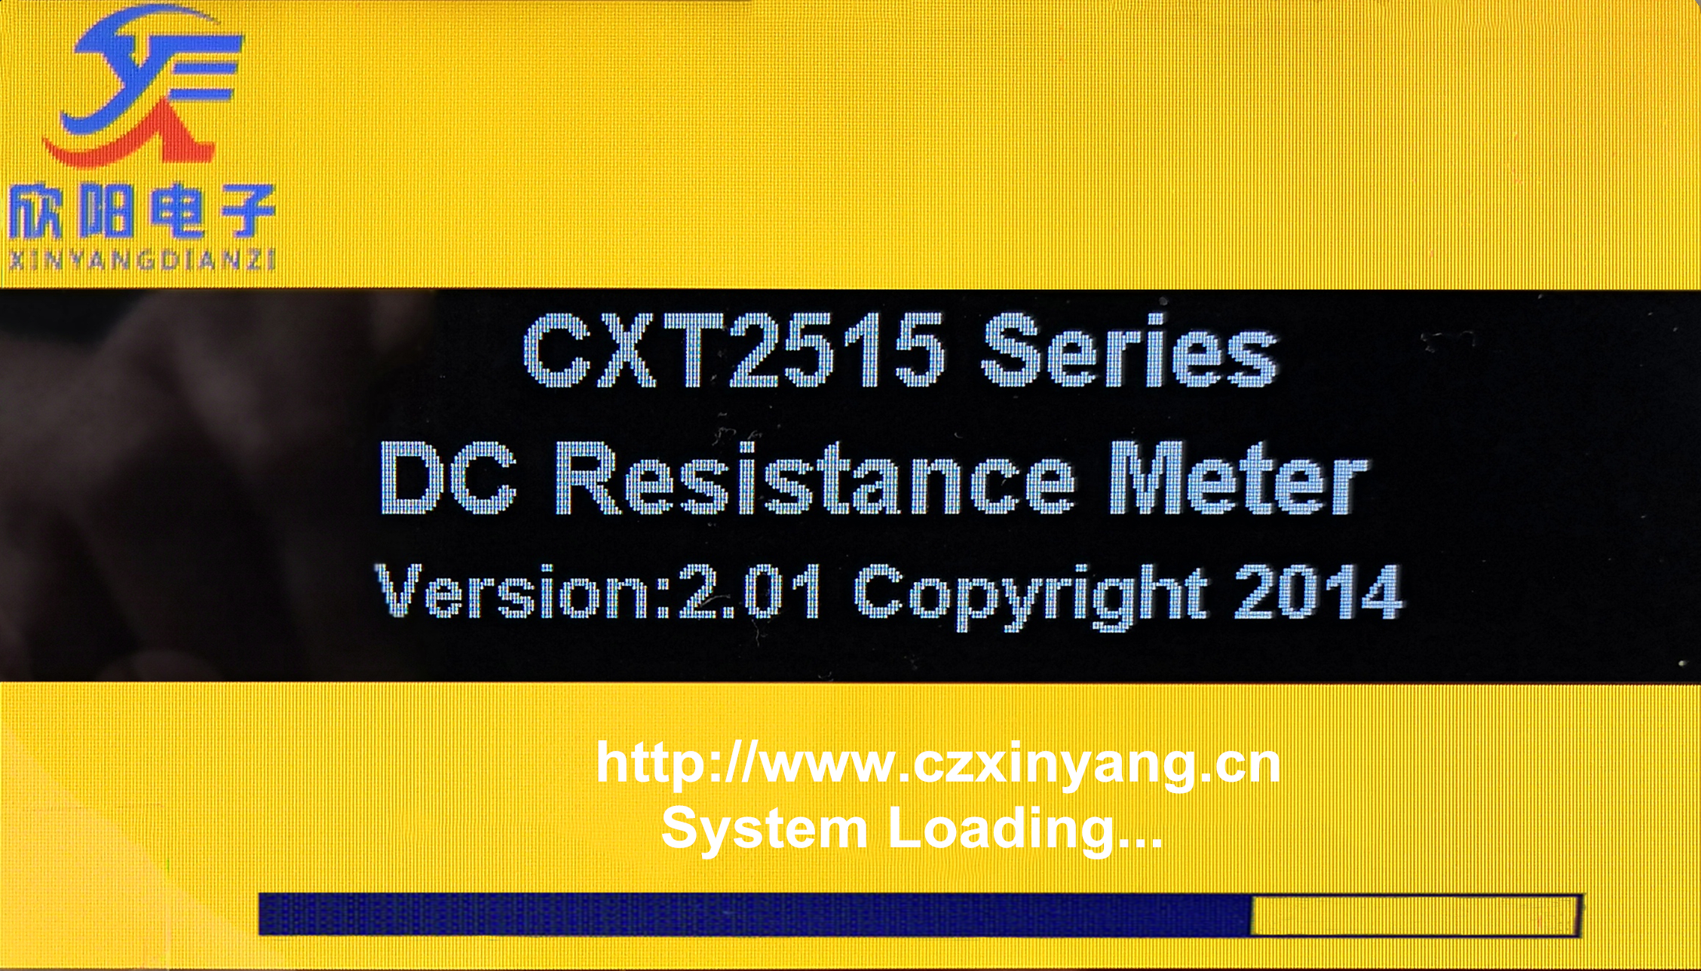
- Release standby mode - when standby mode is removed, the standby key displays green（When the standby key is pressed, device will goes into working mode, and the standby key will turn from red to green and light up.)
When the standby mode is removed, the device will start the self-checking (the self-diagnose of the device)
- Screen lights up;
- The startup screen, company name, model and version number are displayed;
- The device starts self-checking.
- Set to standby mode - when the device is in standby mode, the standby key will display red (that is, if the standby key is pressed again, the standby key will turn from red to green)
By turning of the power switch at the back of the device enclosure, power supply can be cut off during standby
If the power supply cable is pull out from the power input port, the standby key will go out.
If power supply is cut off (circuit breaker OFF, etc.) first and turned on again later, the device can be started even if the standby key is not pressed.
- Power on default: after the device self-checking procedure is successfully completes, the last setting before power off will be displayed.
In the first use, the initial setting will be displayed. Refer to "Device parameter setting" as per demands.
- Preheating time: in order to achieve the specified accuracy, please preheat the device for at least 30 minutes after power on.
- Power off: press the power switch on the rear panel of device, and the switch is in "O" status, "as shown in the figure above."
If power supply cable is pulled out from the power input port, the device will shut down automatically.
If the power is on again, the device will start with the setting before the power is off.
Warning | Do not switch the device on/off rapidly and continuously (or frequently), or, the instant impact may shorten the service life of the device, or even damage it.

Caution | - If power supply is cut off first in the power on status, and turned on again later, the device can be started even if the standby key is not pressed.  - Do not move the fixture casually during normal measurement,.  - After 30 minutes of warm-up, connect the test fixture, clear the short circuit of the test fixture, and then start the measurement.

3.7 Device parameter setting
Refer | Refer to “ Chapter 4 Parameter setting” for details.

3.8 Clear
- This device has the function of self stabilizing zero, so clearing calibration is not necessary. The base number of RK2515(RK2515)/N is basically 0, so in general, users do not need to clear; However, we still reserve the clear function for users.
- After power is on and preheating is completed, device can be cleared. When the ambient temp or the probe changes, device can be cleared. When the residual display content appears due to the influence of electromotive force,device can be cleared. When 4-terminal wiring (Kelvin connection) is difficult, it can be cleared by eliminating the residual resistance of 2-terminal wiring.
- When necessary, short-circuit clear operation can be carried out.
Clear procedure by user:
- To short circuit the test fixture, the wire end should be clamped with the wire end of text fixture, and the non wire end should be clamped with the non wire end; At this time, the base number displayed on LCD screen should be close to 0. If the fixture of the test cable is connected reversely, the data of the test cable will change greatly or display a large negative resistance value; At this time, a correct base number can be obtained by connecting the test fixture reversely. Turn the clear function “ON” , and the device will start to clear automatically in full range (Note: the clear process takes about 3 s, and will not end until the full range clear ends); The figure below illustrates the correct method to clear the short circuit of the test fixture.

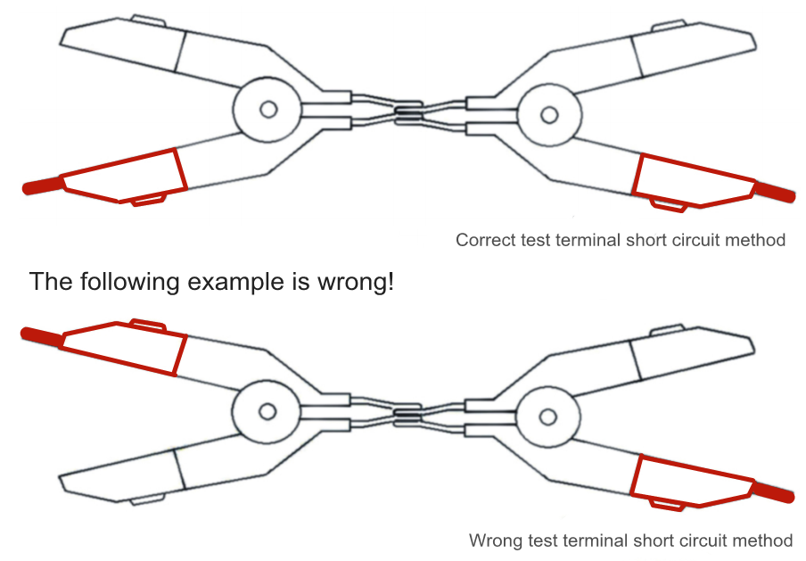

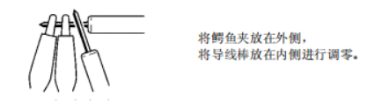

Caution | Fixtures must be at the same side for clearing.
Operation: In the main interface of measurement display: press "Measurement setting" to enter the measurement setting interface. Move the cursor to "Short circuit" with direction key, and the soft key area on the screen will show off/on. Press the corresponding function soft key to select the required clear operation to change the clear status.
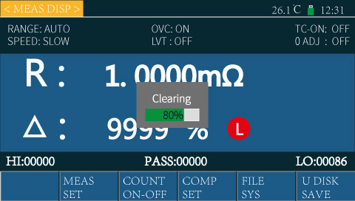
There are two clear functions: ON and OFF. When it’s turned on, the resistance base number in the testing circuit will be cleared
ON:Turn on short circuit clear to conduct open circuit clear for the device. The device will automatically pop up the measurement clear interface, as shown in the figure on the right. When the progress bar goes to the end, the clear is completed. After the clear, the device will automatically return to the test display interface and test status.
In the automatic range, the device will clear all ranges.
When the fixed range is manually chosen, the device will clear the current range only.
If the clear is successful, the cleared data will be stored in the nonvolatile memory.
OFF: turn off short circuit clear of the device, and the test value of the device will not clear the base value.
Caution | Confirm that the test input terminal is correctly short circuited before turning on clear

3.9 Start test
1 Range selection
RK2515N has 10 ranges: 20mΩ200mΩ2Ω20Ω200Ω2KΩ20KΩ200KΩ
2MΩ20MΩ100MΩ。
When the range of the device is set to “AUTO”, the device will choose the best input resistance for different test resistance to achieve the ideal test results.
Tips | - Manual range can effectively improve the test speed
2 Examples
Example I: Example II:
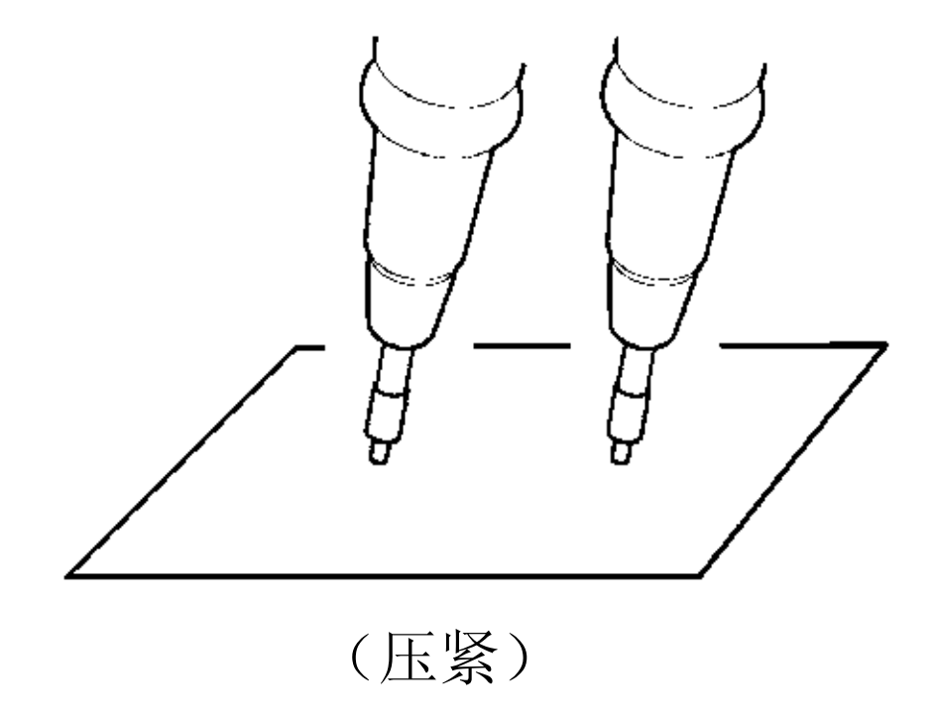
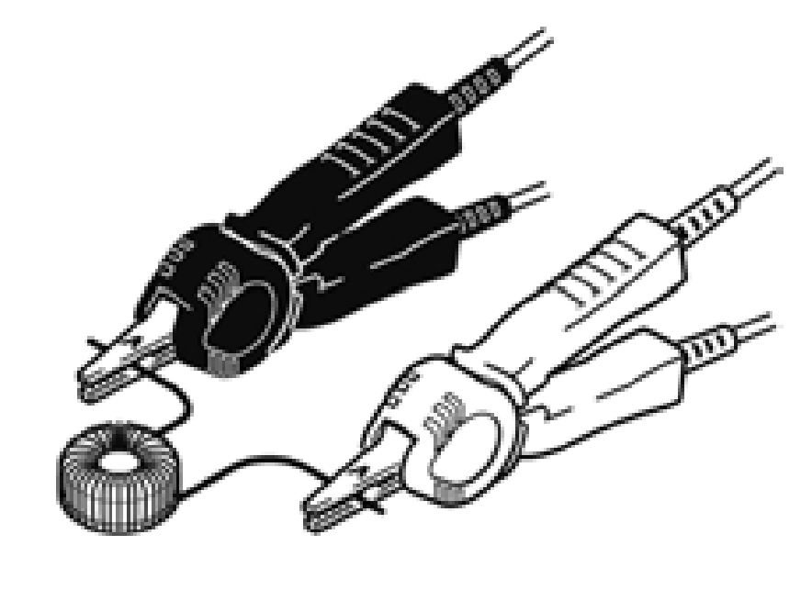

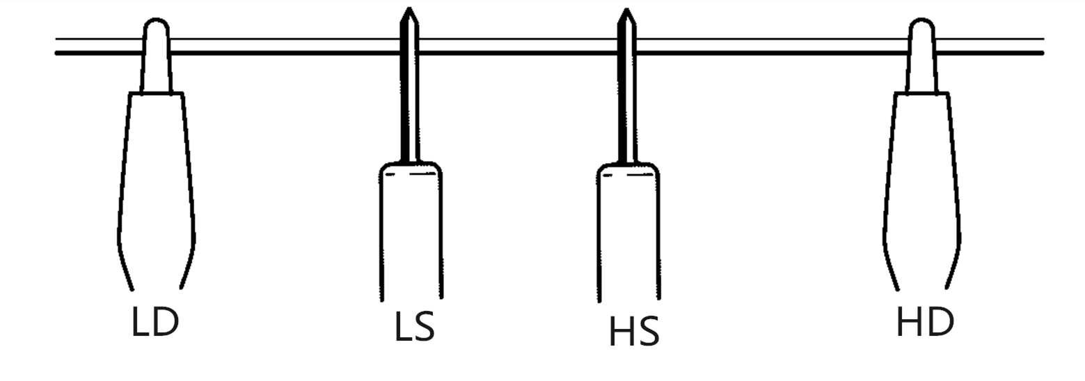
Example III:

Chapter IV Test parameter setting and operation

n this chapter you will learn:
- Confirm the test object
- Methods to set parameters and input values
- Introductions and parameter setting of measurement setting page
  - Confirm the test object
Use temp compensation when the temp depends on the test object largely.
Caution | If the transformer with large inductance or open screw tube coil is tested, the measured value may be unstable. In this case, please connect HD-LD with a 1uF thin film capacitor.

Tips | When measuring a single object, wait for the device to automatically jump to the appropriate gear and read the data. In the measurement of a same object, test the first qualified product, then lock the range after the data is stable, and the device will measure in the fixed range for the next measurement, which can improve the measurement speed and service life of the device.

Caution | When the power transformer with power frequency power supply is to be measured through external trigger, the measurement cannot be made under the preset state of delay setting. Please fully extend or measure through internal trigger.

4.2 Methods to set parameters and input values
Caution | The parameters and data set by the user will be saved automatically.
- Parameter setting
Step 1: Move the cursor with the direction key to the menu bar where the parameters need to be set, select the required parameters and press "OK" “”or press the encoder, the color will change from green to red.
Step 2: Select the parameters displayed at the bottom of the screen through the corresponding functional soft keys at the bottom of the screen, so as to complete the setting
- Digit input
Step 1:Move the cursor to the menu bar where the value needs to be set; Press any number key, and the cursor will from green to red, and enter the value setting status.
Step 2: Input the digit with the number key "0 ~ 9", decimal point "/," key and plus minus "+ / -" key. Select the unit the functional soft keys at the bottom of the screen can to set the unit of digit value; Press the backspace key "" to delete the previously entered characters.
Step 3: Select the parameters (such as units, etc.) displayed at the bottom of the screen by pressing the corresponding soft keys at the bottom of the screen or press the "OK" “” key to complete the setting.

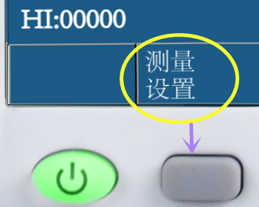
4.3 Introduction and parameter setting of measurement setting page
Operation:Two ways are available to to enter the measurement setting page
- Once turned on, the device will automatically enter the measurement display interface. Press the corresponding soft key under "Measurement setting" at the bottom of the screen to enter the measurement setting interface. As pointed by the arrow on the right:
- Or by pressing the [DISP] menu key on the right side of the screen, < Measurement setting > page will also be displayed on the screen. The test parameters of the device can be set in the measurement settings page as follows: <Potential compensation >, < Open circuit detection >, < Temp compensation >, < Measurement speed >, < Short circuit clear>, < Low voltage test >, < Temp coefficient >, < Compensation temp >, < Range setting >, < Average>, etc. As shown in Figure 4-1:
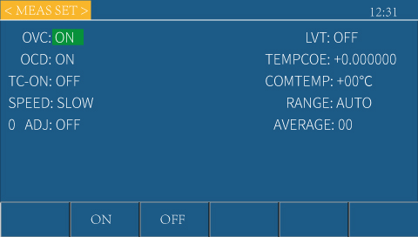

Figure 4-1 Measurement setting interface
- Display area of status bar
This area indicates the name of the currently displayed page, U disc letter and time.
As shown in the figure on the right:
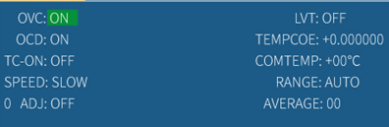
- The description of the parameter setting in the measurement setting interface are as follows:
This area indicates the test parameters of the device that can be set.
As shown in the figure on the right, the test parameters of the device can be set include: < Potential compensation >, < Open circuit detection >, < Temp compensation >, < Measurement speed >, < Short circuit clearing >, < Low voltage test >, < Temp coefficient >, < Compensation temp >, < Range setting >, < Average>, etc.
1）Potential compensation——To choose the thermoelectric compensation function of the device.
Operation: press the direction key to move the cursor to the “Potential compensation” , then press the corresponding functional soft key, and the soft key area on the screen will display ON/OFF . Choose the whether to turn on or off the function.
ON: The device test current will automatically carry out pulse (forward and reverse) test to get rid of the impact of thermo-EMF in the test circuit on the test results.This function is recommended to be turned on when low resistance is required to be tested with high precision.
OFF: The test current of the device is unidirectional, and the measurement of low-value resistance will be impacted by the thermo-EMF in the circuit. This function is recommended to be turned off when the inductance of the test piece is large, or the user’s demand for the test speed is high.
- Low voltage test——To choose the low voltage test mode
of the device.
Operation: Press the direction key to move the cursor to “Low voltage test”, then press the corresponding functional soft key, and the soft key area on the screen will display ON/OFF . Choose the whether to turn on or off the function.
ON: The maximum test voltage of the device (i.e. open circuit voltage) is ≤ 60mV. The effective range is 0-2Ω, 2Ω-20Ω. This function is generally used to test the tested parts which are sensitive to the test voltage
OFF: The device will test according to the normal range.
3）Open circuit detection——To choose the open circuit detection function of the device.
Operation: Press the direction key to move the cursor to “Open circuit detection”, then press the corresponding functional soft key, and the soft key area on the screen will display ON/OFF . Choose the whether to turn on or off the function.
ON: If one terminal of the four-terminal test terminal fails to test, "Poor contact" will be displayed on the measurement display interface so that to prevent misjudgment of test results.
OFF: No poor contact detection.
4）Temp compensation ——To set the temp compensation (TC) function of the device.
Operation: Press the direction key to move the cursor to “Temp compensation”, press the corresponding functional soft key, and the soft key area on the screen will display ON/OFF. Choose whether to turn on or off the function.
ON: Convert the resistance value to the resistance value at the reference temp and display it.
OFF: the resistance value will be displayed normally without conversion
Caution | When temp compensation is turned off, the device status bar will no longer display the temp test value.

When temp compensation is needed, the user should connect the temp sensor to the temp interface on the rear panel of the device. The temp displayed is the temp value measured by the temp sensor.
How to convert the resistance value of components measured at the current ambient temp to the value at the ambient temp set by the user:
Formula: Rt = Rt₀ / { 1 +α*(t-t₀)}
Rt: the resistance value measured at the current ambient temp;
Rt_{0:} corrected resistance value
t_{0:} set compensation temp (usually set to 20 ℃ or 25 ℃);
t: ambient temp value
α: material temp coefficient
When temp compensation is needed, the user should connect the temp sensor to the temp interface on the rear panel of the device.
E.g, the resistance measured at 20℃ is 100Ω(the material coefficient is set as 0.03930ppm), then the value of resistance at 10 ℃ is 96.22, i.e:
R10 = Rt₀ / { 1 +α*(t-t₀)} =100/1+ 0.03930 *（20-10）= 96.22Ω
5）Temp coefficient——To set the temp coefficient of the device.
Operation: two input methods are available.
Method 1: Press the direction key to move the cursor to “Temp coefficient”, then press any number key and + / - key to input the required value, hen press "OK" key, and the cursor changes from red to green. Thus, the setup is done.
Method 2: Press the direction key to move the cursor to “Temp coefficient”, press the corresponding functional soft key to add or subtract numbers and input the required temp.
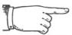Explain | - ↑↑（+ +）  Press the functional soft key, the device will sharply increase the set value up with a step of 10.  - ↑（+）  Press the functional soft key, the device will increase the set value with a step of 1.  - ↓（-）  Press the functional soft key, the device will decrease the set value with a step of 1.  - ↓↓（- -）  Press the functional soft key, the device will sharply decrease the set value up with a step of 10.
The temp coefficients of common metals are shown in the table below:
Metal | Temp coefficient（20℃）
Silver | -0.0038
Copper | -0.00393
Aluminum | -0.0039
Iron | -0.005
Nickel copper alloy | -0.0007
6）Compensated temp——To set the temp to be compensated when the device uses the temp compensation function, i.e., the t₀ in the formula of "Temp compensation" above
Operation: two input methods are available.
Method 1: Press the direction key to move the cursor to “Compensated temp” and press any number key to input the required value, then press "OK" key, and the cursor will change from red to green. Thus, the setup is done.
Method 2: Press the direction key to move the cursor to “Compensated temp” , then press the corresponding functional soft key to add or subtract numbers and input the required temp.
7）Measuring speed——To set the measuring speed of the device.
Operation: Press the direction key to move the cursor to “Measuring speed”, then press the corresponding functional soft key, and the soft key area on the screen will display Fast, Medium, Slow, and Precision.
Choose the required measuring speed.
The completion of one time of test is from the test generation - analog-digital conversion - operation to the display of result of the measurement or sorting measurement. Test speed refers to the number of tests that can be completed per second.
The test speed of RK2514N/RK2515N is mainly determined by the elements below:
- Integral sampling period
- Measurement delay (time from start to start)
- Display time of measurement results
There are four kinds of measuring speed: Fast: 100 times / s, Medium: 25 times / s, Slow: 10 times / s Precision: 4 times / s
The lower the measurement speed is, the higher the measurement accuracy is. The higher the measurement speed is, the easier the external environment can influence the result.
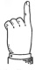  Detail | The above parameters is the speed when potential compensation and open circuit detection” are turned off, and U disc recording and temp compensation are not carried out. When the potential compensation, open circuit detection, U disc recording, or temp compensation is turned on, the test speed will be slowed down.

Tips | Setting the average times can improve the sampling stability, but it will reduce the test speed.
8）Range setting——To choose from “Device auto” or “Locked range”
Operation: Press the direction key to move the cursor to "Range setting", then press the corresponding functional soft key, and the soft key area on the screen will display Auto 20mΩ200mΩ2ΩNext page;
20Ω200Ω2KΩ20KΩNext page;
200KΩ2MΩ100MΩNext page.
Select the desired range setting.
When auto mode is chosen, the device will automatically select the appropriate range and measure.
When other range is chosen, the device will jump to that range and measure.
Detail | - If the range is changed, if the resistance value of the measured object is obviously smaller than the measuring range, the error will increase.  - When greater than 1KΩabove, inductance and coil cannot be measured.
The current of each range is shown in the table below.
Resistance range | Normal test | Low voltage test
20mΩ | 1A | 10mA
200mΩ | 1A | 10mA
2Ω | 100mA | 10mA
20Ω | 10mA | 1mA
200Ω | 1mA | ---
2KΩ | 1mA | ---
20KΩ | 100uA | ---
200KΩ | 10uA | ---
2MΩ | 1uA | ---
110MΩ | Constant | ---

Tips | When auto range is chosen, the device will automatically select the appropriate range for measurement, but it takes a long time to complete the range selecting, so it is not suitable for batch test, and it is not easy to select the appropriate range in the test of large capacitive load. In the batch test of same products, It is suggested to lock the appropriate range to greatly improve the test efficiency.
- Short circuit clear—— To carry out short circuit clear to the device
Refer  Refer | Refer to 3.7 “Clear” for details
- Average——To set the average number of tests for the device. Setting range: 1-999
Operation: Two input methods are available.
Method 1: Press the direction key to move the cursor to “Average” and press any number key to input the required average times, then press "OK" key, and the cursor will change from red to green. Thus, the setup is done.
Method 2: press the direction key to move the cursor to “Average”, then press the corresponding functional soft key to add or subtract numbers, and input the required average times.
The test data is smoothed based on the user-set average number of times. Average and display multiple measured values, in which way, the deviation of the measured value can be reduced.
The user can smooth the measured data (i.e.digital filtering) by setting the average sub device, so that the data is more stable.
Detail | If the trigger mode is external, the average function will not work no matter it is on or off.

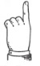  Tips | Setting the average times can improve the sampling stability, but will lower the test speed.

Chapter 5 System setting and file management
In this chapter, you will learn:
- Interface introductions and parameter setting of of system setting
- Interface introductions and parameter setting of file system
- File system description (storage / call function)

5.1 System setting interface
Press the [set] menu key on the right side of any interface, and <System setting> page will also be displayed on the screen. In the system setting interface, device settings including <System alarm sound>, <Bus mode>, <Communication protocol>, <System language>, <Trigger source>, <Enlarge>, <Trigger edge>, <Key tone>, <Baud rate>, <Bus address>, <System time>, etc can be set.
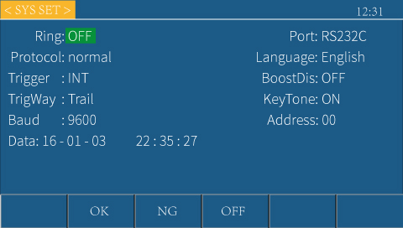

Figure 5-1 System setting interface
- Display are of status bar
This area indicates the name of the currently displayed page, U disc letter and time.
As shown in the figure on the right:
- The introductions of parameter settings in the system setting interface are as below:
In the system setting interface, device settings including <System alarm sound>, <Bus mode>, <Communication protocol>, <System language>, <Trigger source>, <Enlarge>, <Trigger edge>, <Key tone>, <Baud rate>, <Bus address>, <System time>, etc can be set.
- System alarm sound——To select the mode of device sound
Operation: Press the direction key to move the cursor to “System alarm sound”, then press the corresponding functional soft key below, and the soft key area on the screen will display Qualified / Unqualified /Off. Select the desired system alarm sound.
Off: no matter what the test result is, the buzzer will not sound.
Qualified: when the test result is qualified, the buzzer will sound.
Unqualified: when the test result is unqualified, the buzzer will sound.
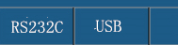
- Bus mode—— To choose RS232 or USB port for remote control
Operation: Press the direction key to move the cursor to “Bus Mode” then press the corresponding functional soft key below, and “RS232” and the soft key area on the screen will display “USB” . Choose the required bus mode.
The device can be operated and remotely controlled through these two interfaces.
If USB is chosen, the device will use the USB HOST interface on the rear panel to communicate with the upper monitor.
If RS232 is chosen, the device will use the RS232 interface of the rear panel to communicate with the upper monitor.
3）Communication protocol——To choose the communication protocol mode of bus
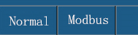
Operation: Press the direction key to move the cursor to “Communication protocol”, then press the corresponding functional soft key below, and the soft key area on the screen will display Normal/Modbus. Choose the required communication protocol mode.
Refer  Refer | Refer to 7.2 “Communication protocol” for details
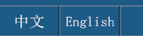
4）System language——To choose the language mode of device interface
Operation: Press the direction key to move the cursor to “System language”, then press the corresponding functional soft key below, and the soft key area on the screen will display Chinese / English. Choose the required system language.
5）Trigger source——To choose the trigger source to start the device measurement
Operation: Press the direction key to move the cursor to “Trigger source”, then press the corresponding functional soft key below, and the soft key area on the screen will display Internal / External / Manual / Contact. Choose the required trigger source.
Users can choose the trigger mode;Trigger is divided into four type namely internal, manual, external and contact.
Internal: continuously measure the test piece and output and display the results.
Manual: press the "[TRIG]" key on the panel, then the device will make one measurement and output and display the result. Otherwise, the device will be kept in standby status.
External: The device will make one measurement after receiving the "Start" signal from the external through the HANDLER or 232 / USB interface at the rear panel, and output and display the measurement results, and then enter the standby status again.
External: The device will make one measurement after receiving the "Start" signal from the external through the HANDLER or 232 / USB interface at the rear panel, and output and display the measurement results, and then enter the standby status again.
Contact: when the user connects the test fixture to the test piece, the device will automatically start to measure, and select a stable value as the test result, then judge and record it. After that, the device will start to wait for the next piece to be connected to the test fixture.
Caution | When “Contact” is chosen as the trigger source, please lock the appropriate range.
6）Enlarge——To choose the font weight of the displayed part of the test result
Operation: Press the direction key to move the cursor to “Enlarge”, then press the corresponding functional soft key below, and the soft key area on the screen will display Off / On. Choose the required enlarged weight.
OFF: The test results are displayed in normal size and font.
ON: The font of the display result is larger for the sake of convenient observation. At this time, press DISP key and the test interface of the device is as shown in the figure on the right:
7）Trigger edge——In external trigger, choose whether to trigger by the rising or falling edge of the trigger signal.
Operation:Press the direction key to move the cursor to “Trigger edge”, press the corresponding functional soft key below, and the soft key area on the screen will display Falling edge / Rising edge. Choose the required trigger edge.
If the rising edge is chosen, when the rising edge of the trigger signal is detected, the device will start the test; vice versa.
8）Key tone—— To choose the prompt tone when the key is pressed
Operation: Press the direction key to move the cursor to “Key tone”, then press the corresponding functional soft key below, and the soft key area on the screen will display ON/OFF. Choose the required key tone.
ON: When the key is pressed, the buzzer will sound, indicating that the key has been pressed.
OFF: The buzzer will not sound when the key is pressed.
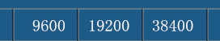
9）Baud rate——To choose the device communication rate, Three groups of Baud rates are available.
Operation: Press the direction key to move the cursor to “Baud rate”, then press the corresponding functional soft key below, and the soft key area of the screen will display 9600 / 19200 / 38400. Choose the required Baud rate.
10）Bus address——00-99.To choose the address of the device in the bus. Bus address range is: 00-99
Operation:Press the direction key to move the cursor to “Bus address”, then press the corresponding functional soft key below to add or subtract numbers to input the required bus address.
When the multiple devices are connected to the bus by 485 interface or MODBUS protocol at the same time, they can be identified by different bus addresses. Only when the bus address in the command is the same as the local address can the device receive the order.
- System time —— Set the correct time of the local time zone of the system; After the setting is done, the device will save it automatically.
E.g: May 13, 2020, 8:15:25 a.m will be displayed as: 20-05-13 08:15:25
Operation: Press the direction key to move the cursor to “System time”, and then move the cursor to the time format to be input. Press the corresponding functional soft key below to add or subtract numbers to input the required system time.

5.2 File system interface
In the measurement display interface of the device, press the corresponding soft key under "File system" to enter the file system interface.
There are two kinds of file systems: internal file system and external file system. User can switch between these two file systems freely.
Operation: In the measurement display interface, press the corresponding soft key under "File system" to enter the file system interface. Press the direction key to move the cursor to "Internal file" or "External file", and then press the corresponding functional soft key below. The soft key area on the screen will display Internal / External / Page turning. Choose the required file interface.
As shown in Figure 5-2: Internal and external file systems interface
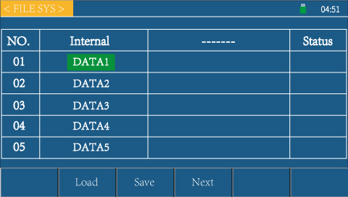
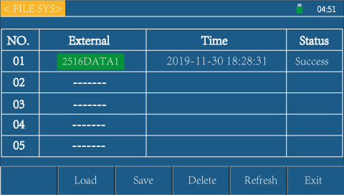

When you press the corresponding function soft key below "internal", the internal file system will pop up;
When you press the corresponding function soft key under "external", the external file system will pop up;
When you press the corresponding function soft key under "turn page": switch internal / external file serial number. RK2515N has 10 groups of files
For saving, press "page" key to select file No.1-5 or file no.6-10.
1、Status bar display area
This area indicates the name of the currently displayed page, the U disk prompt, and the time.
As shown on the right：
2、The internal file system interface parameter settings are described below：
RK2514N/RK2515N series of instruments can store user-set parameters as files in non-volatile storage inside the instrument
Apparatus.The next time you want to use the same settings, the user doesn't need to reset the parameters, just load the appropriate files.
You can get the parameters you set last time.
Action: Press the arrow keys on the internal file system interface to move the cursor to the desired file name, and the screen soft key area will be displayed
Load, save, exit.Select the desired function,Press the corresponding function soft key.
In the file interface, the user can save the settings parameters of the instrument (speed, range, upper and lower limits, etc.) as 1-10 groups
Data for users to quickly read the settings parameters.
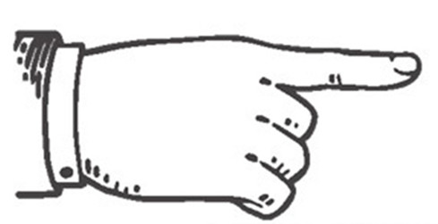  Explain | - Each page of the internal file page and the external file page shows whether the information of the five files on the page has been read or saved.  - The operation of internal file is similar to that of external file. Press the corresponding "down" button in the right soft key of LCD screen,Press the "one page" button to turn the page.1
Internal file：data1～data10
Data1-data10 refers to the 10 addresses that can be used to store and read data inside the instrument. Users can use these 10 addresses to store 10 sets of measurement parameter data. Users can select file addresses.Move the cursor to the corresponding address to read and save the address.
Notice | If a file already exists at the corresponding file ordinal location when the file is saved, the save operation will overwrite the original file.
3、Parameter settings for the external file system interface are described below：
RK2514N/RK2515N of instruments can store information on a U disk. When the same settings are to be used next time or on the same instrument, the user does not need to reset these parameters. Just load the corresponding files to get the last set parameters.See Fig. 5-4 External File System

Figure 5-4 External File System
The external file page displays information about five files, including the file name, save time and status of the file.
Action: Press the arrow keys on the external file system interface to move the cursor to the file name that needs to be edited, and then the screen soft key area will display Load, Save, Delete, Refresh, Exit.Select the desired function and press the corresponding function soft key.
1) load
Select a file, and then press the corresponding function soft key below "load" to import the setting parameters stored in the USB disk into the instrument.
2 ) save
Select a file and press the soft key below "Save" to save the measurement result to the USB disk
3) delete
Select a file and press the corresponding soft key below "Delete".
4) refresh
Select a file and press refresh.
5) quit
Press the soft key below Exit to exit the file system and return to the measurement display page.

5.3 File System Description (Storage/Recall Function)
Function of file calling / storage: save the parameters (upper and lower limits, measuring range, speed, etc.) set by the user of the instrument in the U disk or internal memory of the instrument. The user can call these parameters at any time, which saves the trouble of resetting the parameters by the user.
When selecting internal files, the instrument has 5 groups of parameters for users to store / call. Respectively: 2515data1; 2515data2; 2515data3; 2515data4; 2515data5
The following table describes the storage methods available and their uses：
preservation method |  | Is it callable? | use
Types of | file format
Config save(external u disk) | 2515N DATA..STA | YES | Save the measurement results to the u disk
Config save(Internal FLASH) | HEX |  | Save setup parameters to the instrument
Data save(extenal u disk) | 2515N SAVE.XLS | NO | Save test result to u disk

Note | Note the following when using the u disk on RK2514N/RK2515N:  - Use a u disk with interface usb2.0.  - The u disk file system used should be fat16 or fat32 and formatted using the fat16 or fat32 standard.  - Before connecting the u disk to the RK2516/a/b, it is recommended that the user back up the data saved on the u disk.When we do not use the usb storage device RK2516/a/b, we are responsible for data loss in the usb storage device.  - In order to efficiently save the instrument data to the u disk, it is recommended that there are not too many files or folders in the u disk.

2、Steps for saving instrument test data to U disk
1）、Insert a U disk and wait until the device recognizes the U disk (about 5-10S). If the U disk is recognized, the instrument status bar will display a U disk.Drive letter.
2) Press the screen on the main interface (measurement display interface)The corresponding "U disk record" in the following soft keys can Switch to control U disk recording.If U-disk recording function When turned on, the U drive letter changes from red to green.
3) U disk status prompt When the U disk symbol is green, it means that the instrument is writing data to the U disk. When the U disk symbol is red, it means that the U disk is connected but the instrument does not write data to the U disk.When there is no U disk symbol, it means there is no U disk inserted.
4) Upgrade the software with a U disk.
Warn | Please use the corresponding upgrade software of our company and proceed under the guidance of our technical staff, otherwise this instrument will cause failure or accident.

Chapter 6 Sorting Comparator
In this chapter, you will learn:
- Storing mode
- Ring
- PASS/FALL Indicator light
- Comparison process

6.1 Sorting Settings Interface
Instrument in measurement display interface, press "Sort Settings" below corresponding Soft key to enter the sorting settings interface.Figure 6-1：

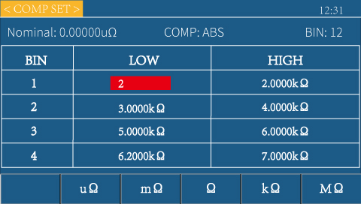
Figure 6-1 Sorting Setup Interface

1. Status bar display area
This area indicates the name of the currently displayed page, the U-disk prompt, and the time.
2. The parameter settings of the sorting and setting interface are described as follows:
This interface can set up the function of the instrument comparator.In the selection setup interface, you can set the name limit of the instrument, the sorting settings, the upper and lower limit values of the sorting files and each position, etc.
1) Nominal Limit - Nominal is made in the case of percentage nominal values.Used to calculate the percentage of excess difference between resistance values and nominal values.
The formula is: (resistance-nominal)/nominal)× 100%.
Operation: Press the direction key to move the cursor to the nominal value, and enter the nominal value that the user needs to set through the number key.
Notice | Nominal is only used when the selection is set to'%'
1) Sorting Settings - Used to select the sorting function of the instrument
Operation: Press the arrow keys to move the cursor to the selected value, screen soft key area

It will show off, on.Press the corresponding function soft key below to select
Select the desired sorting mode.
Select direct reading: the instrument will be sorted by upper and lower limits of direct reading;Set the upper and lower limits, and the measured values will follow
Compare the set values to determine whether they are above the upper limit (H), below the lower limit (L), or at the set value Qualified products within the range (numbers 1-12 represent qualified files).
Selection%: The instrument will sort the upper and lower limits of percentage.The instrument can set nominal values and percentages.
If the nominal value is set to 100 (% percent) and the upper and lower limits are 10, then the value is 100 +10%.Compare the measured value with this setting to determine if it is the upper (H) or lower (L), or Qualified products within the set value range (numbers 1-10 represent qualified files).
- BIN——There are 12 selectable files to select.See 6.3 process selection. If set to "1", there is only one Eligible gear, other qualified gear ignored。
- High/Low ——The upper and lower limits are used to determine the output of the sorting results of the instrument. When sorted as direct reading, the settings in Table 6-1 are
Upper and lower limit for direct reading. When sorted as percentage, the upper and lower limit for percentage is set in table 6-1.
The upper and lower limits of direct reading are set by using the cursor “Arrow keys move to the upper and lower bounds you need to set, press any number keys, then enter numbers through the numeric keyboard (you can set the upper and lower bounds symbols through the +/- keys), enter units through the corresponding soft keys at the bottom of the screen, and press OK key to end after setting.The function soft keys at the bottom of the screen are converted into unit selections when you enter the upper/lower limit value setting.Press the corresponding soft key at the bottom of the screen to enter the unit.
The upper and lower bounds of percentages are set by moving the cursor to the upper and lower bounds that need to be set with the arrow keys, pressing any number key, and then entering numbers through the numeric keyboard (symbols for the upper and lower bounds can be set with the +/-keys).Press OK key to end after setup。

6.2 Ring
"Ring" in "System Setup Interface", see "Section 5.1" to enter the system setup interface, select the system announcement.
When the Signal is set to off, the buzzer will not sound regardless of the test result.
When Signal is set to On, Eligible: When the test results are qualified, the comparator output is qualified, buzzer sound

Unqualified: When the test result is not qualified, the comparator output is not qualified, buzzer sound
Convention: Buzzer can be used to inform the decision result

6.3 PASS/FAIL Light
PASS/FAIL Light：Sort qualified indicator。
According to the output of the sorting comparator, it is shown that it is over/under or qualified.
See the picture on the right.
1. Green light means test data is up to standard.
2. The red light indicates that the test data is not up to standard。

6.3 Comparison Process
There are 14 sorting outputs in RK2514N/RK2515N, which are: 12 qualified P;Super H in level 1;Super L in level 1.
Notice | - Before sorting, we need to set the upper and lower limits in the Sorting Setup Interface.The upper limit set by the user must be greater than the lower limit, otherwise the comparator will not work properly.  - Note: If the measured resistance is negative, the sorting result always exceeds the lower limit;If the test range is exceeded or the open circuit is exceeded, the sorting result always outputs the upper limit.
The instrument will judge the sorted output of the measurement result according to the upper and lower limits set by the user.
If the number of files selected is set to 1. only the upper and lower limits of 1 file are used for comparison.The number of passes is set to 2, and only the upper and lower limits of 1 and 2 passes are compared (in this case, the resistance output exceeds the upper limit, which needs to be greater than the maximum limit of 1 and 2 passes;Output Overrun Lower Limit needs to be less than 1 and 2 minimum lower limits).

Chapter 7 Remote Control
In this chapter you will learn about the following:
- RS232/485 communication method
- Communication Protocol
- Handler interface communication method
- USB HOST interface communication method

7.1 RS232 / 485 communication method
- Before connecting to the RS232c/485 connector
Note | - To avoid accidents, do not plug or unplug the communication cable during operation.  - When connecting or removing the communication cable, be sure to turn off the power to the instrument and the device.Failure to do so may result in malfunction or malfunction.  - After connecting the communication cable, firmly fix the screws that come with the connector. If the connection is not secure, it may cause malfunction or malfunction.
- 2、Interface Description
The widely used serial communication standard is the RS-232 standard, which can also be called the asynchronous serial communication standard. The RS is: “Recommended
Standrad" (recommended standard) English abbreviation, 232 is the standard number, thestandard is the Electronic Industries Association of America (IEA) in 1969
The officially published standard, which stipulates that each time a piece of land is transmitted via a data line.
Note | Like most serial ports in the world, the serial interface of the instrument is not strictly based on the rs-232 standard, but only provides a minimal subset.
- 3、Wiring
- Instrument RS232 signal and pin comparison table
Signal name | abbreviation | Connector pin number
Receive data | TX | 2
send data | RX | 3
Signal ground or shared return line | GND | 5

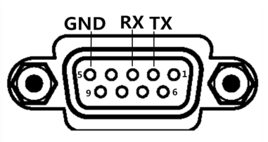
- RS232 wiring method：
When connecting with RS232, please prepare directly connected to theinstrument specifications RS232cable.This instrument uses 2, 3, 5 needles,no other pins, RS232 wiring.
- 485 wiring method (Optional)：
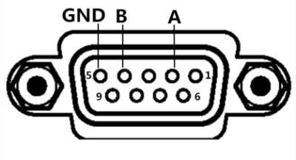
- Rs485 is a standard for defining the electrical characteristics of drivers and receivers in a balanced digital multipoint system, which is defined by the Telecommunications Industry Association will be defined by the Electronic Industry Alliance.The digital communication network using this standard can be used under long distance conditions and in an environment with high electronic noise effective transmission of signals.
- The 485 interface is optional and is a standard 3-wire(a, b, GND)communication mode.
- High-speed communication over long distances.
- The specific wiring method of rs485 is as shown on the right：

7.2 Communication Protocol
Instrument communication protocol is divided into normal and modbus, which can be switched in instrument system settings.
1、Communication Protocol(normal)
This instrument uses RS-232C standard asynchronous serial communication bus interface to communicate with external control equipment. The baud rate can be preset in the instrument (96001920038400 optional). 8 data bits, 1 stop bit, no check bit. The logic level of the signal is ± 12V, and the maximum transmission distance is 15m. The serial interface uses direct communication, only TXD (transmit), RXD (receive), GND (ground) three signal wires, and nine core standard interface socket.
1）、Data sent by the instrument to the upper computer (31 bit data in total)
explain | bit | ASCii | HEX |  | remarks
START | 0 | : | 3AH |  | Start bit
ADR | 1 |  | 00H-63H |  | Communication address. The range is 0-99 decimal. If the local address in the instrument system setting is 99, the bit is 63h
Spare bit | 2 |  | 03H
Spare bit | 3 |  | 00H
Spare bit | 4 |  | 01H
Spare bit | 5 |  | 00H
Resistance data | 6-16 | The sorting result of resistance ,sign and resistance value (8 bits) and unit (1 bit) + 2 bits are all ASCII codes. There are 11 bits of data |  |  | If + 1.23456of represents positive 1.23456 ohm, the sorting output is unqualified. (the corresponding hexadecimal is 2bh 31h 2eh 32H 33H 34h 35h 20h 4fh 46h)  The units are divided into u, m, O, K, m, u, C. they are micro ohm, milliohm, ohm, kilo ohm, megohm, open resistance and poor contact. (the corresponding hexadecimal codes are 75h, 6dh, 4fh, 6bh, 4dh, 55h, 43h) the sorting results are classified into qualified grade 01 / 02 / 03 12(30H31H/30H32H/30H33H… 31h32h) unqualified grade H / L (20h48h / 20hach) and separation failure f (20h46h)
Resistance percentage data | 17-23 | 1-bit symbol + 5-digit percentage value + 1-bit unit. All of them are ASCII code. There are 7-bit data |  |  | If received + 1.23% represents positive 1.23%  The percentage of resistance value is fixed as 7-bit data
temperature | 24-28 | Symbol + 4-digit temperature value, 5 bits in total |  |  | If received + 12.3, it means 12.3 ℃. If + --- indicates that the temperature sensor is not inserted or the temperature compensation function is turned off.
END1 | 29 | CR | 0DH | 结束位1
END2 | 30 | LF | 0AH | 结束位2
For example: 3AH 01H 03H 00H 01H 00H 2BH 31H 2EH 32H 33H 34H 35H 20H 4DH 20H 48H 2BH 31H 32H 2EH 33H 20H 25H 2BH 31H 32H 2EH 30H 0DH 0AH
The resistance of the representative instrument is + 1.2345m Ω, which is sorted up to exceed; the percentage ratio of resistance is 12.3%; the temperature test value is + 12.0 ℃; the bus address is 01.
2）、Write data to instrument
The format of upper computer writing data to the instrument is: ABH + machine number + high storage address + low storage address + 00h + 00h + data + AFH; fixed 18 bit data. The data content is shown in the table below
Serial number | Command function | Instruction data | Format / Notes
01 | Set the upper resistance limit | 10A1H | Gear(30h-33h)+3 digits before the decimal point + 5 digits after the decimal point (30h-39h,0-9 of ASCII) +Unit(uΩ,mΩ,Ω,kΩ,MΩ;The corresponding hex code is 75h,6dh,4f,6b,4dh, u,m,O,k,M of ASCII)
02 | Set the lower limit of resistance | 10A2H | ditto
03 | Set percentage upper limit | 10A3H | Ggear(01h-0ch)+ Sign (+/-,hex is 2BH or2DH)+2 digits before the decimal point +3 digits after the decimal point (30h-39h,0-9 of ASCII) 00H 00H 00H
04 | Set percentage lower limit | 10A4H | ditto
05 | Set nominal value | 10A5H | 3 digits before the decimal point + 5 digits after the decimal point (30h-39h,0-9 of ASCII) +Unit(uΩ,mΩ,Ω,kΩ,MΩ;The corresponding hex code is 75h,6dh,4f,6b,4dh, u,m,O,k,M of ASCII) +00H
06 | Set 0 ADJ | 10A6H | on(01H)oroff(00H) 00H 00H 00H 00H 00H 00H 00H 00H 00H
07 | Set DIS | 10A7H | Dis(00H:ABS 01H:%) 00H 00H 00H 00H 00H 00H 00H 00H 00H
08 | Set Speed | 10A8H | Speed(00H:fast01H:slow) 00H 00H 00H 00H 00H 00H 00H 00H 00H
09 | Set Range | 10A9H | Range(00H:auto 01H:20mΩ 02H:200mΩ 03H:2Ω 04H:20Ω 05H:200Ω 06H:2KΩ 07H:20KΩ 08H:200KΩ 09H:2MΩ) 00H 00H 00H 00H 00H 00H 00H 00H 00H
010 | Set Trigger | 10AAH | Trigger(00H:INT 01H:EXT 02H:MAN) 00H 00H 00H 00H 00H 00H 00H 00H 00H
011 | Set TC on-off | 10ABH | TC(00H:off 01H:on) 00H 00H 00H 00H 00H 00H 00H 00H 00H
012 | Set TEMPCOE | 10ACH | sign（+(2bh)/-(2dh))+6 digits after the decimal point (30h-39h) 00H 00H 00H
013 | Trigger signal | 10ADH | 01H 00H 00H 00H 00H 00H 00H 00H 00H 00H
014 | Set average | 10AEH | Tens + ones (30h-39h,0-9 of ASCII ). To set the average to 98, the data bit is 39H+38H+00H 00H 00H 00H 00H 00H 00H 00H
015 | Set Norm | 10B1H | Norm (0:Fall 1:Rise) 00H 00H 00H 00H 00H 00H 00H 00H 00H
016 | Set OCD | 10B2H | OCD(00H:off 01H:on) 00H 00H 00H 00H 00H 00H 00H 00H 00H
017 | Set COMPTEMP | 10B3H | sign（+(2bh)/-(2dh))+ Tens + ones (30h-39h,0-9 of ASCII ) 00H 00H 00H 00H 00H 00H 00H
018 | Set ring | 10B4H | Ring(0:OK 1:NG 2:OFF ) 00H 00H 00H 00H 00H 00H 00H 00H 00H
019 | Set OVC | 10B5H | OVC(00H:on 01H:off) 00H 00H 00H 00H 00H 00H 00H 00H 00H
020 | Set keytone | 10B6H | Key tone(01H:off 00H:on) 00H 00H 00H 00H 00H 00H 00H 00H 00H
021 | Count on/off | 10B7H | Count on/off(00H:off 01H:on) 00H 00H 00H 00H 00H 00H 00H 00H 00H
022 | U disk save on/off | 10B8H | U disk save (00H:off 01H:on) 00H 00H 00H 00H 00H 00H 00H 00H 00H
023 | Set BIN | 10B9H | BIN(01H:1 02H:2 03H 3) 00H 00H 00H 00H 00H 00H 00H 00H 00H
024 | Set LVT | 10BAH | LVT(00H :off 01H:on) 00H 00H 00H 00H 00H 00H 00H 00H 00H
For example：ABH 01H 10H A1H 00H 00H 00H 01H 31H 30H 30H 32H 35H 00H 00H 00H 6DH AFH.
The upper limit of resistance value of gear 1 is 100.25m Ω. The address of this machine is 1
Send ABH 01H 10H B4H 00H 00H 00H 01H 00H 00H 00H 00H 00H 00H 00H 00H 00H AFH.
Representative set the sound as unqualified. The local address is 1.
2、Communication Protocol (modbus)
This instrument uses RS-232C standard asynchronous serial communication bus interface to communicate with external control equipment. The transmission baud rate can be preset in the instrument (9600190038400 optional). 8-bit data bit, 2-bit stop bit, no check bit.
The logic level of the signal is ± 12V, and the maximum transmission distance is 15m. The serial interface adopts direct communication, only TXD (transmission), RXD (reception) and GND (ground) three signal wires are used, and nine core standard interface socket is used.
。
1、Read instruction (Function code is 03H)
Send format (7 bits in total):
Address | Function code | High address | Low address | 00H | Fixed to 0CH | CRC low | CRC high
Address: Instrument local address, settable. Range 0-99, 00H-63H
Function code;03H. Reader test values
Address High/Low: Storage address for instrument test values. Fixed to 0001H.
High/Low Data Length: The length of the data to be read. The data length is 1/2 of the number of bytes returned by the instrument.Fixed to 0CH.
CRC Low/High: CRC-16 MODBUS Check.
For example:01H 03H 00H 01H 00H 0CH 14H 0FH: Query test value from instrument 01
The test values (resistance, current, monitoring voltage, test status) of the instrument are all on address 0001H.
When the upper computer asks for the test value from the instrument, the value returned by the lower computer returns the complete test data regardless of the number of bytes in the command sent (that is, 24 bytes of data in total are resistance value + resistance percentage value + temperature value + alternate bits).
Return Format:
explain | HEX |  | remarks
START |  |  | Rest period over 10ms
ADR | 00H-63H |  | Communication address. The range is 0-99 decimal. If the local address in the instrument system setting is 99, the bit is 63h
Spare bit | 03H |  | Function code
Spare bit | 18H |  | The following resistance value, sorting result, temperature and length are 24 bits in total, so the data is converted to hexadecimal as 0x18
Resistance data | The sorting result of resistance ,sign and resistance value (8 bits) and unit (1 bit) + 2 bits are all ASCII codes. There are 11 bits of data |  | If + 1.23456of represents positive 1.23456 ohm, the sorting output is unqualified. (the corresponding hexadecimal is 2bh 31h 2eh 32H 33H 34h 35h 20h 4fh 46h)  The units are divided into u, m, O, K, m, u, C. they are micro ohm, milliohm, ohm, kilo ohm, megohm, open resistance and poor contact. (the corresponding hexadecimal codes are 75h, 6dh, 4fh, 6bh, 4dh, 55h, 43h) the sorting results are classified into qualified grade 01 / 02 / 03 12(30H31H/30H32H/30H33H… 31h32h) unqualified grade H / L (20h48h / 20hach) and separation failure f (20h46h)
Resistance percentage data | 1-bit symbol + 5-digit percentage value + 1-bit unit. All of them are ASCII code. There are 7-bit data |  | If received + 1.23% represents positive 1.23%  The percentage of resistance value is fixed as 7-bit data
temperature | Symbol + 4-digit temperature value, 5 bits in total |  | If received + 12.3, it means 12.3 ℃. If + --- indicates that the temperature sensor is not inserted or the temperature compensation function is turned off.
Alternate bit | 00H | 00H
CRC Low |  | CRC check low
CRC High |  | CRC check high
END |  | Rest period over 10ms
EXP:01 03 18 2B 31 2E 32 33 34 35 36 6D 20 48 2B 31 32 2E 33 20 25 2B 31 32 2e 33 00 9F 0C
The resistance representing the instrument is + 1.2345m, the sorting is super, the resistance percentage value is 12.3%, the local address is 01, and the temperature test value is 12.3 C.The CRC check value is 0c9fH.
2、Write instructions (Function code is 10H)
Send as:
Address | Function code | High address | Low address | High number of data (word) | low number of data (word) | Data volume (Byte) | Data bytes 1-n | CRC Low | CRC High
Return format is:
Address | Function code | High address | Low address | High number of data (word) | low number of data (word) | CRC Low | CRCHigh

Here's a detailed explanation of what each parameter means:
2.1 Address
Postal address.The range is decimal 0-99. If the local address in the instrument system settings is 99, the bit is 63H.
2.2 Function code
Write one or more bytes of data to the instrument. Function code 10H
2.3Address High+Address Low
Storage addresses for each parameter of the instrument. Detailed information in tables 6-1.
2.4.Number of data(word)
Write how many sets of data to the instrument parameter storage address. Fixed to 0001H.
2.5Data volume (Byte)
Write how many bytes of data to the instrument parameter storage address.
2.6 Data bytes 1-n.
See Table below for details.
Serial number | Command function | Instruction data | Format / Notes
01 | Set the upper resistance limit | 10A1H | Gear(30h-33h)+3 digits before the decimal point + 5 digits after the decimal point (30h-39h,0-9 of ASCII) +Unit(uΩ,mΩ,Ω,kΩ,MΩ;The corresponding hex code is 75h,6dh,4f,6b,4dh, u,m,O,k,M of ASCII)
02 | Set the lower limit of resistance | 10A2H | ditto
03 | Set percentage upper limit | 10A3H | Ggear(01h-0ch)+ Sign (+/-,hex is 2BH or2DH)+2 digits before the decimal point +3 digits after the decimal point (30h-39h,0-9 of ASCII) 00H 00H 00H
04 | Set percentage lower limit | 10A4H | ditto
05 | Set nominal value | 10A5H | 3 digits before the decimal point + 5 digits after the decimal point (30h-39h,0-9 of ASCII) +Unit(uΩ,mΩ,Ω,kΩ,MΩ;The corresponding hex code is 75h,6dh,4f,6b,4dh, u,m,O,k,M of ASCII) +00H
06 | Set 0 ADJ | 10A6H | on(01H)oroff(00H) 00H 00H 00H 00H 00H 00H 00H 00H 00H
07 | Set DIS | 10A7H | Dis(00H:ABS 01H:%) 00H 00H 00H 00H 00H 00H 00H 00H 00H
08 | Set Speed | 10A8H | Speed(00H:fast01H:slow) 00H 00H 00H 00H 00H 00H 00H 00H 00H
09 | Set Range | 10A9H | Range(00H:auto 01H:20mΩ 02H:200mΩ 03H:2Ω 04H:20Ω 05H:200Ω 06H:2KΩ 07H:20KΩ 08H:200KΩ 09H:2MΩ) 00H 00H 00H 00H 00H 00H 00H 00H 00H
010 | Set Trigger | 10AAH | Trigger(00H:INT 01H:EXT 02H:MAN) 00H 00H 00H 00H 00H 00H 00H 00H 00H
011 | Set TC on-off | 10ABH | TC(00H:off 01H:on) 00H 00H 00H 00H 00H 00H 00H 00H 00H
012 | Set TEMPCOE | 10ACH | sign（+(2bh)/-(2dh))+6 digits after the decimal point (30h-39h) 00H 00H 00H
013 | Trigger signal | 10ADH | 01H 00H 00H 00H 00H 00H 00H 00H 00H 00H
014 | Set average | 10AEH | Tens + ones (30h-39h,0-9 of ASCII ). To set the average to 98, the data bit is 39H+38H+00H 00H 00H 00H 00H 00H 00H 00H
015 | Set Norm | 10B1H | Norm (0:Fall 1:Rise) 00H 00H 00H 00H 00H 00H 00H 00H 00H
016 | Set OCD | 10B2H | OCD(00H:off 01H:on) 00H 00H 00H 00H 00H 00H 00H 00H 00H
017 | Set COMPTEMP | 10B3H | sign（+(2bh)/-(2dh))+ Tens + ones (30h-39h,0-9 of ASCII ) 00H 00H 00H 00H 00H 00H 00H
018 | Set ring | 10B4H | Ring(0:OK 1:NG 2:OFF ) 00H 00H 00H 00H 00H 00H 00H 00H 00H
019 | Set OVC | 10B5H | OVC(00H:on 01H:off) 00H 00H 00H 00H 00H 00H 00H 00H 00H
020 | Set keytone | 10B6H | Key tone(01H:off 00H:on) 00H 00H 00H 00H 00H 00H 00H 00H 00H
021 | Count on/off | 10B7H | Count on/off(00H:off 01H:on) 00H 00H 00H 00H 00H 00H 00H 00H 00H
022 | U disk save on/off | 10B8H | U disk save (00H:off 01H:on) 00H 00H 00H 00H 00H 00H 00H 00H 00H
023 | Set BIN | 10B9H | BIN(01H:1 02H:2 03H 3) 00H 00H 00H 00H 00H 00H 00H 00H 00H
024 | Set LVT | 10BAH | LVT(00H :off 01H:on) 00H 00H 00H 00H 00H 00H 00H 00H 00H
Exp：Send 01H 10H 10H A1H 00H 05H 0AH 01H 31H 30H 30H 32H 35H 30H 30H 30H 6DH d8H 22H.
Represents setting the upper limit of resistance value of machine 01 to 100.25 mΩ.
2.7 16 Bit CRC Check
1、First define two 256-byte checklists
const BYTE chCRCHTalbe[] = // CRC High Bit Byte Value Table
{
0x00, 0xC1, 0x81, 0x40, 0x01, 0xC0, 0x80, 0x41, 0x01, 0xC0, 0x80, 0x41,
0x00, 0xC1, 0x81, 0x40, 0x01, 0xC0, 0x80, 0x41, 0x00, 0xC1, 0x81, 0x40,
0x00, 0xC1, 0x81, 0x40, 0x01, 0xC0, 0x80, 0x41, 0x01, 0xC0, 0x80, 0x41,
0x00, 0xC1, 0x81, 0x40, 0x00, 0xC1, 0x81, 0x40, 0x01, 0xC0, 0x80, 0x41,
0x00, 0xC1, 0x81, 0x40, 0x01, 0xC0, 0x80, 0x41, 0x01, 0xC0, 0x80, 0x41,
0x00, 0xC1, 0x81, 0x40, 0x01, 0xC0, 0x80, 0x41, 0x00, 0xC1, 0x81, 0x40,
0x00, 0xC1, 0x81, 0x40, 0x01, 0xC0, 0x80, 0x41, 0x00, 0xC1, 0x81, 0x40,
0x01, 0xC0, 0x80, 0x41, 0x01, 0xC0, 0x80, 0x41, 0x00, 0xC1, 0x81, 0x40,
0x00, 0xC1, 0x81, 0x40, 0x01, 0xC0, 0x80, 0x41, 0x01, 0xC0, 0x80, 0x41,
0x00, 0xC1, 0x81, 0x40, 0x01, 0xC0, 0x80, 0x41, 0x00, 0xC1, 0x81, 0x40,
0x00, 0xC1, 0x81, 0x40, 0x01, 0xC0, 0x80, 0x41, 0x01, 0xC0, 0x80, 0x41,
0x00, 0xC1, 0x81, 0x40, 0x00, 0xC1, 0x81, 0x40, 0x01, 0xC0, 0x80, 0x41,
0x00, 0xC1, 0x81, 0x40, 0x01, 0xC0, 0x80, 0x41, 0x01, 0xC0, 0x80, 0x41,
0x00, 0xC1, 0x81, 0x40, 0x00, 0xC1, 0x81, 0x40, 0x01, 0xC0, 0x80, 0x41,
0x01, 0xC0, 0x80, 0x41, 0x00, 0xC1, 0x81, 0x40, 0x01, 0xC0, 0x80, 0x41,
0x00, 0xC1, 0x81, 0x40, 0x00, 0xC1, 0x81, 0x40, 0x01, 0xC0, 0x80, 0x41,
0x00, 0xC1, 0x81, 0x40, 0x01, 0xC0, 0x80, 0x41, 0x01, 0xC0, 0x80, 0x41,
0x00, 0xC1, 0x81, 0x40, 0x01, 0xC0, 0x80, 0x41, 0x00, 0xC1, 0x81, 0x40,
0x00, 0xC1, 0x81, 0x40, 0x01, 0xC0, 0x80, 0x41, 0x01, 0xC0, 0x80, 0x41,
0x00, 0xC1, 0x81, 0x40, 0x00, 0xC1, 0x81, 0x40, 0x01, 0xC0, 0x80, 0x41,
0x00, 0xC1, 0x81, 0x40, 0x01, 0xC0, 0x80, 0x41, 0x01, 0xC0, 0x80, 0x41,
0x00, 0xC1, 0x81, 0x40
};
//CRCLow Bit Byte Value Table
const BYTE chCRCLTalbe[] =
{
0x00, 0xC0, 0xC1, 0x01, 0xC3, 0x03, 0x02, 0xC2, 0xC6, 0x06, 0x07, 0xC7,
0x05, 0xC5, 0xC4, 0x04, 0xCC, 0x0C, 0x0D, 0xCD, 0x0F, 0xCF, 0xCE, 0x0E,
0x0A, 0xCA, 0xCB, 0x0B, 0xC9, 0x09, 0x08, 0xC8, 0xD8, 0x18, 0x19, 0xD9,
0x1B, 0xDB, 0xDA, 0x1A, 0x1E, 0xDE, 0xDF, 0x1F, 0xDD, 0x1D, 0x1C, 0xDC,
0x14, 0xD4, 0xD5, 0x15, 0xD7, 0x17, 0x16, 0xD6, 0xD2, 0x12, 0x13, 0xD3,
0x11, 0xD1, 0xD0, 0x10, 0xF0, 0x30, 0x31, 0xF1, 0x33, 0xF3, 0xF2, 0x32,
0x36, 0xF6, 0xF7, 0x37, 0xF5, 0x35, 0x34, 0xF4, 0x3C, 0xFC, 0xFD, 0x3D,
0xFF, 0x3F, 0x3E, 0xFE, 0xFA, 0x3A, 0x3B, 0xFB, 0x39, 0xF9, 0xF8, 0x38,
0x28, 0xE8, 0xE9, 0x29, 0xEB, 0x2B, 0x2A, 0xEA, 0xEE, 0x2E, 0x2F, 0xEF,
0x2D, 0xED, 0xEC, 0x2C, 0xE4, 0x24, 0x25, 0xE5, 0x27, 0xE7, 0xE6, 0x26,
0x22, 0xE2, 0xE3, 0x23, 0xE1, 0x21, 0x20, 0xE0, 0xA0, 0x60, 0x61, 0xA1,
0x63, 0xA3, 0xA2, 0x62, 0x66, 0xA6, 0xA7, 0x67, 0xA5, 0x65, 0x64, 0xA4,
0x6C, 0xAC, 0xAD, 0x6D, 0xAF, 0x6F, 0x6E, 0xAE, 0xAA, 0x6A, 0x6B, 0xAB,
0x69, 0xA9, 0xA8, 0x68, 0x78, 0xB8, 0xB9, 0x79, 0xBB, 0x7B, 0x7A, 0xBA,
0xBE, 0x7E, 0x7F, 0xBF, 0x7D, 0xBD, 0xBC, 0x7C, 0xB4, 0x74, 0x75, 0xB5,
0x77, 0xB7, 0xB6, 0x76, 0x72, 0xB2, 0xB3, 0x73, 0xB1, 0x71, 0x70, 0xB0,
0x50, 0x90, 0x91, 0x51, 0x93, 0x53, 0x52, 0x92, 0x96, 0x56, 0x57, 0x97,
0x55, 0x95, 0x94, 0x54, 0x9C, 0x5C, 0x5D, 0x9D, 0x5F, 0x9F, 0x9E, 0x5E,
0x5A, 0x9A, 0x9B, 0x5B, 0x99, 0x59, 0x58, 0x98, 0x88, 0x48, 0x49, 0x89,
0x4B, 0x8B, 0x8A, 0x4A, 0x4E, 0x8E, 0x8F, 0x4F, 0x8D, 0x4D, 0x4C, 0x8C,
0x44, 0x84, 0x85, 0x45, 0x87, 0x47, 0x46, 0x86, 0x82, 0x42, 0x43, 0x83,
0x41, 0x81, 0x80, 0x40
};
- Then calculate
WORD CRC16(BYTE* pchMsg, WORD wDataLen)
{
BYTE chCRCHi = 0xFF; // High CRC Byte Initialization
BYTE chCRCLo = 0xFF; // Low CRC Byte Initialization
WORD wIndex; // Index in CRC Loop
while (wDataLen--)
{
// Calculate CRC
wIndex = chCRCLo ^ *pchMsg++ ;
chCRCLo = chCRCHi ^ chCRCHTalbe[wIndex];
chCRCHi = chCRCLTalbe[wIndex] ;
}
return ((chCRCHi << 8) | chCRCLo) ;
}

7.3 Handler communication method
Note | - To avoid damage to the interface, do not exceed the power supply voltage requirements.  - To avoid damage to the interface, wire the instrument after it has been turned off.
1、Pin description：
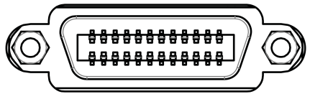
1）、START signal, trigger by rising edge or falling edge, pulse width≈4－30mS. A Bin TRIG signal can be only measured once. If it is always low level signal, then it can be only measured once.
2）、EOM signal, active low, , if it is low, this means that the sorting signal has been active, only the result is not displayed; if it is high, this means that the device is under measurement.
3）、Bin X sorting output signal, active low
Pin | Function
1-12 | Bin 1-12 compares the results to output the signal, low level is effective.
13 | failure compare result output signal, active low.
14 | Down Over Comparison Result Output Signal, Low Level Effective,
15 | EOM signal, active low. If it is high level, this means that the test has not yet come to an end
16 | Over Comparison Result Output Signal, Low Level Effective,
18 | START signal, active falling edge. When the meter is externally triggered and this signal is active, the meter performs a measurement and sorting.
20 | External power source connected to negative terminal (external power source grounded), if there is not external power input, this pin is an internal suspended earth wire (non-grounded)
24 | External interface power connected to positive terminal (12-24V), if there is not external power input, this pin is internal+10V
2、Time sequence table
T1
START

EOM
T2

T3
BIN X

7.4 USB communication method
1. Before Connecting to USB Connector
Consult | For details, see 7.1.1”Before Connecting to the RS232 Connector”
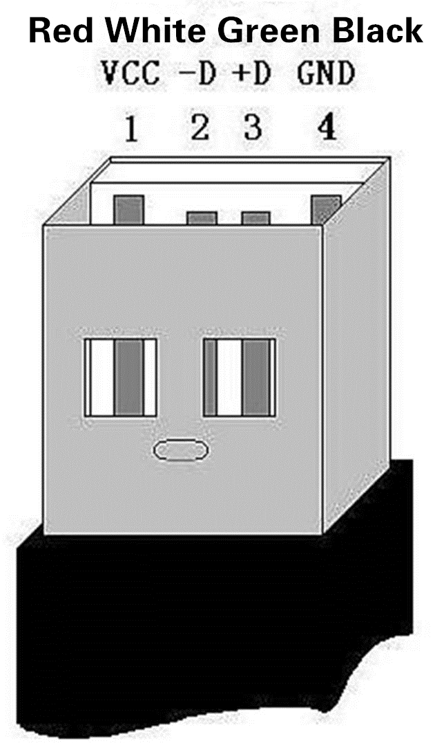
2.Interface description and wiring mode
Connect the USB interface on the back panel of RK 2514/2515 with the USB on the host through the USB cable Interfaces are connected. Universal Serial Bus (USB) is A Serial Bus Standard for Connecting Computer Systems with External Devices and an Input-Output Interface Technical specifications. The connection mode is shown in the USB connection diagram on the right.
USB interface adopts standard four-wire communication interface, which has short communication distance and is suitable for PC camera.
Connect. Its communication rate is selected through the instrument menu. Users can communicate with each other when using USBTMC interface.Visit the instrument through LabVIEW software programming.
3. Install driver
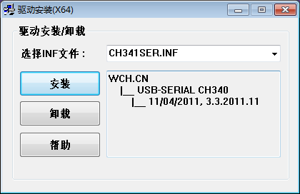
Here's how RK 2514/2515 connects to PC through USB interface.
step1: When connecting the instrument with a USB cable
for the first time, it is necessary to install the corresponding driver to use the USB interface normally.
The installation method is shown in the right figure.
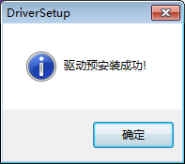

step2: Select CH341SER.INF, click Installation, and a
prompt window will pop up after successful installation,
as shown in the right figure.

step3: After the driver is installed, you
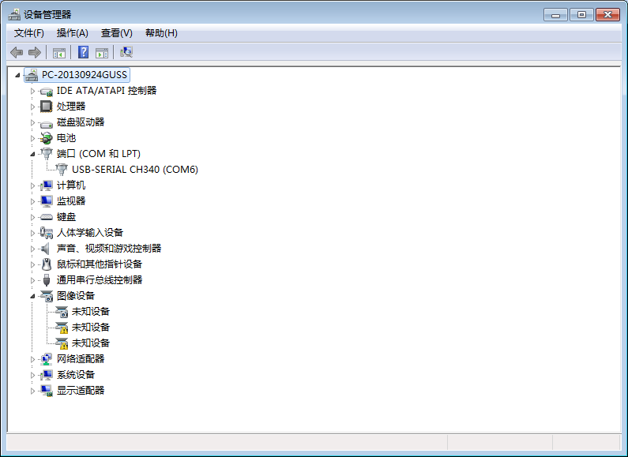
can find "USB-SERIAL CH340" on the device manager of the computer, as shown in the
right figure.。

Caution | The communication protocol of USB is the same as that of RS232 and 485.

Chapter 8 Maintenance and Service
In this chapter you will learn about the following：
- About correction
- Packaging and transportation
- Storage
- Warranty
- clean
- About discarding

8.1 About correction
Note | IMPORTANT: In order to ensure that the measuring instrument obtains the correct measurement within the specified accuracy range, the instrument needs to be calibrated periodically.
The calibration period varies depending on the customer's usage or environment.It is recommended to determine the calibration period based on the customer's usage or environment.and
Entrusted Rek Company to make regular corrections.

8.2 Packaging and Transportation
When transporting the instrument, please use the packaging materials at the time of delivery.The instrument should be handled with care, moisture, and drench during transportation.
When returning repair, please use the packaging that will not be damaged during transportation, and indicate the cause of the malfunction. We will not guarantee the damage caused by transportation.

8.3 Storage
The instrument should be stored in a ventilated room with an ambient temperature of -10 ° C ~ 50 ° C and a relative humidity of not more than 90%. The air should not contain corrosion measurements.
Harmful impurities of the instrument.

8.4 Warranty
Warranty period: The customer purchases the instrument from the company, calculated from the date of shipment of the company, and is shipped from the operating department.
The date is calculated and the warranty period is 2 years.A warranty card should be issued for the warranty.During the warranty period, the user is damaged due to improper operation of the user.
Repair costs are borne by the user.The instrument is repaired by the company for life.
The maintenance of this instrument must be repaired by professional technicians; please do not replace the internal components of the instrument without any repair;
The calibration needs to be re-calibrated to avoid affecting the test accuracy.For the blind maintenance of the user, the instrument damage caused by replacing the instrument parts is not a warranty.
The user should bear the maintenance cost.

8.5 Cleaning
- To prevent the risk of electric shock, unplug the power cord before cleaning.
- Wipe the case and panel gently with a clean, soft cloth dampened with a little water or a mild detergent.
- Do not clean the inside of the instrument.
Note | Do not use solvents (alcohol, benzine, acetone, ketone, thinner, oil-based detergents, etc.) to clean the instrument.

8.6 About discarding
When disposing of the instrument and options, please dispose of them according to the regulations of each region.

Appendix A: Specifications
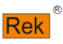 | In Appendix a you will learn about the following:  - Technical indicators  - General specifications  - Dimensions
Test report The following data were measured under the following conditions:
Temperature condition: 23 °C ± 5 °C Humidity condition: ≤ 80% rh
zero value adjustment: clear before test
Warm-up time: >30 minutesTemperature test accuracy:0.2％±0.1℃
Calibration time :1 year
(The accuracy of 200K and above gear is related to the electromagnetic interference of the environment where the tested part is located. If high precision test is required, electromagnetic shielding is required for the tested part.)
RK2515N/AN accuracy: Test current accuracy: 5%
Sampling speed: Fast: about 100 times per second;Medium speed: about 25 times per second;Slow: about 10 times per second;Precise measurement: 4 times per second.
Test range: RK2515N:0.1u~110M; RK2515AN:1u~20M
Range |  | Maximum Display Value | %Rd + %Fs |  | Cur | Open Voltage
 |  |  | Fast | Med、Slow
1 | 20mΩ | 20.0000mΩ | 0.2±0.0025 | 0.1±0.0025 | 1A ±5% | 5V
2 | 200mΩ | 200.000mΩ | 0.2±0.002 | 0.1±0.002 | 1A ±5% | 5V
3 | 2Ω | 2.00000Ω | 0.05±0.002 | 0.02±0.002 | 100mA ±5% | 5V
4 | 20Ω | 20.0000Ω | 0.05±0.002 | 0.02±0.002 | 10mA ±5％ | 5V
5 | 200Ω | 200.000Ω | 0.02±0.002 | 0.01±0.002 | 1mA ±5％ | 5V
6 | 2KΩ | 2000.00Ω | 0.02±0.002 | 0.01±0.002 | 1mA ±5％ | 5V
7 | 20KΩ | 20.0000KΩ | 0.02±0.002 | 0.01±0.002 | 100uA ±5％ | 5V
8 | 200KΩ | 200.000KΩ | 0.05±0.002 | 0.02±0.002 | 10uA ±5％ | 5V
9 | 2MΩ | 2000.00KΩ | 0.1±0.003 | 0.025±0.003 | 1uA ±5％ | 5V
10 | 110MΩ | 110.00MΩ | 1±0.005 | 0.5±0.005 | 恒压 | 8V
RK2515N/AN Low Voltage Test Accuracy
Range |  | Maximum Display Value | %Rd + %Fs |  | Cur | Open Voltage
 |  |  | Fast | Med、Slow
1 | 2Ω | 2.00000Ω | 0.05±0.002 | 0.02±0.002 | 10mA ±5% | 60mV
2 | 20Ω | 20.0000Ω | 0.05±0.002 | 0.02±0.002 | 1mA ±5％ | 60mV
- temperature measurement
Range | -10℃~99.9℃
Resolving power | 0.1℃
Accuracy | 0.1℃+0.25%×Tx

Main features and functions:
1. High brightness, ultra clear 4.3-inch color LCD display: display pixel: 480 * 272, direct reading, percentage error and sorting results, and multiple parameters are displayed at the same time.
2. Double display: when direct reading is displayed, the relative deviation can be displayed at the same time.(∆%)
3. Multiple trigger modes: internal trigger, external trigger, manual trigger and contact test trigger.
4. Temperature test function: the temperature can be tested through the temperature sensor.
5. Correction function: full mileage short circuit clearing function.
6. Comparator (sorting) function: there are 10 sorting data built in, which can judge the object hi / lo.
Comparator function display: directly displayed in the interface.
Comparator output: more detailed sorting results can be output through optional hardler interface, RS232 interface and use interface.
Sound: qualified / unqualified alarm can be set or the sound function can be turned off
7. Thermoelectric potential compensation: in this test mode, the thermoelectric potential is compensated to minimize the influence of thermoelectric potential.
8. Reliable contact detection function can automatically check whether the test end is well connected to avoid misjudgment.
9. Keyboard lock function
10. Interface function:
Handler interface: sorting result output, comparison gear selection input, trigger signal input and EOM signal output.
RS232 interface: use three wire simple serial interface to communicate and connect with the upper computer.
USB hdst: use USB communication cable to communicate and connect with the host computer
USB Devi (: use U disk to access the instrument and save the test data.
11. Provide low voltage test mode.
Technical specifications:
- Screen: high brightness, ultra clear 4.3-inch color LCD display: display pixels: 480 * 272·
- Range: Ten range automatic or manual test.
- Range: rk2514 (RK 2515) / N: 0.1 u Ω ~ 110m Ω;
RK2515AN:1 u Ω~20MΩ
4. Display range: five and a half digits to display the resistance value. 0.1U Ω ~ 110m Ω, minimum resolution: 0.1U Ω
5. Test speed: fast: 100 times / S (turn off the display); medium speed: 25 times / S; slow: 10 times / S; fine test: 4 times / s. 6. Maximum reading: 200000
7. Test signal: I test if the current is constant (test if the 110m gear is constant voltage).
8. Test end: 4-end screen (including 2 inspection rule ends and 2 driving ends) and external screen end.
10. Environment:
1) Operating temperature: O ℃ ~ 40 ℃, humidity < 80% RH
2) Index: temperature 18 ℃ ~ 28 ℃, humidity < 80% RH
3) Storage: temperature o ℃ ~ 50 ℃, humidity 10 ~ 9nf RH
11. Power supply: AC input voltage: 198 ~ 242v (220 ± 10%) > frequency: 50 / 60Hz,
Power: maximum 15va fuse: 0.5A slow melting
12. Weight: about 4.5kg (with packaging weight).
13. Attached accessories: operation manual, test report, quality assurance certificate, warranty card, instrument, power cord
Fuse, four terminal Kelvin test clip, communication cable, temperature probe
Shape size:
Inner Size：L*W*H：340 mm * 88 mm * 216 mm
Outer Size： L*W*H：370 mm * 108 mm * 264 mm

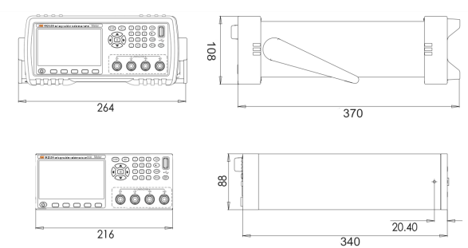

Appendix B: Selection Table
In Appendix b you will learn about the following: RK2511, RK2512, RK2516, RK2516a, RK2516b, RK2515N, RK2515AN, RK2514, RK2510, RK2520, RK2520a.

Characteristic model | Measuring range | Basic accuracy | Maximum test current | USB | RS-232 | Handler | U disk interface | Temperature compensa | Comparison function
RK2511 | 10uΩ-20KΩ | 0.1% | 100mA |  | Optional | Optional |  |  | √
RK2512 | 1uΩ-2MΩ | 0.05% | 1A |  | Optional | √ |  |  | √
RK2516 | 1uΩ-2MΩ | 0.05% | 1A |  | √ | √ | √ | √ | √
RK2516A | 1uΩ-200KΩ | 0.05% | 1A |  | √ | √ | √ |  | √
RK2516B | 10uΩ-20KΩ | 0.05% | 100mA |  | √ | √ | √ |  | √
RK2515N | 0.1uΩ-110MΩ | 0.02% | 1A | √ | √ | √ | √ | √ | √
RK2515AN | 1uΩ-20MΩ | 0.02% | 1A | √ | √ | √ | √ | √ | √
RK2514 | 0.1uΩ-110MΩ | 0.01% | 1A | √ | √ | √ | √ | √ | √
RK2510 | 0.01uΩ-20KΩ | 0.05% | 10A | √ | √ | √ | √ | √ | √
RK2520 | 1uΩ-2MΩ | 0.02% | 100mA | √ | √ | √ | √ |  | √
RK2520A | 1uΩ-20MΩ | 0.02% | 100mA | √ | √ | √ | √ |  | √
RK2518 | 2/4/8/16/32  channel 10uΩ-200KΩ | 0.05% | 100mA | √ | √ | √ |  | √ | √
RK2560 | 0.1uΩ-10MΩ | 0.02% | 1A | √ | √ | √ | √ | √ | √

