Meiruike lnstruction Manual

RK9930
GROUND RESISTANCE TESTER

SHENZHEN MEIRUIKE ELECTRONIC TECHNOLOGO CO.,LTD

Version history:

As there may be errors or omissions in the manual, improve and perfect the instrument functions, update the technology and upgrade the software, the manual will be adjusted, revised and continuously improved to facilitate the use.

Please pay attention to the software version and manual version used.

May 2020 .................................................First Edition

Statement: the company may improve the performance, function, software, structure, appearance, accessories, packaging and instructions of the product, without notice if any! If you are in doubt, please contact us.

Safety warning:

Instrument grounding This instrument is a class I safety instrument. When connecting the power supply, please make sure that the power socket contains grounding wire. If it is not grounded, static electricity or induced electricity on the enclosure may cause personal injury!

Electric shock hazard During operation, test and instrument maintenance, be careful not to get electric shock. Non professionals are not allowed to open the case without permission. If professionals need to replace fuses or carry out other maintenance, they must first unplug the power plug and carry out it in the presence of others. Even if the power plug has been unplugged, there may still be dangerous voltage on the capacitor, so it should be operated after discharging.

Electric shock damage Any incorrect removal or addition of the tested parts during the test will cause abnormal damage to people, property or instruments!!! If the instrument is damaged due to abnormal operation, the maintenance cost shall be borne by the customer.

Input power Please use the power supply according to the power supply parameters specified by the instrument. The power input that does not meet the specifications may damage the instrument.

Keep away from
explosive gas environment Electronic instruments shall not be used in inflammable and explosive gas environment or in environment containing corrosive gas or smoke and dust, because this may cause danger.

Other safety matters Please do not apply any voltage source or current source to the test terminal of this instrument.

Tips An important supplement or reminder to the contents stated.

CONTENTS
Chapter I safety rules 6
1.1 general provisions 6
1.2 maintenance 6
1.3 Test environment 7
1.4 Regulations for operators 8
1.5 Safety grounding regulations 8
1.6 Regulations on fuse replacement 9
1.7 Test safety regulations 9
1.8 Test exception provisions 9
1.9 Safety points 9
1.10 Importance of testing - Safety of users 10
1.11 AC grounding resistance tester 10
Chapter 2 Overview and technical indicators 12
2.1 Product Overview 12
2.2Technical indicators 13
Chapter 3 Front Panel Description 15
3.1 Front panel structure 15
3.2 Rear panel structure 18
3 .3 Definition of screen display area 19
3.4 Main menu keys and corresponding displayed pages 20
Chapter 4 Operation instructions 23
4.1 Startup description and startup screen 23
4.2 Operation steps 24
Chapter 5 PLC remote control interface 25
5.1 PLC remote control signal 25
5.2 Wiring description of remote control output signal 26
5.3 Remote control input signal wiring description 27
Chapter 6 Parameter setting 28
6.1 Mode to be tested 28
6.2 Parameter setting mode 28
6.3 System setting mode 28
6.4 Parameter setting description of grounding resistance 28
6.5 System setting parameter description 29
6.6 Document parameter description 31
Chapter 7 Remote control 32
7.1 RS232C interface description 32
7.2 RS485 interface description 33
7.3 USB storage 34
Chapter 8 SCPI serial port instruction reference 34
8.1 Brief description of instruction format: 34
8.2 SCPI instruction set 35
8.3 Display subsystem command set 35
8.4 FUNCtion subsystem command set 36
Chapter 9 Maintenance guide 43
9.1 Routine maintenance 43
9.2 Simple troubleshooting 44
9.3 Instructions for software upgrading of instrument system 44
Chapter 10 Warranty and accessories 45
10.1 Accessories 45

Chapter I safety rules

The contents of the manual are subject to change without notice

Please contact our company directly if there are any unknown parts in the user manual
Regulations and matters needing attention before test!

1.1 general provisions

■ before using the tester, please read the manual carefully to understand the operating procedures and relevant safety signs to ensure safety.

■ before turning on the input power switch, please select the correct input voltage specification.

Chassis grounding symbol
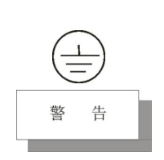
Caution pay attention to the high risk of operation, application or condition that may cause injury or death.

The current generated by the tester is enough to cause casualties. In order to prevent accidental injury or death, when moving and using the tester, be sure to observe clearly before operating.

1.2 maintenance

1.2.1 In order to prevent electric shock, non professionals shall not open the cover of the tester, and all parts inside the tester shall not be replaced without permission. If the tester is abnormal, please ask our company or appointed dealer for help.

1.2.2 Regular maintenance

The tester, power line, test line and relevant accessories shall be carefully inspected and verified at least once a year to ensure the safety of operators and the accuracy of the tester.

1.2.3 User modification

The user is not allowed to change the circuit or parts of the tester, otherwise the company's guarantee will be invalid and will not be responsible for the consequences.

1.3 Test environment

1.3.1 Working position

When operating the tester, it must be ensured that the tester is placed in a place where ordinary people cannot touch it at will. If this is not possible due to the arrangement of the production line, the test area must be isolated from other facilities and marked with "test work area".

1.3.2 Input power supply

The tester uses a single-phase power supply of 220V / 50Hz. Before turning on the power switch, make sure that the power supply voltage meets the requirements. The test area power supply must have a separate switch, installed at the entrance of the test area, to ensure that all personnel can identify. When an emergency occurs, the power supply can be turned off immediately.

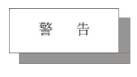In order to prevent tester failure, please use it within the specified voltage range.
1.3.3 Workplace

As far as possible, use a non-conductive work table. The test site must be kept tidy and clean at all times, and shall not be disordered. Please put the unused tester and test line in a fixed position, and make sure that all personnel can immediately distinguish the tested object, the object to be tested and the object to be tested.
There shall be no combustible gas in the test area and surrounding air, and the tester shall not be used beside the combustible materials.

1.4 Regulations for operators

1.4.1 Operator qualification

In case of electric shock caused by wrong operation, the current output by the tester is enough to cause personal injury or fatal, and must be used and operated by trained and qualified personnel.

1.4.2 Safety rules

Operators must be educated and trained at any time to understand the importance of various operation rules and operate the tester according to safety rules. In order to prevent electric shock accidents, please wear insulating gloves before using the tester.

1.4.3Dress code

Operators shall not wear clothes with metal decoration or wear metal hand ornaments and watches. These metal ornaments are easy to cause accidental electric shock. When electric shock occurs, the consequences will be more serious.

1.4.4 Medical regulations

The tester must not be operated by people with heart disease or wearing heart rhythm regulators. Improper grounding or non grounding may lead to electric shock accidents.

1.5 Safety grounding regulations

The tester must be well grounded, and the ground wire must be well grounded before testing to ensure the safety of operators. If the ground connection on the power plug is not reliable, an additional protective ground terminal is provided on the back panel of the tester to connect to the safe ground.
Improper grounding or non grounding may lead to electric shock accidents.

1.6 Regulations on fuse replacement
Please turn off the input power switch, disconnect the power plug before replacing the fuse, and replace the Standard Fuse (5A / 250VAC 10A / 110VAC).
To avoid electric shock, replace the fuse after disconnecting the power cord.

1.7 Test safety regulations

After connecting the test line to the object to be tested, the connection shall be reliable. The operator must make sure that it can operate completely independently, and cannot control the switch and remote control switch by other personnel. When the remote control switch is not used, it shall be placed in a fixed position, and it is not allowed to be placed at will.
Never use the tester on a live circuit board or equipment! Do not touch or connect with the test object during the test.

1.8 Test exception provisions

Under some specific conditions, the tester will not respond to reset key, test time value does not move, display black screen and other phenomena, which is very dangerous.In case of these situations, please turn off the power switch and disconnect the power plug. Do not use it again. Please contact our company.
When the test is abnormal, turn off the power switch immediately and unplug the power plug!

1.9 Safety points

■ unqualified operators and irrelevant personnel should stay away from the test area.

■ a safe and orderly condition must be maintained at all times in the test area.

■ never touch the test object or any object connected with the tested object during the test.

■ in case of any problem, please turn off the output and input power immediately.

1.10 Importance of testing - Safety of users

In today's world of high consumer awareness, every manufacturer of electrical and electronic products must do their best to ensure the safety of their products. The design of each product must try to prevent the user from getting electric shock as much as possible, even if the user has wrong use, there should be no electric shock. In order to meet the generally recognized safety requirements, AC grounding resistance tester must be used. At present, the safety implementation units such as UL, CSA, IEC, BSI, VDE and JSI require manufacturers to use "AC grounding resistance tester" as safety test when designing and manufacturing electronic or electronic goods.

1.11 AC grounding resistance tester

The grounding resistance test is mainly used to measure the grounding resistance between the grounding wire of the instrument and the housing. The measurement method is according to Ohm's Law: flow a current on the contact point, then measure the current and the voltage value of the contact point respectively, and then calculate the resistance value according to Ohm's law.

Generally, it flows through a large current, and the simulator has the condition of abnormal current when there is an exception, which is used as the basis for testing. If the contact resistance of the ground wire on the appliance can pass the test in this harsh environment, the appliance should be relatively safe under normal use.

For the following conditions, the "AC grounding resistance tester" must be used to measure the grounding resistance of the grounding wire on the instrument:

·Function test during design - to ensure that the designed product can meet the required conditions.

·Specification test during production - confirm that the products can meet the required standards.
·Confirmation test during quality assurance - to confirm that the quality of products can meet the standards of safety regulations.

·Safety test after maintenance - confirm that the repaired product can meet the safety standard.

Different products have different technical specifications. Basically, the safety specifications require that a constant current flow through the contact point, which must be maintained for a specified period of time.

If the resistance of the contact point is kept within the specified specification within the specified time, it can be determined that the appliance should be safe to operate under normal conditions.

Proper design and construction can protect users from electric shock. Although the ground resistance can be measured with a general resistance meter, the output current of the resistance meter is usually very small, which does not meet the requirements of Safety specifications and cannot be approved by the security inspection agency. Therefore, the ground resistance tester must be used for measurement. The general user will often touch the appliance. In addition to the CSA specification of 30 A, most security inspection institutions (such as UL, BSA, TUV, VDE, etc.) require 25 A, while the resistance of the contact point must be lower than 100 m Ω, and the current must last for 60 seconds, and the resistance must be maintained below 100 m Ω. However, the specifications of the instruments that are not easy to touch by the user are generally loose, and the current is generally required to be 10 A, while the resistance value of the contact point is less than 500 m Ω, but the time is still 60 seconds. In the world, some specifications are still higher than the above standards, and the standard is 5 times of the rated input current of the appliance, while the resistance value of the contact point is still 100 m Ω, and the test time is 60 seconds. Most of these electrical appliances are dangerous, so the requirements for specifications are higher than those for general appliances. In the current safety regulations in the world, some special requirements are to measure the ground resistance of the grounding wire first, and the resistance of the contact point must meet the requirements before "withstand voltage / insulation test". This is important to prevent the ground wire is not properly connected, and mistaken for a good voltage or insulation. The grounding resistance tester has two forms of output AC and DC, both of which can measure the contact resistance correctly. However, there are significant differences between the two forms for the destructive of poor contact points. Because the calculation reference of resistance value is the effective value of voltage and current, while the effective value and wave peak value of DC are the same, while the wave peak value of AC is 1.414 times of the effective value.

So in the peak of AC wave, its current value is also 1.414 times of DC. When the peak point of alternating current is taken as the comparison of the energy generated for the contact point, according to the power theorem (power = square times of current x resistance), the energy generated for the contact point at the moment of alternating wave peak is twice as much as that at the moment of direct current. At present, although two types of grounding test instruments are allowed to be used by the security inspection agency, but in the selection of grounding resistance tester specifications, AC tester is specially recommended. The above is the main reason. Secondly: most of the general appliances are powered by commercial power supply (mains power), which itself is alternating current, so using alternating current as the test method is fully in line with the actual use conditions.

Chapter 2 Overview and technical indicators

2.1 Product Overview

Thank you for purchasing and using our products. Before using this instrument, please confirm according to the last chapter "accessories" of this manual. If there is any discrepancy, please contact us as soon as possible to protect your rights and interests.

2.1.1 the AC grounding resistance tester is displayed on a 5-inch TFT LCD. The output current adopts hardware feedback and high-speed ARM MCU control technology to make the output current stable and reliable. The output current is driven by DDS + linear power amplifier. The output waveform is pure and the distortion is small. The tester is controlled by single-chip microcomputer, which makes its setting and operation very simple, and provides PLC remote control interface, RS232C, RS485, USB and other interfaces, which can facilitate users to quickly combine into a comprehensive test system.

2.1.2 the tester has the functions of nonconformity identification, audible and visual alarm and automatic control of test time, which can meet the needs of production line or quality inspection.

2.1.3 the tester can be used to test the grounding resistance of household appliances, electronic instruments, electronic equipment, electric tools, electric heating appliances and other products.

2.1.4 service conditions

Power supply voltage: 110 / V2V (± 10%)

Power frequency: 50Hz / 60Hz (± 5%)

Power consumption: RK9930Y < 350VA; RK9930AY < 450va; RK9930BY < 750va;

2.1.5 ambient temperature and humidity

Normal working temperature: 0 ℃ - 40 ℃, humidity: ＜ 90% RH

Measurement ambient temperature: 20 ℃± 8 ℃, humidity: ＜ 80% RH

Transportation environment temperature: 0 ℃ - 55 ℃, humidity: ≤ 93% RH

2.1.6 preheating

Preheating time after startup: ≥ 30 minutes

2.1.7 insulation resistance

Under metering working conditions, the insulation resistance between the power terminal and the shell shall not be less than 50m Ω.

Under the condition of hot and humid transportation, the insulation resistance between the power terminal and the shell shall not be less than 2m Ω.

2.1.8 insulation strength

Under the metering working condition, the power terminal and the shell can withstand the AC power supply with rated voltage of 1.5kV and frequency of 50Hz for one minute, without breakdown and flashover.

2.1.9 electromagnetic compatibility

The transient sensitivity of power supply shall meet the requirements of gb6833.4.

The conduction sensitivity shall meet the requirements of gb6833.6.

Radiation interference shall meet the requirements of gb6833.10.

2.2Technical indicators

Model |  | RK9930Y |  |  | RK9930AY |  |  |  | RK9930BY
basic function | Screen size | 5 inch TFT LCD
 | Number keys | Parameter setting digital input
 | Coding switch | Parameter selection and confirmation function
 | Up, down, left and right function keys | Parameter setting up and down selection function
 | Lock keyboard lock function | Prevent accidental modification of test conditions or prohibit modification of test conditions
 | Alarm function | Sound alarm
 | Communication interface | RS232C、RS484、USB
 | USB interface | Copy, copy and storage functions
 | Control interface | HANDLER(PLC)
Output specifications | current | Current range | AC (3-30)A |  |  |  | AC (3-40)A |  |  | AC (3-60)A
 |  | resolving power | 0.01A/step for 10A and 0.001A/step for 10A and below;
 |  | Accuracy | ±（2% +0.02A)
 | Voltage | Voltage range | AC 6V Max Open circuit voltage |  |  |  | AC 8V Max Open circuit voltage |  |  | AC 12V Max Open circuit voltage
 |  | frequency | 50/60Hz optional
 |  | wave form | sine wave
 | ammeter | Measuring range of ammeter | AC (3-30)A |  |  |  | AC (3-40)A |  |  | AC (3-60)A
 |  | resolving power | 0.01A/step for 10A and 0.001A/step for 10A and below;
 |  | Accuracy | ±（2% +0.1A)
 | Resistance meter | Measuring range of resistance meter | 0-510 m Ω, when the output current is 3-10A; 0-120m Ω, when the output current is 10A-30A |  |  | 0-600m Ω, when the output current is 3-10A;  0-200m Ω, when the output current is 10A-30A;  0-150m Ω, when the output current is 30A-40A |  |  |  |  | 0-600m Ω, when the output current is 3-15A;  0-300m Ω, when the output current is 15A-30A;  0-150m Ω, when the output current is 30A-60A
 |  | resolving power | 0.01A/step for 10A and 0.001A/step for 10A and below;
 |  | Accuracy | ≦ ±（2%+1mΩ)
 | Timer range | 0-999.9S，resolving power：0.1S/step，Accuracy：≦ ±50ms
 | Compensation mode | Manual or automatic, maximum Offset：100mΩ Max，Accuracy：≦ ±（2%+1mΩ)
 | Set the upper limit range of the resistance | 0-510mΩ or 0-600mΩ，resolving power：1m Ω，Accuracy：≦ ±（2% +1m Ω)
 | Test time range setting | 0-999.9S，0 means continuity
Working temperature and humidity | 0℃-40℃，≦75%RH
Power Supply | 100V-121V，198V-242V，47.5-63Hz
Shape and volume | 430mm×105mm×350mm
weight |  | 13KG |  | 14KG |  |  |  | 15KG

Chapter 3 Front Panel Description

3.1 Front panel structure

3.1.1 Front panel diagram

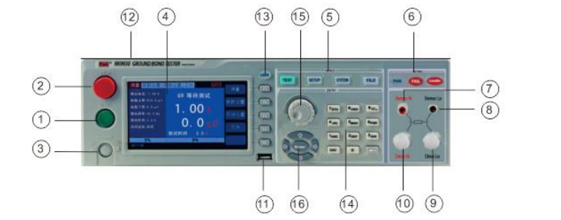

3.1.2 Front panel description

1. Start key

The green instantaneous contact switch has the following functions:

Start switch for test voltage output

2. Reset key (stop)

The red instantaneous contact switch has the following functions:

When setting the mode, it is used as the switch to leave the setting mode.

When testing, it can be used as a switch to interrupt the test.

At the end of the test, it is used as the switch to exit the test display and enter the next state to be tested.

3. Power switch

Working power input of tester

4. . LCD screen

Display various setting information and test data.

5. Functional area

Various setting operation areas

6. Test result indication area

When the tester outputs current, the indicator light will be on, indicating that "there is current output, under test", and the test passes and fails.

7. Voltage detection terminal (sense)

Check the voltage on the ground resistance of the tested part

8. Voltage detection terminal (sense)

Check the voltage on the ground resistance of the tested part

9. Current

Special output terminal can withstand large current above 30A as the current output terminal of the tested object. As the loop test end of the tested part.

10. Current

Special output terminal can withstand large current above 30A as the current output terminal of the tested object. As the loop test end of the tested part.

11. USB storage area

As an interface for copying and copying file data.

12. Model indication of tester

13. Lock key

It is used for panel function keys. During the test, the light is on and all functions of the panel are locked, except stop and start keys.

14. 0-9 numeric keypad

Numeric value for input parameter

15. Rotary coding potentiometer

For parameter setting, you can adjust this potentiometer and press the key to confirm the setting.

16. Up, down, left, right and ENTER confirmation keys

It is used to adjust options when setting parameter functions. Enter is the confirm function key.

3.1.3 description of indication function area

1. Qualified lamp

It contains green LED indicator light. When the tested object passes the test, the indicator light will be on.

2.Unqualified lamp

It contains red LED indicator light, which will be on when the test object fails.

- When the light DANGER is on, it means that the instrument is in the test work, pay attention to safety.

3.1.4 Parameter function area description
TEST key is the function of test status, select this key to enter the test; SETUP key is the parameter setting key, select this key to enter the test parameter settings of the tester;
SYSTEM key is the function setting key of the tester system. Select this key to set various functions of the tester system. FILE key is the function key of the tester file. Select this key to copy, copy and delete the tested data file.

3.2 Rear panel structure

3.2.1 Schematic diagram of rear panel
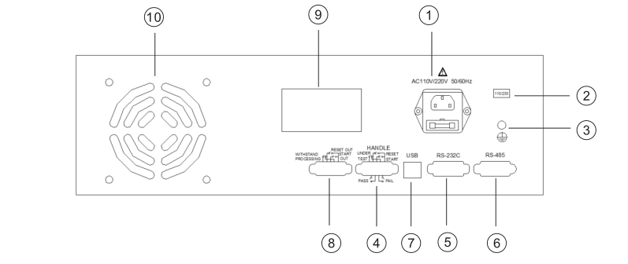

3.2.2 Rear panel description

1. Power socket

The standard input power socket provides working power for the tester. Pay attention to turn off the input power switch, disconnect the power plug before replacing the fuse, and replace the Standard Fuse (5A / 250VAC 10A / 110VAC).
2. 115V / 230V power conversion
3. Grounding terminal
The safety grounding terminal of the tester must be properly grounded to ensure the safety of the operator.
4. PLC signal terminal
A standard 9-core D-type bus terminal block, providing remote control monitoring and control signal interface.
5. RS232C interface
Provide RS232C serial port communication function
6. RS485 interface
Provide RS485 serial port communication function
7. USB interface
Provide USB computer connection USB disk function
8. PLC control signal output
This interface has stop, start and withstand processing functions.
9. Nameplate
Model name, date of manufacture and serial number of tester.
10. Cooling hole
Provide heat dissipation for the tester.

3 .3 Definition of screen display area

The RK9930Y adopts 480 × 272 liquid crystal 5-inch display screen, and the content displayed on the display screen is divided into the following display areas, as shown in the following figure:
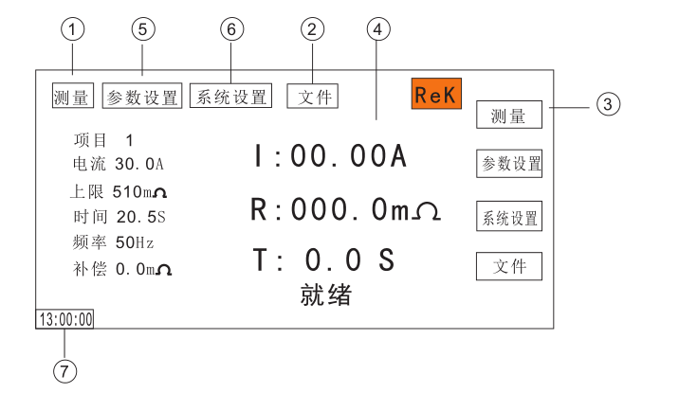
3.3.1 measurement display page area

This field indicates the measurement parameter name of the current page.

3.3.2 file domain

Move the cursor to this area for file management. File management includes: loading, saving and deleting.

3.3.3 soft key area

This area is used to display the function definition of the soft key. The definition of soft key has different function definitions according to the location of cursor area.

3.3.4 display area of measurement results

This area displays test result information and current test conditions.

3.3.5 parameter setting area

This field displays the parameter settings

3.3.6 system settings

This area displays the system parameter settings.

3.3.7 time display area

This area shows the current working time.

3.4 Main menu keys and corresponding displayed pages

3.4.1 measurement display main menu button

It is used to display the home page for various measurements. The function pages of this part include (use "soft key" to select the following page functions, the same below):
<Measurement display>

<Measurement settings>

<System settings>

<Document management>

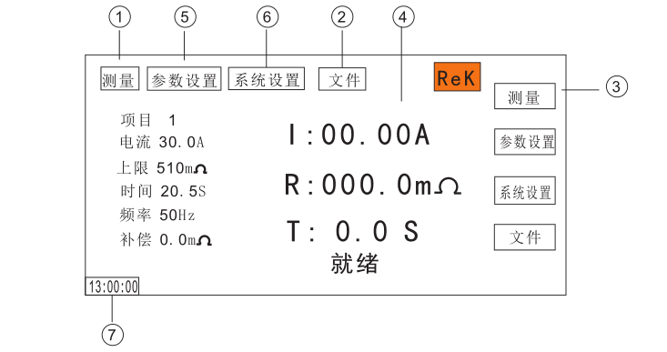
3.4.2 Parameter setting main menu key

It is mainly used to enter the measurement setting interface corresponding to the measurement display. The main interface is as follows:
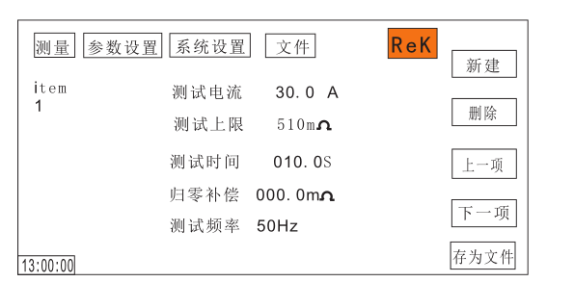
3.4.3 System setting main menu button

Used to access the system settings home page. Mainly about the system settings, the function pages in this part include:
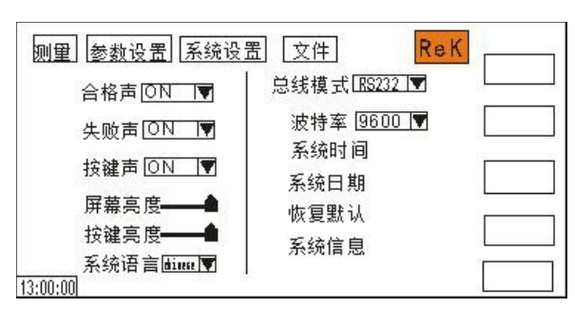
3.4.4 file management main menu button

For file management settings
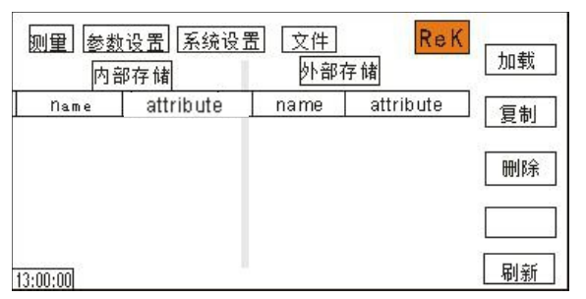

Chapter 4 Operation instructions

4.1 Startup description and startup screen

Before connecting the power cord plug to the mains supply, please turn off the input "power switch", check whether the specification of the fuse is correct, and connect the safety ground wire to the "ground terminal" on the rear panel of the tester.

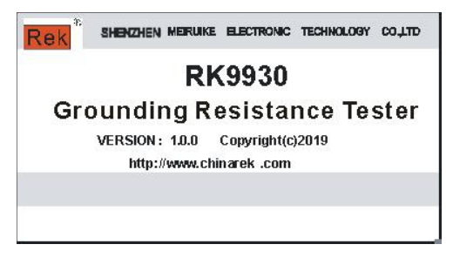

The basic operation is as follows:

■ use the menu key ([test] [setup] [system] [file]) and the soft key to select the page you want to display.

■ move the cursor to the field you want to set using the cursor ([→] [←] [↑] [↓]). When the cursor moves to a field, the field turns blue. The so-called field is the area where you can set the cursor.

■ the field where the current cursor is located can be set with a coded potentiometer or a number key. When the data input is finished, you can use the [Enter] key or lightly press the coding potentiometer to confirm.

4.2 Operation steps

4.2.1 setting tester parameters

Please refer to the "parameter setting" section to set all parameters.
4.2.2 connect the tester and the tested object

Plug in the three wire power plug.

Note: the power supply voltage shall be maintained at 100-121v AV (60Hz) or 198-242v AV (50Hz).

The power input phase line L, zero line N and ground line e shall be the same as the phase line and zero line on the power plug of the instrument.

Turn on the power, press the power switch at the upper and lower left corner of the front panel, the instrument will be turned on, and the power on screen will be displayed. As shown above.

Press the "reset" key once, and make sure that the test indicator is not on, and the display is working normally without current output. Connect two thick wires to the current output terminal, two thin wires to the voltage detection terminal, test the two ends of the tested object, and check whether all the wires are in full contact and reliable.

4.2.3 Press the "start" key to start the test
After pressing the "start" key, the tester will output the current. At this time, the test indicator light on the front panel will be on, and the display will show "under test". At the same time, the current value will be displayed, and the timer will start to work, and the data will be updated constantly.
4.2.4 determination of qualified products

After the test is completed, the tester will automatically turn off the output, the qualified indicator light on the front panel will be on, and a sound will be emitted at the same time. The display will display "pass" and test data, indicating that the tester determines that the tested object is qualified.

If you want to continue the test, you can press the "start" key again, and the tester starts the test again.

If you want to abort the test, you can press the "reset" key, the tester will immediately stop the test, and the display will retain the current test value.

4.2.5 determination of unqualified products

If the test fails, the tester will turn off the output immediately, and the unqualified light on the front panel will turn on. At the same time, a warning sound will be given, and the display will display the test failure prompt and test data, indicating that the tester determines the tested object as unqualified. Test failure prompts include: upper limit failure, overcurrent protection.

To turn off the alarm sound, press the "reset" key.

4.2.6 Start and stop operation instructions

The start key is the start test key. Press this key to start the instrument into the test state. The stop key is the reset stop key. In the test state, press the stop key once to interrupt the instrument test. The running light danger is off, and the lock light is on. Press the stop key twice to enter the reset state, and the danger and lock lights are off.

The red and black terminals of the instrument are connected with the four terminal test line provided by the instrument itself. When the tested object is not connected, press the start key to start the instrument. At this time, the instrument appears "open circuit failure" and gives an alarm sound.

Chapter 5 PLC remote control interface

5.1 PLC remote control signal

The tester has remote monitoring and remote control wiring interface, which can connect the working state of the tester to the monitoring center as monitoring, and can connect the remote control for operation.This terminal is a standard 9pin D type terminal block, which contains three monitoring signal outputs, i.e. processing, pass and fail Two remote control input signals are test and stop.

5.2 Wiring description of remote control output signal

The tester provides three "normally open" contact signals, which are respectively provided by three relays inside the tester. The contact capacity is AC 250V 1.0a/dc 250V 0.5A. These contacts are not limited by positive and negative polarity, and each signal is independent wiring, without common ground wire.

The terminal block is attached with pin number mark, and the wiring of output signal is as follows:
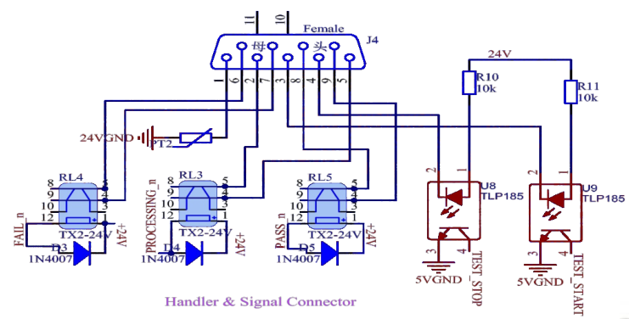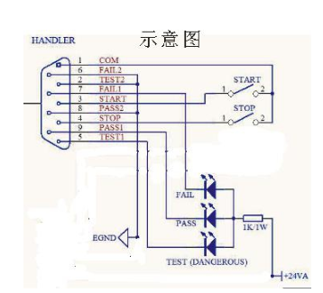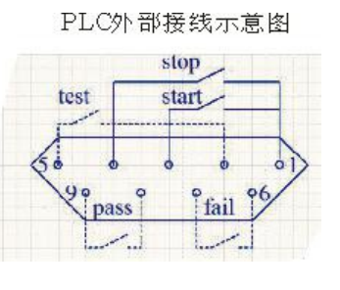

1. Processing signal: the output signal is connected between pin5 and Pin2.
2. Pass signal: the output signal is connected between pin8 and pin9.
3. Fail signal: the output signal is connected between pin6 and pin7.
4. Start out: the output signal is connected between PIN3 and Pin1.
5. Reset out: the output signal is connected between pin4 and Pin1.

5.3 Remote control input signal wiring description
The tester is equipped with remote control contact, which can be operated by external remote control device for test (start) and reset (reset) functions of the instrument, and input the execution signal of the withstand voltage tester. The following three functions are available: with stand processing (input the working signal of the withstand voltage tester), test (test switch function). The "momentary contact" switch must be used as the controller. Please note that it is absolutely forbidden to connect any other power supply. If other power supply is connected, the internal circuit will be damaged or malfunction will occur.
The function of with stand processing input signal is specially used for the signal of the interface of the connected test of the voltage withstand tester related to our company.
If the process signal on the PLC remote control output terminal of the back panel of the company's voltage withstand tester is connected to the input terminal of the signal, when the voltage withstand tester is performing the test, the LCD of the AC grounding resistance test will display "W-on", if the AC ground resistance tester is executing and the withstand voltage tester is started at the same time, the AC ground resistance tester will immediately stop executing the test and the LCD will also display "w-on".
As long as the connecting signal is connected between two instruments, only one instrument can be allowed to perform the test at a time, and the pressure tester has the priority to perform the test.

Remote control signal input wiring description
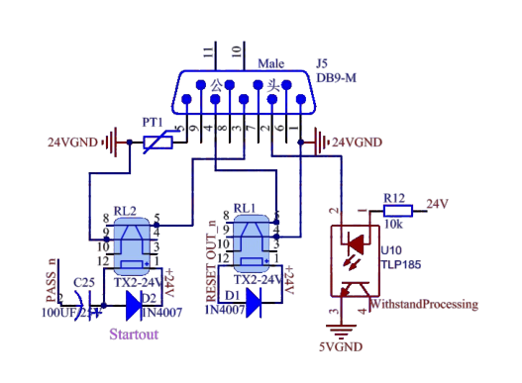
The terminal block has a pin number, and its detailed wiring is as follows:

1. Reset control: control switch between Pin1 and 4

2. Test control: control switch between pin 1 and 3

3. With stand processing: between Pin2 and 5

4. Pin6, 7, 8 and 9 are unused empty feet

Chapter 6 Parameter setting

6.1 Mode to be tested

6.2 Parameter setting mode

6.3 System setting mode

6.4 Parameter setting description of grounding resistance

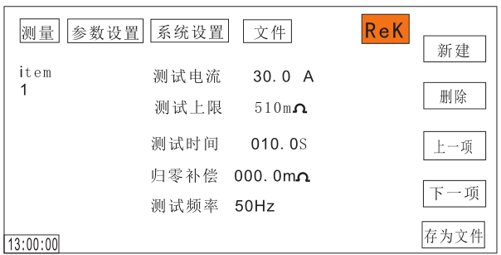
6.4.1 Output current: output test current setting value of grounding resistance. You can use the [↑] and [↓] cursors to select the setting item, and use the number key or adjust the coding potentiometer to input the setting value. This setting range is 3-30A.

6.4.2 Upper limit of resistance:
Set the upper limit of grounding resistance. You can use the [↑] and [↓] cursors to select the setting item, and use the number key or adjust the coding potentiometer to input the setting value. This setting range is 0-510M Ω.

6.4.3 Test judgment time:
Make judgment after the test current is stable to prevent misjudgment. When the determination time is "0", the test will continue without stopping unless the test fails or the test is stopped manually. You can use the [↑] and [↓] cursors to select the setting item, and use the number key or adjust the coding potentiometer to input the setting value. This setting range is 0-999.9s.

6.4.4 Output frequency:
Frequency setting value of output current waveform. You can use the [↑] and [↓] cursors to select the setting item, and use the number key or adjust the coding potentiometer to input the setting value. This setting has 50Hz and 60Hz.

6.4.5 Zero compensation:
Since the test line has a certain resistance value, compensation settings should be carried out to avoid test errors. There are two ways to set the instrument to zero. One is automatic reset setting mode, the other is manual input reset setting mode. The setting mode of automatic zeroing is that the instrument automatically measures the test lead and fixture, and then automatically memorizes them. The setting method of human input zeroing is to measure the resistance value of test wire and fixture by human, and then input the value at the time of zeroing. When setting the zeroing parameters in the automatic zeroing setting mode, the test leads and clamps form a circuit, and the two ends of the circuit are respectively connected to the "current" end and "return" end of the instrument, and then press the "start" switch, the instrument will automatically test the resistance values of the leads and clamps, and automatically store them in the memory body.

6.4.6 Parameter setting file saving function:

After setting all parameters, you can save the current setting as a file in the memory of the instrument. Press the software key [save as file] in the lower right corner of the panel to open the save as file interface, where you can enter the file name to save.

6.5 System setting parameter description
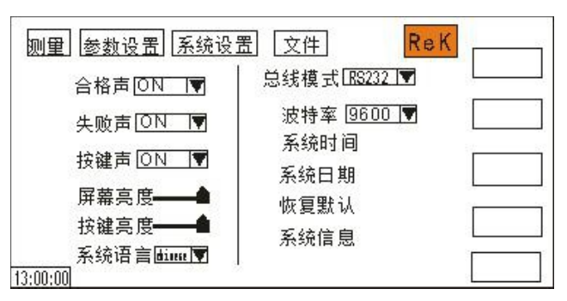

6.5.1 Qualified sound
This option has two functions, on and off. You can select the setting item with the cursor [↑], [↓], [←], [→], and adjust the encoding potentiometer to select the function item to be set.

6.5.2 Failure sound
This option has two functions, on and off. You can select the setting item with the cursor [↑], [↓], [←], [→], and adjust the encoding potentiometer to select the function item to be set.

6.5.3 Button sound
This option has two functions, on and off. You can select the setting item with the cursor [↑], [↓], [←], [→], and adjust the encoding potentiometer to select the function item to be set.

6.5.4 Screen brightness

You can select the setting item with the cursor [↑], [↓], [←], [→], and adjust the encoding potentiometer to select the value to be set.

6.5.5 Key brightness
You can select the setting item with the cursor [↑], [↓], [←], [→], and adjust the encoding potentiometer to select the value to be set.

6.5.6 System language
There are two languages, Chinese and English. The setting items can be selected with the cursor [↑], [↓], [←], [→], and the coding potentiometer can be adjusted to select the items to be set.

6.5.7 Bus mode
There are two bus modes, RS232 and RS485. The setting items can be selected with the cursor [↑], [↓], [←], [→], and the coding potentiometer can be adjusted to select the items to be set.

6.5.8 Baud rate
There are four baud rates: 9600, 38400, 19200, 115200. The setting items can be selected with the cursor [↑], [↓], [←], [→], and the coding potentiometer can be adjusted to select the items to be set.

6.5.9 System time
This item can set the current time of the instrument. Once the system time is set, the time function will continue regardless of the power on and power off state, unless the internal battery fails. You can select the setting item with the cursor [↑], [↓], [←], [→], and adjust the encoding potentiometer to select the value to be set.

6.5.10 System date

This item can set the current time of the instrument. Once the system time is set, the time function will continue regardless of the power on and power off state, unless the internal battery fails. You can select the setting item with the cursor [↑], [↓], [←], [→], and adjust the coding potentiometer to select the setting item

6.5.11 Restore default
This function is to restore system settings, parameter settings and factory settings. All settings will be cleared. You can select the setting item with [↑], [↓], [←], [→], press [Enter] to open the [OK] and [Cancel] interface, and press [OK] to confirm. Press [Cancel] to cancel.

6.5.12 system information
This item includes the model, software version, hardware version, power on times, test times and internal storage of the instrument.

6.6 Document parameter description
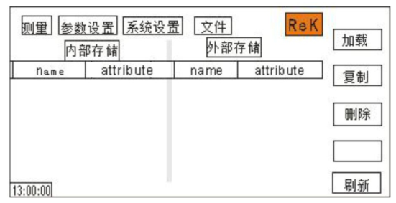
6.6.1 internal storage: storage capacity 16m.

6.6.2 U disk function: this item has external U disk storage function.

6.6.3 the software key on the right side of the screen has the functions of file loading, file copying, file deleting and refreshing. Select the corresponding functions by selecting different software keys.

Chapter 7 Remote control

7.1 RS232C interface description

At present, the widely used serial communication standard is RS-232 standard, which can also be called asynchronous serial communication standard. RS is the abbreviation of "Recommended Standard". 232 is the standard number. This standard is officially published by the electronic industry association of America (IEA) in 1969. It stipulates that one data line should be transmitted one by one at a time. Like most serial ports in the world, the serial interface of the instrument is not strictly based on RS-232 standard, but only provides a minimum subset. The following table:
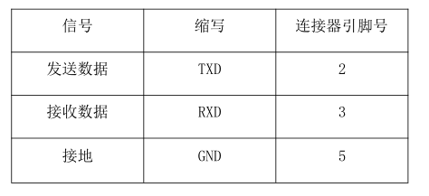

Instrument RS232 signal and pin comparison

The reason is that the operation of three lines is much cheaper than that of five or six lines, which is the biggest advantage of using serial port communication. The connection between the instrument and the computer is shown in the figure:
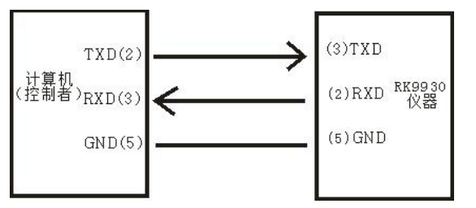
Diagram of computer and instrument connection

As can be seen from the figure, the pin definition of the instrument is different from that of the 9-core connector serial interface used by the computer. RS232 interface baud rate can be selected from 9600 to 115200, no parity, 8-bit data bit, 1-bit stop bit.

The instrument command conforms to the SCPI standard. When the command string is sent to the instrument, LF (hex: 0ah) should be sent as the end character. The maximum number of SPCI command string bytes that the instrument can accept at a time is 2kbyte. For the format of the result data sent by the instrument to the computer, see the instructions in the command reference section.

7.2 RS485 interface description

The full name of RS485 standard is TIA / EIA-485 serial communication standard. RS485 data signal adopts the differential signal negative logic transmission mode, also known as balanced transmission, so it has the Limited strong anti common mode interference ability. RS485 adopts semi industrial communication mode, in which 2V - + 6V represents "0". In general, ordinary twisted pair communication is used, and coaxial cable with shielding layer is used in high demand environment. RS485 communication interface is the standard communication interface of the tester.

The connection mode of RS485 interface is as follows:
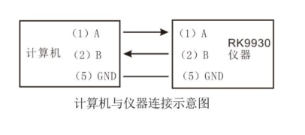

7.3 USB storage

The machine is built-in with 16m storage, which can be used to connect the rear USB interface when the USB disk is used.

Chapter 8 SCPI serial port instruction reference

8.1 Brief description of instruction format:

8.1.1 The instrument instruction set only describes the actual characters accepted or sent by the instrument.

8.1.2 Instruction characters are ASCII characters.

8.1.3 The instruction data "<??? >" are ASCII strings. The default format of the system is integer or floating-point number, and the unit of data is the default value, which does not appear in the instruction.

8.1.4 The end of instruction must be marked with the end of instruction: the identifier of the end of an instruction without which the instrument will not parse the instruction.

8.1.5 The default end marks are: carriage return (NL), print control character (\ n), decimal number (10), hexadecimal number (0 × 0A).End tag of IEEE-488 bus: keyword (^ END), signal (EOI).

The example of sending multiple instructions can be simplified as follows: Note: in the example, "_" Is a space mark.

FUNC：SOUR：ITEM_ 1： I ：I_ 10.00；
FUNC：SOUR：ITEM_ INS (NL^END)
FUNC：SOUR：ITEM_ 2： I ：I_ 10.00；

8.2 SCPI instruction set

RK9930Y series instrument subsystem command

● DISPlay

● SYSTem

● FUNCtion

● MMEM

● FETC

8.3 Display subsystem command set

The display subsystem command set is mainly used to set the display page of the instrument Character ?

You can query the current page.

DISPlay:PAGE

Command syntax:

DISPlay：PAGE <page name> Note: page name is represented by number

The details of < page name > are as follows:

1——TEST Set display page to: measurement display page

2——TESTSET Set display page to: measurement setting page

3——SYSSet Set display page to: system setting page

4——FLIE Set display page to: (internal) file list

Character? You can query the current page.

---- example:

Set the display page to: measurement display page.

Setting command: DISP: PAGE 1

Query command: DISPlay: PAGE?

Return value: 1

8.4 FUNCtion subsystem command set

8.4.1 FUNCtion subsystem command set is mainly used to set test parameters of instrument test function.

Command tree: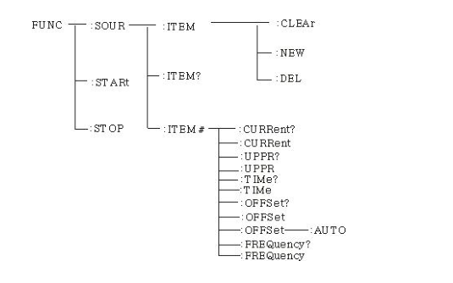
8.4.2 PROG function command set
FUNC:STARt When the instrument is in the test interface, start the test.
FUNC:STOP When the instrument is in the test interface, stop the test.
FUNC:SOUR:ITEM:CLEAr Clear a new test item in the existing test plan (ITEM).
FUNC:SOUR:ITEM:DEL In the existing test plan (ITEM), delete the current test project. FUNC:SOUR:ITEM:NEW Create an empty test plan to write a new test plan.
FUNC:SOUR:ITEM?: Query the current test scheme.
ITEM## Function command set

FUNC:SOURce ： ITEM# :CURRent Set query current

--Format

Set up Format:FUNC:SOUR:ITEM#:CRREnt
Query format：FUNC:SOUR:ITEM#:CRREnt

--Data < Sn >

Data type: integer

Data range: 1-20

Data accuracy: 1

Example:

Set the CURREnt value to: 10.00A

Format: FUNC:SOUR : ITEM:CURRent ：<10.00>

Query format: FUNC:SOUR : ITEM:CURRent ：?

Near return value: 10.00

FUNC:SOURce ：ITEM# ：UPPR Set the upper limit of query resistance

--Format

Set up Format:FUNC:SOUR:ITEM#:UPPR< resistance value >
Query format：FUNC:SOUR:ITEM#:UPPR?

--Data < resistance value >

Data type: floating point

Data range: 0-510M Ω

Data accuracy: 0.1

Data unit: m Ω

Example:

Set the upper limit of resistance to 100.0m Ω

Format FUNC:SOURce ：ITEM# ：UPPR：100.00

Query format: FUNC:SOURce ：ITEM# ：UPPR？

Near return value: 100.0

FUNC:SOURce : ITEM# ：TIMe Set query current test time

--Format

Set up Format:FUNC:SOUR:ITEM#:TIMe< Time value >
Query format：FUNC:SOUR:ITEM#:TIMe?

--Data < time value >

Data type: floating point

Data range: 0-999.9 (where 0 is continuous test)

Data accuracy: 0.1

Data unit: S

Example:

Set the test time to: 1s

Format: FUNC:SOURce ： ITEM# ： TIMe：1

Query format: FUNC:SOURce ：ITEM# ：TIMe?

Near return value: 1

FUNC:SOURce ： ITEM#：OFFSet Set query zero compensation value

--Format

Format: FUNC:SOURce : ITEM#: OFFSet < compensation value >

Query format: FUNC:SOURce ：ITEM#：OFFSet?

--Data < compensation value >

Data type: floating point

Data range: 0-100

Data accuracy: 0.1

Data unit: m Ω

Example:

Set offset value to 100m Ω

Format: FUNC:SOURce ：ITEM#：OFFSet 100

Query format: FUNC:SOURce ：ITEM#：OFFSet？

Near return value: 100

FUNC:SOURce ： ITEM# ：FREQuency Set the test frequency of inquiry current

--Format

Format: FUNC:SOURce : ITEM# ：FREQuency < frequency >

Query format: FUNC:SOURce ：ITEM# ：FREQuency?

--Data < frequency >

Data types: characters

Data range: 50 / 60

Data unit: Hz

Example:

Set the test frequency to 50Hz

Format: FUNC:SOURce ：ITEM# ：FREQuency 50

Query format: FUNC:SOURce ：ITEM# ：FREQuency？

Near return value: 50

8.4.3 SYSTEM function command set

Command tree
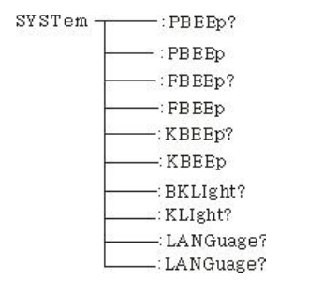
SYSTem ：PBEE/FBEE/KBEE
Set / query test pass / fail / button buzzer status
--Format

Format: SYST：PBEE<ON/OFF>OR<1/0>

Query format: SYST：PBEE？

--Data:<ON/OFF>

Data types: characters

Data range: 0（OFF）,1（ON）

Example:

Set beep to 1

Set command: SYST:BEEP 1

--Return information

Query command: SYST:BEEP? Return value: buzzer status, such as 1

SYSTem ：REset Restore all defaults

--Format:

Format:SYST：RES

8.4.4 MME Subsystem command set

MMEM ： SAVE Save current file to file number

--Format:
Format: MMEM:SAVE < file name >

--Data < file name >

Data type: String

MMEM LOAD Exports the file specified by the file number to the current

--Format:

Format: MMEM: LOAD < file name >

--Data < file name >

Data type: String

8.4.5 FETCH Subsystem command set
FETCH Used to obtain the measurement results of the instrument

--Format:

Format: FETCh:AUTO

Query format: FETCh:AUTO?

--Data:<ON/OFF>

Data types: characters

Data range: 0（OFF）,1（ON）

-Example:

Return test data to ON automatically

Command: FETCh：AUTO ON or： FETCh：AUTO 1

--Return information

Query command: FETCh? , returns the current measurement result of the instrument.

Command syntax: FETCh?

After receiving this command, the instrument will automatically send out the test results until the end of the test.

Return format:

Step: Test item: Test current (a) Test resistance (m Ω) Sorting result

1. The separator between step and test item, test item and data is (:)

2. The separator between test data is (,) the separator between different unit data is (;)

3. The separator between steps is (: + space), and the data end character is uyly (0X0A)

Note: 1. All data are in integer or floating-point format, ASCII string.

2. The default data unit is the same as the FCUN setup instruction set.

The test results are:

Step1: I: 30A, test resistance 100m Ω, result PASS

Return data format:
STEP1 I :30,100,PASS；（SPACE）

8.4.6 Other control command sets

*IDN Query instrument model and version information

Query return: < manufacturer >, < model >, < firmware > < NL ^ END >

Here: < manufacturer > gives the name of the manufacturer ( REK)

< model > give machine model (such as RK9930Y)

< firmware > gives the software version number (such as Version 1.0.0)

For example: WrtCmd ("* IDN?")

Chapter 9 Maintenance guide

9.1 Routine maintenance

9.1.1 The use environment of the tester shall be well ventilated, dry and free of dust and electromagnetic interference.

9.1.2 If the tester is not used for a long time, it shall be powered on regularly, usually once a month, and the power on time shall be less than 30 minutes.

9.1.3 After the tester works for a long time, if it is about 8 hours, it should be powered off for more than 10 minutes to keep the tester in good working condition.

9.1.4 The tester may have poor contact or open circuit after long-term use, and it shall be maintained regularly.

9.2 Simple troubleshooting
Fault phenomenon | Processing method
After starting, there is no display button and no response | Please check whether the power supply is normal and whether the fuse is blown. If it is blown out, please replace the fuse
After starting, the test lamp is not on, but there is current output | The test lamp is broken
After starting, the test lamp does not light up and there is no current output | The start button is not in good contact
After starting, there is no current or resistance display | Please check whether the test line is open, the tested object is not in good contact or the tested object is open
After the test fails, the unqualified lamp does not light up | Failure of unqualified lamp

If there is any fault that can not be eliminated in time, please contact our company or the dealer as soon as possible, and we will provide service for you in time.

9.3 Instructions for software upgrading of instrument system

9.3.1 Connect the USB interface on the back panel of the instrument to the computer, the power resource manager displays the USB disk, copies the upgrade files to the target disk of the instrument, and restarts the instrument to complete the system software upgrade. In case of technical problems in upgrading, please contact us in time.

9.3.2 Press and hold the stop + start key to restart the power supply, clear the data error caused by version change, and restore the setting data to the default factory setting.

Chapter 10 Warranty and accessories

10.1 Accessories

The tester shall be equipped with the following items at the factory:

1. 1 power cord

2. 1 set of test line

3. 1 manual

4. 1 Certificate

After receiving the instrument, the user shall open the box to check the above contents. In case of shortage, please contact our company or the dealer.

Scan the code with a browser
Vsit our website for more product information.
SHENZHEN MEIRUIKE ELECTRONIC TECHNOLOGY.,LTD

