美瑞克仪器
MEIRU IKE INSTRUMENT

Manual
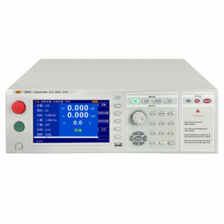

RK9961
Rk9961 Series Program e H I-POT Mult Tester

深圳市美瑞克电子科技有限公司

Safety warning:

Instrument grounding

This instrument is a class I safety instrument. When connecting the power supply, please confirm that the power socket contains the grounding wire. If not grounded, the static electricity or induced electricity on the casing may cause personal injury!

The danger of electric shock

Electric shock damage

Guard against electric shock during operation, testing and instrument maintenance. Non-professionals should not open the case without authorization. If professionals need to replace the fuse or carry out other maintenance, they must unplug the power plug first and be accompanied by others. Even if the power plug is unplugged, there may still be a dangerous voltage on the capacitor, which should be operated after discharge.

Any incorrect removal or addition during the test will cause abnormal damage to person, property or equipment!!! If the instrument is damaged due to abnormal operation, the maintenance cost is borne by the customer.

Input power supply Please use the power supply according to the power supply parameters specified in the instrument. The power supply input that does not meet the specification may damage the instrument.

Stay away from the explosive gas environment

Electronic instruments may not be used in flammable and explosive gas environments or containing corrosive gases or soot because this may
Bring danger.

Other safety
item

point out

Please do not apply any voltage source or current source to the test terminal of this instrument.

An important supplement or reminder to the content stated.

Instructions for use:
* Carefully read and understand what described in the manual before operating the tester. After reading, please put the instructions near the operator for immediate use
Read when needed. When moving the tester from one workplace to another, carry the instructions with the instrument to avoid loss.
* With the improvement of the instrument function and the upgrade of the software, the operation manual will be continuously improved and upgraded. Please note the software and instructions of the tester
edition.

美瑞克仪器 1

Chapter I: Safety Rules 1
Chapter 2 Overview 6
Chapter 3: Panel description 11
Chapter 4: Operating instructions 20
Chapter 5: HANDLER interface and SINGAL interface 23
Chapter 6 Parameter settings 25
Chapter 7: Remote control 56
Chapter 8 SCPI serial port command reference 64
Chapter 9 Maintenance Guide 85
Chapter 10 Warranty and accessories 87

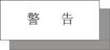

Chapter I: Safety Rules
Subject to change without notice
If it is unknown, please contact our company directly

Provisions and matters to pay attention to before the test!
Warning: To prevent failure or damage to the tester, use the tester within the specified voltage range.
1.1 General provisions
■ Before using the tester, please read the manual carefully and understand the operating procedures and relevant safety signs to ensure safety.
■ Select the correct input voltage specification before opening the input power switch.
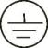Case grounding symbol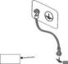
Warning It should be noted that the operations, applications or conditions performed are of high risk and may lead to personnel
Injuries or deaths.

The current generated by the tester is sufficient to cause casualties. In order to prevent accidental injury or death, please take care of it when moving and using the tester
Must observe clearly first, and then operate.

1.2 Maintenance and maintenance
1.2.1 In order to prevent electric shock, non-professionals should not open the lid of the tester. All the parts inside the tester should not be replaced without permission. If the tester occurs, please ask our company or designated dealer for help.
1.2.2 Periodic maintenance
The tester, power cord, test line and related accessories should be carefully inspected and checked at least once a year to ensure the safety of the operator and the tester
The accuracy of.
1.2.3 User modification
The user shall not change the wiring or parts of the tester, otherwise the company's guarantee will fail and shall not be responsible for any consequences.

1.3 Test environment
1.3.1 Working location
When operating the tester, ensure that the tester is placed in a place for ordinary personnel. If it cannot be done because of the production line arrangement,
The test area must be isolated from other facilities and specifically marked as "test work area".

1.3.2 Input power supply
The tester uses a single-phase power supply of 220V 50Hz / 60Hz. Before opening the power switch, make sure that the power supply voltage meets the requirements. The power supply in the test area must have a separate switch, installed at the entrance of the test area, to ensure that all personnel can identify it. Once an emergency occurs, it can be closed immediately
source.

To prevent the tester from failure, use it within the specified voltage range.

1.3.3 Workplace
Use workbench with non-conductive material whenever possible. The test site must be kept neat and clean at all times without confusion. Not used for the tester and
Please place the test line in a fixed position, so that all personnel can immediately separate the test object, the tested object and the tested object.
The test area and the surrounding air shall not contain combustible gas, nor should the tester be used beside flammable items.
1.4 Operators' regulations
1.4.1 Operators qualification
The current output by the tester is sufficient to cause personnel injury or fatal, and must be used and operated by qualified personnel.
1.4.2 Safety Code
Operators must provide education and training at any time to understand the importance of various operating rules and operate the tester according to the safety rules for preparation
To prevent the electric shock accident, please wear the insulating gloves before using the tester.
1.4.3 Clothing regulations
Operators should not wear clothes with metal decoration or wear metal hand accessories and watches, these metal ornaments are easy to cause accidental electric shock.get an electric shock
The consequences will also be more serious.
1.4.4 Medical regulations
The tester must never be operated by someone with heart disease or a rhythm regulator.
Incorrect grounding or ungrounding may have electric shock accidents.
1.5 Safety and grounding regulations
The tester must be well grounded, and the ground wire must be connected before testing to ensure the safety of the operator. If the ground wire connection on the power plug
Unreliable, an additional protective ground end is provided on the rear panel of the tester for connection to the safe ground.

Incorrect grounding or ungrounding may have electric shock accidents.

1.6 Replace the fuse regulations
Please turn off the input power switch, disconnect the power plug before replacing the fuse, and should replace the standard specification
Fuses (200V-240V 47Hz-63Hz 5A).

To avoid electric shock accident, always replace the fuse after disconnecting the power cable.

1.7 Test safety regulations
After the connection test line receives the object to be tested, the connection shall be reliable. The operator must be able to operate completely independently and cannot be controlled by other personnel
System switch and remote control switch, remote control switch should be placed in a fixed position, not placed at will.

Never use the tester on a live circuit board or on the equipment! Do not touch with or with the test object during the test
Connected objects!

1.8 Test abnormal regulations
Under some specific conditions, the tester will not respond to the reset button during the test process, the test time value, display the black screen and other phenomena, which is very
dangerous. When these situations occur, please be sure to turn off the power switch and disconnect the power plug, do not use it again, please contact the company.

When the test is abnormal, immediately close the power switch and unplug the power plug!

1.9 Safety key points
■ Qualified operators and unrelated personnel should be kept away from the test area.
■ Safe and orderly condition must be maintained in the test area.
■ Do not touch the test object or any object connected to the test object during the test process.
■ In case of any problems, please turn off the output and input power supply immediately.

Chapter 2 Overview
2.1foreword

Thank you for purchasing the RK 9961 Ttester.
RK 9961 The programmable safety gauge integrated tester is controlled by a high-performance ARM microprocessor, with excellent speed and performance. Provide five test functions; DC insulation resistance test, DC voltage withstand test, AC voltage withstand test, grounding impedance test and leakage current test.
You can edit the comprehensive test list using the built-in file editor or the RS 232 interface to complete the efficient test.

2.2main specifications
RK 9961 Technical specifications, including the basic technical indicators of the instrument and the allowable range of the instrument test. These specifications are achieved when the instrument leaves the factory.

parameter | type | RK9961
Communication pressure resistance test | voltage range | 0.050kV ~ 5.000kV
 | voltage accuracy | ± (1% + 0.2% full range)
 | resolution ratio | 1V
 | maximumoutput | 100VA ( 5.000kV/20mA)
 | Maximum rated current | 20mA
 | Lower limit current range | 0 ~ 50mA, 0= no judgment lower limit
 | Current accuracy | ±（1 .5% reading + 5 words)
 | discharge waveform | sinusoidal wave
 | Output the waveform distortion degree | 5% (no-load or pure resistive load)
 | Output signal type | The DDS linear power amplifier
 | Voltage up time | 0.1s to 999.9s, OFF = voltage rise time off
 | testing time | 0.3s to 999.9s, OFF = continuous test
 | Voltage drop time | 0.1s to 999.9s, OFF = voltage down time off
DC voltage resistance test | voltage range | 0.050kV ~ 6.000kV
 | voltage accuracy | ± (1% + 0.2% full range)
 | resolution ratio | 1V
 | maximumoutput | 60W ( 6.000kV/10mA)
 | Maximum rated current | 0 ~ 10mA
 | Lower limit current range | 0 ~ 10mA
 | Current accuracy | ±（1 .5% reading + 5 words)
 | ripple factor | ≤ 5% (6kV/10mA)
 | discharge time | ≤ 200ms
 | Voltage up time | 0.1s to 999.9s, OFF = voltage rise time off
 | testing time | 0.3s to 999.9s, OFF = continuous test
 | Voltage drop time | 0.1s to 999.9s, OFF = voltage down time off
Insulation test | Output voltage setting | 0.050kV ~ 5. 000kV resolution: 1V volts / Step
 | The resistance upper limit is set | Range: (0.2M ~ 100G) Ω
 | The lower limit of resistance is set | Range: (0.1M ~ 100) G Ω
 | Voltage up time | 0.1s to 999.9s, OFF = voltage rise time off
 | testing time | 0.3s to 999.9s, OFF = continuous test
 | Voltage drop time | 0.1s to 999.9s, OFF = voltage down time off
 | ohmmeter | ≥500v 0.10MΩ-1.0GΩ ±5% 1.0G-50.0 GΩ ±10%  50.0 GΩ-100.0 GΩ±15%  <500V 0.20MΩ-1.0GΩ ±10% 1.0GΩ-10.0GΩ  No precision requirements

earthing resistance | current range | (3.0-32.0)A
 | Current accuracy | ± (1% Read Value + 0.2A)
 | resolution ratio | 0.1A
 | The resistance upper limit is set | Maximum range is up to 600m
 | The lower limit of resistance is set | 0 to the upper resistance limit
 | Resistor accuracy | ±（1 .5% reading ± 5 words)
 | discharge waveform | sinusoidal wave
 | Output the waveform distortion degree | 3% (no-load or pure resistive load)
 | Output signal type | Linear power amplifier to drive the output
 | current rise time | 0.1s to 999.9s, OFF = voltage rise time off
 | testing time | 0.3s to 999.9s, OFF = continuous test
 | Voltage drop time | 0.1s to 999.9s, OFF = voltage down time off
leakage current  (This function shall be used with an isolation transformer) | voltage range | 30.0V～300.0V
 | voltage accuracy | ± (1% Read Value + 2V)
 | resolution ratio | 0.1V
 | maximumoutput | 5000VA （220V) 3000VA (110V)
 | Current upper limit setting | 0.1uA ~20.00mA
 | Current lower limit setting | 0.1 uA ~ upper current limit
 | Current accuracy | ±（1 .5% reading + 5 words)
 | testing time | 0,1.0s~999.9s 0 = OFF for continuous testing
type |  | horizontal type
isolation transformer |  | Attachment optional
Arc detection |  | 1mA -20mA
output frequency |  | AC 50Hz /60Hz GR 50Hz /60Hz
input characteristics |  | 230V±10% 50Hz /60Hz
Test alarm |  | Buzzer, LCD display, FAIL indicator light
screen size |  | A 7-inch TFT LCD
communication interface |  | HANDLER, RS 232, RS 485, USBDRV (computer interface), USBHOST (U disk interface)
memorizer |  | 16M flash Each file can store 50 test steps
Overall shape volume (WDH) |  | 480×480×480
weight (KG) |  | 30.25KG
Random standard accessories |  | Power line RK 00018, RS 232 communication cable RK 00002, RS 232 to USB cable  RK 00003, USB transfer square port connection line RK 00006,16 GU disk (manual), wire interface transfer drive disc, test line RK 26003A, test line RK 00048, high pressure rod  RK 8N +, test line RK 00027, test line RK 261156-1 RK 9966MODBUS test, upper machine
Choose accessories |  | RK 00031 USB Turn RS 485 female serial port line industrial grade, connecting line 1.5 meters long, upper machine, isolation transformer RK 00065
Contact check |  | Optionally on or off

MD human network: the instrument has built-in 8 simulated human networks (MD-A, MD-B, MD-B1, MD-C, MD-D, MD-E, MD-F, MD-G)
0 .22μF
10k Ω
B
0 .22μF

1 .5kΩ
U 1
0 .22μF

0 .22μF

375Ω
A
B
U1
1k Ω
B

1.5kΩ

1.5k Ω

A

0 .022μF
U 1
U2
500Ω

A
B

500Ω

A

10kΩ

20kΩ
0 .0091μ F U 3
U 1

0 .0062μF
500Ω
B

MD -A

MD -C

500Ω

MD -D

A
2k Ω

B

MD -G

A

1 .5μF
150Ω

B
MD -F

10kΩ
0 .015μF
A

MD -E

MD-A: GB / T12113-2003 (IEC60990:1999) for contact current measurement; GB4793.1-2007 (IEC61010-1:2001) Electrical equipment for measurement, control and laboratory use
MD-B / B1: GB / T12113-2003 (IEC60990:1999) Contact current measurement, GB 4793.1-2007 (IEC61010-1:2001) measurement, control and electrical equipment for laboratory use
GB4706.1-2005 (IEC60335-1:2004) Electrical appliances for household and similar purposes, GB4943.1-2011 (IEC60950-1:2005) information technology equipment,
GB8898-2011 (IEC60065:2005) Audio, video and similar electronic equipment, IEC60335-1-2010,GB7000.1-2015 (IEC60598-1:2014) lamps MD-C: GB / T12113-2003 (IEC60990:1999) contact current measurement, GB7000.1-2015 (IEC60598-1:2014) lamps
MD-D:GB4793.1-2007 (IEC61010-1:2001) for measurement, control, and laboratory electrical equipment
MD-E:GB9706.1-2007/IEC60601-1-1988 Medical electrical equipment, UL2601-2022 Medical electrical equipment
MD-F:GB9706.1-2007/IEC60601-1-1988 Medical electrical equipment, UL2601-2022 Medical electrical equipment

pay attention to:
1. The above technical parameters are standard parameters, and the measurement shall meet the conditions such as the measurement environment and add no auxiliary accessories such as test boxes to reduce the influence of external factors on the measurement accuracy.
2. When using the instrument test, it is recommended to conduct the test in the measurement order of grounding, insulation, pressure resistance, leakage and power. The user can also change the measurement order according to the actual requirements of the side product.

Chapter 3: Panel description

3.1RK9961 Front panel description

front panel
graph 3-1
5
10
11
13
6
3

7
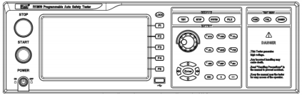
2

1

12 9 8 4
3.1.1 Power Supply Switch (POWER)
mains switch. Check the instrument power type and the test line connection before first startup.
3.1.2 START key, and STOP key
START Key (green circle): to start the test, the HV indicator is on.
STOP, key (red circle): stop key to abort test; also to cancel PASS, FAIL, etc.
3.1.3, trademark and model number
Instrument trademark and model number
3.1.4, digital key area
Used to enter the numerical values
3.1.5, the indicator light area
FAIL
●

●
During the test, if the test data exceeds the setting, the instrument determines that the test is unqualified, and the FAIL judgment light is on.
PASS
After the test, no test data beyond the initial setting is found, the instrument determines that the test is qualified, and the PASS judgment light is on. In the case of the test timing function turned off (TIM E OFF), the test can only be concluded with 'STOP' without PASS judgment.
3.1.6 Functional Area (FUNCTION)
Select the test mode setting, system setting, and file operation interface.
TEST
●
Press the key to light up and the instrument enters the readiness for test. Only in this state will the instrument be allowed to start the high pressure test
● SETUP
Press this key to light up, and the instrument enters the parameter setting interface; only in this state, the instrument changes the test parameters
●
SYSTEM
The key is lit, and the display system setting interface (SYSTEM) is used to configure the parameters related to the test and the test system, such as display and communication
● FILE
This key is illuminated to display the file operation interface (FILE)

3.1.7 DANGER
!! As long as the test is on, the light is on, indicating that the test is ongoing.
3.1.8 Move the key
For the movement of the cursor on the screen and the selection of parameter items.
3.1.9 Rotate the encoded potentiometer
For the adjustment and confirmation of the parameters.
3.1.10 shortcut function key
F1-F5 corresponds to the functional operation area on the right side of the LCD for quick operation.
3.1.11 800 * 480 TFT dot-array LCD display screen, display and setting interface, measurement interface, etc.
3.1.12 USB interface
Implement the parameter setting for copy storage.
3.1.13 LOCK lock key
Press this key to lock all keys on the operation panel except START and STOP to prevent misoperation.

Figure 3-2 The RK9961 rear panel

2
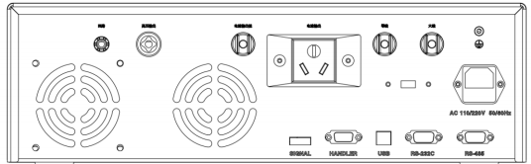

1

3

4 5 6 7

8

9

10 11 12 13 14
3.2.1, the high-pressure output terminal
High voltage output end of the high voltage test interface.
3.2.2 Loop end
Output end and current sampling end of the test voltage.
3.2.3Low current output
The special output end can withstand a large current above 30A and serve as the current output end of the measured object. As the loop test end of the tested unit.
3.2.4 Current output
The test socket has three main functions, specifically as follows:
1) When testing GR mode, test the grounding end of the socket as the current output end of GR grounding test.
2) When testing AC / DC / IR, the fire wire and zero line of the test socket output high voltage at the same time, as the output high voltage end, and the ground end of the test socket as the loop end.3) When testing LC leakage, the fire line and zero line of the test socket shall output 30~300V AC voltage, and the ground end of the test socket shall serve as the MD signal input end.

3.2.5 Zero line
Input, usually connected to the isolation transformer zero line.
3.2.6 Firewire
Input, usually connected to the isolation transformer fire wire.
3.2.7, protective ground terminal
When the three-legged power socket connected by the instrument power supply can not guarantee a reliable connection to the earth，This must be connected to a reliable ground row。
3.2.8 Power socket: come with a fuse box.
For input AC power, use the voltage within the specified input voltage range of the instrument and use the power cord provided with the instrument.
3.2.9 110 / 220V transfer switch
Realize the conversion of input supply voltage 110V 220V.
3.2.10 SIGNAL interface
An interface to output dedicated signals to connect a multiple scan controller。
3.2.11 HANDLER interface
Control and output connection for connecting the instrument to the external control equipment.

3.2.12 USB Serial communication interface
Upgrade the instrument by connecting to the computer.
3.2.13 RS232C Serial interface
Serial communication interface to realize the communication with the computer.
,

3.2.14RS485 Serial interface
Serial communication interface to realize the communication with the computer.

3.3 The screen displays the area definition
RK 9961 Using the 800480 LCD 7-inch display screen, the display content is divided into the following display area, as shown below:
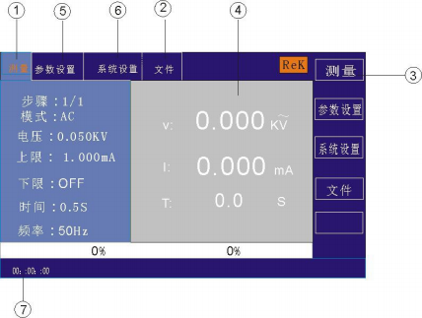

3.5.1 Measurement display page area
The area indicates the name of the measurement parameter for the current page.
3.5.2 File domain
Move the cursor to the area for file management operations. File management includes: loading, saving, and deleting.
3.5.3 Soft-key area
This region was used to display the functional definitions of the soft keys. The definition of a soft key has different functional definitions depending on the location of the region of the cursor.
3.5.4 Areas of the measurement results are displayed
This area displays the test results information and the current test conditions.
3.5.5 Parameter setting area
The area displays the parameter settings
3.5.6 System Settings
This area displays the system parameter settings.
3.5.7Time display area
The area displays the current working hours.
3.4 Main menu buttons and the corresponding displayed page
3.4.1 Measure and display the main menu button
Used to perform various measurements to display the home page. In this part, the page has (use the "soft key" to select the following page function, the same below):

Measurements shown
Measurement Settings
System Settings
〈 file management 〉

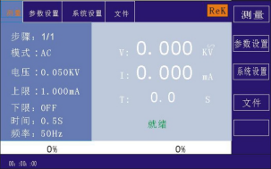

3.4.2 Set the main menu button for the parameters
It is mainly used to enter the measurement setting interface corresponding to the measurement display. The main interface is as follows:

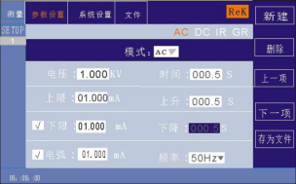

AC DC IR GR PW ST LC
3.4.3 The system sets the main menu button
Access to the System Settings home page. Mainly about the system setting, the function page of this section is:

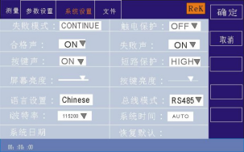

3.4.4 Document management main menu button
For the file management settings.

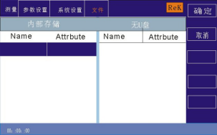

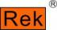

Chapter 4: Operating instructions
4.1 Boot on description and boot screen
Before the power cord plug is connected to the mains, please turn off the input "power switch", check whether the insurance specification is correct, and connect the safety grounding wire for testing
"Ground end" on the rear panel.

Shenzhen Meiruike Electronic Technology Co.,Ltd.

RK 9961
PV Programmable Auto Safety Tester
VERSION ：1.0.0 Copyright(c)2023-2024

http://www.chinarek.com

The basic operations are described as follows:
■ Use the menu buttons ([TEST] [SETUP] [SYSTEM] [FILE]) and the soft keys to select the page you want to display.
■ Use the cursor ([] [] [] []) to move the cursor to the domain you want to set up. When the cursor moves to a domain, the domain turns on in blue. A domain is an area where you can set the cursor.
■ The current cursor can set the parameter value by encoding potentiometer or number key. When the data is entered, use the [ENTER] key or tap the encoded potentiometer.
4.2 Operation steps
4.2.1 Set the tester parameters
Please refer to the "Parameter Setting" section to set each parameters.
4.2.2 Connect the tester to the measured object
Plug in the three-wire power supply plug.
Note: The supply voltage shall be maintained operating at 198-242V AC (50Hz).
The power supply input phase line L, zero line N and ground line E shall be the same as the phase line and zero line on the power supply plug of this instrument.
Turn on the power supply, press the power switch on the lower left corner of the front panel, turn the instrument on, and display the boot screen. As shown above.
Please press the "reset" key once, and determine that the test indicator is not on, the display is working normally and no output, connect the test line, and check the station
Whether all wiring contact reliable.

4.2.3 Press the Start Up key to start the test
After pressing the "Start" key, the tester output, the test indicator on the front panel will light, and the display will display "in test" at the same time
Test the value, the timer also starts to work, and the data will be constantly updated.
4.2.4. Judgment of qualified products
After the test is completed, the tester will automatically turn off the output, the qualified indicator light on the front panel will light up and sound, and the display will display "PASS"
And test data, indicating that the tester determines the test object as a qualified product.
If you want to continue the test, press Start again and the tester will restart the test.
If you want to abort the test, press the reset key, the tester immediately stops the test, and the monitor retains the current test value.
4.2.5 Judgment of nonconforming products
If the test fails, the tester will immediately turn off the output, the front panel will light on and the warning sound, and the display will display the test
Test failure prompt and test data, indicating that the tester determines the tested object as an unqualified product. Test failure prompt is: upper limit failure, overcurrent protection.
To turn off the alarm sound, you can press the "reset" button.
4.2.6 Operation instructions of START and STOP
START The key is the start test key, press this key to start into the test state; the STOP key is the reset stop key, in the test state, press STOP
Key primary instrument interrupt test, running light DANGER off, LOCK lights on; press STOP secondary instrument to enter the reset state, DANGER and LOCK lights off.
The red and black terminals of the instrument are connected to the four ends of the instrument itself. When there is no connection to the measured object, press the START key to start the instrument, and then start the instrument
Open failure and alarm (in ground resistance function option).

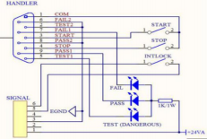

Chapter 5: HANDLER interface and SINGAL interface
5.1 Circuit structure and use of the interface between HANDLER and SINGAL interface
The control interface principle is shown below. This terminal is a standard type 9PIN D terminal hub with PROCESSING (in test) and PSASS (test pass
Three monitoring signals output including pass) and FALL (test failure) and two remote control input signals including TEST (start) and STOP (reset).
5.2 Description of the output signal
HANDLER Interface: START, STOP and COM signals form the remote input control, and the switch input is closed effectively.
HANDLER Interface: TEST, PASS, and FAIL signals constitute the remote output control. The switch closure is valid. The TEST can be used as a high-pressure starter
A dynamic signal, or a pulse signal where the instrument works normally.
SINGAL The interface mainly provides the instrument selection signal (INTLOCK) during multi-instrument online test. This signal is short circuit by default and prohibited during open circuit
This instrument starts the high pressure output.
SINGAL The interface provides about + 24V, the power supply, the output current is less than 0.5A, with the HANDLER interface control signal, can drive the indicator light,
Photoelectric switch, low-power solenoid valve, etc. This interface is generally used for remote control and test synchronization or indication.

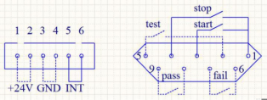

1. PROCESSING signal: the output signal is connected between PIN 5 and PIN 2.
2. PASS signal: the output signal is connected between PIN 8 and PIN 9.
3. FALL signal: the output signal is connected between PIN 6 and PIN 7.
4. START OUT: The output signal is connected between PIN 3 and PIN 1.
5. RESET OUT: The output signal is connected between PIN 4 and PIN 1.

Chapter 6 Parameter settings
6.1 Instrument startup and self-test
6.1.1 Instrument start-up self-inspection items
The screen displays as follows when the tester runs the boot self-test

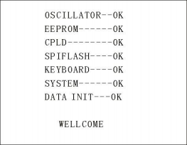

The self-inspection items are as follows:
1. Working state detection of internal crystal vibration: display OK if normal; if abnormal, issue alarm sound and cannot enter the self-inspection of the next project.
2. Input and output memory status detection: if OK, if OK, the alarm sound will not enter the self-test of the next item.3. Complex programmable logic state detection: if normal, display OK, if abnormal, the alarm sound can not enter the self-inspection of the next project.
4. Serial peripheral interface status detection: if OK, display OK, if abnormal, emit alarm sound and can not enter the self-test of the next project.
5. Keypad status detection: If OK, display OK, sound an alarm and cannot enter the self-test of the next project.
6. System status detection: if OK, OK will be displayed, and the alarm sound will not enter the self-inspection of the next project.
7. Data initialization status detection: If OK, the alarm sound will not enter the self-inspection of the next project.
If there is no error in the above self-test, the instrument self-test is successful. Enter the test interface, as shown below:

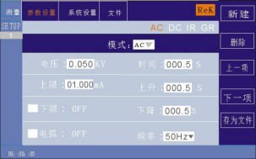

6.2 Parameter setting mode
Press the "SETUP" or "F2" key on the instrument panel to enter the parameter setting page
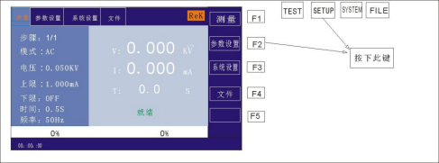

The parameter settings interface is as follows:

AC DC IR GR LC

Note: The specific situation varies according to the test mode of the test step.
6.2.1 Description of the parameter setting
Test Mode: One parameter in the step detail panel is always the test mode parameter. Eiting this parameter can change the test mode of the test step. Range: Test mode supported by the instrument. Press "" on this parameterEnter"After the key, modify the test mode control value according to the selection box control modification method and press" Enter " again to save the modification. If the test mode of the test step changes, automatically update to the parameter panel corresponding to the new test mode. In repair
During modification, press ESC to cancel all current operations.
6.2.2 Description of the test mode supported in the step
The test mode supported by the test step is determined by the following factors: the test mode and file working mode supported by the tester.
For example: assume that the tester supports the ACW、DCW、IR、GR、PW, ST, LC test mode, when the file working mode is GR, it is GR test condition.
6.2.3 Setting of ACW AC pressure withstand parameters
Select "AC" withstand voltage test mode under the parameter panel setting, and the test parameters are set into "AC" withstand voltage mode, as shown below

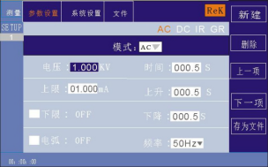
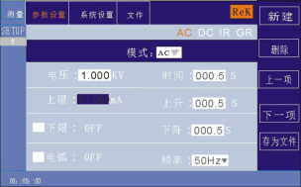

AC DC IR GR LC

Set the parameters are as follows:
Test mode: After the cursor moves to test mode, press "ENTER" to enter the test mode edit, press "" or "" to change the test mode
Set AC AC voltage tester to select AC and press ENTER to save. In this way, the following parameters are changed to AC voltage parameters.
Output voltage: press the "" key or code pull disk to move the cursor to the value after the output voltage, as shown in the figure below:

AC DC IR GR LC

On this interface, press the"ENTER"The Key can edit the output voltage value, and the output voltage range is (0.050-5.000) KV. To change the output voltage value, just enter the number key. For example, to input a voltage of 2.000KV, just press the number key 2”And "ENTER" can be done. To enter a 4.750KV,
”
Press 4,7,5,0, and 0ENTER"The key can be.
Current limit: press the "" key or code pull disk to move the cursor to the current limit, as shown in the figure below:

AC DC IR GR LC

On this interface, press the"ENTER"The Key can edit the current upper limit, the range is (0.001-50.00) mA. To change the current limit,

Just enter the number key. For example, to enter 0.515mA, press the "0", "5", "1", "5", and "ENTER" keys.
Lower Current Limit: Press the "" key or code pull disk to move the cursor to the lower current limit, as shown in the figure below:
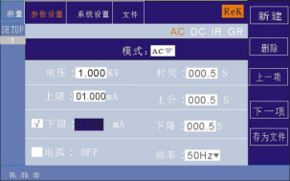

AC DC IR GR LC

Note: Use the "ENTER" key to open or close the lower limit function, the lower limit range: (0.001-10) mA.
After opening the lower limit function, gently press the lower limit of the encoded potentiometer. To change the lower limit of current, just enter the number key.for example
To enter the 0.515mA, press the 0,5,1,5, and ENTER keys.
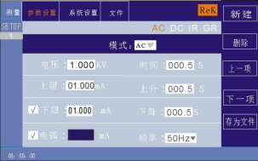
Arc function: Press the "" key or code pull disk to move the cursor to the arc function item, as shown in the figure below:

AC DC IR GR LC

Note: Use"ENTER"Key on or off the arc function, arc range: (0.1-50) mA
After turning on the arc function, operate the arc setting function by tapping the coding potentiometer. To change the arc value, just enter the number key. For example, to lose
Enter the 0.515mA and press the 0,5,1,5, and ENTER keys.
The smaller the arc value is set, in the test process, the measured object ignition or flashover phenomenon, the tester can not detect.
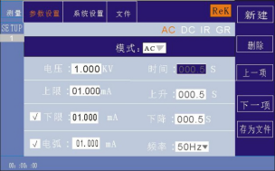
Test time: Press "" key or code pull disk to move the cursor to the time function item, as shown in the figure below:

AC DC IR GR LC

In this interface, press the ENTER key to edit the time, and the range is (0.1-999.9) S. To change the time value, simply enter the number key
Can. For example, to enter 101.2, press the 1,0,1,2, and ENTER keys.
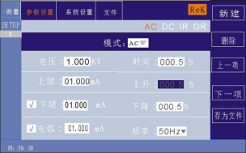
Up Time: Press "'key or code disk to move the cursor to the up time function, as shown in the figure below:

AC DC IR GR LC

In this interface, press the ENTER key to edit the time, and the range is (0.1-999.9) S. To change the time value, simply enter the number key
Can. For example, to enter 101.2, press the 1,0,1,2, and ENTER keys.
Drop time: Press the "" key or code pull disk to move the cursor to the drop time function item, as shown in the figure below:

AC DC IR GR LC

In this interface, press the ENTER key to edit the time, and the range is (0.1-999.9) S. To change the time value, simply enter the number key
Can. For example, to enter 101.2, press the 1,0,1,2, and ENTER keys.
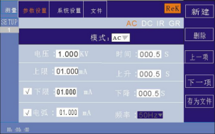
Frequency: Press the "" key or code pull to move the cursor to the frequency function item, as shown in the figure below:

AC DC IR GR LC

Under this interface, press the "ENTER" key to edit the frequency at (50 / 60) Hz. Press, or rotate the coding potential

Device wants to change the frequency value.
New Step: In the test interface, press the "F1" key "New" to create a new test step. A total of 20 tests can be built
step. A new test step is established later in the current step with the default test mode-AC voltage.
Delete step: in the test interface, press the "F2" key on the panel to "Delete", you can delete the test step, the tester can delete the current step,
The later step moves down to the current step below.
Previous page: (Step forward) In the test interface, press the "F3" key on the panel "last page", can move the current step forward, that is, the current test step and the previous test step content exchange, can easily realize the test step sorting function, but in the current step is the first test step, forward operation
Do invalid.
Next page: (Step back) In the test interface, press the "F 4" key "next page" on the panel, the current step back, that is, the current test step and the latter test step content swap, can easily implement the test step sorting function, but in the current step is the last test step, the back operation
Do invalid.
Save as a file: press the "F5" key "Save as a file" on the test interface, and you can store the current test steps in the form of a file
Save, convenient to use. Press Save as File, and pop up the storage interface, as shown below:

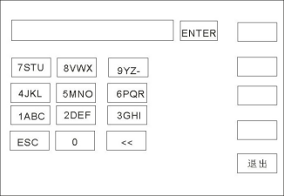

After entering the above interface, press the number key on the panel, and the screen displays as follows:

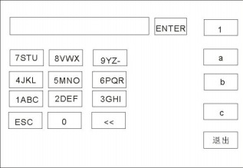

Type the relevant characters on the screen, press the "ENTER" key, and the file is stored inside the tester memory.

6.2.4 Setting of DCW DC withstand voltage parameters
Select "DC" withstand voltage test mode under the parameter panel setting, and the test parameters are set into "DC" withstand voltage mode, as shown below:

Set the parameters are as follows:
Test Mode: After the cursor has been moved to the test mode, press"ENTER"Key to test mode edit, press" "or" " key to change the test mode
Where, set DC DC withstand tester select DC and then press"ENTER"Keys save. In this way, the following parameters are changed to DC voltage parameters.
Output voltage: press the "" key or code pull disk to move the cursor to the value after the output voltage, as shown in the figure below:
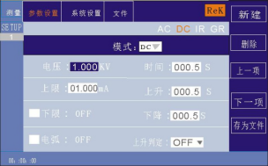

AC DC IR GR LC

On this interface, press the"ENTER"The Key can edit the output voltage value, and the output voltage range is (0.050-6.000) KV. To change the output voltage value, just enter the number key. For example, to input the voltage of 2.000KV, just press the number key 2 "and" ENTER ". To enter a 4.750KV,
”
Press the 4,7,5,0, and ENTER keys.

Current limit: press the "" key or code pull disk to move the cursor to the current limit, as shown in the figure below:
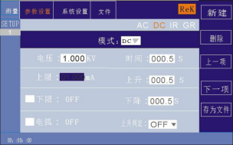

AC DC IR GR LC

In this interface, press "ENTER" to edit the upper current limit, ranging from (0.001-20.00) mA. To change the current limit,
Just enter the number key. For example, to enter 0.515mA, press "0", "5", "1", "5", and"ENTER"The key can be.

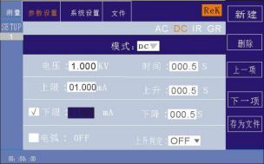

Lower Current Limit: Press the "" key or code pull disk to move the cursor to the lower current limit, as shown in the figure below:

AC DC IR GR LC

Note: Use the "ENTER" key to open or close the lower limit function, the lower limit range: (0.001-20) mA.
After opening the lower limit function, gently press the lower limit of the encoded potentiometer. To change the lower limit of current, just enter the number key.for example
To enter the 0.515mA, press the 0,5,1,5, and ENTER keys.

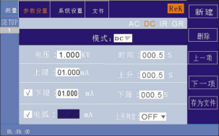
Arc function: Press the "" key or code pull disk to move the cursor to the arc function item, as shown in the figure below:

AC DC IR GR LC

Note: use the "ENTER" key to turn on or off the arc function, the arc range: (0.1-20) mA
After turning on the arc function, operate the arc setting function by tapping the coding potentiometer. To change the arc value, just enter the number key. For example, to lose
Enter the 0.515mA, and press the 0,5,1,5, and ENTER keys.
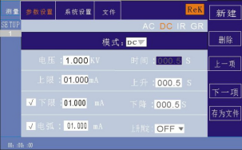
The smaller the arc value is set, in the test process, the measured object ignition or flashover phenomenon, the tester can not detect.
Test time: Press "" key or code pull disk to move the cursor to the time function item, as shown in the figure below:

AC DC IR GR LC

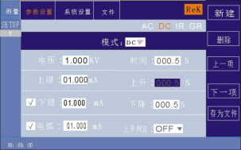
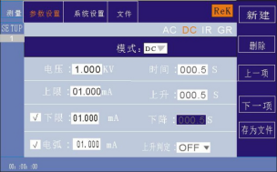
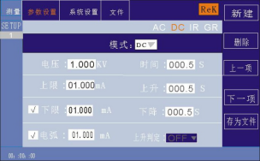

On this interface, press the"ENTER"Key to edit the time, the range is (0.1-999.9) S. To change the time value, simply enter the number key
Can. For example, to enter 101.2, press "1", "0", "1", "2", and"ENTER"The key can be.
Up Time: Press "'key or code disk to move the cursor to the up time function, as shown in the figure below:

AC DC IR GR LC

In this interface, press the ENTER key to edit the time, and the range is (0.1-999.9) S. To change the time value, simply enter the number key
Can. For example, to enter 101.2, press "1", "0", "1", "2", and"ENTER"The key can be.

Drop time: Press the "" key or code pull disk to move the cursor to the drop time function item, as shown in the figure below:

AC DC IR GR LC

In this interface, press the ENTER key to edit the time, and the range is (0.1-999.9) S. To change the time value, simply enter the number key.
To change the time value, simply enter the number key. For example, to enter 101.2, press "1", "0", "1", "2", and"ENTER"The key can be.

Rising judgment: press the "" key or code to move the cursor to the rise determination function item, as shown in the figure below:

AC DC IR GR LC

Under this interface, press "ENTER" to edit the range (ON / OFF). Press '' '' or rotate the code

potential device.
New Step: In the test interface, press the "F1" key "New" to create a new test step. A total of 20 tests can be built
step. A new test step is established later in the current step with the default test mode-AC voltage.
Delete step: in the test interface, press the "F2" key on the panel to "Delete", you can delete the test step, the tester can delete the current step,
The later step moves down to the current step below.
Previous page: (Step forward) In the test interface, press the "F3" key on the panel "last page", can move the current step forward, that is, the current test step and the previous test step content exchange, can easily realize the test step sorting function, but in the current step is the first test step, forward operation
Do invalid.
Next page: (Step back) In the test interface, press the "F 4" key "next page" on the panel, the current step back, that is, the current test step and the latter test step content swap, can easily implement the test step sorting function, but in the current step is the last test step, the back operation
Do invalid.
Save as a file: press the "F5" key "Save as a file" on the test interface, and you can store the current test steps in the form of a file
Save, convenient to use. Press Save as File, and pop up the storage interface, as shown below:
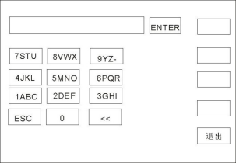
After entering the above interface, press the number key on the panel, and the screen displays as follows:
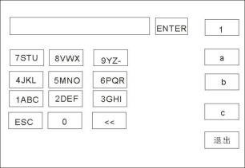

Type the relevant characters on the screen, press the "ENTER" key, and the file is stored inside the tester memory.

6.2.5 Set of IR insulation resistance parameters
Select "IR" insulation test mode under the parameter panel setting, and set into "IR" withstand voltage mode, as shown below:
Set the parameters are as follows:
Test mode: After the cursor moves to the test mode, press "ENTER" to enter the test mode editing, and press "" or "" " to change the test mode
Where, set the IR insulation test and press ENTER to save. So that the following parameters are all changed to the parameters of the insulation resistance.
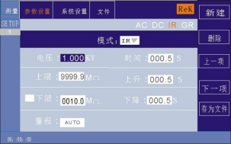
Output voltage: press the "" key or code pull disk to move the cursor to the value after the output voltage, as shown in the figure below:

AC DC IR GR LC

99999.9

In this interface, press the "ENTER" key to edit the output voltage value, and the output voltage range is (0.050-3.000) KV. To change the output power
Pressure value, just enter the number key. For example, to enter a 1.000KV, press the 1,0,0,0, and ENTER keys.
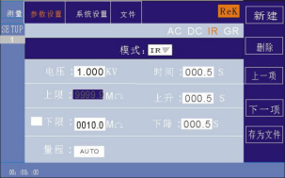
Upper resistance limit: Press "" key or code pull disk to move the cursor to the upper resistance limit, as shown in the figure below:

AC DC IR GR LC

In this interface, press "ENTER" to edit the current limit, (0.1-99999.9) M Ω. To change the upper resistance limit, simply enter the number key. For example, to enter 0.515mA, press the "0", "5", "1", "5", and "ENTER" keys.
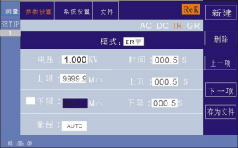
Lower resistance: Press "" key or code pull disk to move the cursor to the value after the lower resistance, as shown in the figure below:

AC DC IR GR LC

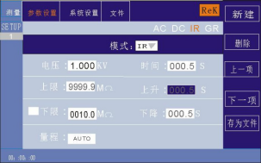

Note: Use the "ENTER" key to open or close the lower limit function, the lower limit range: (0.1-99999.9) M Ω.
After opening the lower limit function, gently press the lower limit of the coding potentiometer. To change the lower limit of resistance, just enter the number key.for example
To enter the 1000M Ω, press the values of 1,0,0,0, and 0ENTER"The key can be.
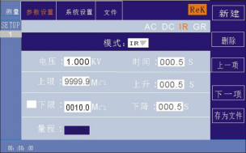
Range function: Press the "" key or code to remove the disk to move the cursor to the range function item, as shown in the figure below:

AC DC IR GR LC

99999.9

The measuring range is divided into: AUTO, 1M, 10M, 100M, 1G and 100G.
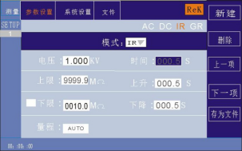
Test time: Press "" key or code pull disk to move the cursor to the time function item, as shown in the figure below:

AC DC IR GR LC

99999.9

In this interface, press the "ENTER" key to edit the time, in the range of (0.1-999.9) S. To change the time value, simply enter the number key
Can. For example, to enter 101.2, press the 1,0,1,2, and ENTER keys.
Up Time: Press "'key or code disk to move the cursor to the up time function, as shown in the figure below:

AC DC IR GR LC

Under this interface, press "ENTER" to edit the determination (ON / OFF). Press “↓”“↑” or rotate the code potential device.
New Step: In the test interface, press the "F1" key "New" to create a new test step. A total of 20 tests can be built step. A new test step is established later in the current step with the default test mode-AC voltage.
Delete step: in the test interface, press the "F2" key on the panel to "Delete", you can delete the test step, the tester can delete the current step, The later step moves down to the current step below.
Previous page: (Step forward) In the test interface, press the "F3" key on the panel "last page", can move forward the current step, that is, the current test step and the previous test step content exchange, can easily realize the test step sorting function, but in the current step is the first test step, forward operation Do invalid.
Next page: (Step back) In the test interface, press the "F4" key "next page" on the panel, the current step back, that is, the current test step and the latter test step content swap, can easily implement the test step sorting function, but in the current step is the final test step, the back operation Do invalid.
Save as a file: press the "F5" key "Save as a file" on the test interface, and store the current test steps in the form of a file Save, convenient to use. Press Save as file, and the storage interface is displayed below:
After entering the above interface, press the number key on the panel, and the screen displays as follows:
Type the relevant characters on the screen, press the "ENTER" key, and the file is stored inside the tester memory.

6.2.5 Set of IR insulation resistance parameters
Select "IR" insulation test mode under the parameter panel setting, and set into "IR" withstand voltage mode, as shown below: Set the parameters are as follows: Test mode: After the cursor moves to the test mode, press "ENTER" to enter the test mode editing, and press“→ ” or “←”to change the test mode Where, set the IR insulation test and press ENTER to save. So the following parameters are changed to the parameters of insulation resistance. Output voltage: press the “←” key or code pull disk to move the cursor to the value of the output voltage, as shown in the figure below:

AC DC IR GR LC

99999.9

In this interface, press the "ENTER" key to edit the output voltage value, and the output voltage range is (0.050-3.000) KV. To change the output power Pressure value, just enter the number key. For example, to enter a 1.000KV, press the 1,0,0,0, and ENTER keys. Upper resistance: Press “↓” key or code pull disk to move the cursor to the value after the upper resistance, as shown in the figure below:

AC DC IR GR LC

In this interface, press "ENTER" to edit the current limit of (0.1-99999.9) MΩ. To change the upper resistance limit, simply enter the number key. For example, to enter 0.515mA, press the "0", "5", "1", "5", and "ENTER" keys. Lower resistance: Press In this interface, press "ENTER" to edit the current limit of (0.1-99999.9) MΩ. To change the upper resistance limit, simply enter the number key. For example, to enter 0.515mA, press the "0", "5", "1", "5", and "ENTER" keys. Lower resistance: Press "" key or code pull disk to move the cursor to the value after the lower resistance, as shown in the figure below: key or code pull disk to move the cursor to the value after the lower resistance, as shown in the figure below:

AC DC IR GR LC

Note: Use the "ENTER" key to open or close the lower limit function, the lower limit range: (0.1-99999.9) MΩ. After opening the lower limit function, gently press the lower limit of the coding potentiometer. To change the lower limit of resistance, just enter the number key.for example To enter the 1000M Ω, press the 1,0,0,0, and ENTER keys. Range function: Press the “↓” key or code to remove the disk to move the cursor to the range function item, as shown in the figure below:

AC DC IR GR LC

99999.9

The measuring range is divided into: AUTO, 1M, 10M, 100M, 1G and 100G. Test time: Press “↓”key or code pull disk to move the cursor to the time function item, as shown in the figure below:量程分为： AUTO、 1M、10M、100M、1G、100G

AC DC IR GR LC

99999.9

In this interface, press the "ENTER" key to edit the time in the range of (0.1-999.9) S. To change the time value, simply enter the number key Can. For example, to enter 101.2, press the 1,0,1,2, and ENTER keys. Up Time: Press “↓”key or code disk to move the cursor to the up time function, as shown in the figure below:

In this interface, press ENTER to edit the time in the range of (0.1-999.9) S. To change the time value, simply enter the number key Can. For example, to enter 101.2, press the 1,0,1,2, and ENTER keys. Drop time: Press the “↓” key or code pull disk to move the cursor to the drop time function item, as shown in the figure below:
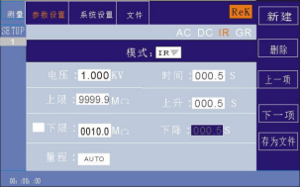

99999.9

In this interface, press the ENTER key to edit the time, and the range is (0.1-999.9) S. To change the time value, simply enter the number key Can. For example, to enter 101.2, press the 1,0,1,2, and ENTER keys.
New Step: In the test interface, press the "F1" key "New" to create a new test step. A total of 20 tests can be built step. A new test step is established later in the current step with the default test mode-AC voltage.
Delete step: in the test interface, press the "F2" key on the panel to "Delete", you can delete the test step, the tester can delete the current step, The later step moves down to the current step below.
Previous page: (Step forward) In the test interface, press the "F3" key on the panel "last page", can move forward the current step, that is, the current test step and the previous test step content exchange, can easily realize the test step sorting function, but in the current step is the first test step, forward operation Do invalid.
Next page: (Step back) In the test interface, press the "F4" key "next page" on the panel, the current step back, that is, the current test step and the latter test step content swap, can easily implement the test step sorting function, but in the current step is the final test step, the back operation Do invalid.

Save as a file: press the "F5" key "Save as a file" on the test interface, and store the current test steps in the form of a file Save, convenient to use. Press Save as file, and the storage interface is displayed below:
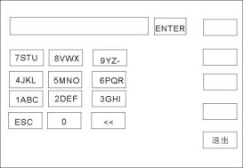

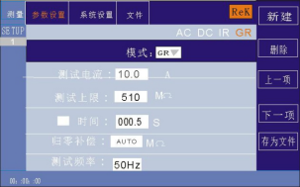
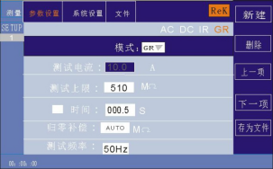

After entering the above interface, press the number key on the panel, and the screen displays as follows:
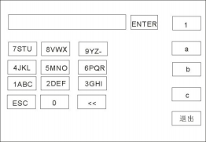

Type the relevant characters on the screen, press the "ENTER" key, and the file is stored inside the tester memory.

6.2.6 GR ground resistance parameter setting Select the "GR" grounding resistance test mode under the parameter panel setting, and the test parameter set enters the "GR" grounding resistance test mode, as shown below:

AC DC IR GR LC

600

000.0

Set the parameters are as follows: Test mode: After the cursor moves to test mode, press "ENTER" to enter test mode editing, and press “→ ”or “←” to change the test mode Where, set the GR ground test and press ENTER to save. So the following parameters are changed to ground resistance parameters. Output current: press the“↓” key or pull the code disk to move the cursor to the value after the output current, as shown in the figure below:

AC DC IR GR LC

600

000.0

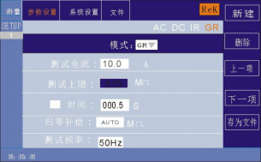

In this interface, press the "ENTER" key to edit the output voltage value, and the output voltage range is (3-32.0) A. To change the output current value, Just enter the number key. For example, to enter a 10.0A, press the 1,0,0, and ENTER keys. Upper resistance test limit: press the “↓” key or code pull disk to move the cursor to the value after the upper test limit, as shown in the figure below:

AC DC IR GR LC

000.0

In this interface, press "ENTER" to edit the test limit from (0.1-600) m Ω. To change the upper resistance limit, simply enter the number key. For example, to enter 100m Ω, press "1", "0", "0" and "ENTER" keys. Test time: Press In this interface, press "ENTER" to edit the test limit from (0.1-600) m Ω. To change the upper resistance limit, simply enter the number key. For example, to enter 100m Ω, press "1", "0", "0" and "ENTER" keys. Test time: Press "" key or code pull disk to move the cursor to the time function item, as shown in the figure below: key or code pull disk to move the cursor to the time function item, as shown in the figure below:
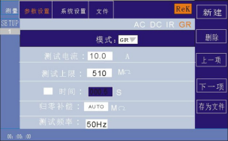

AC DC IR GR LC

600

000.0

Note: Use the "ENTER" key to turn the time function on or off, range: (0.1-999.9) S. After opening the time function, tap the encoding potentiometer operation time to set the function. To change the time value, just enter the number key. For example, to lose Enter the 100S and press the 1,0,0, and ENTER keys. Zero compensation: press the “↓”key or code pull disk to move the cursor to the zero compensation function item, as shown in the figure below:
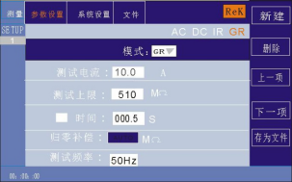

AC DC IR GR LC

600

Zero compensation is divided into: AUTO, manual. Automatic compensation state only two test lines are automatically recorded to the tester; manual state It is necessary to measure the compensation value of the line loss in advance, and enter the corresponding numerical value can be used. Test frequency: press the “↓” key or code pull to move the cursor to the test frequency function item, as shown in the following figure:

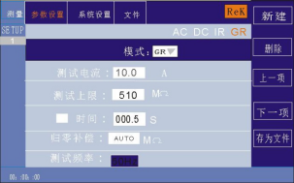

AC DC IR GR LC

600

000.0

In this interface, press the ENTER key to edit the frequency at (50 / 60) Hz.
New Step: In the test interface, press the "F1" key "New" to create a new test step. A total of 20 tests can be built step. A new test step is established later in the current step with the default test mode-AC voltage.
Delete step: in the test interface, press the "F2" key on the panel to "Delete", you can delete the test step, the tester can delete the current step, The later step moves down to the current step below.
Previous page: (Step forward) In the test interface, press the "F3" key on the panel "last page", can move forward the current step, that is, the current test step and the previous test step content exchange, can easily realize the test step sorting function, but in the current step is the first test step, forward operation Do invalid. Next page: (Step back) In the test interface, press the "F4" key "next page" on the panel, the current step back, that is, the current test step and the latter test step content swap, can easily implement the test step sorting function, but in the current step is the final test step, the back operation Do invalid.
Save as a file: press the "F5" key "Save as a file" on the test interface, and store the current test steps in the form of a file Save, convenient to use. Press Save as file, and the storage interface is displayed below:

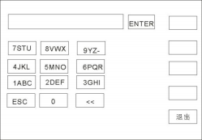

电流上限：
电流上限：
电流上限：
电流上限：

After entering the above interface, press the number key on the panel, and the screen displays as follows:
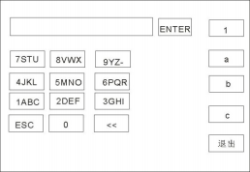

Enter the relevant characters on the screen, press the "ENTER" key, and the file is stored inside the tester memory.
6.2.7 LC leakage parameter setting Select the "LC" leakage test mode under the parameter panel settings, and the test parameter settings enter the "LC" leakage test mode, as shown below

电压上限：300.0 V 电压下限：000.0 V
20.000 mA
00.000 mA

AC DC IR GR LC
LC
√ 0 10.0
判定模式
测试模式
HOT ▼
MAX ▼
MD 网络：A ▼

Set the parameters are as follows: Test mode: After the cursor moves to the test mode, press "ENTER" to enter the test mode editing, and press“→ ”or “←”to change the test mode Where, set the LC leak test, and then press ENTER to save. This changes all of the following parameters to the leaked parameters. Upper voltage limit: Press the key “↓”or remove the cursor to the value of the upper voltage limit as shown in the figure below:设置参数如下：

电压上限： 300.0 V 电压下限：000.0 V
20.000 mA
00.000 mA

AC DC IR GR LC
LC
√ 0 10.0
判定模式
测试模式
HOT ▼
MAX ▼
MD 网络：A ▼

20.000
00.000 mA
电流上限：
电流上限：
In this interface, press the "ENTER" key to edit the voltage value, the voltage range is (0.1~300) V. To change the voltage value, Just enter the number key. For example, to enter 100V, press the 1,0,0, and ENTER keys. Current test limit: Press “↓” key or code pull disk to remove the cursor to the value after the test limit, as shown in the figure below:

电压上限：300.0 V
电压下限：000.0 V
电流上限： mA
电流上限：

AC DC IR GR LC
LC
√ 0 10.0
判定模式
测试模式
HOT ▼
MAX ▼
MD网络：A ▼

In this interface, press "ENTER" to edit the test limit from (0.001 to 20) mA. To change the upper current limit, just enter the number key. For example, to enter a 10.0mA, press the 1,0,0, and ENTER keys. Test Time: Press“↓”key or code pull disk to move the cursor to the time function item, as shown in the figure below:

电压上限：300.0 V 电压下限：000.0 V
20.000 mA
00.000 mA

AC DC IR GR LC
LC
√ 0 10.0
判定模式
测试模式
HOT ▼
MAX ▼
MD网络：A ▼

Note: Use the "ENTER" key to turn the time function on or off, range: (0.1-999.9) S. After opening the time function, tap the encoding potentiometer operation time to set the function. To change the time value, just enter the number key. For example, to lose Enter the 100S and press the 1,0,0, and ENTER keys.

New Step: In the test interface, press the "F1" key "New" to create a new test step. A total of 20 tests can be built step. A new test step is established later in the current step with the default test mode-AC voltage.
Delete step: in the test interface, press the "F2" key on the panel to "Delete", you can delete the test step, the tester can delete the current step, The later step moves down to the current step below.
Previous page: (Step forward) In the test interface, press the "F3" key on the panel "last page", can move the current step forward, that is, the current test step and the previous test step content exchange, can easily realize the test step sorting function, but in the current step is the first test step, forward operation Do invalid.
Next page: (Step back) In the test interface, press the "F4" key "next page" on the panel, the current step back, that is, the current test step and the latter test step content swap, can easily implement the test step sorting function, but in the current step is the last test step, the back operation Do invalid.
Save as a file: press the "F5" key "Save as a file" on the test interface, and you can store the current test steps in the form of a file Save, convenient to use. Press Save as File, and pop up the storage interface, as shown below:

After entering the above interface, press the number key on the panel, and the screen displays as follows:

Enter the relevant characters on the screen, press the "ENTER" key, and the file is stored inside the tester memory.

6.3 System setting mode
6.3.1 Description of the system setting parameters

6.3.1.1 Failure mode
This option has two functions， CONTINUE 、STOP 、RESTART 、NEXT ，可用[↑][↓]【←】【→ 】Cursor selection Select the setting items, adjust the encoding potentiometer to select the function items to be set.
6.3.1.2Qualified voice
This option has 2 functions, ON and OFF.可用[↑] [↓] 【←】【 →】Select the cursor setting item and adjust the encoded potentiometer selection Function item to be set up.

6.3.1.3 keying chirps
This option has 2 functions, ON and OFF.可用[↑] [↓] 【←】【 →】Select the cursor and adjust the coding potentiometer Function item to set.
6.3.1.4 screen intensity
可用[↑][↓]【←】【→ 】The cursor selects the setting item and adjusts the encoded potentiometer to select the value to set.
6.3.1.5 system language
There are 2 languages, Chinese and English.可用[↑][↓]【←】【→ 】The cursor selects the coding potential The device selects the items that you want to set up.
6.3.1.6 Baud rate
This item has four baud rates： 9600、38400、19200、115200。可用[↑][↓]【←】【→ 】The cursor selects the coding potential The device selects the items that you want to set up.

6.3.1.7 System date
This can set the current time of the instrument, once the system time is set, regardless of the machine state time function, unless the internal battery lose efficacy.可用[↑][↓]【←】【→ 】The cursor selects the setting item and adjusts the encoded potentiometer to select the desired setting
6.3.1.8 Electric shock protection
This option has 2 functions, ON and OFF.可用[↑][↓]【←】【→ 】Cursor selection setting item and adjust the coding potentiometer selection Function item to be set in.
6.3.1.9 Sound of failure
This option has 2 functions, ON and OFF.可用[↑][↓]【←】【→ 】Select the cursor setting item and adjust the encoded potentiometer selection Function item to be set up.
6.3.1.10short-circuit protection
This option has 2 functions, HIGH and LOW.可用[↑] [↓] 【←】【 →】The cursor selects the coding potential Select the function item that you want to set.
6.3.1.11Key brightness
可用[↑][↓]【←】【→ 】The cursor selects the setting item and adjusts the encoded potentiometer to select the value to set.

6.3.1.12 Bus mode
This item has two bus modes, RS232 and RS485.可用[↑][↓]【←】【→ 】The cursor selects the coding potential The device selects the items that you want to set up.

6.3.1.13 System time
This can set the current time of the instrument, once the system time is set, regardless of the machine state time function, unless the internal battery lose efficacy.可用[↑][↓]【←】【→ 】The cursor selects the setting item and adjusts the encoded potentiometer to select the value to set.
6.3.1.14 Restore the default
This function is to restore system Settings, parameter Settings and restore factory Settings, all Settings will be cleared.可用[↑][↓]【←】【→ 】light Select the setting item, press [ENTER] to pop up the [OK] [Cancel] interface, and press [OK] to determine. Press the [Cancel] key to cancel.

6.4 Document parameter description
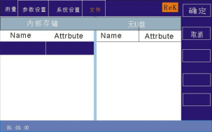

6.4.1 Internal storage: with a 16M storage capacity.
6.4.2 U disk function: This item has an external U disk storage function.

6.5 Description of the contact inspection function
Contact inspection Test through a 1kV high pressure to determine whether the equipment to be tested is contacted, which is usually used for testing the equipment to be tested below 100G. Contact inspection recommends the use of a high-pressure rod output test.
测量 | 参数设置 |  | 系统设置 | 文件
 |  |  |  |  |  | 上一页
VERSION:0.0.221226 LC0.0.0
接触检查： |  | OFF
步骤模式： Normal
通讯协议： Scpi
地址： 001
10:20:15

6.6 Communication protocol selection
SCPI Modbus Description, support SCPI and Modbus two kinds, Modbus address location can be set.

Chapter 7: Remote control
7.1 RS232C Interface description
The current widely used serial communication standard is RS-232 standard, or asynchronous serial communication standard, RS is "Recommended Standard" (recommended standard), 232 is standard number, the American Electronics Industry Association (IEA) in 1969, which stipulates that one person is transmitted through a data line at a time. Like most serial ports in the world, the serial interface of this instrument is not strictly based on the RS-232, standard, but rather Only a minimal subset is provided. The following table:

信号 | 缩写 | 连接器引脚号
发送data | TXD | 2
接收data | RXD | 3
接地 | GND | 5

仪器 RS232 信号与引脚对照
其原因是三条线的运作比五条线或六条的运作要便宜的多 ，这是使用串行口通讯的最大优点 。 仪器与计算机连接如
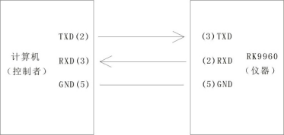
图所示：

RK996 1

Schematic diagram of the computer and the instrument connection
As you can see from the figure, the pin definition of the instrument is different from the 9-core connector serial interface pin definition used by the computer machine. RS232 Interface port rate can be Select with 9600~115200, no check (no parity), 8 bit data bits, 1 bit stop bits. The instrument command meets the SCPI standard, when the command string sends After sending the instrument, the LF (hexadecimal: 0 AH) is sent as the end character. The maximum number of SPCI command string bytes acceptable at a time is 2kByte。See the Command Reference section for the resulting data format to which the instrument is sent to the computer.

A
B

7.2 RS485 / 232C interface description
The communication interface of the tester can provide RS232C and RS485 for users to choose. The interface is defined as follows:

信号正端 信号负端
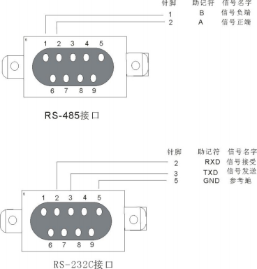
G ND 参考地

7.3 USBTMC, Remote control system
The USB (Universal Serial Bus) remote control system controls the device through a USB interface. The connection complies with the USB2.0 protocol. Connect the USB interface on the rear panel of RK9961 to the USB interface on the host via USB cable.
7.4 Instrument communication protocol (modbus)
This instrument uses the RS-232 CRS-485 standard Asynchronous serial communication bus interface to communicate with the external control equipment, and the transmission port rate can be preset at the instrument (9600,19200,38400 115200 optional).8-bit data bit, 1-bit stop bit, and no check bit. The logical level of the signal is ± 12V, with a maximum transmission distance of 15 m. The serial interface adopts direct communication, only TXD (send), RXD (accept), GND (ground) three signal lines, using the nine-core standard interface socket.
1、Read instruction (function code is 03H)
发送form(共 7 位data):

地址 | 功能码 | 地址高位 | 地址低位 | data量高位 | data量低位 | CRC 低 | CRC 高
返回form:

地址 | 功能码 | 地址高位 | 地址低位 | data量高位 | data量低位 | data字节 | CRC 低 | CRC 高
Data byte: When the data type is U16, the data byte is 2 byte, and the low level is before When the data type is float, the data byte is 4 byte and the low level is before When the data type is double, the data byte is 8 byte, and the low level is before
Example: Send 01 03 10 01 00 02 91 0B to query the current selection step to the 01 instrument Returns 01 03 10 01 00 02 01 00 2D C7 Different address bits return different data
寄存器列表
serial number | Register address | Register name | data type | byte | instruction | data area | Reading and writing type | range of application
1 | 1001H | Sel Step | U16 | 2 | Current Step Number / Number of steps selected |  | RW
2 | 1002H | To l Step | U16 | 2 | Total number of steps |  | R
3 | 1003H | New Step | U16 | 2 | New steps |  | W
4 | 1004H | Del Step | U16 | 2 | Remove the number of steps |  | W
5 | 1005H | Mode | U16 | 2 | model | 1-7 | RW | 全
6 | 1006H | Volt | float | 4 | voltage | AC 0.05-5.0  DC 0.05-6.0  IR 0.05-3.0 | RW | AC DC IR
7 | 1007H | Cur rUp lim | float | 4 | Current upper limit | AC 0.001-50  DC 0.001-20 | RW | A C DC
8 | 1008H | Cur rUp lim | float | 4 | Current lower limit | AC 0.0-49.999  DC 0.001-19.999 | RW | A C DC
9 | 1009H | Arc | float | 4 | Arc setting | 0-20 | RW | A C DC
10 | 100AH | T ime | float | 4 | Time setting | 0.1-999.9 0 （不限时） | RW | A C DC IR GR
11 | 100BH | R ise T ime | float | 4 | Rising time setting | 0-999.9 | RW | AC DC IR
12 | 100CH | Fall T ime | float | 4 | Decline time setting | 0-999.9 | RW | AC DC IR
13 | 100DH | Freq | U16 | 2 | Frequency setting | 50 60 | RW | AC
14 | 100EH | Ramp | U16 | 2 | Rising judgment | 0 1 | RW | DC
15 | 100FH | Res Up lim | float | 4 | Resistance upper limit | 0.1-99999.9 | RW | IR
16 | 1010H | Res Dn lim | float | 4 | Resistance lower limit | 0.1-99999.8 0 （无下限） | RW | IR
17 | 1011H | Range | U16 | 2 | range | 0 1 2 3 4 5 | RW | IR
18 | 1012H | GR Test Cur r | float | 4 | test current | 3-32A | RW | GR

serial number | Register address | Register name | data type | byte | instruction | data area | Reading and writing type | range of application
19 | 1013H | GR Test Up lim | float | 4 | Test upper limit | 10-600 | RW | GR
20 | 1014H | GROFF SET | float | 4 | Zero compensation |  | RW | GR
21 | 1015H | GROFF SET AUTO | U16 | 2 | Automatic zero compensation |  | W | GR
22 | 1016H | GR Fr eq | U16 | 2 | Gr frequency | 50 60 | RW | GR
23 | 101CH | Volt Up lim | float | 4 | Voltage upper limit | 0.1-300 | RW | LC
24 | 101DH | Volt Dn lim | float | 4 | lower limit of voltage | 0-299.9 | RW | LC
25 | 101EH | LCC ur rUp lim | float | 4 | LC current limit | 0.001-30 | RW | LC
26 | 101FH | LCC ur rD n lim | float | 4 | LC current limit | 0-29.999 | RW | LC
27 | 1020H | Judge Mode | U16 | 2 | Determination mode | 0 1 | RW | LC
28 | 1021H | Test Mode | U16 | 2 | Test settings | 0 1 | RW | LC
29 | 1022H | MD Net | U16 | 2 | MD network | 0-7 | RW | LC
30 | 1060H | Start | U16 | 2 | Start the test |  | W
31 | 1061H | Stop | U16 | 2 | Stop testing |  | W
32 | 1062 | fetch one | U8 | 1 | The pattern of the current step |  | R | A C DC IR L C
 |  |  | U8 | 1 | Test results for the current step
 |  |  | float | 4 | Test voltage for the current step
 |  |  | float | 4 | Test current for the current step
returned value说明：
Mode 模式：1交流耐压 2直流耐压 3绝缘电阻 4接地电阻 5泄漏
Range 量程：AUTO 1M 10M 100M 10G 100G
Judge 判定模式：0 Judge End 1 Judge Max
TestMode 测试模式：0 Cold 1 Hot
MDNet MD网络：0MD A、1MD B、2MD B1、3MD C、4MD D、5MD E、6MD F、7MD G

Fetch one

模式 | data字节
交流（AC）  直流（DC） | 状 态（byte ） 电压（float) 电流（float)
绝缘（IR） | 状 态（byte ） 电压（float) 电 阻（float)
接地（GR） | 状 态（byte ） 电流（float) 电 阻（float)
泄 漏（LC） | 状 态（byte ） 电压（float) 电流（float) 功率（float）

状态：
00H未测试 01H测试 中 02H测试合格 03H超过上 限 04H低于下 限 05H超过GR电压 06H GR开路 07H短路失败 08H电弧失败
09H人体保护失败 OAH GR偏置 O BH接触检查失败 OCH电流超上 限 OD H电流低于下 限 O EH功率超上 限
OF H功率低于下 限 10H电压超上 限 11H电压低于下 限 12H泄 漏 电压超 限 13H泄 漏 电流超 限

- Write instructions (the function code is 10H)

Send format:

地址 | 功能码 | 地址  高位 | 地址  低位 | data量高 位(word) | data量低 位(word) | data量 (Byte) | data字 节 1-n | CRC 低 | CRC 高

Return format is:

地址 | 功能码 | 地址  高位 | 地址  低位 | data量高 位(word) | data量低 位(word) | CRC 低 | CRC 高
Here are the details of the meaning of each parameter:
2.1 address postal address.
Range is decimal 1-247. If the native address in the instrument system setting is 99, then this bit is 63H

2.2, the function code
Write one or more bytes of data to the instrument. Functional code is 10H
2.3 Address high + address low
Storage address of each parameter of the instrument. See the table below for more details
2.4.Amount of data (word)
Write how many sets of data to the instrument parameter storage address. Fixed as 0001H

2.5 Data volume (Byte)
Write how many bytes of data to the instrument parameter storage address.

2.6 Data Bytes 1-n. See the table below for details

序号 | 寄存器地址 | 寄存器名称 | 字节 | data type | 说明 | data方范围 | 读写类型 | 使用范围
1 | 1001H | Sel Step | 2 | U16 | 当前 步数/ 选中步数 |  | RW
2 | 1002H | To l Step | 2 | U16 | 总步数 |  | R
3 | 1003H | New Step | 2 | U16 | 新增步数 |  | W
4 | 1004H | Del Step | 2 | U16 | 删除步数 |  | W
5 | 1005H | Mode | 2 | U16 | 模式 | 1-7 | RW | 全
6 | 1006H | Volt | 4 | float | 电压 | AC 0.05-5.0  DC 0.05-6.0  IR 0.05-3.0 | RW | AC DC IR
7 | 1007H | Cur rUp lim | 4 | float | 电流上限 | AC 0.001-50  DC 0.001-20 | RW | A C DC
8 | 1008H | Cur rUp lim | 4 | float | 电流下限 |  | RW | A C DC
9 | 1009H | Arc | 4 | float | 电弧设置 | 0-20 | RW | A C DC
10 | 100AH | T ime | 4 | float | 时间设置 | 0. 1-999.9 0 （不限时） | RW | A C DC IR GR
11 | 100BH | R ise T ime | 4 | float | 上升时间设置 | 0-999.9 | RW | AC DC IR
12 | 100CH | Fall T ime | 4 | float | 下降时间设置 | 0-999.9 | RW | AC DC IR
13 | 100DH | Freq | 2 | U16 | frequency设置 | 50 60 | RW | AC
14 | 100EH | Ramp | 2 | U16 | 上升判定 | 0 1 | RW | DC
15 | 100FH | Res Up lim | 4 | float | 电阻上限 | 0. 1-99999.9 | RW | IR
16 | 1010H | Res Dn lim | 4 | float | 电阻下限 | 0. 1-99999.8 0 （无下限） | RW | IR
17 | 1011H | Range | 2 | U16 | 量程 | 0 1 2 3 4 5 | RW | IR
18 | 1012H | GR Test Cur r | 4 | float | 测试电流 | 3-32A | RW | GR
19 | 1013H | GR Test Up lim | 4 | float | 测试上限 | 10-600 | RW | GR
20 | 1014H | GROFF SET | 4 | float | 归零补偿 |  | RW | GR
21 | 1015H | GROFF SET AUTO | 2 | U16 | 自动归零补偿 |  | W | GR
22 | 1016H | GR Fr eq | 2 | U16 | Grfrequency | 50 60 | RW | GR
23 | 101CH | Volt Up lim | 4 | float | 电压上限 | 0.1-300 | RW | LC
24 | 101DH | Volt Dn lim | 4 | float | 电压下限 | 0-299.9 | RW | LC
25 | 101EH | LCC ur rUp lim | 4 | float | LC 电流上 限 | 0.001-30 | RW | LC
26 | 101FH | LCC ur rD n lim | 4 | float | LC 电流下 限 | 0-29.999 | RW | LC
27 | 1020H | Judge Mode | 2 | U16 | 判定模式 | 0 1 | RW | LC
28 | 1021H | Test Mode | 2 | U16 | 测试设置 | 0 1 | RW | LC
29 | 1022H | MD Net | 2 | U16 | MD 网络 | 0-7 | RW | LC
30 | 1060H | Start | 2 | U16 | 启动测试 | AC 0.0-49.999  DC 0.00 1- 19.999 | W
31 | 1061H | Stop | 2 | U16 | 停止测试 |  | W
32 | 1062 | fetch one | 1 | U8 | 当前步骤的模式 |  | R | A C DC IR L C
 |  |  | 1 | U8 | 当前步骤的测试结果
 |  |  | 4 | float | 当前步骤的测试电压
 |  |  | 4 | float | 当前步骤的测试电流
例如：发送 01H 10H 10H 06H 00H 01H 04H 00H 00H 00H 40H BFH 86H
代表设置 01 号机magnitude of voltage 为2KV。
发送 01H 10H 10H 06H 00H 01H E5H 08H代表设置 01 号机讯响为不合格.

2.The 716-bit CRC calibration is performed
1、First define 2256-byte check tables
const BYTE chCRCHTalbe[]
= // CRC 高位字节
值表
{
0x00, 0xC1, 0x81, 0x40, 0x01, 0xC0, 0x80, 0x41, 0x01, 0xC0, 0x80, 0x41,
0x00, 0xC1, 0x81, 0x40, 0x01, 0xC0, 0x80, 0x41, 0x00, 0xC1, 0x81, 0x40,
0x00, 0xC1, 0x81, 0x40, 0x01, 0xC0, 0x80, 0x41, 0x01, 0xC0, 0x80, 0x41,
0x00, 0xC1, 0x81, 0x40, 0x00, 0xC1, 0x81, 0x40, 0x01, 0xC0, 0x80, 0x41,
0x00, 0xC1, 0x81, 0x40, 0x01, 0xC0, 0x80, 0x41, 0x01, 0xC0, 0x80, 0x41,
0x00, 0xC1, 0x81, 0x40, 0x01, 0xC0, 0x80, 0x41, 0x00, 0xC1, 0x81, 0x40,
0x00, 0xC1, 0x81, 0x40, 0x01, 0xC0, 0x80, 0x41, 0x00, 0xC1, 0x81, 0x40,
0x01, 0xC0, 0x80, 0x41, 0x01, 0xC0, 0x80, 0x41, 0x00, 0xC1, 0x81, 0x40,
0x00, 0xC1, 0x81, 0x40, 0x01, 0xC0, 0x80, 0x41, 0x01, 0xC0, 0x80, 0x41,
0x00, 0xC1, 0x81, 0x40, 0x01, 0xC0, 0x80, 0x41, 0x00, 0xC1, 0x81, 0x40,
0x00, 0xC1, 0x81, 0x40, 0x01, 0xC0, 0x80, 0x41, 0x01, 0xC0, 0x80, 0x41,
0x00, 0xC1, 0x81, 0x40, 0x00, 0xC1, 0x81, 0x40, 0x01, 0xC0, 0x80, 0x41,
0x00, 0xC1, 0x81, 0x40, 0x01, 0xC0, 0x80, 0x41, 0x01, 0xC0, 0x80, 0x41,
0x00, 0xC1, 0x81, 0x40, 0x00, 0xC1, 0x81, 0x40, 0x01, 0xC0, 0x80, 0x41,
0x01, 0xC0, 0x80, 0x41, 0x00, 0xC1, 0x81, 0x40, 0x01, 0xC0, 0x80, 0x41,
0x00, 0xC1, 0x81, 0x40, 0x00, 0xC1, 0x81, 0x40, 0x01, 0xC0, 0x80, 0x41,
0x00, 0xC1, 0x81, 0x40, 0x01, 0xC0, 0x80, 0x41, 0x01, 0xC0, 0x80, 0x41,
0x00, 0xC1, 0x81, 0x40, 0x01, 0xC0, 0x80, 0x41, 0x00, 0xC1, 0x81, 0x40,
0x00, 0xC1, 0x81, 0x40, 0x01, 0xC0, 0x80, 0x41, 0x01, 0xC0, 0x80, 0x41,
0x00, 0xC1, 0x81, 0x40, 0x00, 0xC1, 0x81, 0x40, 0x01, 0xC0, 0x80, 0x41,
0x00, 0xC1, 0x81, 0x40, 0x01, 0xC0, 0x80, 0x41, 0x01, 0xC0, 0x80, 0x41,
0x00, 0xC1, 0x81, 0x40
};

//CRC 低位字节值表
const BYTE chCRCLTalbe[]
=
{
0x00, 0xC0, 0xC1, 0x01, 0xC3, 0x03, 0x02, 0xC2, 0xC6, 0x06, 0x07, 0xC7,
0x05, 0xC5, 0xC4, 0x04, 0xCC, 0x0C, 0x0D, 0xCD, 0x0F, 0xCF, 0xCE, 0x0E,
0x0A, 0xCA, 0xCB, 0x0B, 0xC9, 0x09, 0x08, 0xC8, 0xD8, 0x18, 0x19, 0xD9,
0x1B, 0xDB, 0xDA, 0x1A, 0x1E, 0xDE, 0xDF, 0x1F, 0xDD, 0x1D, 0x1C, 0xDC,
0x14, 0xD4, 0xD5, 0x15, 0xD7, 0x17, 0x16, 0xD6, 0xD2, 0x12, 0x13, 0xD3,
0x11, 0xD1, 0xD0, 0x10, 0xF0, 0x30, 0x31, 0xF1, 0x33, 0xF3, 0xF2, 0x32,
0x36, 0xF6, 0xF7, 0x37, 0xF5, 0x35, 0x34, 0xF4, 0x3C, 0xFC, 0xFD, 0x3D,
0xFF, 0x3F, 0x3E, 0xFE, 0xFA, 0x3A, 0x3B, 0xFB, 0x39, 0xF9, 0xF8, 0x38,
0x28, 0xE8, 0xE9, 0x29, 0xEB, 0x2B, 0x2A, 0xEA, 0xEE, 0x2E, 0x2F, 0xEF,
0x2D, 0xED, 0xEC, 0x2C, 0xE4, 0x24, 0x25, 0xE5, 0x27, 0xE7, 0xE6, 0x26,
0x22, 0xE2, 0xE3, 0x23, 0xE1, 0x21, 0x20, 0xE0, 0xA0, 0x60, 0x61, 0xA1,
0x63, 0xA3, 0xA2, 0x62, 0x66, 0xA6, 0xA7, 0x67, 0xA5, 0x65, 0x64, 0xA4,
0x6C, 0xAC, 0xAD, 0x6D, 0xAF, 0x6F, 0x6E, 0xAE, 0xAA, 0x6A, 0x6B, 0xAB,
0x69, 0xA9, 0xA8, 0x68, 0x78, 0xB8, 0xB9, 0x79, 0xBB, 0x7B, 0x7A, 0xBA,
0xBE, 0x7E, 0x7F, 0xBF, 0x7D, 0xBD, 0xBC, 0x7C, 0xB4, 0x74, 0x75, 0xB5,

0x77, 0xB7, 0xB6, 0x76, 0x72, 0xB2, 0xB3, 0x73, 0xB1, 0x71, 0x70, 0xB0,
0x50, 0x90, 0x91, 0x51, 0x93, 0x53, 0x52, 0x92, 0x96, 0x56, 0x57, 0x97,
0x55, 0x95, 0x94, 0x54, 0x9C, 0x5C, 0x5D, 0x9D, 0x5F, 0x9F, 0x9E, 0x5E,
0x5A, 0x9A, 0x9B, 0x5B, 0x99, 0x59, 0x58, 0x98, 0x88, 0x48, 0x49, 0x89,
0x4B, 0x8B, 0x8A, 0x4A, 0x4E, 0x8E, 0x8F, 0x4F, 0x8D, 0x4D, 0x4C, 0x8C,
0x44, 0x84, 0x85, 0x45, 0x87, 0x47, 0x46, 0x86, 0x82, 0x42, 0x43, 0x83,
0x41, 0x81, 0x80, 0x40
};
2、然后进行计算
WORD CRC16(BYTE* pchMsg, WORD wDataLen)
{
BYTE chCRCHi = 0xFF; // 高 CRC 字节初始化
BYTE chCRCLo = 0xFF; // 低 CRC 字节初始化
WORD wIndex; // CRC 循环中的索引
while (wDataLen--)
{
// 计算 CRC
w Index = chCRCLo ^ *pchMsg++ ;
chCRCLo = chCRCHi ^ chCRCHTalbe[wIndex];
chCRCHi = chCRCLTalbe[wIndex] ;
}
return ((chCRCHi << 8) | chCRCLo) ;

Chapter 8 SCPI serial port command reference

8.1 Brief description of the instruction format:
8.1.1、The instrument instruction set describes only the actual characters accepted or sent by the instrument.
8.1.2、 The struction characters are all ASCII characters.
8.1.3、 Data for the instruction " <???> " Are all ASCII strings. The system default format is integer or floating point number, the unit of data is the default value does not appear in the instruction.
8.1.4 The end of an instruction must have an instruction end mark: an identifier for the end of the instruction, without which the instrument does not resolve the instruction.
8.1.5 The default end marks are: return (NL), print controller (\ n), decimal (10), hexadecimal (00A). End mark of the IEEE-488 bus: keyword (^ END), signal (EOI).
Multiple instructions can simplify sending examples as follows: Note: In the example, "_" is a space mark
FUNC：SOUR：STEP_1： I ： I_10.00；
FUNC：SOUR：STEP_ INS (NL^END)
FUNC：SOUR：TEP_2： I ： I_10.00；

8.2 SCPI order set
RK9961 Series of instrument subsystem commands
● DISPlay
● SYSTem
● FUNCtion
●MMEM
●FETC
8.3 DISPLAY Subsystem command set
DISPlay 子系统命令集主要用于设定仪器的显示页面，character ？可以查询当前的页面。
DISPLay:PAGE
命令语法：
DISPlay：PAGE <pagename>
<pagename> 具体如下：
TEST
TESTSET
SYSSet
FLIE
Set the display page to: Measure display page
Set the display page to: Measurement Settings page

Set the display page to: System Settings page Set the display page to: (internal) file list character? Can query the current page.
- - 范例：
Set the display page to: Measure display page.
设置指令： DISPLay：PAGE
查询指令： DISPlay：PAGE?
returned value：
TEST32
8.4 FUNCtion Subsystem command set
8.4.1 FUNCtion 子系统命令集主要用于设定仪器测试功能的测试参数。 命令树：
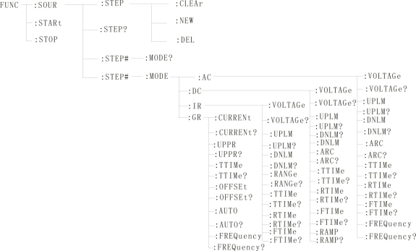
8.4.2 PROG Functional command set
FUNC:STARt When the instrument is in the test interface, start the test.
FUNC:STOP When the instrument is at the test interface, stop the test.
FUNC:SOUR:STEP:CLEAr Clear a new test item within the existing test protocol (ITEM)
FUNC:SOUR:STEP:DEL Within the existing test protocol (ITEM), delete the current test item.
FUNC:SOUR:STEP:NEW Create a new empty test scheme to is used to write a completely new test scheme.
FUNC:SOUR:STEP?:Queries about the current test scheme.

8.4.3 STEP#Functional command set
8.4.3.1 AC SETUP Functional command set
FUNC:SOURce：STEP#:MODE:AC:VOLTage Set / query the voltage of the AC
--form
Set the format： FUNCE：STEP#:MODE:AC:VOLTage<magnitude of voltage >
Query format： FUNCE：STEP#:MODE:AC:VOLTage？
--data<magnitude of voltage >：
data type：floating number Set the format： FUNC ：STEP :<num>: AC ：VOLT <magnitude of voltage >
data area： 0.050-5.000
Data accuracy： 0.001
data unit ： KV
范例：把 STEP1 中 AC 的magnitude of voltage 这样设置为 1000V
Set the command： FUNCE：STEP1:MODE:AC:VOLTage 1.000
Query command： FUNCE：STEP1:MODE:AC:VOLTage？
FUNC:SOURce：STEP#:MODE:AC:UPLM Set / query the upper limit current of the AC
--form
Set the format： FUNCE：STEP#:MODE:AC:UPLM<current value>
Query format： FUNCE：STEP#:MODE:AC:UPLM？
--data<current value>
data type：floating number
data area： 0.001-20.00mA
Data accuracy： 0.001
data unit ： mA
范例：把 STEP1 中 AC 的current value这样设置为 1mA
Set the command： FUNCE：STEP1:MODE:AC:UPLM 1.000
Query command： FUNCE：STEP1:MODE:AC:UPLM？
returned value： 1
FUNC:SOURce：STEP#:MODE:AC:DNLM Set / query the lower limit current of the AC
--form
Set the format： FUNCE：STEP#:MODE:AC:DNLM<current value>
Query format： FUNCE：STEP#:MODE:AC:DNLM？
--data<current value>
data type：floating number
data area： 0.001-20.00mA

Data accuracy： 0.001
data unit ： mA
Example: Set the current value of the AC in the STEP1 this to 1mA
Set the command： FUNCE：STEP1:MODE:AC:UPLM 1.000
Query command： FUNCE：STEP1:MODE:AC:UPLM？
returned value： 1
FUNC:SOURce：STEP#:MODE:AC:ARC Set / query the arc value
--form
Set the format： FUNCE：STEP#:MODE:AC:ARC<Arc value>
Query format： FUNCE：STEP#:MODE:AC:ARC？
--data<Arc value>：
data type：floating number
data area： 0.001-20.00mA
Data accuracy： 0.001
data unit ： mA
Example: Set the current value of the AC in the STEP1 this to 1mA
Set the command： FUNCE：STEP1:MODE:AC:ARC 1.000
Query command： FUNCE：STEP1:MODE:AC:ARC？
returned value： 1
FUNC:SOURce：STEP#:MODE:AC:TTIMe Set up / query the test time for the AC
--form
Set the format： FUNCE：STEP#:MODE:AC:TTIMe<time>
Query format： FUNCE：STEP#:MODE:AC:TTIMe？
--data<time>
data type：integer
data area： 0-999.9
Data accuracy： 0.1
data unit ： S
Example: Set the time value of AC in STEP1 to 1S
Set the command： FUNCE：STEP1:MODE:AC:TTIMe 1
Query command： FUNCE：STEP1:MODE:AC:TTIMe？
returned value： 1
FUNC:SOURce：STEP#:MODE:AC:RTIMe Set / query the rise time of the AC

--form
Set the format： FUNCE：STEP#:MODE:AC:RTIMe<time>
Query format： FUNCE：STEP#:MODE:AC:RTIMe？
--data<time>
data type：integer
data area： 0-999.9
Data accuracy： 0.1
data unit ： S
Example: Set the time value of AC in STEP1 to 1S
Set the command： FUNCE：STEP1:MODE:AC:RTIMe 1
Query command： FUNCE：STEP1:MODE:AC:RTIMe？
returned value： 1
FUNC:SOURce：STEP#:MODE:AC:FTIMe Set / query the drop time of the AC
--form
Set the format： FUNCE：STEP#:MODE:AC:FTIMe<time>
Query format： FUNCE：STEP#:MODE:AC:FTIMe？
--data<Time value>
data type：integer
data area： 0-999.9
Data accuracy： 0.1
data unit ： S
Example: Set the time value of AC in STEP1 to 1S
Set the command： FUNCE：STEP1:MODE:AC:FTIMe 1
Query command： FUNCE：STEP1:MODE:AC:FTIMe？
returned value： 1
FUNC:SOURce：STEP#:MODE:AC:FREQuency Set up / query the test frequency of the AC
--form
Set the format： FUNCE：STEP#:MODE:AC:FREQuency<frequency>
Query format： FUNCE：STEP#:MODE:AC:FREQuency？
--data<frequency值>
data type：integer
data area： 50/60
Data accuracy： 0.1

data unit ： Hz
Example: Set the frequency value of AC in STEP1 to 50Hz
Set the command： FUNCE：STEP1:MODE:AC:FREQuency 50
Query command： FUNCE：STEP1:MODE:AC:FREQuency？
returned value： 50
8.4.3.2 DC SETUP Functional command set
FUNC:SOURce：STEP#:MODE:DC:VOLTage Set / query the voltage of the DC
--form
Set the format： FUNCE：STEP#:MODE:DC:VOLTage<magnitude of voltage >
Query format： FUNCE：STEP#:MODE:DC:VOLTage？
--data<magnitude of voltage >：
data type：floating number
data area： 0.050-6.000
Data accuracy： 0.001
data unit ： KV
Example: Set the magnitude of voltage of DC in STEP1 to 1000V
Set the command： FUNCE：STEP1:MODE:DC:VOLTage 1.000
Query command： FUNCE：STEP1:MODE:DC:VOLTage？
FUNC:SOURce：STEP#:MODE:DC:UPLM Set / query the upper limit current of the DC
--form
Set the format： FUNCE：STEP#:MODE:DC:UPLM<current value>
Query format： FUNCE：STEP#:MODE:DC:UPLM？
--data<current value>
data type：floating number
data area： 0.001-10.00mA
Data accuracy： 0.001
data unit ： mA
Example: Set the current value of DC in STEP1 to 1mA
Set the command： FUNCE：STEP1:MODE:DC:UPLM 1.000
Query command： FUNCE：STEP1:MODE:DC:UPLM？
returned value： 1
FUNC:SOURce：STEP#:MODE:DC:DNLM Set / query the lower limit current of the DW
--form

Set the format： FUNCE：STEP#:MODE:DC:DNLM<current value>
Query format： FUNCE：STEP#:MODE:DC:DNLM？
--data<current value>
data type：floating number
data area： 0.001-10.00mA
Data accuracy： 0.001
data unit ： mA
Example: Set the current value of DC in STEP1 to 1mA
Set the command： FUNCE：STEP1:MODE:DC:UPLM 1.000
Query command： FUNCE：STEP1:MODE:DC:UPLM？
returned value： 1
FUNC:SOURce：STEP#:MODE:DC:ARC Set up / query the Arc value
--form
Set the format： FUNCE：STEP#:MODE:DC:ARC<Arc value>
Query format： FUNCE：STEP#:MODE:DC:ARC？
--data<Arc value>：
data type：floating number
data area： 0.001-10.00mA
Data accuracy： 0.001
data unit ： mA
Example: Set the current value of DC in STEP1 to 1mA
Set the command： FUNCE：STEP1:MODE:DC:ARC 1.000
Query command： FUNCE：STEP1:MODE:DC:ARC？
returned value： 1
FUNC:SOURce：STEP#:MODE:DC:TTIMe Set up / query the test time of the DC
--form
Set the format： FUNCE：STEP#:MODE:DC:TTIMe<时间>
Query format： FUNCE：STEP#:MODE:DC:TTIMe？
--data<Time value>
data type：integer
data area： 0-999.9
Data accuracy： 0.1
data unit ： S

Example: Set the Time value of DC in STEP1 to 1S
Set the command： FUNCE：STEP1:MODE:AC:TTIMe 1
Query command： FUNCE：STEP1:MODE:AC:TTIMe？
returned value： 1
FUNC:SOURce：STEP#:MODE:DC:RTIMe Set / query the rise time of the DC
--form
Set the format： FUNCE：STEP#:MODE:DC:RTIMe<时间>
Query format： FUNCE：STEP#:MODE:DC:RTIMe？
--data<Time value>
data type：integer
data area： 0-999.9
Data accuracy： 0.1
data unit ： S
Example: Set the Time value of DC in STEP1 to 1S
Set the command： FUNCE：STEP1:MODE:DC:RTIMe 1
Query command： FUNCE：STEP1:MODE:DC:RTIMe？
returned value： 1
FUNC:SOURce：STEP#:MODE:AC:FTIMe Set / query the drop time of the DC
--form
Set the format： FUNCE：STEP#:MODE:DC:FTIMe<时间>
Query format： FUNCE：STEP#:MODE:DC:FTIMe？
--data<Time value>
data type：integer
data area： 0-999.9
Data accuracy： 0.1
data unit ： S
Example: Set the Time value of DC in STEP1 to 1S
Set the command： FUNCE：STEP1:MODE:DC:FTIMe 1
Query command： FUNCE：STEP1:MODE:DC:FTIMe？
returned value： 1
FUNC:SOURce：STEP#:MODE:AC:RAMP Set up / query the boost status of the DC
--form
Set the format： FUNCE：STEP#:MODE:DC:RAMP<Boost pressure determination>

Query format： FUNCE：STEP#:MODE:DC:RAMP？
--data<Boost pressure determination>
data type：integer
data area： 0/1(OFF/ON)
Data accuracy：无
data unit ：无
Example: Set the frequency value of DC in STEP1 to 0 (OFF)
Set the command： FUNCE：STEP1:MODE:DC:RAMP 0
Query command： FUNCE：STEP1:MODE:DC:RAMP？
returned value： 0（OFF）
8.4.3.3 IR SETUP Functional command set
FUNC:SOURce：STEP#:MODE:IR:VOLTage Set / query the voltage of the IR
--form
Set the format： FUNCE：STEP#:MODE:IR:VOLTage<magnitude of voltage >
Query format： FUNCE：STEP#:MODE:IR:VOLTage？
--data<magnitude of voltage >：
data type：floating number
data area： 0.050-1.000
Data accuracy： 0.001
data unit ： KV
Example: Set the magnitude of voltage of IR in STEP1 to 1000V
Set the command： FUNCE：STEP1:MODE:IR:VOLTage 1.000
Query command： FUNCE：STEP1:MODE:IR:VOLTage？
returned value： 1
FUNC:SOURce：STEP#:MODE:IR:UPLM Set / query the upper limit of the IR
--form
Set the format： FUNCE：STEP#:MODE:IR:UPLM<resistance value>
Query format： FUNCE：STEP#:MODE:IR:UPLM？
--data<current value>
data type：floating number
data area： 0-1E4(0 为 OFF)MΩ
Data accuracy： 0.1MΩ
data unit ： MΩ

Example: Set the upper resistance limit of IR in STEP1 to 100M Ω
Set the command： FUNCE：STEP1:MODE:IR:UPLM 100
Query command： FUNCE：STEP1:MODE:IR:UPLM？
returned value： 100
FUNC:SOURce：STEP#:MODE:IR:DNLM Set / query the lower limit value of the IR
--form
Set the format： FUNCE：STEP#:MODE:IR:DNLM<resistance value>
Query format： FUNCE：STEP#:MODE:IR:DNLM？
--data<current value>
data type：floating number
data area： 0-1E4 MΩ
Data accuracy： 0.1MΩ
data unit ： 0.1MΩ
Example: Set the resistance value of IR in STEP1 to 10M Ω
Set the command： FUNCE：STEP1:MODE:IR:UPLM 10
Query command： FUNCE：STEP1:MODE:IR:UPLM？
returned value： 10
FUNC:SOURce：STEP#:MODE:IR:RANGe Set / query the resistance range
--form
Set the format： FUNCE：STEP#:MODE:IR:RANGe<Range value>
Query format： FUNCE：STEP#:MODE:IR:RANGe？
--data<A Range value>：
data type：integer
data area： 1、10、100
Data accuracy：无
data unit ： MΩ
Example: Set the resistance range of IR in STEP1 to 100M Ω
Set the command： FUNCE：STEP1:MODE:IR:RANGe 100
Query command： FUNCE：STEP1:MODE:IR:RANGe ？
returned value:100
FUNC:SOURce：STEP#:MODE:IR:TTIMe Set up / query the test time for the IR
--form
Set the format： FUNCE：STEP#:MODE:IR:TTIMe<时间>

Query format： FUNCE：STEP#:MODE:IR:TTIMe？
--data<Time value>
data type：integer
data area： 0-999.9
Data accuracy： 0.1
data unit ： S
Example: Set the Time value of IR in STEP1 to 1S
Set the command： FUNCE：STEP1:MODE:IR:TTIMe 1
Query command： FUNCE：STEP1:MODE:IR:TTIMe？
returned value： 1
FUNC:SOURce：STEP#:MODE:IR:RTIMe Set / query the rise time of the IR
--form
Set the format： FUNCE：STEP#:MODE:IR:RTIMe<时间>
Query format： FUNCE：STEP#:MODE:IR:RTIMe？
--data<Time value>
data type：integer
data area： 0-999.9
Data accuracy： 0.1
data unit ： S
Example: Set the Time value of IR in STEP1 to 1S
Set the command： FUNCE：STEP#:MODE:IR:RTIMe 1
Query command： FUNCE：STEP#:MODE:IR:RTIMe？
returned value： 1
FUNC:SOURce：STEP#:MODE:IR:FTIMe Set / query the drop time of the IR
--form
Set the format： FUNCE：STEP#:MODE:IR:FTIMe<时间>
Query format： FUNCE：STEP#:MODE:IR:FTIMe？
--data<Time value>
data type：integer
data area： 0-999.9
Data accuracy： 0.1
data unit ： S
Example: Set the Time value of IR in STEP1 to 1S

Set the command： FUNCE：STEP1:MODE:IR:FTIMe 1
Query command： FUNCE：STEP1:MODE:IR:FTIMe？
returned value： 1

8.4.3.4 GR SETUP Functional command set

FUNC:SOURce：STEP#:MODE:GR:CURRent Set the query current
--form
Set the format： FUNC:SOUR:STEP#:MODE:GR:CRREnt
Query format： FUNC:SOUR:STEP#:MODE:GR:CRREnt?

--data<sn>
data type：integer
data area： 1-20
Data accuracy： 1
--data<current value>：
data type：floating number
data area： 3-30
Data accuracy： 0.1
data unit ： A
example: Set the CURREnt value to: 10.00A
Set the format： FUNC:SOUR:STEP#:MODE:GR:CRREnt ：<10.00>
Query format： FUNC:SOUR:STEP#:MODE:GR:CRREnt ：?
近回值： 10.00

FUNC:SOURce：STEP# ：MODER:GR:UPPR Set the upper limit of the query resistance
--form
Set the format： FUNC:SOURce：STEP# ：MODER:GR:UPPR<resistance value>
Query format： FUNC:SOURce：STEP# ：MODER:GR :UPPR?
--data<resistance value>
data type：floating number
data area： 0-510mΩ
Data accuracy： 0.1

data unit mΩ:
example: Set the upper resistance limit to: 100.0mΩ
Set the format FUNC:SOURce：STEP# ：MODER:GR： UPPR：100.00
Query format： FUNC:SOURce：STEP# ：MODER:GR :UPPR？
Near back value： 100.0
FUNC:SOURce：STEP# ：MODER:GR:TIMe Set the query current test time
--form
Set the format： FUNC:SOURce：STEP# ：MODER:GR：TIMe<Time value>
Query format： FUNC:SOURce：STEP# ：MODER:GR ：TIMe?
--data<Time value>
data type：floating number
data area： 0-999.9（Where 0 is a continuous test)
Data accuracy： 0.1
data unit ： S
example: Set the test time to: 1S
Set the format： FUNC:SOURce：STEP# ：MODER:GR :TIMe：1
Query format： FUNC:SOURce：STEP# ：MODER:GR :TIMe?
Near back value： 1

FUNC:SOURce：STE#：MODER:GR：OFFSet Set the query return to zero compensation value
--form
Set the format： FUNC:SOURce：STEP#：MODER:GR：OFFSet<building-out >
Query format： FUNC:SOURce：STEP#：MODER:GR:OFFSet?
--data<building-out 值>
data type：floating number
data area： 0-100
Data accuracy： 0.1
data unit ： mΩ

example: Set the OFFSET value to: 100m Ω

Set the format： FUNC:SOURce：STEP#：MODER:GR:OFFSet 100
Query format： FUNC:SOURce：STEP#：MODER:GR:OFFSet？
近回值： 100
FUNC:SOURce：STEP# ：MODER:GR:FREQuency Set up the test frequency for the query current
--form
Set the format： FUNC:SOURce：STEP# ：MODER:GR:FREQuency<frequency>
Query format： FUNC:SOURce：STEP# ：MODER:GR:FREQuency?
--data<frequency>
data type：character
data area： 50/60
Data accuracy： 0.1
data unit ： Hz
example: Set the test frequency to: 50Hz
Set the format： FUNC:SOURce：STEP# ：MODER:GR:FREQuency 50
Query format： FUNC:SOURce：STEP# ：MODER:GR:FREQuency？
近回值： 50
返回 10.0
8.4.3.5 LC SETUP Functional command set
FUNCtion:SOURce:STEP#:MODE:LC:CURRUPLM?
FUNCtion:SOURce:STEP#:MODE:LC:CURRUPLM
Set / query the upper current limit in LC mode (mA)
--data < data值 >
data type： float
data area： 0.001-20.000
Example: Example: Query / set the upper limit current of the LC mode in STEP 1 to 20 mA

FUNCtion:SOURce:STEP 1 :MODE:LC:CURRUPLM?
FUNCtion:SOURce:STEP 1 :MODE:LC:CURRUPLM 20
返回 20.0

FUNCtion:SOURce:STEP#:MODE:LC:CURRDNLM?
FUNCtion:SOURce:STEP#:MODE:LC:CURRDNLM

Set / query the lower current limit in LC mode (mA)
--data <data值 >
data type： float
data area： 0.000-19.999
Example: Example: Query / set the lower limit current of LC mode in STEP1 to 1mA

FUNCtion:SOURce:STEP 1 :MODE:LC:CURRDNLM?
FUNCtion:SOURce:STEP 1 :MODE:LC:CURRDNLM 1.0
返回 1.0

FUNCtion:SOURce:STEP#:MODE:LC:VOLTUPLM?
FUNCtion:SOURce:STEP#:MODE:LC:VOLTUPLM
Set / query the upper voltage limit in LC mode
--data < data值 >
data type： float
data area： 0.1-300.0
Example: Query / set the upper voltage limit of the LC mode in STEP 1 to 300V
FUNCtion:SOURce:STEP 1 :MODE:LC:VOLTUPLM?
FUNCtion:SOURce:STEP 1 :MODE:LC:VOLTUPLM 300.0
返回 300.0

FUNCtion:SOURce:STEP#:MODE:LC:VOLTDNLM?
FUNCtion:SOURce:STEP#:MODE:LC:VOLTDNLM
Set / query the lower voltage limit in LC mode
--data < data值 >
data type： float
data area： 0.0-299.9

Example: Query / set the lower voltage limit of the LC mode in STEP 1 to 100VFUNCtion:SOURce:STEP 1 :MODE:LC:VOLTDNLM?
FUNCtion:SOURce:STEP 1 :MODE:LC:VOLTDNLM 100.0
返回 100.0

FUNCtion:SOURce:STEP#:MODE:LC:TTIMe?
FUNCtion:SOURce:STEP#:MODE:LC:TTIMe
Set up / query the test time in LC mode
--data < data值 >
data type： float
data area： 1.0-999.9
Example: Query / set the test time of the LC mode in STEP 1 to 10s

FUNCtion:SOURce:STEP 1 :MODE:LC:TTIMe?
FUNCtion:SOURce:STEP 1 :MODE:LC:TTIMe 10.0
返回 10.0
FUNCtion:SOURce:STEP#:MODE:LC:JUDGEMODE?
FUNCtion:SOURce:STEP#:MODE:LC:JUDGEMODE
Set / query the determination mode in LC mode
--data < data值 >
data type： byte
data area： 01
Example: Query / set that the determination mode of the LC mode in STEP 1 is Judge_End

FUNCtion:SOURce:STEP 1 :MODE:LC:JUDGEMODE?
FUNCtion:SOURce:STEP 1 :MODE:LC:JUDGEMODE 0
返回 0

FUNCtion:SOURce:STEP#:MODE:LC:TESTMODE?
FUNCtion:SOURce:STEP#:MODE:LC:TESTMODE
Set up / query the test mode in the LC mode
--data < data值 >
data type： byte
data area： 01
Example: Query / set the LC mode in STEP 1 as COLD
FUNCtion:SOURce:STEP1 :MODE:LC:TESTMODE?
FUNCtion:SOURce:STEP1 :MODE:LC:TESTMODE 0
返回 0

FUNCtion:SOURce:STEP#:MODE:LC:MDNET?
FUNCtion:SOURce:STEP#:MODE:LC:MDNET
Set up / query the MD network in LC mode
--data < data值 >
data type： byte
data area： 0 1 2 3 4 5 6 7 (分别对应 MD_A MD_B MD_B1 MD_C MD_E MD_F MD_G)
Example: Query / set the LC in STEP1, the MD channel of the mode is MD_A

FUNCtion:SOURce:STEP
FUNCtion:SOURce:STEP
返回 0

1 :MODE:LC:MDNET?
1 :MODE:LC:MDNET

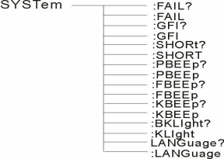
8.4.4 SYSTEM Functional command set

Command tree

SYSTem ：PBEE/FBEE/KBEE
Set / query test pass / fail / key buzzer status
-- form
Set the format： SYST ：PBEE<ON/OFF>OR<1/0>
Query format： SYST ：PBEE ？
-- data：<ON/OFF>
data type：character
data area： 0（OFF）,1（ON）
example: Set the BEEP to 1
Set the command： SYST:BEEP 1
-- 返回信息
Query command： SYST:BEEP?，returned value： Buzzer states, such as the 1
SYSTem ：REset Restore all of the default states
-- form：
Set the format： SYST ：RES
8.4.5 MMEM Subsystem, and the command set
MMEM：SAVE Save the current file to the file number
-- form：
Set the format： MMEM：SAVE<file name>
-- data<file name>
data type：character 串

MMEM LOAD Export the file specified by the file number to the current one
-- form：
Set the format： MMEM：LOAD<file name>
-- data<file name>
data type：character 串

8.4.6 FETCH Subsystem, and the command set
FETCH To obtain the measurements of the instrument
--form：
Set the format： FETCh：AUTO
Query format： FETCh:AUTO?
--data<ON/OFF>or <1/0>
data type：character
data area： 0（OFF）， 1（ON）
--example: Return the test data to ON automatically
命令： FETCh：AUTO ON 或者： FETCh：AUTO 1

--return information
Query command： FETCh？，Return the result of the current measurement of the instrument.
Command syntax： FETCh？
After receiving this command, the instrument will automatically issue the test results until the test ends.
返回form：
Step: Test item: Test current (A) Test resistance (m Ω) sorting results
1、The separator between steps and test items, test items and data is(:)
2、The separator between the test data is（，）The separator between the different units of data is(;)
3、The separator between the steps is for（： +blank），data结束符 uy ly（0X0A）
Note: 1. All data are integer or floating numberform, ASCII character string.
2、data unit 默认与 FCUN Set the instruction set the same.
The test results are all listed below:
STEP1 : I :30A，Test resistance 100m Ω, result PASS.
返回dataform：
STEP1 I :30,100,PASS；（SPACE）

8.4.7 Other control command sets
*IDN Query the instrument model and version information
The query is returned： <manufacturer>,<model>,<firmware><NL^END>
这里： <manufacturer> 给出制造商名称（即 ReK）

<model> | 给出机器型号（如 RK9961）
<firmware> | 给出软件版本号（如 Version 1.0.0）
例如： “*IDN? ”

--返回信息
Query command： FETCh？，Return the result of the current measurement of the instrument.
Command syntax： FETCh？
After receiving this command, the instrument will automatically issue the test results until the test ends.
return form:
Step: Test item: Test current (A) Test resistance (m Ω) sorting results
1、The separator between step and test item, test item and data is(:)
2、The separator between the test data is（，）The separator between the different units of data is(;)
Note: 1. All data are integer or floating numberform, ASCII character string.
2、data unit 默认与 FCUN Set the instruction set the same.
The test results are all listed below:
STEP1 : I :30A，测试电阻 100mΩ,结果 PASS.
返回dataform：
STEP1 I :30,100,PASS；（SPACE）

Chapter 9 Maintenance Guide
9.1 Daily maintenance
9.1.1 The operating environment of the tester shall be well ventilated, dry, free of dust and electromagnetic interference.
9.1.2 If the tester is not used for a long time, it shall be energized regularly, usually once a month, and the power-on time shall not be less than 30 minutes.
9.1.3 After a long time of work of the tester, for about 8 hours, the power should be turned off for more than 10 minutes to maintain the good working condition of the tester. 9.1.4 Poor contact or short-circuit phenomenon may occur after long-term use of the tester, so it should be repaired regularly.

9.2 简单故障处理

fault phenomenon | processing method
After the boot | Please check whether the power supply is normal and the fuse is fused, please Change the fuse
After starting, the test light is not on but has a current output | The test light is bad
After starting, the test lamp is not on with no current output | The start button is not well touched
After startup, no current or resistance is shown | Please check whether the test line is open, the object is not touched or tested The object has been cleared
After the test fails, the unqualified light is not on | Unqualified lights are bad

If any fault cannot be eliminated in time, please contact our company or dealer as soon as possible, we will provide service for you in time.
9.3 Description of the instrument system software upgrade procedure
9.3.1 Connect the USB interface of the back panel of the instrument to the computer, the power resource manager displays the U disk, copy the upgrade file to the instrument target disk, and restart the instrument to complete the system software upgrade. If you encounter technical problems, please contact us in time.
9.3.2 Press and hold down the STOP + START key to restart the power supply, clear the data errors caused by the version changes, and restore the setting data as the default factory setting.

Chapter 10 Warranty and accessories
10.1 Guarantee
The user of the instrument from the company, from the shipping date of the company, from the user of the distribution department buyer, from the shipping date of the distribution unit, the host warranty for 1 year. During the warranty, the warranty card should be presented to the instrument, and the company shall provide lifetime maintenance service for all outgoing instruments. During the warranty period, If the instrument is damaged due to improper user operation, the maintenance cost shall be borne by the user.
10.2 accessory

1、power line | 1 条
2、RK1156 Power cord assembly(RK00028) | 1 条
3、RS232 cable | 1 条
4、RS232 turn USB drive disc | 1 张
5、RS232turnUSB | 1 条
6、USB transfer line | 1 条
7、Manual / modbus test tool (U disk) | 1 个
8、certificate 1 张
9、calibration certificate 1 份
10、private wire 3 条
11、High pressure rod 1 条

