OVERVIEW 1
Ⅱ、 Panel Description 2
Ⅲ、USER GUIDE 3
Ⅳ、ACCESSORIES AND RELATE DOCUMENTS 5
Ⅴ、Others 5

OVERVIEW
The instrument suitable for testing of any type, size, materials, impedance
of the speakers, headphones, Dynamic receiver of the "+", "-" polarity for
automatic fast-discrimination purposes. The instrument is easy to operate,
must not misjudge, automatic LED alarm indicator. Instrument is automatically and quickly using the latest pulse measurement method.

ⅠMain technical characteristics
1．1The width of Pulse:0.4（±0.2ms）
1．2The scope of pulse:≥10vp-p（when the switch is put onto “H”
When the range switch placed onto “H”: Adapt to general speaker
When the range switch placed onto “M”: Adapt to dome speaker
When the range switch placed onto “L”: Adapt to MYLAR
Speaker or the dynamic receiver.
1．3 Sensing microphone: condenser microphone for audio.
1．4 Buzzer: You can switch "+" or "-" Alarm.
1．5 Test Sensitivity: ≥ 25cm to the speaker.
1．6 Discriminant speed: 0.2 seconds.

Ⅱ、 Panel Description
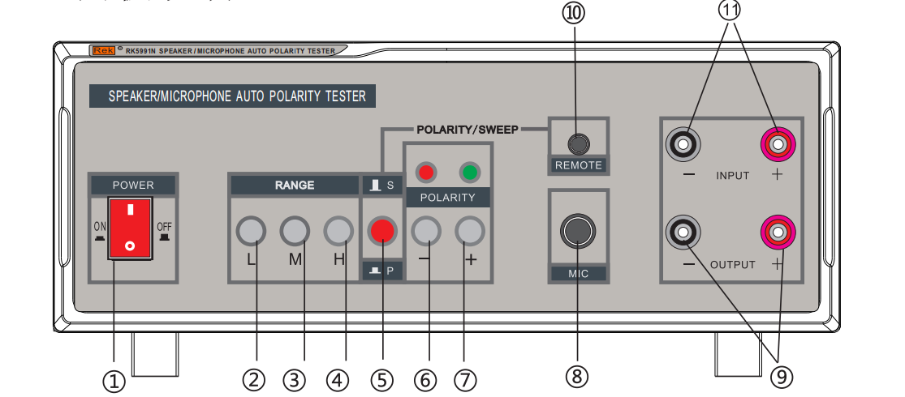
1．（POWER）switch，press down it，the red Indicator will bright.
2． “L” Options button
3．“ M” Options button
4． “H” Options button
5．P: polarity button. S: sweep button.
6．7．（POLARTTY）“-”、“+”The switch with the buzzer , "-" polarity
indicator, "+" polarity indicator.
8．（MIC）Sensor microphone input
9．（OUTPUT）Output port，contact with the tested speaker or thedynamic receiver.
10．（REMOTE）Please contact Remote control here.
11．（INPUT） When this machine is contact with the audio sweeping
generator, the output of the generator must be contacted here.

Ⅲ、USER GUIDE
3．1 Put on the power switch, the indicator light will bright.
3．2 Select different button in different accordance. There have three
switches: high, low, middle, changing the speaker output level tester.
3.2.1 High: Adapt to General loudspeakers.
3.2.2 Low: Adapt to MYLAR speaker /Dynamic receiver.
3.2.3 Middle: Adapt to the spheroid speaker.
3. 3 P: polarity, this instrument dedicated to test polarity. S: sweep. The
audio sweeping generator must contact with the output port. If the remote
of the switch of the microphone is turn off, the sound output into the
speaker is the sweep signal. You must press down the switch to turn on
the remote to test the polarity.
3．4 Sensing microphone: when testing, Insert the
plug into the “MIC” and turn on the microphone.
3．5 Please connect the instruments and parts according to the figure
below, and then take the tested speakers close to the microphone sensor.
Green (+) light-emitting diode, it means output line at the
green speaker terminal polarity is "+."Red (-) light-emitting diode, it means output line at the red speaker terminal polarity is "-."
3．6 Buzzer selector switch placed in the "+”, then the green light
and the buzzer alarm. Switch placed in the "-”, then the red light
and the buzzer alarm.
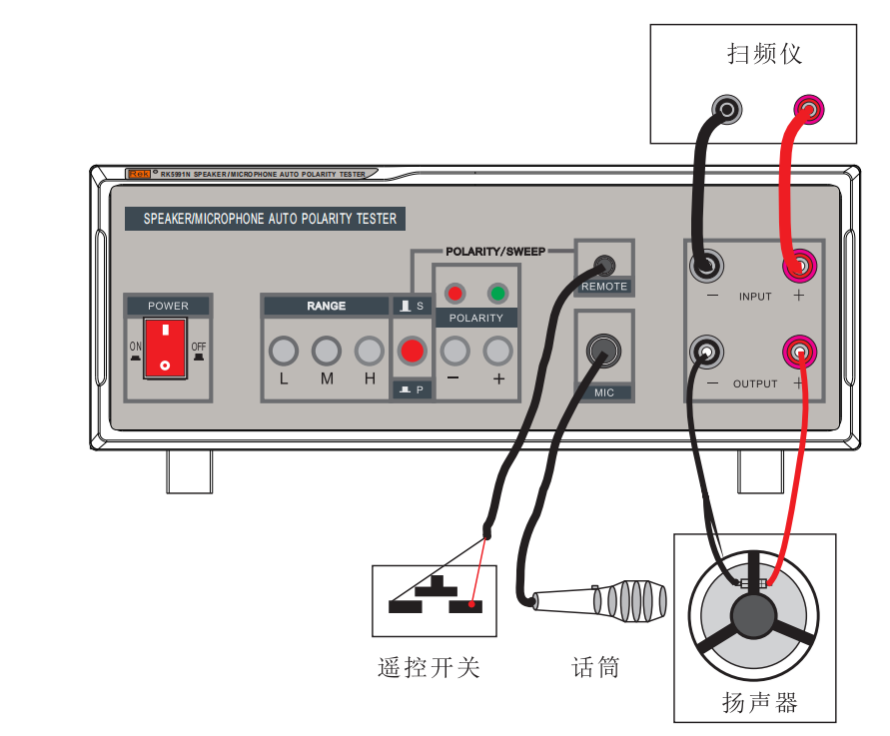

Ⅳ、ACCESSORIES AND RELATE DOCUMENTS
4．1 Manual 1 pcs
4．2 Sensing Microphone +adapter 1 pcs
4．3Test line 1 pcs
4．4 Remote Port 1 pcs
4．5 Product certificate 1 pcs
- 6 Power line 1 pcs

Ⅴ、Others
5．1 Please read the manual carefully first before using.
5．2 The warranty period of Our products is one year. If there have
some quality problems, please contact the company's quality control
section. If the quality problem was caused by the damage of use or
other reasons, we will charge maintenance costs.
5．3 Please contact with us if you have Special needs.
5．4 The company's goal is :Credibility first, customers first, quality
first!

Shenzhen Meiruike Electronic Technology Co.,Ltd
Floor 5 ,Block 1 ,Qingchangtai Industrial Zone ,No 365 ,Silian Road ,Henggang
Town ,Longgang District ,Shenzhen

