SHENZHEN MEIRUIKE ELECTRONIC TECHNOLOGY C0.,LTD

RK9960 Programmable Auto Safety Tester

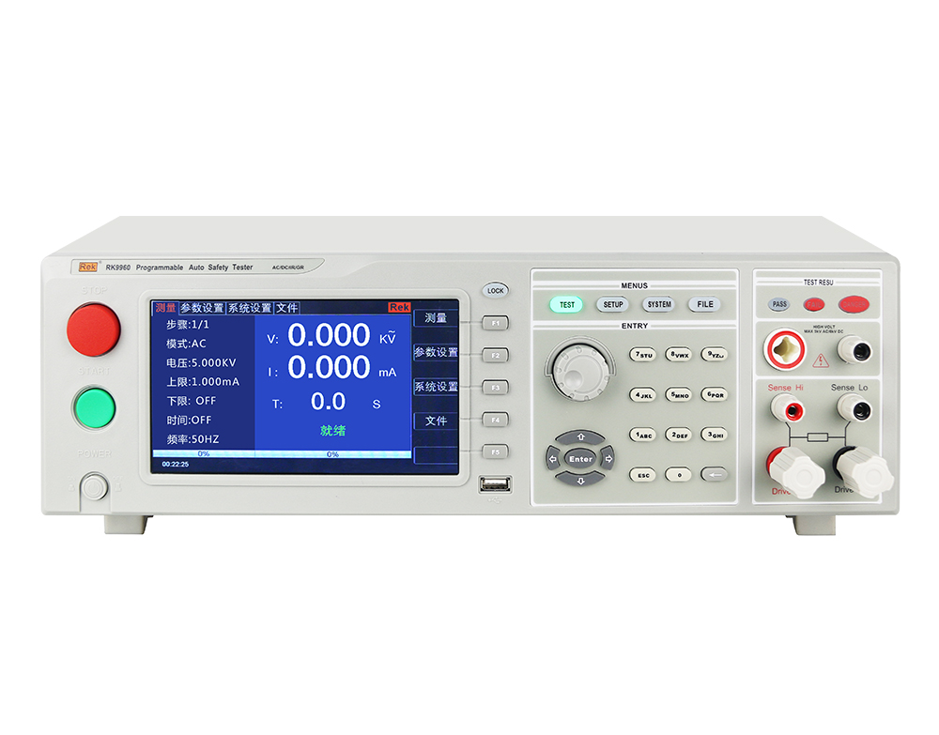
User manual V1.0

Version history:

Due to the possible errors or omissions in the manual, improvement and perfection of instrument functions, updating of technology and upgrading of software, the manual will be adjusted and revised accordingly and continuously improved for the convenience of use.

Please pay attention to the software version and manual version.

August 2020.........................................Vision 1

Statement: the company may improve an

d improve the performance, function, software, structure, appearance, accessories, packaging and instruction manual of the product. Any modification is subject to no further notice!

If in doubt, please contact us.
Safety warning:
Instrument grounding

This instrument is a class I safety instrument. When connecting the power supply, please make sure that the power socket contains grounding wire.
If not grounded, static electricity or induced electricity on the chassis may cause personal injury!

Electric shock hazard

Avoid electric shock during operation, test and instrument maintenance. Non professionals are not allowed to open the chassis without permission. If professionals need to replace the fuse or carry out other maintenance, they must first pull out the power plug and carry out it with others.

Even if the power plug has been removed, there may still be dangerous voltage on the capacitor, which should be operated after discharging.

Electric shock damage

In the process of testing, any improper removal or addition of the tested parts will cause abnormal damage to people, property or instruments!!!

If the instrument is damaged due to abnormal operation, the maintenance cost shall be borne by the customer.

Input power

Please use the power supply according to the power parameters of the instrument. The power input that does not meet the specifications may damage the instrument.

Keep away from explosive gas environment

Electronic instruments can not be used in flammable and explosive gas environment or environment containing corrosive gas or smoke, because it may bring danger.

Other safety issues

Please do not apply any voltage source or current source to the test terminal of this instrument.

Tips

An important supplement or reminder to the content.

Instructions for use:

*Please read and understand the instructions carefully before operating the tester. After reading, please put the manual near the operator for reading when necessary. When carrying the tester from one workplace to another, please carry the instructions with the instrument to avoid losing them.

*With the improvement of the function of the instrument and the upgrade of the software, the user manual will also be improved and upgraded. Please note the version of the tester software and instruction manual.

目录
Chapter 1 Safety Rules 6
1.1 General Provisions 6
1.2 Maintenance 6
1.3 Test environment 7
1.4 Operator Regulations 8
1.5 Safety grounding regulations 9
1.6 Regulations on fuse replacement 9
1.7 Test safety regulations 9
1.8 Test exception provisions 9
1.9 Safety points 10
Chapter 2 Overview and technical indicators 10
2.1 Product Overview 10
2.2 Function introduction 12
2.3 Technical indicators 14
Chapter 3 Front panel description 15
3.1 Front panel structure 15
3.2 Rear panel structure 18
3.4 Main menu buttons and corresponding displayed pages 20
Chapter 4 Operating Instructions 22
4.1 Boot instructions and boot screen 22
4.2 Operation steps 23
Chapter 5 handler interface and singal interface 25
5.1 Structure and application of handler interface and singal interface circuit 25
Chapter 6 Parameter setting 27
6.1 Instrument power on self test 27
6.2 Parameter setting mode 28
6.3 System setting mode 44
6.4 Description of document parameters 46
Chapter 7 Remote control 46
7.1 RS232C interface description 46
7.2 RS485 / 232C interface description 47
7.3 USBTMC remote control system 48
Chapter 8 SCPI serial port instruction reference 49
8.1 Brief description of instruction format: 49
8.2 SCPI instruction set 49
8.3 DISPLAY subsystem command set 50
8.4 FUNCtion subsystem command set 50
SYSTem ：PBEE/FBEE/KBEE 68
Chapter 9 Maintenance guide 71
9.1 Daily maintenance 71
9.2 Simple troubleshooting 72
9.3 Software upgrade steps of instrument system 72

Chapter 1 Safety Rules
The contents of the manual are subject to change without prior notice

Please contact our company directly if there is anything unknown in the manual
Regulations and matters needing attention before testing!

Warning: to prevent failure or damage to the tester, please use the tester within the specified voltage range.

General Provisions
Before using the tester, please read the manual carefully to understand the operation procedures and relevant safety signs to ensure safety.

Before turning on the input power switch, please select the correct input voltage specification.

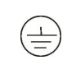 Chassis earthing symbol
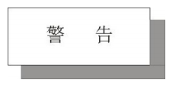Warning: it should be noted that the operation, application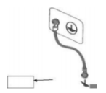 or condition carried out is highly dangerous, which may lead to personal injury or death.

The current generated by the tester is enough to cause casualties. In order to prevent accidental injury or death, when moving and using the tester, please observe clearly before operating.

Maintenance
1.2.1 in order to prevent electric shock, non professionals should not open the cover of the tester. All parts inside the tester should not be replaced without permission. If the tester is abnormal, please ask our company or the designated dealer for help.

1.2.2 regular maintenance

The tester, power line, test line and related accessories should be carefully inspected and calibrated at least once a year to ensure the safety of operators and the accuracy of the tester.

1.2.3 user modification

The user is not allowed to change the circuit or parts of the tester by himself, otherwise the warranty of our company will be invalid and we will not be responsible for the consequences.

1.3 Test environment

1.3.1 Working position

When operating the tester, it must be ensured that the tester is placed in a place that ordinary personnel cannot touch at will. If it cannot be done because of the arrangement of the production line, the test area must be isolated from other facilities and specially marked with "test work area".

1.3.2 Input power

The tester uses single-phase power supply of 220 V / 110 V and 50 Hz / 60 Hz. Before turning on the power switch, please ensure whether the power supply voltage meets the requirements.

The test area power supply must have a separate switch, installed at the entrance of the test area, to ensure that all personnel can identify. In case of emergency, turn off the power immediately.
In order to prevent the tester from failure, please use it within the specified voltage range.

1.3.3 workplace

Use non-conductive material as much as possible. The test site must be kept neat and clean at all times, and no disorder is allowed. Please put the unused tester and test line in a fixed position, so that all personnel can immediately distinguish the tested object, the object to be tested and the object to be tested.
The air in and around the test area shall not contain combustible gas, and the tester shall not be used beside combustible materials.

1.4 Operator Regulations

1.4.1 Operator Qualification
The output current of the tester is enough to cause personal injury or death in case of electric shock due to wrong operation, so it must be used and operated by trained and qualified personnel.

1.4.2 Safety rules
Operators must give education and training at any time to make them understand the importance of various operation rules, and operate the tester according to the safety rules, so as to ensure the safety of the tester.
In order to prevent the occurrence of electric shock accidents, please wear insulating gloves before using the tester.

1.4.3 Clothing regulations
Operators are not allowed to wear metal ornamented clothes or metal hand ornaments and watches. These metal ornaments are easy to cause accidental electric shock.
When you get an electric shock, the consequences will be even more serious.

1.4.4 Medical regulations

The tester must not be operated by people with heart disease or wearing a heart rate regulator.
Incorrect grounding or ungrounded may lead to electric shock accident.

1.5 Safety grounding regulations
The tester must be well grounded, and the ground wire must be well grounded before the test to ensure the safety of the operator. If the ground connection on the power plug is not reliable, an additional protective ground terminal is provided on the back panel of the tester to connect to the safe ground.
Incorrect grounding or ungrounded may lead to electric shock accident.

1.6 Regulations on fuse replacement
Please turn off the input power switch and disconnect the power plug before replacing the fuse,the Standard Fuse (100v-120v 47hz-63hz 3.15a; 200v-240v 47hz-63hz 5a) should be replaced.To avoid electric shock, be sure to replace the fuse after disconnecting the power cord.

1.7 Test safety regulations
After connecting the test line to the object to be tested, the connection shall be reliable. The operator must make sure that the switch and remote control switch can be operated completely independently and can not be controlled by other personnel. When the remote control switch is not in use, it should be placed in a fixed position and can not be placed at will.

Never use a tester on a live circuit board or equipment! Do not touch the test object or the object connected with the test object during the test!

1.8 Test exception provisions

Under some specific conditions, the tester will not respond to the reset key, the test time value will not move, and the display will be black screen, which is very dangerous. When these situations occur, please be sure to turn off the power switch and disconnect the power plug, do not use, please contact our company.
When the test is abnormal, turn off the power switch immediately and unplug the power plug!

1.9 Safety points

■ Unqualified operators and irrelevant personnel should stay away from the test area.

■ The test area must be kept in a safe and orderly state at all times.

■ During the test, it is not allowed to touch the test object or any object connected with the tested object.

■ In case of any problem, please turn off the output and input power immediately.

Chapter 2 Overview and technical indicators

2.1 Product Overview
Thank you for purchasing and using our products. Before using this instrument, please confirm it according to the "accessories" in the last chapter of this manual.
If there is any discrepancy, please contact us as soon as possible to protect your rights and interests.
2.1.1 The programmable automatic safety tester is a 7-inch TFT LCD display. The sine wave voltage required for AC withstand voltage test and the sine wave current required for grounding test are driven by DDS + linear power amplifier. The output waveform is pure and the distortion is small. The tester adopts high-speed MCU and large-scale digital circuit design, and its output voltage size, frequency and voltage rise and fall are completely controlled by MCU; it can display the breakdown current value and voltage value in real time; it makes its setting and operation very simple, and provides PLC remote control interface, RS232C, RS485, USB and other interfaces, which is convenient for users to quickly combine into a comprehensive test system.

2.1.2 The tester has the functions of unqualified identification, sound and light alarm and automatic control of test time, which can meet the needs of production line or quality inspection.

2.1.3 The tester can be used for household appliances, electronic instruments, electronic equipment, electric tools, electric heating appliances and other products.

2.1.4 Service conditions

Power supply voltage: 110/V220V（±10%）

Power frequency: 50 Hz / 60 Hz (± 5%)

Power consumption: RK9960 ＜350VA；RK9960A ＜450VA

2.1.5 ambient temperature and humidity

Normal working temperature: 0 ℃ - 40 ℃, humidity: < 90% RH
Measuring environment temperature: 20 ℃± 8 ℃, humidity: < 80% RH
Transportation environment temperature: 0 ℃ - 55 ℃, humidity: ≤ 93% RH

2.1.6 preheating

Preheating time after startup: ≥ 30 minutes

2.1.7 insulation resistance

Under metering working conditions, the insulation resistance between the power terminal and the shell shall not be less than 50m Ω.

Under the condition of hot and humid transportation, the insulation resistance between the power terminal and the shell shall not be less than 2m Ω.

2.1.8 insulation strength

Under the metering working conditions, the power supply terminal and the shell can withstand the rated voltage of 1.5kV and the frequency of 50 Hz AC power supply for 1 minute without breakdown and flashover.

2.1.9 Electromagnetic compatibility and compliance standards

The transient sensitivity of the power supply is GB6833.4. Conduction sensitivity is GB6833.6. Radiation interference is required according to GB6833.10.

Standard for household electrical appliances (IEC60335, GB4706.1-2005) and luminaire standard
(IEC60598-1-1999,GB7000.1-2007),information standard(GB8898-2011, GB12113，GB4943.1-2011, IEC60065, IEC60590) and so on.

2.2 Function introduction

2.2.1 automatic adjustment of output voltage (current) the output voltage of withstand voltage and insulation test and the output current of grounding resistance test of this series of testers are all controlled by negative feedback circuit. During the test, the tester can automatically adjust to the voltage value (current value) set by the user.

2.2.2 for automatic boost, the user can set the speed of voltage rise according to the time. For example, if the rated test voltage is 1000V and the tester needs to rise 50V per second, the voltage rise time can be set as 20s. If the tester needs to rise 200V per second, the voltage rise time can be set as 5S. In the process of voltage rise, if the test current is greater than the upper limit of the set current, the instrument will automatically cut off the output, give an audible and visual alarm, and keep the current value showing the current voltage value on the display screen. This function is often used to test or analyze the voltage breakdown point of the tested object, and can also be used to test the withstand voltage of capacitive tested object. This function can not be achieved by the traditional withstand voltage test device.

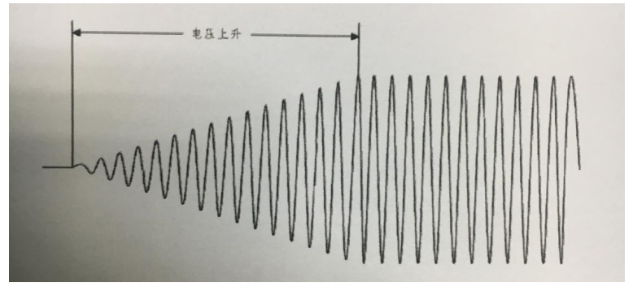
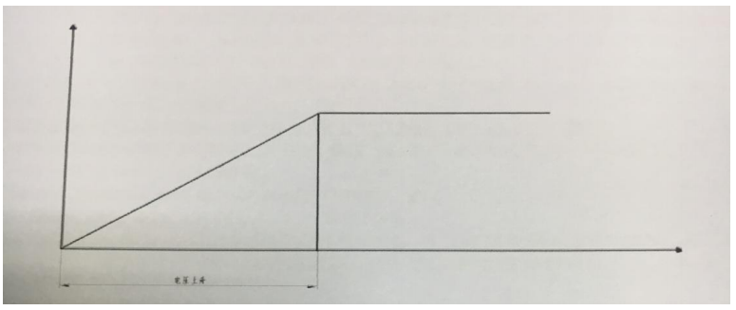
2.2.3 automatic Depressurization

The user can set the speed of voltage drop according to the time. For example, if the rated test voltage is 1000V and the tester drops 50V per second, the voltage drop time can be set as 20s. If the tester drops 200V per second, the voltage drop time can be set as 5S. In the process of voltage drop, if the test current is greater than the upper limit of the set current, the instrument will automatically cut off the output, give an audible and visual alarm, and keep the current value showing the current voltage value on the display screen.
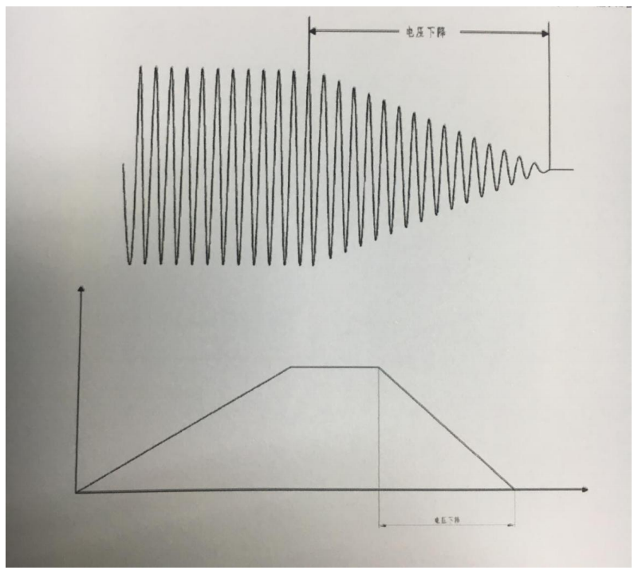

2.3 Technical indicators
Model |  | RK9960 | RK9960A
Withstand Voltage Test | Output Voltage（KV） | AC:0.050-5.000 DC:0.050-6.000
 | Test Accuracy | ± (2.0% Setting + 2V)
 | Output Accuracy | ± (2.0% Setting + 5V)No Load
 | Test Current（MA） | AC:0.001mA-20mA DC:0.1uA-10mA | AC:0.001mA-10mA DC:0.1uA-5mA
 | Test Accuracy | ± (2.0% Reading + 5 Words)
Insulation Test | Output Voltage（KV） | DC:0.100-1.000
 | Test Accuracy | ± (2.0% Setting + 2V)
 | Test Resistance | 0.1MΩ-10GΩ
 | Test Accuracy | 0.1MΩ-999MΩ ±10%
 |  | 1.0MΩ-10GΩ ±20%
 | Discharge Function | Automatic Discharge After Test
Grounding Resistance | Output Current | AC 3-30A
 | Current Accuracy | ±（2.0%Setting+0.02A）
 | Resistance Test Range | 0-510mΩ, When The Output Current Is 3-10A; 0-120mΩ, When The Output Current Is 10-30A;
 | Resistance Accuracy | ± (2.0% Reading Value + 1m Ω)
ARC Detector | Current Measurement Range | 1mA-20mA
Test Time |  | 0.1S-999.9S
Output Frequency |  | 50Hz/60Hz
Input Characteristics |  | 115V/230V±10% 50Hz/60Hz
Test Alarm |  | Buzzer, LCD, Fail Indicator
Keyboard Lock |  | Independent Keyboard Lock Key
Screen Size |  | 7-Inch TFT LCD
Communication Interface |  | HANDLER、RS232、RS485、USBDRV(Computer Interface)、USBHOST(U Disk Interface)
Voltage Rise Time |  | 0.1S-999.9S
Test Time Setting（AC/DC） |  | 0.2S-999.9S
Voltage Drop Time |  | 0.1S-999.9S
Waiting Time |  | 0.2S-999.9S
Storage |  | 16M Flash, Each File Can Store 50 Test Steps
Dimensions（W×H×D） |  | 440mm×135mm×485mm
Weight |  | 23KG | 21KG
Standard Accessories |  | High Voltage Test Line, Grounding Wire, Grounding Resistance Test Line, Power Line
Optional Accessories |  | PC Software (CD), RS-232C Serial Communication Data Line, RS485 Serial Communication Data Line

Chapter 3 Front panel description

3.1 Front panel structure
3.1.1 schematic diagram of front panel
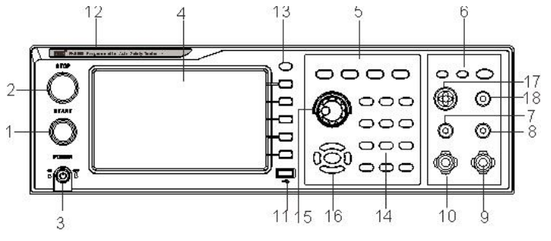

3.1.2 front panel description

1. start key (START)

The green instantaneous contact switch functions as: starting switch for testing voltage output.

2. reset key (STOP)

Red instantaneous contact switch, its function is: in the setting mode, as a switch to leave the setting mode. When testing, it can be used as a switch to interrupt the test.

At the end of the test, it is used as a switch to exit the test and enter the next state to be tested.

3. power switch (POWER)

Working power input of tester

4. LCD screen

Display various setting information and test data.

5. Functional area

Operation area of various settings

6. Test result indication area

When the tester has output, the indicator light will be on, indicating that "there is output, under test", indicating that the test has passed and failed.

7. voltage detection end (SENSE H)

Detect the voltage on the grounding resistance of the tested part

8. voltage detection end (SENSE L)

Detect the voltage on the grounding resistance of the tested part

9. current output terminal (CURRENT H)

Special output terminals, which can withstand high currents within 30A, are used as current outputs of the measured objects. As the loop test end of the tested part.

10. current loop end (CURRENT L)

Special output terminals, which can withstand high currents within 30A, are used as current outputs of the measured objects. As the loop test end of the tested part.

11. USB storage area

As the interface of file data copy and copy.

12. Tester model indication

13. LOCK lock key

For the function keys of the panel, the lights in the test process are lit and the functions of the panel are locked, except for STOP and START keys.

14. 0-9 number pad

The numeric value used to enter the parameter

15. Rotary encoder potentiometer

For parameter setting, you can adjust the potentiometer and press the key to confirm the setting.

16. upper and lower, left and right, and ENTER acknowledgement keys.

When setting parameter function, the adjustment option is used. ENTER is the confirmation function key.

17. High voltage output

18. High voltage circuit end

3.1.3 Description of indication function area

1. Qualified lamp

It contains green LED indicator light, which will be on when the object to be tested passes the test.

2. Unqualified lamp

It contains red LED indicator light, which will be on when the test fails.

2. When the light is on, it means that the instrument should pay attention to safety during the test.

3.1.4 Parameter function area description

Key is the function of test status, select this key to enter the test; key is the parameter setting key, select this key to enter the test parameter setting of the tester;

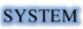Key is the function setting key of the tester system. Select this key to set various functions of the tester system;
Key is the function key of tester file. Select this key to copy, copy and delete the test data file.

3.2 Rear panel structure

3.2.1 Schematic diagram of rear panel
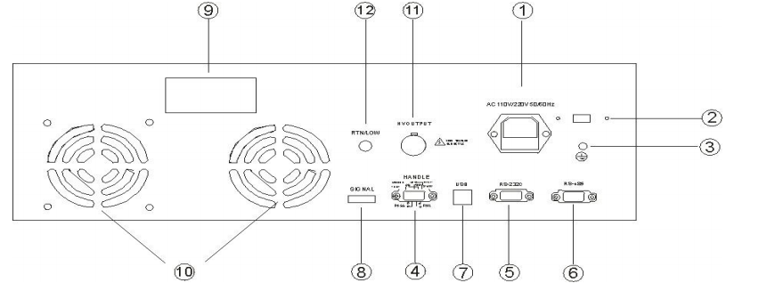

3.2.2 Rear panel description
1. Power socket
The standard input power socket provides working power for the tester. Pay attention to turn off the input power switch and disconnect the power plug before replacing the fuse, and replace the Standard Fuse (3.15A/250VAC, 5A / 110VAC).

2. 115V / 230V power conversion

3. Ground terminal

The safety grounding terminal of the tester must be properly grounded to ensure the safety of the operator.

4. PLC signal terminal

A standard 9-core D-type female terminal block provides remote control monitoring and control signal interface.

5. RS232C interface

RS232C serial communication function is provided

6. RS485 interface

Provide RS485 serial communication function

7. USB interface

Provide USB computer to connect U disk function

8. Control signal output

This interface has the function of 24 V output.

9. Name plate

Tester model name, date of manufacture and serial number.

10. Cooling hole

Provide heat dissipation for the tester.

11. High voltage output (option)

- High voltage circuit end (option)

3.3 definition of screen display area

RK9960 uses a 800 * 480 LCD 7 inch display. The contents displayed in the display are divided into the following display areas.
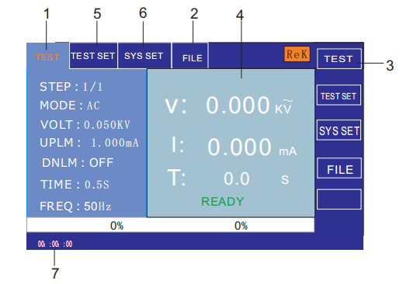

3.3.1 Measurement display page area

This area indicates the measurement parameter name of the current page.

3.3.2 File domain
Move the cursor to this area for file management. File management includes loading, saving and deleting.

3.3.3 Soft key area
This area is used to display the function definition of the soft key. The definition of soft key has different function definition according to the location of the cursor area.

3.3.4 Display area of measurement results
This area displays test result information and current test conditions.

3.3.5 Parameter setting area
This area displays the parameter settings

3.3.6 System settings
This area displays the parameter settings of the system.

3.3.7 Time display area
This area displays the current working time.

3.4 Main menu buttons and corresponding displayed pages

3.4.1 Main menu button of measurement display
Used for all kinds of measurement and display the home page. The function pages of this part include (use the "soft key" to select the following page functions, the same below):

Measurement display
Measurement setup
System settings
Document management
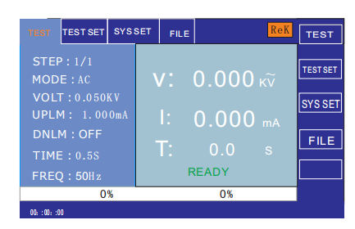

3.4.2 Main menu button of parameter setting
It is mainly used to enter the measurement setting interface corresponding to the measurement display. The main interfaces are as follows:
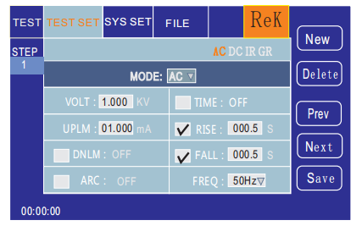

3.4.3 system setting main menu button
Used to enter the system settings home page. It is mainly about system settings. The function pages of this part are as follows:
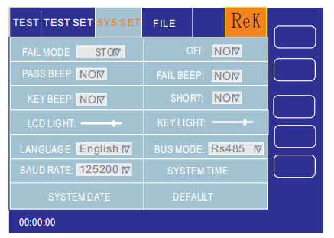

3.4.4 Main menu button of file management
Used for file management settings.
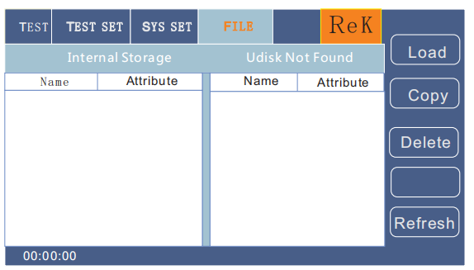

Chapter 4 Operating Instructions

4.1 Boot instructions and boot screen

Before the power cord plug is connected to the mains, please turn off the input "power switch", check whether the specification of the fuse is correct, and connect the safety ground wire to the "ground terminal" on the back panel of the tester.
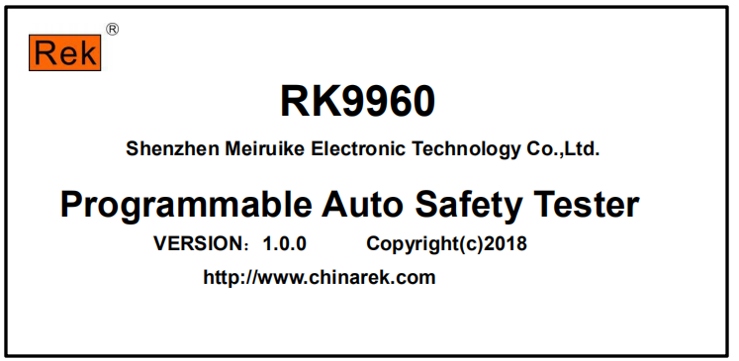
The basic operations are as follows:

■Use the menu button（［TEST ］［SETUP ］［SYSTEM ］［FILE］）and the soft key to select the page you want to display.

■ move the cursor （［→］［←］［↑］［↓］） to the field you want to set by using the cursor. When the cursor moves to a field, the field turns blue. The so-called field is the area where the cursor can be set.

■The field where the current cursor is located can be set by coding potentiometer or number key. When the data input is finished, you can use the ［ ENTER ］ key or lightly press the coding potentiometer to confirm.

4.2 Operation steps

4.2.1 Setting tester parameters

Please refer to the section "parameter setting" to set the parameters.

4.2.2 Connect the tester to the object

Plug in the three wire power plug.

Note: keep the supply voltage at 90-121v AV (60Hz) or 198-242v AV (50Hz).

The power input phase line L, zero line N and ground line E shall be the same as the phase line and zero line on the power plug of the instrument.

Turn on the power supply and press the power switch at the upper and lower left corner of the front panel to turn on the instrument and display the power on screen. As shown in the picture above.

Please press the "reset" key once, and make sure that the test indicator is not on, the display works normally, and there is no current output. Connect two thick wires to the current output terminal, and two thin wires to the voltage detection terminal. Test the two ends of the object to be tested, and check whether all the wiring is reliable.

4.2.3 Press the "start" button to start the test

After pressing the "start" key, the tester outputs current. At this time, the test indicator on the front panel will light up, and the display will show "under test". At the same time, the current value will be displayed. The timer will start to work, and the data will be updated continuously.

4.2.4 determination of qualified products

After the test, the tester will automatically turn off the output, the qualified indicator light on the front panel will be on, and the sound will be emitted at the same time. The display will display "pass" and test data, indicating that the tester determines that the tested object is qualified.

If you want to continue the test, you can press the "start" key again to restart the test.

If you want to stop the test, you can press the "reset" key, the tester will stop the test immediately, and the display will keep the current test value.

4.2.5 determination of unqualified products
If the test fails, the tester will turn off the output immediately, the unqualified light on the front panel will turn on, and a warning sound will be given. The display will display the test failure prompt and test data, indicating that the tester determines that the tested object is unqualified. The test failure prompts are: upper limit failure, over-current protection.

To turn off the alarm sound, press the "reset" key.

4.2.6 Operation instructions of START and STOP
The START key is to start the test key. Press this button and the instrument starts to enter the test state.

The STOP key is reset and stop key. In the test state, press the STOP key to interrupt the test of the instrument once, the running lamp is DANGER, and the LOCK lamp is bright.

According to STOP two times, the instrument enters the reset state, and the DANGER and LOCK lights go out.

The two terminals of the red and black terminals of the instrument are connected with the four terminal test line that the instrument is equipped with, and the START is used to start the instrument when there is no connection with the tested objects.

Chapter 5 handler interface and singal interface

5.1 Structure and application of handler interface and singal interface circuit

The control interface principle is shown below, which is the standard 9PIN D terminal block.

It contains three remote control input signals including PROCESSING (test), PSASS (test pass), FALL (test failure), and TEST (start) and STOP (reset) two monitoring signals.

5.2 the output signal indicates the HANDLER interface: START, STOP and COM signals constitute remote input control, and the switch input is closed effectively.

HANDLER interface: TEST, PASS and FAIL signals constitute remote output control. The switch is closed effectively. TEST can be used as a high voltage start signal or a normal pulse signal.

The SINGAL interface mainly provides the instrument selection signal (INTLOCK) for multi instrument on-line test. The signal is short circuited by default, and the high voltage output is prohibited when the instrument is opened.

The SINGAL interface provides a power supply of about +24V, and the output current is less than 0.5A. With the HANDLER interface control signal, it can drive indicator lights, photoelectric switches, and small power solenoid valves. This interface is usually used for remote control and test synchronization or indication.

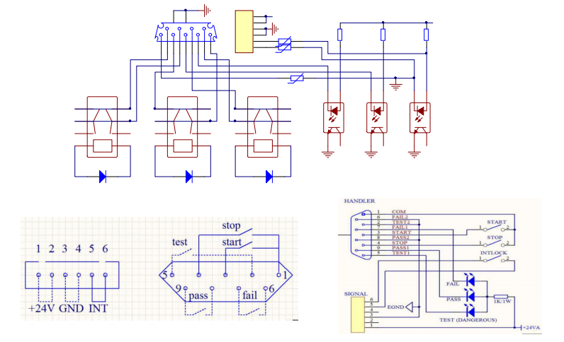
1, PROCESSING signal: the output signal is connected between PIN5 and PIN2.

2, PASS signal: the output signal is connected between PIN8 and PIN9.

3, FALL signal: the output signal is connected between PIN6 and PIN7.

4, START OUT: the output signal is connected between PIN3 and PIN1.

5, RESET OUT: the output signal is connected between PIN4 and PIN1.

Chapter 6 Parameter setting

6.1 Instrument power on self test

6.1.1 Instrument self check items
When the tester runs power on self-test, the screen displays as follows:
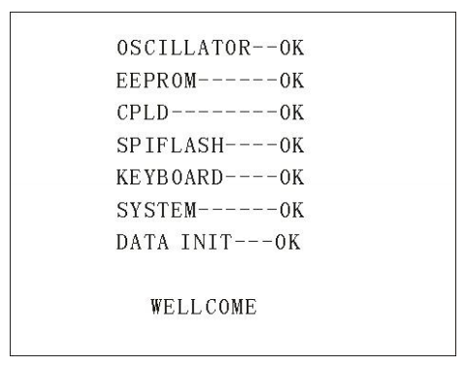

The self inspection items are as follows:

1. Internal crystal working state detection: if it is normal, it will display OK, if it is abnormal, it will give an alarm sound, and can not enter the self inspection of the next project.

2. Input and output memory status detection: if it is normal, it will display OK, if it is abnormal, it will give an alarm sound, and it can not enter the self inspection of the next project.

3. Complex programmable logic state detection: if it is normal, it will display OK, if it is abnormal, it will give an alarm sound, and it can not enter the self inspection of the next project.

4. Serial peripheral interface status detection: if it is normal, it will display OK, if it is abnormal, it will give an alarm sound, and can not enter the self inspection of the next project.

5. Keyboard status detection: if it is normal, it will display OK, if it is abnormal, it will give an alarm sound, and it can not enter the self inspection of the next project.

6. System status detection: if it is normal, it will display OK, if it is abnormal, it will give an alarm sound, and can not enter the self inspection of the next project.

7. Data initialization status detection: if it is normal, it will display OK, if it is abnormal, it will give an alarm sound and cannot enter the self inspection of the next project.

If there is no error in the above self-test, the instrument self-test is successful. Enter the test interface, as shown in the following figure:
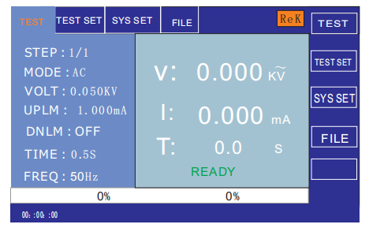

6.2 Parameter setting mode

Enter the parameter settings page according to the "SETUP" or "F2" key on the instrument panel at the measurement interface.
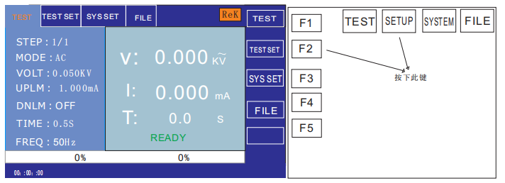
The parameter setting interface is as follows:
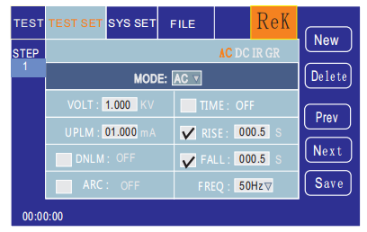
Note: the details vary according to the test mode of the test steps.

6.2.1 parameter setting description

Test mode: a parameter in the step detail panel is always a test mode parameter. Editing this parameter can change the test mode of the test step. Scope: test mode supported by the instrument. After pressing the "Enter" button on this parameter, modify the test mode control value according to the selection box control method, then press the "Enter" button again to save the modification. If the test mode of the test step changes, it will be automatically updated to the parameter panel corresponding to the new test mode. In the process of modification, press the "ESC" key to cancel all current operations.

6.2.2 description of test mode supported by step

The test mode supported by the test step is determined by the following factors: the test mode supported by the tester, the file working mode.

For example, suppose that the tester supports ACW, DCW, IR and GR test mode. When the file mode is GR, it is the test condition of GR.

6.2.3 ACW AC withstand voltage parameter setting

Select the "AC" withstand voltage test mode under the parameter panel setting, and enter the "AC" withstand voltage test mode for the test parameter setting, as shown in the figure below：
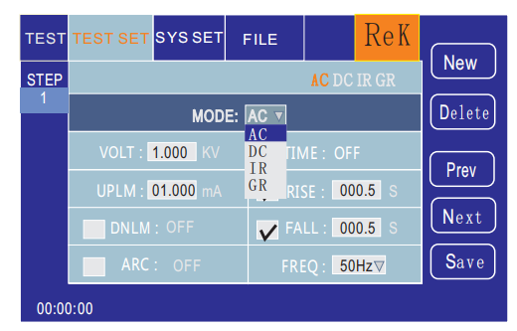
The setting parameters are as follows:

Test mode: after the cursor moves to the test mode, press the "ENTER" button to enter the test mode edit.Press "→" or "←" to change the test mode,
Set up AC AC voltage tester and select AC, then press "ENTER" button to save. In this way, the following parameters are all changed to AC withstand voltage parameters.
Output voltage: press the "↓" key or code dial to move the cursor to the value after the output voltage, as shown in the figure below:
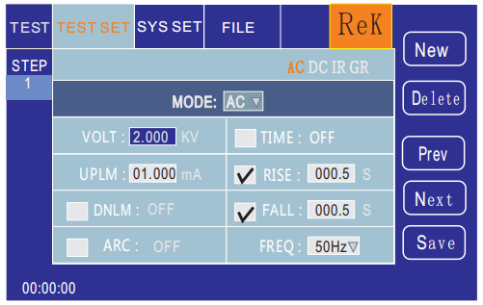
In this interface, according to the "ENTER" button, the output voltage value can be edited, and the output voltage range is (0.050-5.000) KV. To change the output voltage, just input the number key. For example, if you want to input the voltage 2.000KV, you just need to press the numeric key "2" and "ENTER". To input 4.750KV, press "4", "7", "5", "0" and "ENTER" key.

Upper current limit: press "↓" key or code dial to move the cursor to the value after the upper current limit, as shown in the figure below:
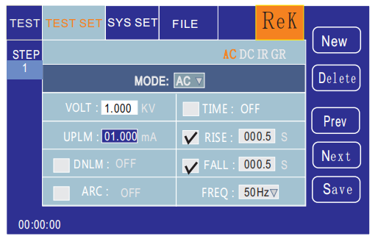
In this interface, press the "ENTER" button to edit the upper limit of current, with a range of (0.001-20.00) mA. To change the upper limit of current, just input the number key. For example, to input 0.515mA, press "0", "5", "1", "5" and "ENTER" key.

Lower current limit: press the "↓" key or code dial to move the cursor to the value after the lower current limit, as shown in the figure below:
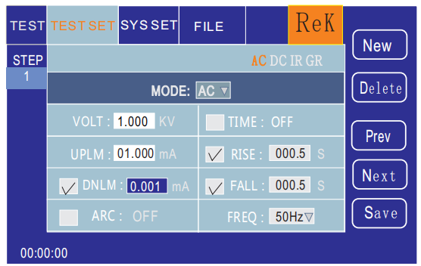
Note: the lower limit function is opened or closed with the "ENTER" key, and the lower limit is: (0.001-10) mA.

After the lower limit function is turned on, the lower limit setting function can be operated by gently pressing the coding potentiometer. To change the lower limit value of current, you only need to input the number key. For example, to input 0.515mA, press "0", "5", "1", "5" and "ENTER" key.

Arc function: press the "↓" key or code dial to move the cursor to the arc function item, as shown in the figure below:
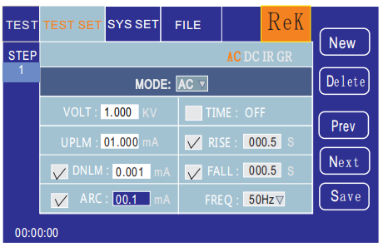
Note: use the "ENTER" button to turn on or off the arc function. The arc range is (0.1-20) mA.

After the arc function is turned on, the arc setting function can be operated by gently pressing the coding potentiometer. To change the arc value, just input the number key.

For example, to input 0.515mA, press "0", "5", "1", "5" and "ENTER" key.

The smaller the arc value is set, the less the tester can detect the ignition or flashover of the object.

Test time: press the "↓" key or code dial to move the cursor to the time function item, as shown in the figure below:
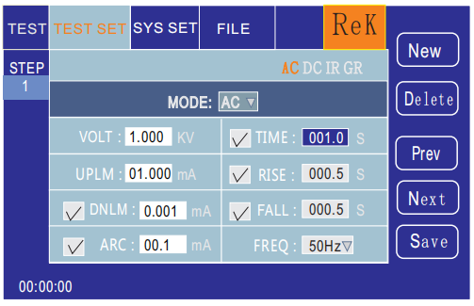
In this interface, press the "ENTER" button to edit the time, with a range of (0.1-999.9) S. To change the time value, just enter the number key. For example, input 101.2, press "1", "0", "1", "2" and "ENTER" key.

Rise time: press the "↓" key or code dial to move the cursor to the rise time function item, as shown in the figure below:
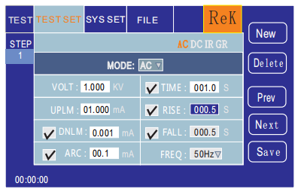
In this interface, press the "ENTER" button to edit the time, with a range of (0.1-999.9) S. To change the time value, just enter the number key. For example, input 101.2, press "1", "0", "1", "2" and "ENTER" key.

Descending time: press the "↓" key or code dial to move the cursor to the descending time function item, as shown in the figure below:
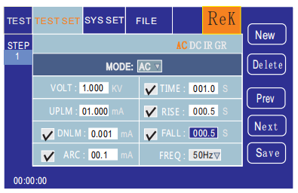
In this interface, press the "ENTER" button to edit the time, with a range of (0.1-999.9) S. To change the time value, just enter the number key. For example, input 101.2, press "1", "0", "1", "2" and "ENTER" key.

Frequency: press the "↓" key or code dial to move the cursor to the frequency function item, as shown in the figure below:
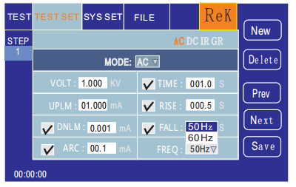
Under this interface, the frequency is edited according to the "ENTER" key, and the range is (50/60) Hz. To change the frequency value, press "↓" and "↑" or rotate the coding potentiometer.
New step: in the test interface, press "F1" key "new" on the panel to create a new test step. A total of 20 test steps can be created. Create a new test step after the current step. This new test step adopts the default test mode AC voltage.

Delete steps: in the test interface, press the "F2" key "delete" on the panel to delete the test steps. The tester will delete the current step and move the following steps to the current step.

Previous page: (step forward) in the test interface, press the "F3" key "previous page" on the panel to move forward the current step, that is, the content of the current test step is exchanged with that of the previous test step, which can easily realize the test step sorting function. However, when the current step is the first test step, the forward operation is invalid.

Next page: (step backward) in the test interface, press the "F4" key "next page" on the panel to move the current step backward, that is, the content of the current test step is exchanged with that of the next test step, which can easily realize the test step sorting function. However, when the current step is the last test step, the backward operation is invalid.

Save as file: in the test interface, press "F5" key "save as file" on the panel to save the current test steps in the form of file.
It is easy to access and use. Press save as to open the storage interface, as shown below:

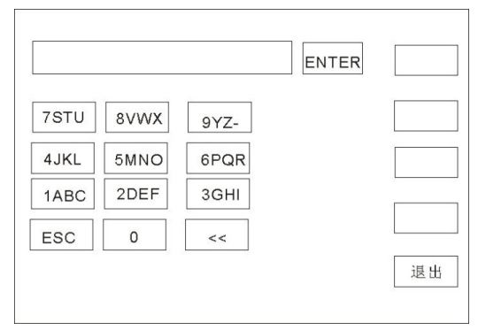
After entering the interface above, press the number key on the board below, and the screen will display as follows: type the relevant characters on the screen, press the "enter" key, and the file will be saved in the memory of the tester.
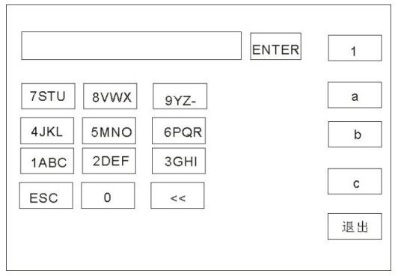
6.2.4 IR insulation resistance parameter setting

Select the "IR" insulation test mode under the parameter panel setting, and enter the "IR" withstand voltage mode for the test parameter setting, as shown in the figure below:

The setting parameters are as follows:

Test mode: after the cursor moves to the test mode, press the "ENTER" button to enter the test mode edit and change the test mode according to the "to" or "click" keys.

Set up IR insulation test and press the "ENTER" button to save it. In this way, the following parameters are all changed to the parameters of insulation resistance.

Output voltage: press the "↓" key or code dial to move the cursor to the value after the output voltage, as shown in the figure below:
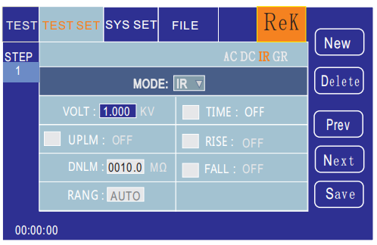
In this interface, according to the "ENTER" button, the output voltage value can be edited, and the output voltage range is (0.050-1.000) KV. To change the output voltage, just input the number key. For example, to input 1.000KV, press "1", "0", "0", "0" and "ENTER" key.

Upper limit of resistance: press the "↓" key or code dial to move the cursor to the value after the upper limit of resistance, as shown in the figure below:
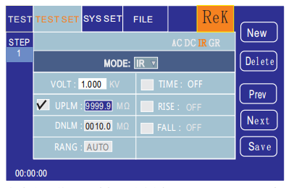
In this interface, press the "ENTER" button to edit the upper limit of current, with a range of (0.1-9999.9) M ohm. To change the upper limit of current, just input the number key. For example, to input 0.515mA, press "0", "5", "1", "5" and "ENTER" key.

Lower limit of resistance: press the "↓" key or code dial to move the cursor to the value after the lower limit of current, as shown in the figure below:
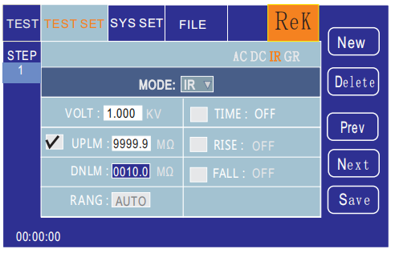
Note: the lower limit function is opened or closed with the "ENTER" key, and the lower limit is: (0.1-9999.9) mΩ.

After the lower limit function is turned on, the lower limit setting function can be operated by gently pressing the coding potentiometer. To change the lower limit value of current, you only need to input the number key. For example, to input 1000mΩ, press "1", "0", "0", "0" and "ENTER" key.

Range function: press "↓" key or code dial to move the cursor to the range function item, as shown in the figure below:
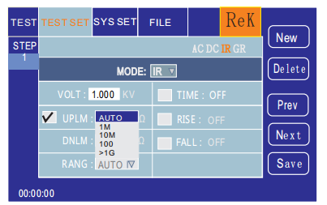
The range is divided into: Auto, 1m Ω, 10m Ω, 100m Ω, > 1GΩ.

Test time: press the "↓" key or code dial to move the cursor to the time function item, as shown in the figure below:
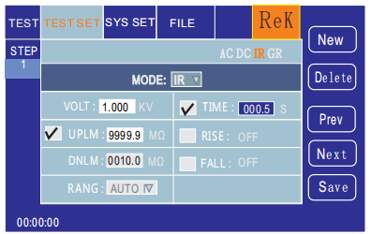
In this interface, press the "ENTER" button to edit the time, with a range of (0.1-999.9) S. To change the time value, just enter the number key. For example, input 101.2, press "1", "0", "1", "2" and "ENTER" key.

Rise time: press the "↓" key or code dial to move the cursor to the rise time function item, as shown in the figure below:
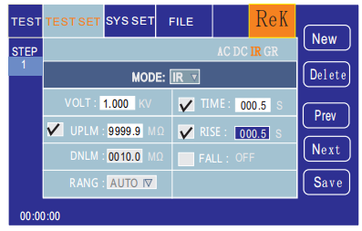
In this interface, press the "ENTER" button to edit the time, with a range of (0.1-999.9) S. To change the time value, just enter the number key.

For example, input 101.2, press "1", "0", "1", "2" and "ENTER" key.

Descending time: press the "↓" key or code dial to move the cursor to the descending time function item, as shown in the figure below:
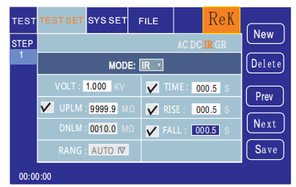
In this interface, press the "ENTER" button to edit the time, with a range of (0.1-999.9) S. To change the time value, just enter the number key. For example, input 101.2, press "1", "0", "1", "2" and "ENTER" key.
New step: in the test interface, press "F1" key "new" on the panel to create a new test step. A total of 20 test steps can be created. Create a new test step after the current step. This new test step adopts the default test mode AC voltage.

Delete steps: in the test interface, press the "F2" key "delete" on the panel to delete the test steps. The tester will delete the current step and move the following steps to the current step.

Previous page: (step forward) in the test interface, press the "F3" key "previous page" on the panel to move forward the current step, that is, the content of the current test step is exchanged with that of the previous test step, which can easily realize the test step sorting function. However, when the current step is the first test step, the forward operation is invalid.

Next page: (step backward) in the test interface, press the "F4" key "next page" on the panel to move the current step backward, that is, the content of the current test step is exchanged with that of the next test step, which can easily realize the test step sorting function. However, when the current step is the last test step, the backward operation is invalid.

Save as file: in the test interface, press "F5" key "save as file" on the panel to save the current test steps in the form of file.
It is easy to access and use. Press save as to open the storage interface, as shown below:
After entering the interface above, press the number key on the board below, and the screen will display as follows: type the relevant characters on the screen, press the "enter" key, and the file will be saved in the memory of the tester.

6.2.5 GR grounding resistance parameter setting

Select the "GR" grounding resistance test mode under the parameter panel settings, and enter the "GR" withstand voltage mode for the test parameter settings, as shown in the figure below:
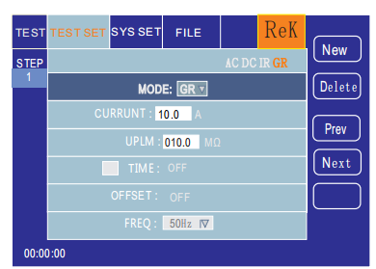
The setting parameters are as follows:

Test mode: after the cursor moves to the test mode, press the "ENTER" button to enter the test mode edit, press the "to" or "click" button to change the test mode, set the GR insulation test, and then press the "ENTER" button to save it. In this way, the following parameters are all changed to the parameters of grounding resistance.

Output current: press the "↓" key or code dial to move the cursor to the value after the output current, as shown in the figure below:
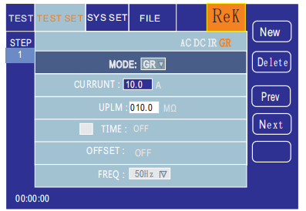
In this interface, according to the "ENTER" button, the output voltage value can be edited, and the output voltage range is (1-30.0) A. To change the output current value, just input the number key. For example, to input 10.0A, press "1", "0", "0" and "ENTER" key.

Upper limit of resistance test: press "↓" key or code dial to move the cursor to the value after the upper limit of resistance test, as shown in the figure below:
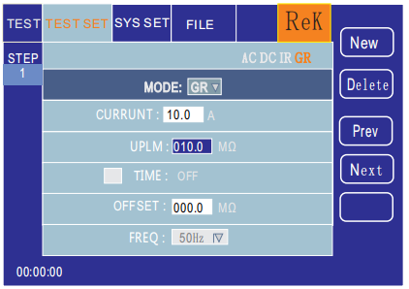
In this interface, press the "ENTER" key to edit the test upper limit, with a range of (0.1-10) m ohm. To change the upper limit of current, just input the number key. For example, to input 100m Omega, press "1", "0", "0" and "ENTER" keys.

Test time: press the "↓" key or code dial to move the cursor to the time function item, as shown in the figure below:
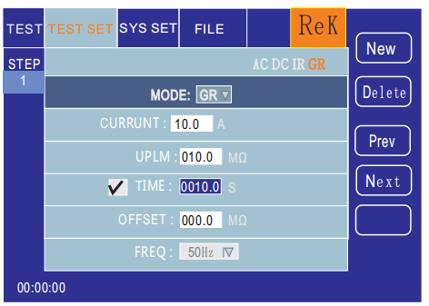
Note: use the "ENTER" key to turn on or close the time function. The range is: (0.1-999.9) S.

After the time function is turned on, the time setting function can be operated by gently pressing the coding potentiometer. To change the time value, just input the number key. For example, to input 100S, press "1", "0", "0" and "ENTER" key.

Zero compensation: press the "↓" key or code dial to move the cursor to the zero compensation function, as shown in the figure below:
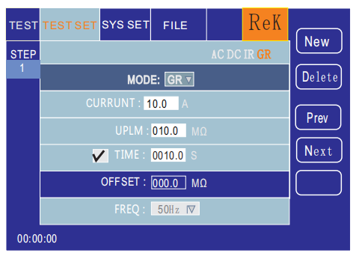
Zero compensation is divided into: Auto, manual. In the automatic compensation state, only two test lines are short circuited, and the compensation value is automatically recorded in the tester; in the manual state, the compensation value of line loss should be measured in advance, and the corresponding digital value can be input.

Test frequency: press the "↓" key or code dial to move the cursor to the test frequency function item, as shown in the figure below:
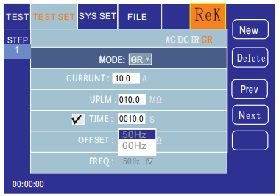
In this interface, press the "ENTER" button to edit the frequency, with a range of (50/60) Hz.

New step: in the test interface, press "F1" key "new" on the panel to create a new test step. A total of 20 test steps can be created. Create a new test step after the current step. This new test step adopts the default test mode AC voltage.

Delete steps: in the test interface, press the "F2" key "delete" on the panel to delete the test steps. The tester will delete the current step and move the following steps to the current step.

Previous page: (step forward) in the test interface, press the "F3" key "previous page" on the panel to move forward the current step, that is, the content of the current test step is exchanged with that of the previous test step, which can easily realize the test step sorting function. However, when the current step is the first test step, the forward operation is invalid.

Next page: (step backward) in the test interface, press the "F4" key "next page" on the panel to move the current step backward, that is, the content of the current test step is exchanged with that of the next test step, which can easily realize the test step sorting function. However, when the current step is the last test step, the backward operation is invalid.

Save as file: in the test interface, press "F5" key "save as file" on the panel to save the current test steps in the form of file.
It is easy to access and use. Press save as to open the storage interface, as shown below:
After entering the interface above, press the number key on the board below, and the screen will display as follows: type the relevant characters on the screen, press the "enter" key, and the file will be saved in the memory of the tester.

6.3 System setting mode
6.3.1 System setting parameter description
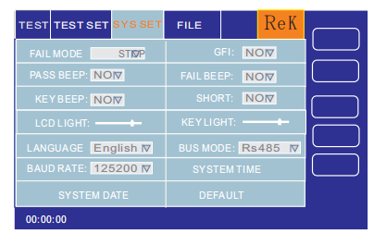
6.3.1.1 failure mode

This option has two functions, CONTINUE, STOP, RESTART and NEXT.

You can select the setting item with the cursor of ［↑］［↓］【←】【→】
, adjust the coding potentiometer, and select the function item to be set.

6.3.1.2 qualified sound

This option has 2 functions, ON and OFF.

You can select the setting item with the cursor of ［↑］［↓］【←】【→】, adjust the coding potentiometer, and select the function item to be set.

6.3.1.3 button sound

This option has 2 functions, ON and OFF.

You can select the setting item with the cursor of［↑］［↓］【←】【→】, adjust the coding potentiometer, and select the function item to be set.

6.3.1.4 screen brightness

You can select the setting item with the cursor of ［↑］［↓］【←】【→】, adjust the coding potentiometer and select the value to be set.

6.3.1.5 system language
This item is available in two languages, Chinese and English.

You can select the setting item with the cursor of［↑］［↓］【←】【→】, and adjust the coding potentiometer to select the item to be set.

6.3.1.6 baud rate

This item has four baud rates: 9600, 38400, 19200, 115200. You can select the setting item with the cursor of ［↑］［↓］【←】【→】, and adjust the coding potentiometer to select the item to be set.

6.3.1.7 system date

This item can set the current time of the instrument. Once the system time is set, the time function will continue regardless of the power on / off state, unless the internal battery fails. You can select the setting item with the cursor of ［↑］［↓］【←】【→】, and adjust the coding potentiometer to select the setting item

6.3.1.8 electric shock protection

This option has 2 functions, ON and OFF. You can select the setting item with the cursor of［↑］［↓］【←】【→】, adjust the coding potentiometer, and select the function item to be set.

6.3.1.9 failure

This option has 2 functions, ON and OFF. You can select the setting item with the cursor of ［↑］［↓］【←】【→】, adjust the coding potentiometer, and select the function item to be set.

6.3.1.10 short circuit protection

This option has 2 functions, HIGH and LOW. You can select the setting item with the cursor of ［↑］［↓］【←】【→】, adjust the coding potentiometer, and select the function item to be set.

6.3.1.11 key brightness

You can select the setting item with the cursor of ［↑］［↓］【←】【→】, adjust the coding potentiometer and select the value to be set.

6.3.1.12 bus mode

There are two bus modes, RS232 and RS485. You can select the setting item with the cursor of ［↑］［↓］【←】【→】, and adjust the coding potentiometer to select the item to be set.

6.3.1.13 system time

This item can set the current time of the instrument. Once the system time is set, the time function will continue regardless of the power on / off state, unless the internal battery fails. You can select the setting item with the cursor of［↑］［↓］【←】【→】, adjust the coding potentiometer and select the value to be set.

6.3.1.14 restore default

This function is to restore system settings, parameter settings and factory settings. All settings will be cleared. The cursor selection settings can be used, and the ENTER button will be ejected to confirm the interface. Press the [Cancel] key to cancel.

6.4 Description of document parameters
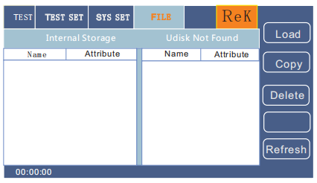
6.4.1 internal storage: storage capacity 16M.

6.4.2 U disk function: this item has external U disk storage function.

Chapter 7 Remote control

7.1 RS232C interface description
At present, the widely used serial communication standard is RS-232 standard, which can also be called asynchronous serial communication standard,
The standard is officially promulgated by the American Electronics Industry Association (IEA) in 1969.
It must be transmitted by one data line at a time. Like most serial ports in the world, the serial interface of the instrument is not strictly based on RS-232 standard, but only provides a minimal subset. The results are as follows:
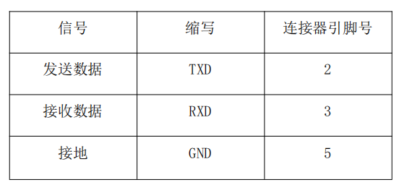
Instrument RS232 signal and pin comparison

The reason is that the operation of three lines is much cheaper than that of five or six lines, which is the biggest advantage of serial communication. The connection between the instrument and the computer is shown in the figure:
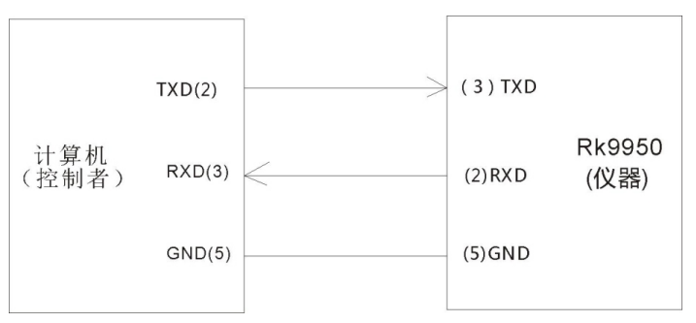
Schematic diagram of connection between computer and instrument

It can be seen from the figure that the pin definition of the instrument is different from that of the 9-core connector serial interface used by the computer. The baud rate of the RS232 interface can be 9600~115200 selected, no check (no parity), 8 bit data bits, and 1 bit stop bits. The instrument command conforms to SCPI standard

After sending the instrument to the instrument, you need to send LF (sixteen hexadecimal: 0AH) as the ending character. The maximum number of bytes of the SPCI command string that the instrument can receive at one time is 2kByte. For the result data format sent by the instrument to the computer, please refer to the instruction in the command reference section.

7.2 RS485 / 232C interface description
The communication interface of the tester can provide RS232C and RS485 serial communication interfaces for users to choose：
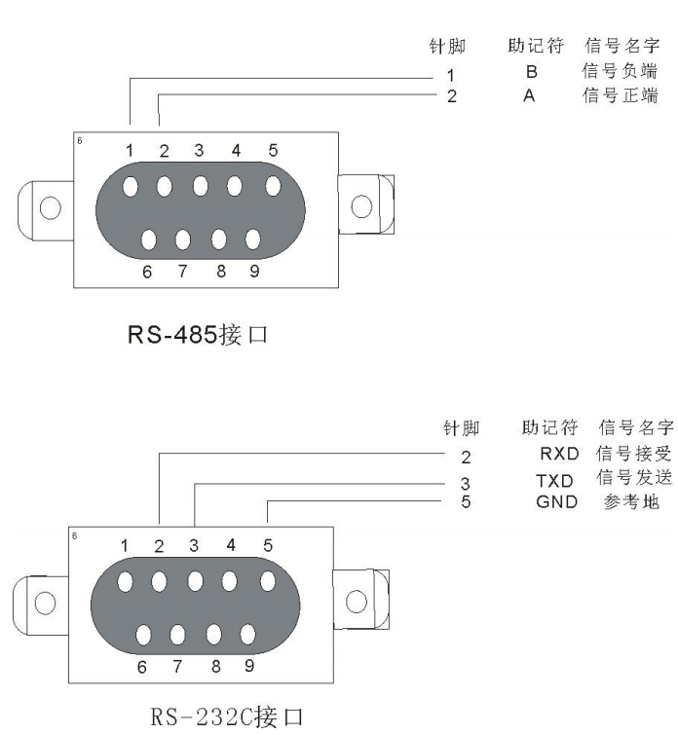

7.3 USBTMC remote control system
USB (Universal Serial Bus) remote control system controls the equipment through USB interface. The connection conforms to usbtmc-usb488 and USB2.0 protocol.
The USB interface on the rear panel of RK9950 is connected to the USB interface on the host through the USB cable.

Chapter 8 SCPI serial port instruction reference

8.1 Brief description of instruction format:

8.1.1 instrument instruction set only describes the actual characters received or sent by the instrument.

8.1.2 command characters are all ASCII characters.

8.1.3 the data “<???>”of the instruction are all ASCII strings. The default format of the system is integer or floating-point number, and the unit of data is the default value, which does not appear in the instruction.

8.1.4 the end of an instruction must have an end of instruction mark: an identifier of the end of an instruction, without which the instrument will not parse the instruction.

8.1.5 the default end marks are: carriage return (NL), print control (\ n), decimal number (10), hexadecimal number (0 × 0A).
The end of the IEEE-488 bus flag: the key word (^END) and the signal (EOI).

8.2 SCPI instruction set

RK9950 series instrument subsystem command

● DISPlay

● SYSTem

● FUNCtion

● MMEM

● FETC

8.3 DISPLAY subsystem command set

The command set of display subsystem is mainly used to set the display page of the instrument, character? You can query the current page.

DISPLay:PAGE

Command syntax:

DISPlay：PAGE <page name>

< page name > is as follows:
TEST
TESTSET
SYSSet
FLIE
Set display page to: measurement display page

Set display page to: survey setting page

Set display page to: system settings page

Set display page to: (internal) file list

Character? You can query the current page.
-- example:

Set the display page to: measurement display page.

Set instruction: DISP:PAGE TEST

Query instruction: DISPlay:PAGE?

Return value:

TEST32

8.4 FUNCtion subsystem command set

8.4.1 FUNCtion subsystem command set is mainly used to set test parameters of instrument test function.

Command tree:
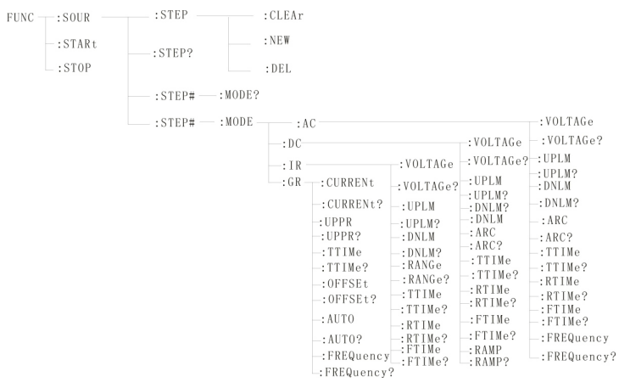

8.4.2 PROG function command set

FUNC:STARt When the instrument is in the test interface, start the test.

FUNC:STOP When the instrument is in the test interface, stop the test.

FUNC:SOUR ITEM#: CLEAr clears a new test item in the existing test plan (ITEM).

FUNC:SOUR ITEM#: DEL removes the current test items in the existing test plan (ITEM).

FUNC:SOUR ITEM#: NEW, create an empty test plan to write a brand new test plan.

FUNC:SOUR ITEM? Query the current test plan.
8.4.3 STEP# function command set

8.4.3.1 AC SETUP function command set

FUNC:SOURce ：STEP#: MODE:AC VOLTage set / inquire the voltage of AC.

--Format

Format: FUNCE:STEP#: MODE:AC VOLTage< voltage value >

Query format: FUNCE:STEP#: MODE:AC :VOLTage？

--Data < voltage value >:

Data type: floating point setting format: FUNC:STEP: <num>: AC:VOLT < voltage value >

Data range: 0.050-5.000

Data accuracy: 0.001

Data unit: KV

Example: set the voltage value of AC in step1 to 1000V

Set command: FUNCE:STEP1: MODE:AC :VOLTage 1.000

Query command: FUNCE:STEP1: MODE:AC :VOLTage？

FUNC:SOURce ：STEP#: MODE:AC UPLM: set up / inquire the upper limit current of AC.

--Format

Format: FUNCE:STEP#: MODE:AC UPLM< current value >

Query format: FUNCE:STEP#: MODE:AC :UPLM？

--Data < current value >

Data type: floating point number

Data range: 0.001-20.00mA

Data accuracy: 0.001

Data unit: mA

Example: set the current value of AC in STEP1 to 1mA.

Set command: FUNCE:STEP1: MODE:AC :UPLM 1.000

Query command: FUNCE:STEP1: MODE:AC :UPLM？

Return value: 1

FUNC:SOURce ：STEP#: MODE:AC DNLM sets / inquires the lower limit current of AC.

--Format

Format: FUNCE:STEP#: MODE:AC DNLM< current value >

Query format: FUNCE:STEP#: MODE:AC :DNLM？

--Data < current value >

Data type: floating point number

Data range: 0.001-20.00mA
Data accuracy: 0.001

Data unit: mA

Example: set the current value of AC in STEP1 to 1mA.

Set command: FUNCE:STEP1: MODE:AC :UPLM 1.000

Query command: FUNCE:STEP1: MODE:AC :UPLM？

Return value: 1

FUNC:SOURce ：STEP#: MODE:AC ARC setting / query arc value.

--Format

Format: FUNCE:STEP#: MODE:AC ARC< arc value >

Query format: FUNCE:STEP#: MODE:AC :ARC？

--Data < arc value >:

Data type: floating point number

Data range: 0.001-20.00mA

Data accuracy: 0.001

Data unit: mA

Example: set the current value of AC in step1 to 1mA

Set command: FUNCE:STEP1: MODE:AC :ARC 1.000

Query command: FUNCE:STEP1: MODE:AC :ARC？

Return value: 1

FUNC:SOURce ：STEP#: MODE:AC TTIMe setup / query AC test time

--Format

Format: FUNCE:STEP#: MODE:AC TTIMe< time >

Query format: FUNCE:STEP#: MODE:AC :TTIMe？

--Data < time value >

Data type: integer

Data range: 0-999.9

Data accuracy: 0.1

Data unit: S

Example: set the time value of AC in STEP1 to 1S.

Set command: FUNCE:STEP1: MODE:AC :TTIMe 1

Query command: FUNCE:STEP1: MODE:AC :TTIMe？

Return value: 1

FUNC:SOURce ：STEP#: MODE:AC RTIMe setup / query AC rise time
--Format

Format: FUNCE:STEP#: MODE:AC RTIMe< time >

Query format: FUNCE:STEP#: MODE:AC :RTIMe？

--Data < time value >

Data type: integer

Data range: 0-999.9

Data accuracy: 0.1

Data unit: S

Example: set the time value of AC in STEP1 to 1S.

Set command: FUNCE:STEP1: MODE:AC :RTIMe 1

Query command: FUNCE:STEP1: MODE:AC :RTIMe？

Return value: 1

FUNC:SOURce ：STEP#: MODE:AC FTIMe set / query AC fall time.

--Format

Format: FUNCE:STEP#: MODE:AC FTIMe< time >

Query format: FUNCE:STEP#: MODE:AC :FTIMe？

--Data < time value >

Data type: integer

Data range: 0-999.9

Data accuracy: 0.1

Data unit: S

Example: set the time value of AC in STEP1 to 1S.

Set command: FUNCE:STEP1: MODE:AC :FTIMe 1

Query command: FUNCE:STEP1: MODE:AC :FTIMe？

Return value: 1

FUNC:SOURce ：STEP#: MODE:AC : frequencyset / query the test frequency of AC

--Format

Format: FUNCE:STEP#: MODE:AC FREQuency< frequency >

Query format: FUNCE:STEP#: MODE:AC :FREQuency？

--Data < frequency value >

Data type: integer

Data range: 50 / 60

Data accuracy: 0.1
Data unit: Hz

Example: set the frequency of AC in STEP1 to 50Hz.

Set command: FUNCE:STEP1: MODE:AC :FREQuency 50

Query command: FUNCE:STEP1: MODE:AC :FREQuency？

Return value: 50

8.4.3.2 DC SETUP function command set

FUNC:SOURce ：STEP#: MODE:DC VOLTage set / inquire the voltage of DC.

--Format

Format: FUNCE:STEP#: MODE:DC VOLTage< voltage value >

Query format: FUNCE:STEP#: MODE:DC :VOLTage？

--Data < voltage value >:

Data type: floating point number

Data range: 0.050-6.000

Data accuracy: 0.001

Data unit: KV

Example: set the voltage value of DC in STEP1 to 1000V.

Set command: FUNCE:STEP1: MODE:DC :VOLTage 1.000

Query command: FUNCE:STEP1: MODE:DC :VOLTage？

FUNC:SOURce ：STEP#: MODE:DC UPLM: set up / inquire the upper limit current of DC.

--Format

Format: FUNCE:STEP#: MODE:DC UPLM< current value >

Query format: FUNCE:STEP#: MODE:DC :UPLM？

--Data < current value >

Data type: floating point number

Data range: 0.001-10.00mA

Data accuracy: 0.001

Data unit: mA

Example: set the current value of DC in STEP1 to 1mA.

Set command: FUNCE:STEP1: MODE:DC :UPLM 1.000

Query command: FUNCE:STEP1: MODE:DC :UPLM？

Return value: 1

FUNC:SOURce ：STEP#: MODE:DC DNLM sets / inquires the lower limit current of DW.

--Format
Format: FUNCE:STEP#: MODE:DC DNLM< current value >

Query format: FUNCE:STEP#: MODE:DC :DNLM？

--Data < current value >

Data type: floating point number

Data range: 0.001-10.00mA

Data accuracy: 0.001

Data unit: mA

Example: set the current value of DC in STEP1 to 1mA.

Set command: FUNCE:STEP1: MODE:DC :UPLM 1.000

Query command: FUNCE:STEP1: MODE:DC :UPLM？

Return value: 1

FUNC:SOURce ：STEP#: MODE:DC ARC setting / query arc value.

--Format

Format: FUNCE:STEP#: MODE:DC ARC< arc value >

Query format: FUNCE:STEP#: MODE:DC :ARC？

--Data < arc value >:

Data type: floating point number

Data range: 0.001-10.00mA

Data accuracy: 0.001

Data unit: mA

Example: set the current value of DC in STEP1 to 1mA.

Set command: FUNCE:STEP1: MODE:DC :ARC 1.000

Query command: FUNCE:STEP1: MODE:DC :ARC？

Return value: 1

FUNC:SOURce ：STEP#: MODE:DC TTIMe setup / query DC test time

--Format

Format: FUNCE:STEP#: MODE:DC TTIMe< time >

Query format: FUNCE:STEP#: MODE:DC :TTIMe？

--Data < time value >

Data type: integer

Data range: 0-999.9

Data accuracy: 0.1

Data unit: S
Example: set the time value of DC in STEP1 to 1S.

Set command: FUNCE:STEP1: MODE:AC :TTIMe 1

Query command: FUNCE:STEP1: MODE:AC :TTIMe？

Return value: 1

FUNC:SOURce ：STEP#: MODE:DC RTIMe setup / query DC rise time

--Format

Format: FUNCE:STEP#: MODE:DC RTIMe< time >

Query format: FUNCE:STEP#: MODE:DC :RTIMe？

--Data < time value >

Data type: integer

Data range: 0-999.9

Data accuracy: 0.1

Data unit: S

Example: set the time value of DC in STEP1 to 1S.

Set command: FUNCE:STEP1: MODE:DC :RTIMe 1

Query command: FUNCE:STEP1: MODE:DC :RTIMe？

Return value: 1

FUNC:SOURce ：STEP#: MODE:AC FTIMe set / query DC fall time.

--Format

Format: FUNCE:STEP#: MODE:DC FTIMe< time >

Query format: FUNCE:STEP#: MODE:DC :FTIMe？

--Data < time value >

Data type: integer

Data range: 0-999.9

Data accuracy: 0.1

Data unit: S

Example: set the time value of DC in STEP1 to 1S.

Set command: FUNCE:STEP1: MODE:DC :FTIMe 1

Query command: FUNCE:STEP1: MODE:DC :FTIMe？

Return value: 1

FUNC:SOURce ：STEP#: MODE:AC RAMP: set up / query the boost state of DC.

--Format

Format: FUNCE:STEP#: MODE:DC RAMP< boost decision >
Query format: FUNCE:STEP#: MODE:DC :RAMP？

--Data < step up decision >

Data type: integer

Data range: 0/1 (OFF/ON)

Data accuracy: None

Data unit: None

Example: set the frequency of DC in STEP1 to 0 (OFF).

Set command: FUNCE:STEP1: MODE:DC :RAMP 0

Query command: FUNCE:STEP1: MODE:DC :RAMP？

Return value: 0 (OFF)

8.4.3.3 IR SETUP function command set

FUNC:SOURce ：STEP#: MODE:IR VOLTage set / inquire the voltage of IR.

--Format

Format: FUNCE:STEP#: MODE:IR VOLTage< voltage value >

Query format: FUNCE:STEP#: MODE:IR :VOLTage？

--Data < voltage value >:

Data type: floating point number

Data range: 0.050-1.000

Data accuracy: 0.001

Data unit: KV

Example: set the voltage value of IR in STEP1 to 1000V.

Set command: FUNCE:STEP1: MODE:IR :VOLTage 1.000

Query command: FUNCE:STEP1: MODE:IR :VOLTage？

Return value: 1

FUNC:SOURce ：STEP#: MODE:IR UPLM: setting up / querying the upper limit of IR.

--Format

Format: FUNCE:STEP#: MODE:IR UPLM< resistance >

Query format: FUNCE:STEP#: MODE:IR :UPLM？

--Data < current value >

Data type: floating point number

Data range: 0-1E4 (0 OFF) M Ω

Data accuracy: 0.1M Ω

Data unit: m Ω
Example: set the resistor upper limit of IR in STEP1 to 100M ohm.

Set command: FUNCE:STEP1: MODE:IR :UPLM 100

Query command: FUNCE:STEP1: MODE:IR :UPLM？

Return value: 100

FUNC:SOURce ：STEP#: MODE:IR DNLM: set / query the lower limit of IR.

--Format

Format: FUNCE:STEP#: MODE:IR DNLM< resistance >

Query format: FUNCE:STEP#: MODE:IR :DNLM？

--Data < current value >

Data type: floating point number

Data range: 0-1E4 M Ω

Data accuracy: 0.1M Ω

Data unit: 0.1M Ω

Example: set the resistance value of IR in STEP1 to 10M Ω.

Set command: FUNCE:STEP1: MODE:IR :UPLM 10

Query command: FUNCE:STEP1: MODE:IR :UPLM？

Return value: 10

FUNC:SOURce ：STEP#: MODE:IR RANGe setting / query resistance range.

--Format

Format: FUNCE:STEP#: MODE:IR RANGe< range value >

Query format: FUNCE:STEP#: MODE:IR :RANGe？

--Data < a range value >:

Data type: integer

Data range: 1,10,100

Data accuracy: None

Data unit: m Ω

Example: set the resistance range of IR in STEP1 to 100M ohm.

Set command: FUNCE:STEP1: MODE:IR :RANGe 100

Query command: FUNCE:STEP1: MODE:IR :RANGe ？

Return value: 100

FUNC:SOURce ：STEP#: MODE:IR TTIMe setup / query IR test time

--Format

Format: FUNCE:STEP#: MODE:IR TTIMe< time >
Query format: FUNCE:STEP#: MODE:IR :TTIMe？

--Data < time value >

Data type: integer

Data range: 0-999.9

Data accuracy: 0.1

Data unit: S

Example: set the time value of IR in STEP1 to 1S.

Set command: FUNCE:STEP1: MODE:IR :TTIMe 1

Query command: FUNCE:STEP1: MODE:IR :TTIMe？

Return value: 1

FUNC:SOURce ：STEP#: MODE:IR RTIMe setup / query IR rise time

--Format

Format: FUNCE:STEP#: MODE:IR RTIMe< time >

Query format: FUNCE:STEP#: MODE:IR :RTIMe？

--Data < time value >

Data type: integer

Data range: 0-999.9

Data accuracy: 0.1

Data unit: S

Example: set the time value of IR in STEP1 to 1S.

Set the command: FUNCE:STEP#: MODE:IR :RTIMe 1

Query command: FUNCE:STEP#: MODE:IR :RTIMe？

Return value: 1

FUNC:SOURce ：STEP#: MODE:IR FTIMe set / query IR fall time.

--Format

Format: FUNCE:STEP#: MODE:IR FTIMe< time >

Query format: FUNCE:STEP#: MODE:IR :FTIMe？

--Data < time value >

Data type: integer

Data range: 0-999.9

Data accuracy: 0.1

Data unit: S

Example: set the time value of IR in STEP1 to 1S.
Set command: FUNCE:STEP1: MODE:IR :FTIMe 1

Query command: FUNCE:STEP1: MODE:IR :FTIMe？

Return value: 1

8.4.3.4 GR SETUP function command set

FUNC:SOURce ：STEP#: MODE:GR CURRent sets query current.

--Format

Format: FUNC:SOUR :STEP#: MODE:GR :CRREnt

Query format: FUNC:SOUR :STEP#: MODE:GR :CRREnt?

--Data < Sn > 0

Data type: integer

Data range: 1-20

Data accuracy: 1

--Data < current value >:

Data type: floating point number

Data range: 3-30

Data accuracy: 0.1

Data unit: A

example:

Set the CURREnt value to: 10.00A

Format: FUNC:SOUR :STEP#: MODE:GR :CRREnt ：<10.00>

Query format: FUNC:SOUR :STEP#: MODE:GR :CRREnt ：?

Near return value: 10.00

FUNC:SOURce ：STEP# ： MODER:GR UPPR sets the upper limit of query resistance.

--Format

Format: FUNC:SOURce ：STEP# ： MODER:GR UPPR< resistance >

Query format: FUNC:SOURce ：STEP# ： MODER:GR :UPPR?

--Data < resistance value >

Data type: floating point number

Data range: 0-510MΩ

Data accuracy: 0.1
Data unit m Ω:

example:

Set the upper limit of resistance to 100.0m Ω

Format FUNC:SOURce ：STEP# ： MODER:GR ： UPPR：100.00

Query format: FUNC:SOURce ：STEP# ： MODER:GR :UPPR？

Near return value: 100.0

FUNC:SOURce ：STEP# ： MODER:GR TIMe set query current test time.

--Format

Format: FUNC:SOURce ：STEP# ： MODER:GR TIMe< time value >

Query format: FUNC:SOURce ：STEP# ： MODER:GR ：TIMe?

--Data < time value >

Data type: floating point number

Data range: 0-999.9 (where 0 is continuous test)

Data accuracy: 0.1

Data unit: S

example:

Set the test time to: 1s

Format: FUNC:SOURce ：STEP# ： MODER:GR :TIMe：1

Query format: FUNC:SOURce ：STEP# ： MODER:GR :TIMe?

Near return value: 1

FUNC:SOURce ：STE#： MODER:GR OFFSet set query zero return value.

--Format

Format: FUNC:SOURce ：STEP#： MODER:GR OFFSet< compensation value >

Query format: FUNC:SOURce ：STEP#： MODER:GR :OFFSet?

--Data < compensation value >

Data type: floating point number

Data range: 0-100

Data accuracy: 0.1

Data unit: m Ω

example:

Set offset value to 100m Ω
Format: FUNC:SOURce ：STEP#： MODER:GR :OFFSet 100

Query format: FUNC:SOURce ：STEP#： MODER:GR :OFFSet？

Near return value: 100

FUNC:SOURce ：STEP# ： MODER:GR : frequencyset the test frequency of the query current

--Format

Format: FUNC:SOURce ：STEP# ： MODER:GR : frequency < frequency >

Query format: FUNC:SOURce ：STEP# ： MODER:GR :FREQuency?

--Data < frequency >

Data type: character

Data range: 50 / 60

Data accuracy: 0.1

Data unit: Hz

example:

Set the test frequency to 50 Hz

Format: FUNC:SOURce ：STEP# ： MODER:GR :FREQuency 50

Query format: FUNC:SOURce ：STEP# ： MODER:GR :FREQuency？

Near return value: 50

8.4.3 SYSTEM function command set

Command tree
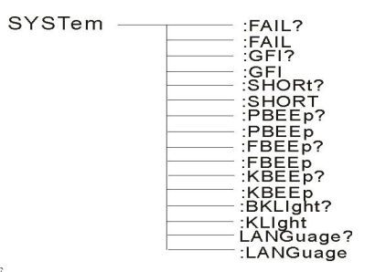

SYSTem ：PBEE/FBEE/KBEE
Set / query test pass / fail / key buzzer status

--Format

Format: SYST:PBEE<ON/OFF>OR<1/0>

Query format: syst: PBEE?

- Data: <ON/OFF>

Data type: character

Data range: 0 (OFF), 1 (ON).

example:

Set BEEP to 1

Set command: SYST:BEEP 1

--Return information

Query command: SYST:BEEP? , return value: buzzer status, such as 1

SYSTem:REset restore all default States

--Format:

Format: SYST:RES

8.4.4 MMEM subsystem command set

MMEM:SAVE saves the current file to the file number.

--Format:

Format: MMEM:SAVE< file name >

--Data < file name >

Data type: String

MMEM LOAD exports the file specified by the file number to the current

--Format:

Format: MMEM:LOAD< file name >

--Data < file name >

Data type: String

8.4.5 FETCH subsystem command set

FETCH is used to obtain measurement results of instruments.

--Format:

Format: FETCh:AUTO

Query format: FETCh:AUTO?

-- data <ON/OFF>or <1/0>

Data type: character

Data range: 0 (OFF), 1 (ON).

--Example:

Automatically return test data to ON

Command: FETCh:AUTO ON or FETCh:AUTO 1
--Return information

Query command: FETCh? To return the current measurement result of the instrument.

Command syntax: FETCh?

After receiving this command, the instrument will automatically send test results until the end of the test.

Return format:

Step: test item: test current (A) test resistance (MΩ) sorting results

1. The separator between step and test item, test item and data is (:)

2. The separator between test data is (,) the separator between different unit data is (;)

3. The separator between steps is (: + space), and the data terminator is uyly (0x0A)

Note: 1, all data are integer or floating point format, ASCII string.

2, data unit default is the same as FCUN set instruction set.

The test results are as follows

STEP1: I: 30A, test resistance 100mΩ, result PASS.

Return data format:

STEP1 I :30,100,PASS；（SPACE）

8.4.6 other control command sets

*IDN query instrument model, version information

Query return: <manufacturer>, <model>, <firmware><NL^END>

Here: < manufacturer > gives the name of the manufacturer (REK)

<model> gives the machine type (e.g. RK9960).

<firmware> gives the software version number (such as Version 1.0.0).

For example: "IDN?"

Chapter 9 Maintenance guide

9.1 Daily maintenance
9.1.1 the tester shall be used in a well ventilated and dry environment without dust and electromagnetic interference.

9.1.2 if the tester is not used for a long time, it should be powered on regularly, usually once a month, and the power on time should be less than 30 minutes.

9.1.3 after the tester works for a long time, such as about 8 hours, it should be turned off for more than 10 minutes to keep the tester in good working condition.

9.1.4 the tester may have poor contact or open circuit after long-term use, so it should be repaired regularly.

9.2 Simple troubleshooting
Fault phenomenon | processing method
After power on, there is no display button and no response | Please check whether the power supply is normal and whether the fuse is broken. If it is broken, please replace the fuse
After starting, the test lamp is not on but has output | The test lamp is out of order
After starting, the test lamp is not on and there is no output | The start button doesn't touch well
After starting, there is no current or voltage display | Please check whether the test line is open, the object is not in good contact or the object is open
After the test fails, the unqualified lamp does not light up | Unqualified lamp broken

If there is a problem that can not be eliminated in time, please contact our company or dealer as soon as possible, and we will provide you with service in time.

9.3 Software upgrade steps of instrument system
9.3.1 connect the USB interface on the back panel of the instrument to the computer, the power resource manager displays the USB disk, copies the upgrade file to the target disk of the instrument, and restarts the instrument to complete the system software upgrade.

If you encounter technical problems in upgrading, please contact us in time.

9.3.2 press the STOP+START button to restart the power, remove the data errors caused by the version changes, and restore the settings data as the default factory settings.

