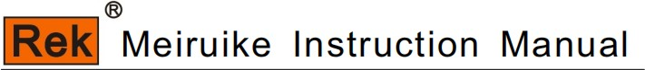

RK9966 Series
Photovoltaic safety comprehensive tester
operation instruction

SHENZHEN MEIRUIKE ELECTRONIC TECHNOLOGY CO.,LT

Safety warning:

Instrument grounding

This instrument is a Class I safety instrument. When connecting the power supply, please make sure that the power socket contains grounding wire. If it is not grounded, static electricity or induced electricity on the casing may cause personal injury!

Danger of electric shock

Electric shock damage

Beware of electric shock during operation, testing and instrument maintenance. Non-professionals are not allowed to open the chassis without authorization. If professionals need to change the fuse or carry out other maintenance, they must unplug the power plug first and be accompanied by others. Even if the power plug has been unplugged, there may still be dangerous voltage on the capacitor, so it should be operated after discharge.

Any incorrect removal or addition of the tested part during the test will cause abnormal damage to people, property or instruments! ! ! If the instrument is damaged due to abnormal operation, the maintenance cost shall be borne by the customer.

Please use the power supply according to the power supply parameters specified in this instrument, and the power supply input that does not meet the specifications may damage this instrument.

Stay away from the explosion
Sexual gas environment

Electronic instruments should not be used in flammable and explosive gas environment or environment containing corrosive gas or smoke, because it may bring danger.

Other safety
item

point out

Please do not apply any voltage source or current source to the test terminal of this instrument.

An important supplement or reminder to the content elaborated.

Instructions for use:
* Please read and understand the contents described in the instruction carefully before operating the tester. After reading, please put the instruction manual near the operator so that it can be used in
Read when necessary. When moving the tester from 1 workplace to another, please carry the manual with the instrument to avoid losing it.
* With the improvement of instrument function and the upgrade of software, the instruction manual will be improved and upgraded continuously. Please pay attention to the software and instructions of the tester.
Version.

catalogue
Chapter 1 Safety Rules
1.1 General provisions 1
1.2 Maintenance and maintenance 1
1.3 test environment 1
1.4 operator regulations 2
1.5 Safety grounding regulations 2
1.6 fuse replacement regulations 3
1.7 test safety regulations 3
1.8 test exception regulations 3
1.9 safety points 3
Chapter 2 Overview and Technical Indicators
2.1 product overview 4
2.2 Function introduction 5
2.3 technical indicators 7
Chapter 3 Panel Description
3.1 front panel description 9
3.2 Description of rear panel 13
3.3 Definition of screen display area 15
3.4 Main menu buttons and corresponding displayed pages 15
Chapter 4 Operating Instructions
4.1 boot instructions and boot screen 18
4.2 operation steps 18
Chapter 5 HANDLER Interface and SIGNAL Interface
5.1 Circuit structure and use of handler interface and SIGNAL interface 20
5.2 Description of output signals 20
Chapter 6 Parameter Settings
6.1 instrument self-test. 21
6.2 parameter setting mode 22

6.3System setup mode 37
6.4File parameter description 39

Chapter 7 Remote Control
7.1 RS232C Interface Description 40
7.2 description of RS485/232c interface 41
7.3 （modbus）...................................................................................................................................41

Chapter 8 SCPI serial port instruction reference
  - Brief description of instruction format 49
  - SCPI instruction set 49
  - DISPLAY instruction set 49
  - FUNCTION subsystem command set 50

Chapter 9 Maintenance Guide
  - daily maintenance 65
  - Simple fault handling 65
  - Instructions for software upgrade steps of instrument system 65

Chapter 10 Warranties and Accessories
10.1 Warranty 66
10.2 Accessories 66

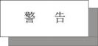
Chapter 1 Safety Rules
The contents of the user manual are subject to change without prior notice.
If there is anything unclear in the user manual, please contact us directly.
Rules and matters needing attention before testing!
Warning: To prevent malfunction or damage to the tester, please use the tester within the specified voltage range.
1.1 General provisions
■ Before using the tester, please read the manual carefully to understand the operating procedures and related safety signs to ensure safety.
■ Please select the correct input voltage specification before turning on the input power switch.
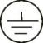
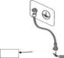
Chassis grounding symbol
Warning: It should be noted that the operations, applications or conditions performed are very dangerous, which may lead to personal injury.
Injury or death.

The current generated by the tester is enough to cause casualties. In order to prevent accidental injury or death, please take care when moving and using the tester.
You must observe clearly before you operate.

1.2 Maintenance and maintenance
1.2.1 In order to prevent electric shock, non-professionals should not open the cover of the tester, and all parts inside the tester should not be replaced without permission. If there is any abnormality in the tester, please seek the help of our company or the designated dealer.
1.2.2 Regular maintenance
Testers, power cords, test lines and related accessories should be carefully inspected and calibrated at least once a year to ensure the safety of operators and testers.
The accuracy of.
1.2.3 user's modification
Users are not allowed to change the circuit or parts of the tester by themselves, otherwise our guarantee will be invalid and we will not be responsible for the consequences.

1.3 test environment
1.3.1 Working position
When operating the tester, you must ensure that the tester is placed in a place that ordinary people can't touch at will. If it can't be d1 because of the arrangement of the production line,
The test area must be isolated from other facilities and specially marked with "test work area".

1.3.2 input power supply
The tester uses 220V/110V 50Hz/60Hz single-phase power supply. Before turning on the power switch, please ensure that the power supply voltage meets the requirements. The power supply in the test area must have a separate switch, which is installed at the entrance of the test area to ensure that all personnel can identify it. Once an emergency occurs, it can be set up.
That is, turn off the power.

To prevent the tester from malfunction, please use it within the specified voltage range.

1.3.3 Workplace
Use a workbench made of non-conductive materials as much as possible. The test site must be kept neat and clean at all times, and must not be chaotic. Unused testers and
Please put the test line in a fixed position, and make sure that all personnel can immediately separate the tested object, the tested object and the tested object.
The air in the test area and the surrounding area must not contain flammable gas, nor can the tester be used next to flammable items.
1.4 operator regulations
1.4.1 Qualification of operators
The current output by the tester is enough to cause personal injury or death when it is electrocuted by wrong operation, so it must be used and operated by trained and qualified personnel.
1.4.2 Safety Code
Operators must give education and training at any time to make them understand the importance of various operating rules, and operate the tester according to safety rules, in order to pre-.
To prevent electric shock accidents, please wear insulating gloves before using the tester.
1.4.3 dress code
Operators are not allowed to wear clothes decorated with metal or wear metal ornaments and watches, which can easily cause accidental electric shock. get an electric shock
, the consequences will be more serious.
1.4.4 Medical regulations
The tester must not be operated by people who have heart disease or wear a pacemaker.
Incorrect grounding or ungrounded grounding may lead to electric shock accidents.
1.5 Safety grounding regulations
The tester must have a good grounding, and the ground wire must be connected well before the test to ensure the safety of the operator. If the ground wire on the power plug is connected
Unreliable, an additional protective grounding terminal is provided on the back panel of the tester for connecting to a safe ground.

1.6 fuse replacement regulations

Incorrect grounding or ungrounded grounding may lead to electric shock accidents.

Please turn off the input power switch and disconnect the power plug before replacing the fuse, and the standard one should be replaced.
Fuse (200V-240V 10A RK9966/RK9966B).
（200V-240V 8A RK9966A）
（200V-240V 5A RK9966C）

In order to avoid electric shock, be sure to disconnect the power cord before replacing the fuse.

1.7 test safety regulations
After connecting the test line to the object to be tested, make sure the connection is reliable. Operators must ensure that they can operate completely independently and cannot be controlled by other personnel.
Control switch and remote control switch should be placed in a fixed position when not in use, and should not be placed at will.

Never use the tester on a live circuit board or equipment! Do not touch or contact the test object during the test.
Connected objects!

1.8 test exception regulations
Under some specific conditions, the tester will not respond to the reset key, the test time value will not move, and the black screen will be displayed during the test, which is very
Dangerous. When these situations occur, please turn off the power switch and disconnect the power plug. Do not use it again, please contact our company.

Turn off the power switch and unplug the power plug immediately when the test is abnormal!

1.9 safety points
■ Unqualified operators and irrelevant personnel should stay away from the test area.
■ The test area must be kept in a safe and orderly state at all times.
■ Never touch the test object or anything connected with the test object during the test.
■ In case of any problems, please turn off the output and input power immediately.

chapter 2 outlines the technical indicators.

2.1 product overview
Thank you for purchasing and using our products. Before using this instrument, please confirm it according to the "Annex" in the last chapter of this manual. If there is any,
Please contact our company as soon as possible to safeguard your rights and interests.
2.1.1 The photovoltaic safety comprehensive tester is displayed on a 7-inch TFT LCD screen. The sine wave voltage required for AC withstand voltage test and sine wave current required for grounding test are driven by DDS+ linear power amplifier, and the output waveform is pure and the distortion is small. The tester adopts high-speed MCU and large-scale digital circuit design, and its output voltage, frequency and voltage rise and fall are completely controlled by MCU. The breakdown current value and voltage value can be displayed in real time; It is very simple to set up and operate, and provides PLC remote control interface, RS232C, RS485, USB and other interfaces, which can be easily combined by users.
Integrated test system.
Complete functions: The test items include DC withstand voltage, insulation resistance, DC grounding on resistance, arc detection, open circuit detection, etc.
Powerful performance: touch screen, high precision, basic safety accuracy of 1%; Fast speed, synchronous output of grounding and withstand voltage.
2.1.2 The tester has the function of nonconformity discrimination, acousto-optic alarm and automatic control of test time, which can meet the needs of production line or quality inspection.
2.1.3 The tester can be used for household appliances, electronic instruments, electronic equipment, power tools, electric heating appliances and other products.
2.1.4 Conditions of use
Power supply voltage: 110 V/220 V (10%)
Power frequency: 50Hz/60Hz (±5%%)
Power consumption: < ＜450VA
2.1.5 ambient temperature and humidity
Normal working temperature: 0℃-40℃, humidity: < 90% RH.
Measurement environment temperature: 20℃ 8℃, humidity: < 80% RH.
Transportation environment temperature: 0℃-55℃, humidity: ≤93%RH.
2.1.6 Preheating
Warm-up time after startup: ≥30 minutes
2.1.7 insulation resistance
Under the metering working conditions, the insulation resistance between the power supply terminal and the shell shall not be less than 50MΩ.

Under the condition of hot and humid transportation, the insulation resistance between the power supply terminal and the shell shall not be less than 2MΩ.
2.1.8 Insulation strength
Under the metering working conditions, the AC power supply with rated voltage of 1.5KV and frequency of 50Hz can withstand between the power supply terminal and the housing for 1 minute without breakdown.
And arcing phenomenon.

2.1.9 Electromagnetic compatibility and compliance with standards
The transient sensitivity of power supply shall meet the requirements of GB6833.4. The conduction sensitivity is in accordance with the requirements of GB6833.6. Radiation interference shall meet the requirements of GB6833.10.
Household appliances standards (IEC60335, GB4706.1-2005), lamps standards (IEC60598-1-1999, GB7000.1-2007), information standards (GB8898-2011, GB12113, GB4943.1-2011)
Standard (UL1703), photovoltaic DC grounding resistance standard (IEC61730-1) and so on.

2.2 Function introduction
2.2.1 Automatic adjustment of output voltage (current)
The voltage output by withstand voltage and insulation test and the current output by grounding resistance test of this series of testers are all controlled by negative feedback circuit.
When testing, the tester can automatically adjust to the voltage value (current value) set by the user.
2.2.2 Automatic booster
The user can set the speed of voltage rise according to the time, for example, the rated test voltage is 1000V, and the voltage rise time can be set to 20S if the tester rises 50V per second, and 5S if the tester rises 200V per second. In the process of voltage rising, if the test current is greater than the upper limit of the set current, the instrument will automatically cut off the output, send out an audible and visual alarm prompt, and keep the current value showing the current voltage value on the display screen. This function is often used to test or analyze the voltage breakdown point of the tested object, and can also be used to test the capacitive tested object.
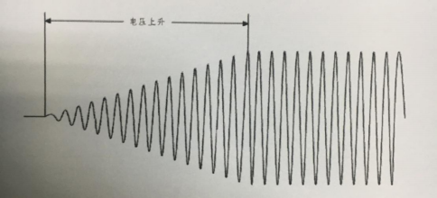
Pressure resistance. This function can not be achieved by traditional withstand voltage testing devices.

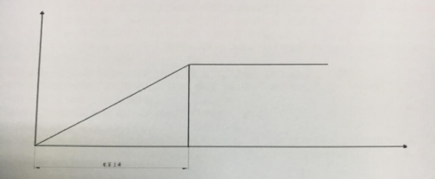

2.2.3 Automatic depressurization
The user can set the speed of voltage drop according to the time, for example, the rated test voltage is 1000V, and the voltage drop time can be set to 20S if the tester drops 50V per second, and 5S if the tester drops 200V per second. In the process of voltage drop, if the test current is greater than the upper limit of the set current, the instrument will automatically cut off the output, send out an audible and visual alarm prompt, and keep the display on the display screen.
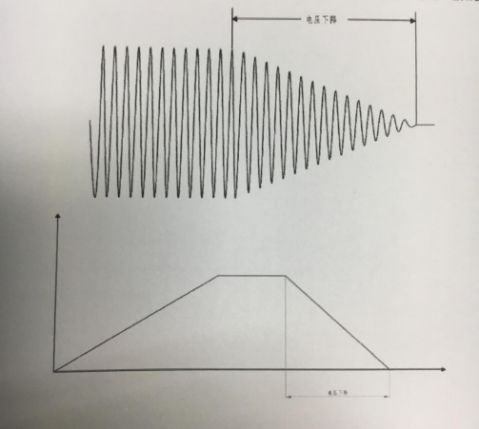
A current value indicating the current voltage value.

2.3 technical indicators
Parametric model |  | RK9966 | RK9966A | RK9966B | RK9966C
ACW | Output voltage range | (0.1 ～10.00)kV | (0.05～5.00)kV | (0.05～5.00)kV | (0.05～5.00)kV
 | Maximum output power | 200VA(10.0kV 20mA) | 100VA(5.0kV 20mA) | 100VA(5.0kV 20mA) | 100VA(5.0kV 20mA)
 | Maximum rated current | 20mA | 20mA | 20mA | 20mA
 | Output waveform | Sine wave DDS+ power amplifier | Sine wave DDS+ power amplifier | Sine wave DDS+ power amplifier | Sine wave DDS+ power amplifier
DCW | Output voltage range | (0.1 ～10.00)kV | (0.05～6.00)kV | (0.05～6.00)kV | (0.05～6.00)kV
 | Maximum output power | 100VA(10.0kV 10mA) | 60VA(6.0kV 10mA) | 60VA(6.0kV 10mA) | 60VA(6.0kV 10mA)
IR | output range | 0.1～10KV | 0.05 ～5.000KV | 0.05 ～2.500KV | 0.05 ～2.500KV
 | Maximum upper limit setting | 499.9GΩ | 99.99GΩ | 49.99GΩ | 199.99GΩ
 | Maximum and lower limit setting | 499.8GΩ | 99.98GΩ | 49.98GΩ | 199.98G Ω
 | Minimum lower limit setting | 0.1MΩ | 0.1MΩ | 0.1MΩ | 0.1MΩ
 | Test range | ≥500V ＜1.5KV 100GΩ/10M～100GΩ  < ＜500V 100K～1G,1G, and the accuracy is not guaranteed above 1g.  ≥1.5KV 500GΩ/10M～500GΩ | < 500V100k ~ 1g, and the accuracy of more than 1g is not guaranteed to be ≥500V 100GΩ. | < ＜500V 100K～1G,1G, and the accuracy of more than 1g is not guaranteed to be ≥ 500 v 50g ω. | < ＜500V 100K～1G,1G, and the accuracy is not guaranteed above 1g.
 | precision | 0.1MΩ~1000MΩ ±5%+5 1GΩ~50GΩ ±10%+10 | 0.1MΩ~1000MΩ ±5%+5 1GΩ~50GΩ ±10%+10 | 0.1MΩ~1000MΩ ±5%+5 | 0.1MΩ~1000MΩ±5%+51000MΩ~50GΩ±10%+10
 |  | 50GΩ~500GΩ±15%+5 | 50GΩ~100GΩ±15%+10 | 1000MΩ~50GΩ±10%+10 | 50GΩ ~200GΩ±15%+10
GR | Output current range | 3～60A（DC） | 3～40A（AC） | 3～60A（DC） | /
 | Current accuracy | (1% reading +0.2A) | (1% reading +0.2A) | (1% reading +0.2A) | /
 | resolution ratio | 0.1A | 0.1A | 0.1A | /
 | Resistance upper limit setting | (Maximum current/current setting) × 105m | (Maximum current/current setting) × 105m | (Maximum current/current setting) × 105m | /
 | Resistance accuracy | (1.5% reading+1m) | 1.5% reading+1m) | 1.5% reading+1m) | /
 | Resistance test range | 0-600 mω, 0-120 mω when the output current is 3-10A, and 10-60A when the output current is 10-60a. | 0-600 mω, 0-120 mω when the output current is 3-10A, and 10-60A when the output current is 10-60a. | 0-600 mω, 0-120 mω when the output current is 3-10A, and 10-60A when the output current is 10-60a. | /
 | Lower resistance setting | 0 ~ upper limit value of resistance | 0 ~ upper limit value of resistance | 0 ~ upper limit value of resistance | /
Electromanometer | range | AC (0.1 ～10.00)kV  DC(0.1 ～10.00)kV | AC (0.05～5.00)kV  DC(0.05～6.00)kV | AC (0.05～5.00)kV  DC(0.05～6.00)kV | AC (0.05～5.00)kV  DC(0.05～6.00)kV
 | precision | ±（1.5%+5V） | ±（1.5%+5V） | ±（1.5%+5V） | ±（2%+5V）
galvanometer | measuring range | AC 5uA～20mA  DC：0.5uA～ 10mA | AC 5uA～20mA  DC：0.5uA～ 10mA | AC 5uA～20mA  DC：0.5uA～ 10mA | AC 5uA～20mA  DC：0.5uA～ 10mA
 | measurement accuracy | ≥ 2ma (1.5%+5 words) < 2ma (2%+5 words) | ≥ 2ma (1.5%+5 words) < 2ma (2%+5 words) | ≥ 2ma (1.5%+5 words) < 2ma (2%+5 words) | ≥ 2ma (1.5%+5 words) < 2ma (2%+5 words)
timer | range | 0.1-999.9S | 0.1-999.9S | 0.1-999.9S | 0.1-999.9S
 | Minimum resolution | 0.1S | 0.1S | 0.1S | 0.1S
 | precision | ±（1%+50ms） | ±（1%+50ms） | ±（1%+50ms） | ±（1%+50ms）
testTime |  | 0.1S-999S 0FF= continuous test. | 0.1S-999S 0FF= continuous test. | 0.1S-999S 0FF= continuous test. | 0.1S-999S 0FF= continuous test.
Arc detection |  | 0-20mA | 0-20mA | 0-20mA | 0-20mA
Output frequency |  | 50Hz/60Hz | 50Hz/60Hz | 50Hz/60Hz | 50Hz/60Hz
Working temperature |  | 0-40℃≤75%RH | 0-40℃≤75%RH | 0-40℃≤75%RH | 0-40℃≤75%RH
power requirement |  | 110/220±10%  50Hz/60Hz±3Hz | 110/220±10%  50Hz/60Hz±3Hz | 110/220±10%  50Hz/60Hz±3Hz | 110/220±10%  50Hz/60Hz±3Hz
joggle/interface |  | Standard RS232, USB and PLC, optional LAN and RS485. | Standard RS232, USB and PLC, optional LAN and RS485. | Standard RS232, USB and PLC, optional LAN and RS485. | Standard RS232, USB and PLC, optional LAN and RS485.
screen |  | 7 inch TFT 800*480 | 7 inch TFT 800*480 | 7 inch TFT 800*480 | 7 inch TFT 800*480
Overall volume (D×H×W) |  | 440mm×155mm×760mm | 440mm×150mm×490mm | 440mm×150mm×760mm | 440mm×150mm×490mm
weight |  | 36.25KG | 24.55KG | 30.6KG | 18.85KG
Optional standard accessories |  | Power supply line RK00018, test line  RK26003A, test line RK00048, test line RK00007, high voltage bar 8N+  , RS232 communication cable Rk0002, RS232 to USB cable RK00003,  USB adapter cable RK00006 and wire interface adapter drive CD.  U disk (manual) and 1 set of terminal (red and black) | Power supply line RK00018, test line  RK26003A, test line RK00048, test line RK00007, high voltage bar 8N+  , RS232 communication cable RK00002,  RS232 to USB cable RK00003,  USB square port connecting cable RK00006,  Wire interface switching drive CD,  U disk (manual) and 1 set of terminal (red and black) | Power supply line RK00018, test line  RK26003A, test line RK00048, test line RK00007, high voltage bar 8N+  , RS232 communication cable RK00002,  RS232 to USB cable RK00003,  USB square port connecting cable RK00006,  Wire interface adapter drive CD, U disk (manual) and 1 set of terminal (red and black) | Power supply line RK00018, test line  RK26003A, test line RK00048,  High voltage rod 8N+,  RS232 communication cable RK00002,  RS232 to USB cable RK00003,  USB square port connecting cable RK00006,  Wire interface switching drive CD,  U disk (manual)
Optional parts |  | USB to RS485 bus serial line industrial grade  The connecting line is 1.5 meters long.  upper computer | USB to RS485 bus serial line industrial grade  The connecting line is 1.5 meters long.  upper computer | USB to RS485 bus serial line industrial grade  The connecting line is 1.5 meters long.  upper computer | USB to RS485 bus serial line industrial grade  The connecting line is 1.5 meters long.  upper computer

Chapter 3 Front Panel Description
3.1 Front Panel Structure
3.1.1RK9966/9966A/9966B Front Panel Description

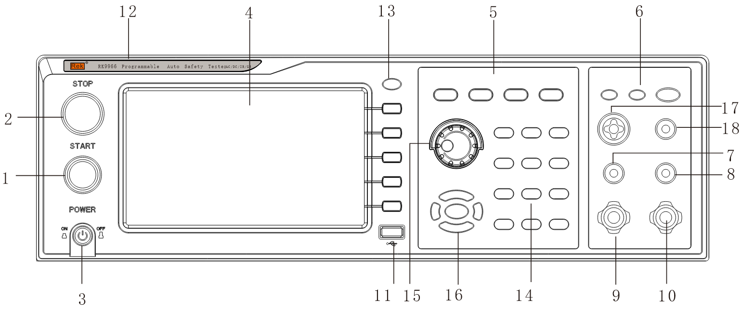

1. START key (start)
Green instantaneous contact switch, its function is:
Start switch for testing voltage output
2. Reset key (STOP)
Red instantaneous contact switch, its function is:
When setting the mode, it is used as a switch to leave the setting mode.
When testing, it can be used as a switch to interrupt the test.
At the end of the test, it is used as a switch to exit the test display and enter the next state to be tested.
3. POWER switch (power)
Working power input of tester
4. LCD screen
Display various setting information and test data.
5. Functional area
Various setting operation areas
6. Test result indicator area
When the tester has output, the indicator light will light up, indicating "output, being tested", and the test passes and fails.

7. Voltage detection terminal (SENSE H)
Detecting the voltage on the grounding resistance of the tested part
8. Voltage detection terminal (SENSEL)
Detecting the voltage on the grounding resistance of the tested part
9. Current output (CURRENTH)
Special output terminal, which can bear large current above 70A, is used as the current output terminal of the measured object. As the loop test end of the DUT.
10. Current loop end (CURRENTL)
Special output terminal, which can bear large current above 70A, is used as the current output terminal of the measured object. As the loop test end of the DUT.
11.USB storage area
As an interface for copying and copying file data.
12. Tester model indication
13.LOCK key
Used for panel function keys. During the test, the lights are on and all functions of the panel are locked, except the STOP and START keys.
14.0-9 numeric keypad
Numeric value for input parameter.
15. Rotary coding potentiometer
When used for parameter setting, you can adjust this potentiometer and press the key to confirm the setting.
16. Up and down, left and right and ENTEN confirm keys
Used to adjust options when setting parameter functions, and ENTER is the confirmation function key.
17. High voltage output terminal
High voltage output of high voltage test interface.
18. High-voltage circuit end
Output end of test voltage and current sampling end.
3.1.3 Description of Indicating Ribbon
1. Qualified lamp
Contains green LED indicator light, which will light up when the object to be tested passes the test.
2. Unqualified lamp
Contains a red LED indicator, which will light up when the test of the object to be tested fails.
4. When the 4.DRANG light is on, it means that the instrument should pay attention to safety during testing.
3.1.4 Description of Parameter Ribbon
Key is the function of test status. Select this key to enter the test; Key is the parameter setting key. Select this key to enter all test parameters of the tester.

Number setting; Key is the function setting key of the tester system. Select this key to set various functions of the tester system; The key is the function key of the tester file. Select this key to copy, copy and delete the tested data file.

3.1.2 RK9966C front panel description

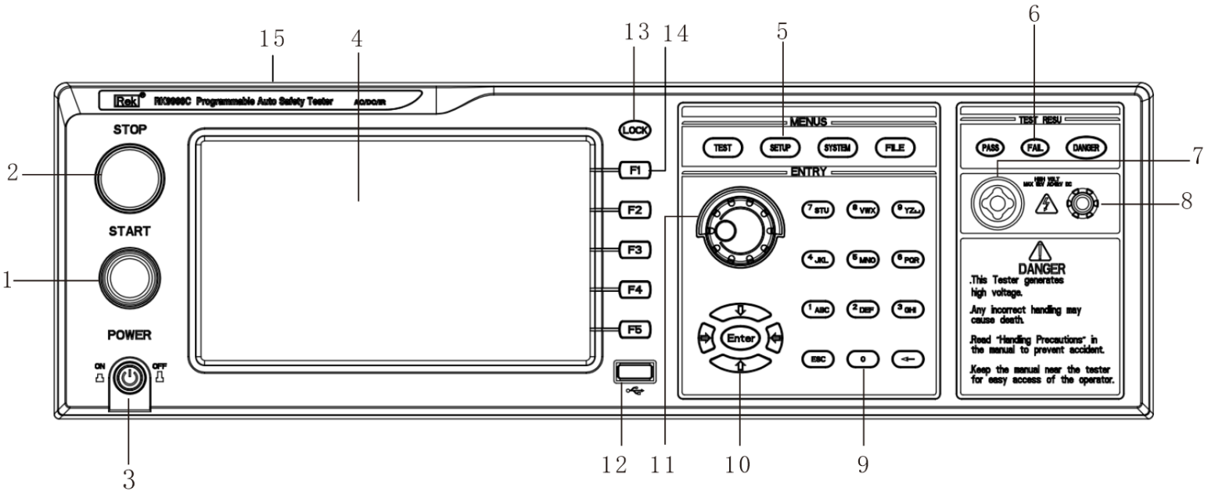

1. START key (start)
Green instantaneous contact switch, its function is:
Start switch for testing voltage output
2. Reset key (STOP)
Red instantaneous contact switch, its function is:
When setting the mode, it is used as a switch to leave the setting mode.
When testing, it can be used as a switch to interrupt the test.
At the end of the test, it is used as a switch to exit the test display and enter the next state to be tested.
3. POWER switch (power)
Working power input of tester
4. LCD screen
Display various setting information and test data.
5. Functional area
Various setting operation areas
6. Test result indicator area
When the tester has output, the indicator light will light up, indicating "output, being tested", and the test passes and fails.
7. High voltage output terminal
8. High voltage loop end
9.0-9 numeric keypad
Numeric value for input parameter.
10. Up and down, left and right and ENTEN confirm keys
Used to adjust options when setting parameter functions, and ENTER is the confirmation function key.

11. Rotary coding potentiometer
When used for parameter setting, you can adjust this potentiometer and press the key to confirm the setting.
12.USB storage area
As an interface for copying and copying file data.
13.LOCK key
Used for panel function keys. During the test, the lights are on and all functions of the panel are locked, except the STOP and START keys.
14. Shortcut function keys
F1-F5 correspond to the LCD, and the function operation area on the right side realizes quick operation.
15. Tester model indication

3.2 Description of rear panel
3.2.1RK9966A/9966C Rear Panel Description
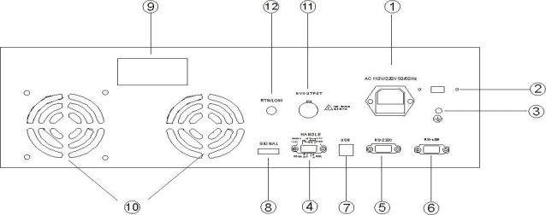

1. Power socket
The standard input power socket provides working power for the tester. Pay attention to turn off the input power switch and disconnect the power plug before replacing the fuse.
And the standard fuse (RK9966A 8A/250AC; RK9966C 5A/250AC ）。
2, 115V/230V power conversion
3. Grounding terminal
For the safety grounding terminal of the tester, please be sure to connect the ground wire properly to ensure the safety of the operator.
4. PLC signal terminal
A standard 9-core D-type female terminal base provides remote monitoring and control signal interface.
5. RS232C interface
Provide RS232C serial communication function.
6. RS485 interface
Provide RS485 serial communication function.
7. USB interface
Provide USB computer with the function of connecting U disk.
8. Control signal output
This interface has 24V output function.
9. Nameplate
Model name, date of manufacture and serial number of the tester.
10, cooling holes
Provide heat dissipation for the interior of the tester.
11. High-voltage output terminal (option)
12. High-voltage circuit end (option)

3.2.2 RK9966/9966B Rear Panel Description

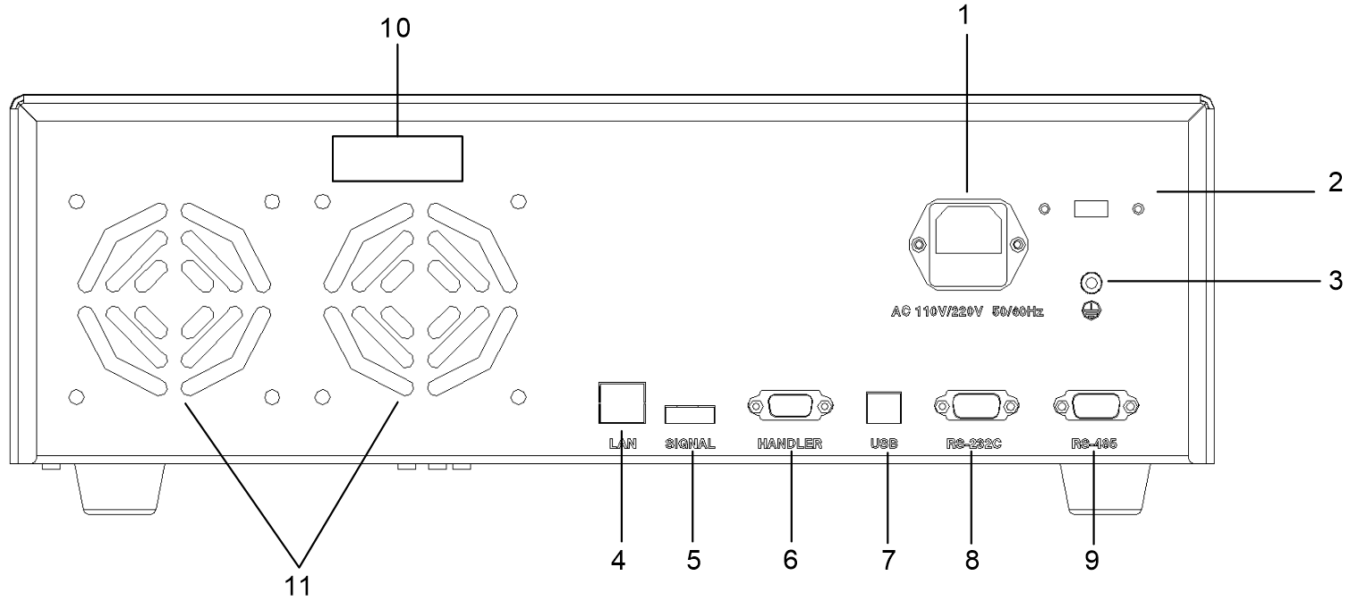

1. Power socket
The standard input power socket provides working power for the tester. Pay attention to turn off the input power switch and disconnect the power plug before replacing the fuse.
And the standard fuse (RK9966 10A/250AC; RK9966B 10A/250AC）
2, 115V/230V power conversion
3. Grounding terminal
For the safety grounding terminal of the tester, please be sure to connect the ground wire properly to ensure the safety of the operator.
4. LAN interface
LAN communication interface to realize communication with computer.
5. Control signal output
This interface has 24V output function.
6. PLC signal terminal
A standard 9-core D-type female terminal base provides remote monitoring and control signal interface.
7. USB interface
Provide USB computer with the function of connecting U disk.
8. RS232C interface
Provide RS232C serial communication function.
9. RS485 interface
Provide RS485 serial communication function.
10. Nameplate
Model name, date of manufacture and serial number of the tester.
11, cooling holes
Provide heat dissipation for the interior of the tester.

3.3 Definition of screen display area
RK9966 adopts an 800×480 LCD 7-inch display screen, and the contents displayed on the display screen are divided into the following display areas, as shown below:
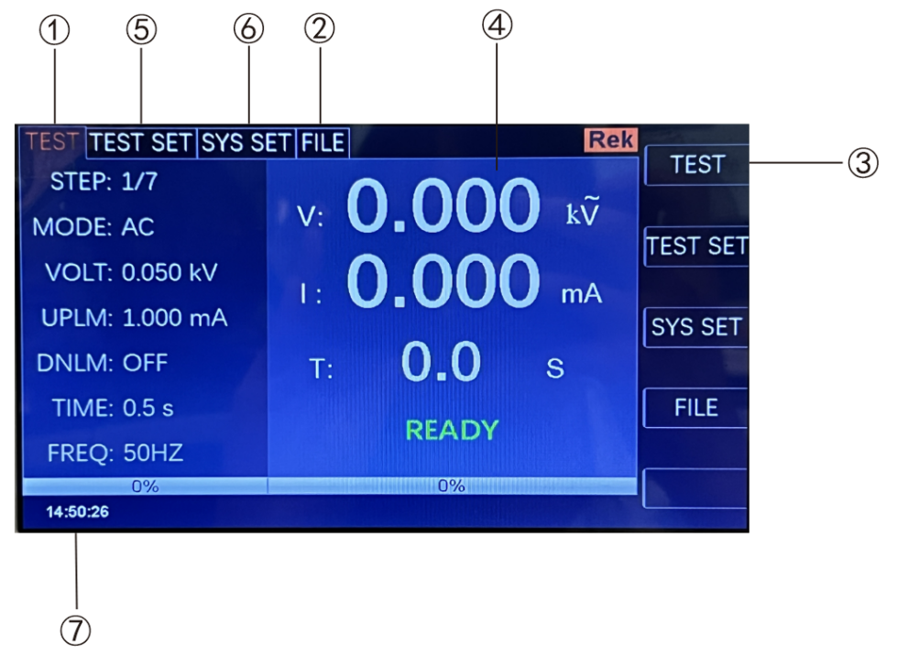
3.3.1 Measure the display page area.
The area indicates the measurement parameter name of the current page.
3.3.2 file domain
Move the cursor to this area for file management. File management includes: loading, saving and deleting.
3.3.3 Soft key area
This area is used to display the function definition of soft keys. The definition of soft keys has different function definitions depending on the location of the cursor area.
3.3.4 Measurement result display area
This area displays test result information and current test conditions.
3.3.5 Parameter setting area
This area displays various parameter settings.
3.3.6 System Settings
This area displays the system parameter settings.
3.3.7 Time display area
This area displays the current working time.
3.4 Main menu buttons and corresponding displayed pages
3.4.1 Measurement Display Main Menu Keys
Display home page for various measurements. The function pages in this part are (use the "soft key" to select the following page functions, the same below):

< measurement display >
< measurement settings >
< system settings >
"document management"

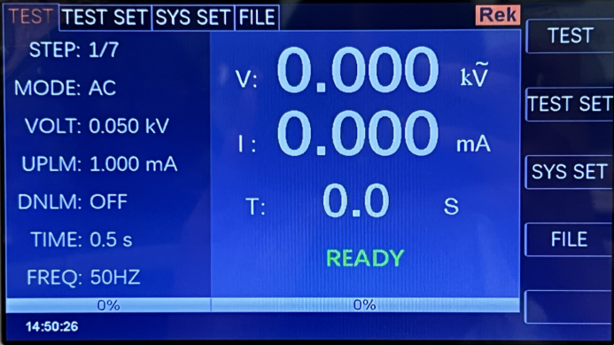

3.4.2 Parameter Settings Main Menu Keys
It is mainly used to enter the measurement setting interface corresponding to the measurement display. The main interfaces are as follows:

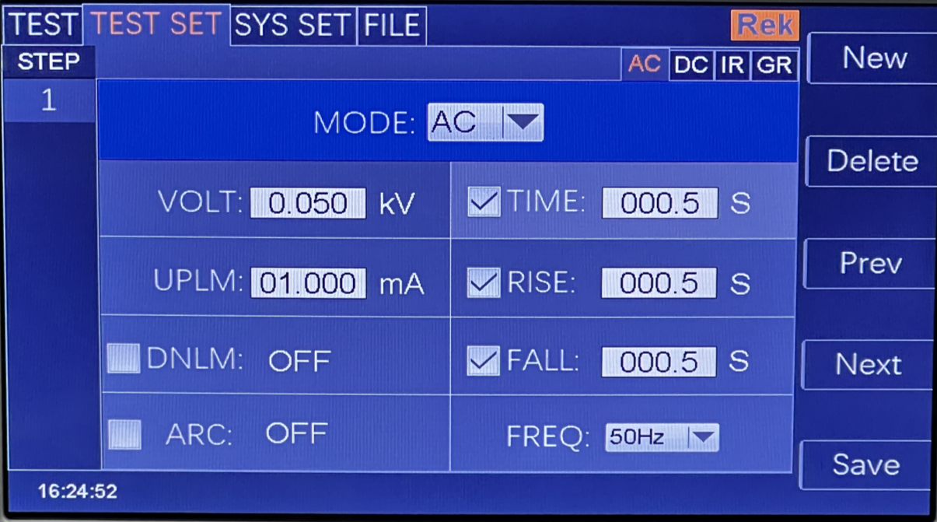

3.4.3 System Settings Main Menu Button
Used to enter the system settings home page. Mainly about the system settings, this part of the function page are:

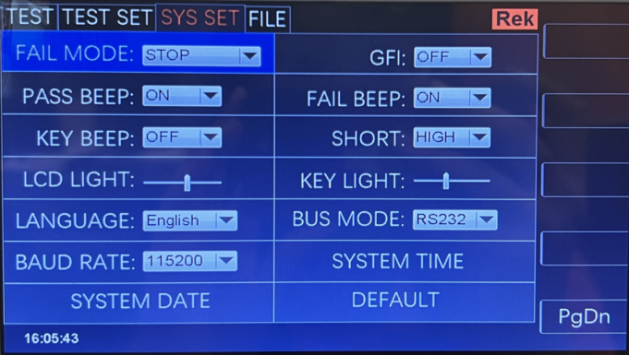

3.4.4 Description of contact inspection function
Contact inspection is conducted by a high voltage of 1kV to determine whether it contacts the equipment under test, which is usually used for testing equipment under 100G.
It is recommended to use high-voltage rod for contact inspection when testing.

measure | Parameter setting |  | system setup | document | Rek
 |  |  |  |  |  | the previous page
VERSION:0.0.221226 LC0.0.0
Contact inspection: |  | OFF
Step mode: Normal
Communication protocol: Scpi
Address: 001
10:20:15

3.4.5 File Management Main Menu Button
Used for file management settings.
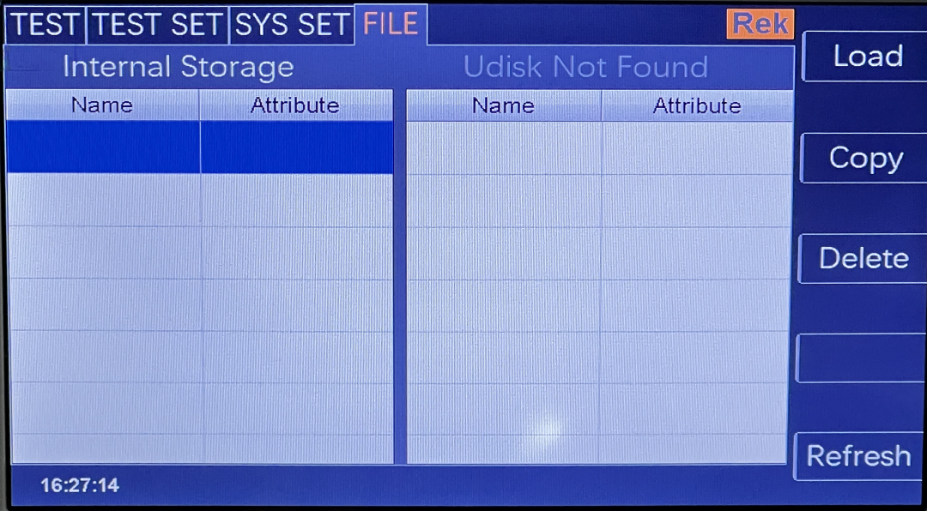

The 4 chapter explains the operation
4.1 boot instructions and boot screen
Before the power cord plug is connected to the mains supply, please turn off the input "power switch", check whether the safety specification is correct, and connect the safety grounding wire to the test.
"Ground terminal" on the back panel of tester.

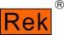
RK9966
Shenzhen Meiruike Electronic Technology Co.,Ltd.
ProgrammableAuto Safety Tester
VERSION：1.0.0Copyright(c)2023
http://www.chinarek.com

The basic operation is as follows:
■ Use the menu button ([test] [setup] [system] [file]) and soft keys to select the page you want to display.
■ Use the cursor ([→] [←] [↑] [↓]) to move the cursor to the field you want to set. When the cursor moves to a field, the field will turn blue. A domain is an area where the cursor can be set.
■ The domain where the current cursor is located can be used to set the parameter value by coding potentiometer or numeric keys. When the data input is finished, you can use the [Enter] key or lightly press the coding potentiometer to confirm.
4.2 operation steps
4.2.1 Setting tester parameters
Please refer to the chapter "Parameter Settings" to set various parameters.
4.2.2 Connect the tester with the tested object.
Plug in the three-wire power plug.
Note: The power supply voltage should be kept at 90-121VAC(60Hz) or 198-242VAC (50Hz).
The power input phase line L, neutral line N and ground line E should be the same as those on the power plug of this instrument.
Turn on the power, press the power switch in the lower left corner of the front panel, and the instrument will be turned on, displaying the boot screen. As shown above.
Please press the "reset" button once first, and make sure that the test indicator light is off, the monitor works normally and there is no output, then connect the test line and check the laboratory.
Whether all connections are reliable.
4.2.3 Press the "Start" key to start the test.

After pressing the "Start" key, the tester outputs, and at this time, the test indicator light on the front panel will light up, and the display will display "Being Tested" and display at the same time.
The test value, the timer also starts to work, and the data will be updated continuously.
4.2.4 Determination of qualified products
After the test is completed, the tester will automatically turn off the output, the qualified indicator light on the front panel will light up and make a sound at the same time, and the display will display "PASS".
And the test data indicate that the tester determines that the tested object is qualified.
If you want to continue the test, you can press the "Start" button again and the tester will start the test again.
If you want to stop the test, you can press the "Reset" key, and the tester will stop the test immediately, and the display will keep the current test value.
4.2.5 Determination of nonconforming products
If the test fails, the tester will immediately turn off the output, the unqualified light on the front panel will light up, and a warning sound will be given, and the monitor will display the test.
The trial failure prompt and test data indicate that the tester determines that the tested object is unqualified. Test failure tips include: upper limit failure and over-current protection.
If you want to turn off the alarm sound, you can press the "Reset" key.
4.2.6 START and STOP operation instructions
START key is the key to start the test. Press this key to start the test. STOP key is the reset STO P key. In the test state, press STO P key once to interrupt the test of the instrument. The running light DANGER turns off and the LOCK light turns on. Press STOP to enter the reset state of the secondary instrument, DANGER and Loc K.
The lights went out.
Both ends of the red and black terminal of the instrument are connected to the four-terminal test line equipped by the instrument, and when the measured object is not connected, press the START key to start the instrument. At this time, the instrument
The device appears "open circuit failure" and gives an alarm sound (when the grounding resistance function option is selected).

Chapter 5 HANDLER Interface and SIGNAL Interface
5.1 Circuit structure and use of handler interface and SIGNAL interface
The principle of control interface is shown in the following figure. This terminal is a standard 9PIN D terminal holder, which contains PROCESSING (under test) and PASS (test pass).
Over), FALL (TEST failure) and other three monitoring signals output and test (start), STOP (reset) two remote control input signals.
5.2 Description of output signals
HANDLER interface: START, STOP and COM signals constitute remote input control, and the switch input is closed effectively.
HANDLER interface: remote output control is composed of TEST, PASS and FAIL signals. The switch is closed effectively. TEST can be used as a high voltage starter.
Dynamic signal, or pulse signal that the instrument works normally.
SINGAL interface is mainly used to provide an instrument selection signal (INTLOCK) for multi-instrument online testing. This signal is prohibited when a single machine is short-circuited by default and open-circuited.
This instrument starts high voltage output.
SINGAL interface provides about +24V power supply, and the output current is less than 0.5A With the control signal of HANDLER interface, the indicator lamp can be driven.
Photoelectric switch, low-power electromagnetic valve, etc. This interface is generally used for remote control and test synchronization or indication.
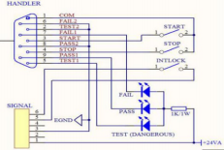
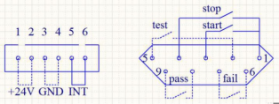

1. PROCESSING signal: the output signal is connected between PIN5 and PIN2.
2. PASS signal: The output signal is connected between PIN8 and PIN9.
3. FALL signal: The output signal is connected between PIN6 and PIN7.
4. START OUT: the output signal is connected between PIN3 and PIN1.
5. RESET OUT: the output signal is connected between PIN4 and PIN1.

Chapter 6 Parameter Setting
6.1 instrument self-check.
6.1.1 Instrument power-on self-check items
When the tester runs POST, the screen displays as follows

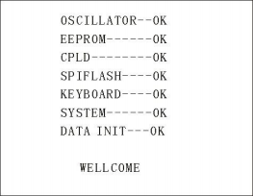

The self-inspection items are as follows:
1. Detection of internal crystal oscillator working state: If it is normal, it will display OK; if it is abnormal, it will give an alarm sound and cannot enter the self-inspection of the next project.
2. I/O memory status detection: If it is normal, OK will be displayed; if it is abnormal, an alarm sound will be given, and the next self-check cannot be entered. 3. State detection of complex programmable logic: If it is normal, OK will be displayed; if it is abnormal, an alarm sound will be given, and the self-check of the next project cannot be entered.
4. State detection of serial peripheral interface: If it is normal, OK will be displayed; if it is abnormal, an alarm sound will be given, and the self-check of the next item will not be entered.
5. Keyboard status detection: If it is normal, OK will be displayed; if it is abnormal, an alarm sound will be given, and the next item cannot be self-checked.
6. System status detection: If it is normal, OK will be displayed; if it is abnormal, an alarm sound will be given, and the self-inspection of the next project cannot be entered.
7. Data initialization status detection: If it is normal, OK will be displayed; if it is abnormal, an alarm sound will be given, and the next self-check cannot be entered.
If there are no errors in the above self-inspection, the instrument self-inspection is successful. Enter the test interface, as shown below:

6.2 parameter setting mode
Press the "SETUP" or "F2" key on the instrument panel in the measurement interface to enter the parameter setting page.
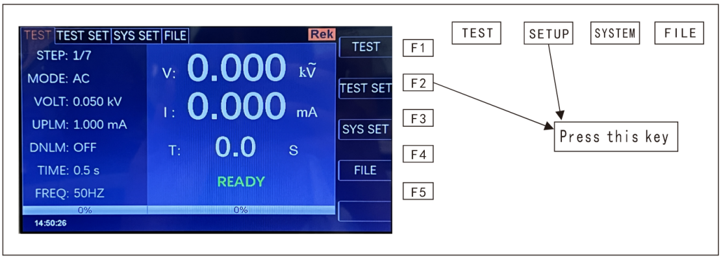

The parameter setting interface is as follows:

Note: It varies according to the test mode of the test steps.
6.2.1 Description of parameter setting
Test mode: a parameter in the step details panel is always a test mode parameter. Editing this parameter can change the test mode of the test step. Scope: Test modes supported by the instrument. After pressing the "Enter" key on this parameter, modify the test mode control value according to the selection box control modification method, and then press the "Enter" key again to save the modification. If the test mode of the test step changes, the parameter panel corresponding to the new test mode is automatically updated. Under repair
During the modification, you can press the "ESC" key to cancel all current operations.
6.2.2 Description of test modes supported by step
The test mode supported by the test step is determined by the following factors: the test mode supported by the tester and the file working mode.
For example, suppose that the tester supports ACW, DCW, IR and GR test modes, and when the file working mode is GR, it is a GR test condition.
6.2.3 ACW AC withstand voltage parameter setting
Select "AC" withstand voltage test mode under the parameter panel setting, and the test parameter setting will enter "AC" withstand voltage mode, as shown below.

Set the parameters as follows:
Test mode: after the cursor moves to the test mode, press "ENTER" to enter the test mode editing, and press "→" or "←" to change the test mode.
Type, set AC withstand voltage tester, select AC, and then press "ENTER" to save. In this way, all the following parameters are changed to AC withstand voltage parameters.
Output voltage: press the "↓" key or code dial to move the cursor to the value after the output voltage, as shown in the following figure:

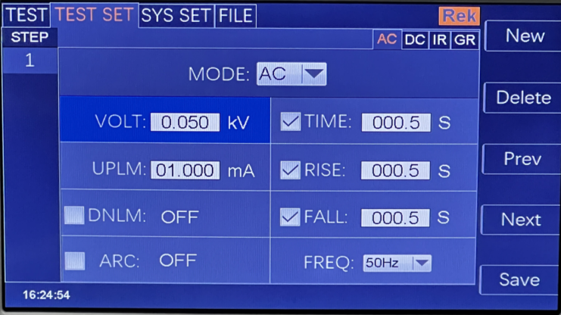

In this interface, press the "ENTER" key to edit the output voltage value, and the output voltage range is (0.050-5.000)KV. To change the output voltage value, just enter the number keys. For example, to input a voltage of 2.000KV, just press the number keys 2 "and" ENTER ". To input 4.750KV,
"
Just press "4", "7", "5", "0" and "ENTER".
Current upper limit: press the "↓" key or code dial to move the cursor to the value after the current upper limit, as shown in the following figure:
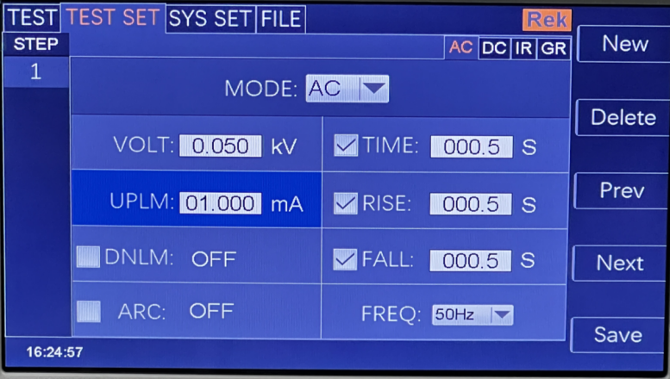

In this interface, press the "ENTER" key to edit the upper limit value of current, with the range of (0.001-20.00)mA. To change the current upper limit,

Just enter the number keys. For example, to ENTER 0.515mA, just press "0", "5", "1", "5" and "Enter".
Lower current limit: press the "↓" key or code dial to move the cursor to the value after the lower current limit, as shown in the following figure:

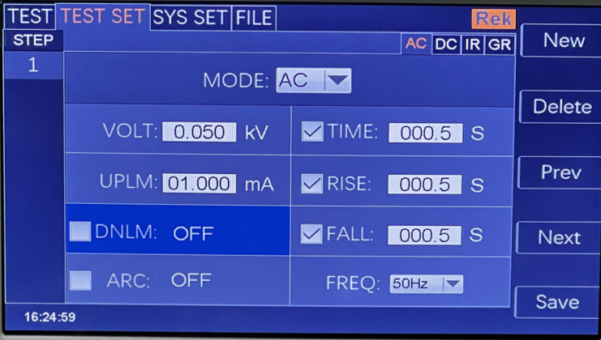

Note: Turn on or off the lower limit function with the "ENTER" key. The lower limit range is (0.001-10)mA.
After the lower limit function is turned on, the lower limit setting function can be operated by lightly pressing the coded potentiometer. To change the current lower limit value, just enter the number keys. for example
To ENTER 0.515mA, just press "0", "5", "1", "5" and "Enter".
Arc function: press the "↓" key or code dial to move the cursor to the arc function item, as shown in the following figure:
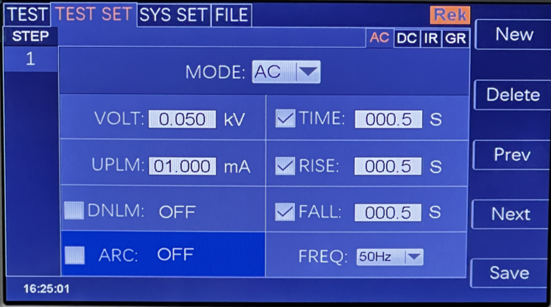
Note: Turn on or off the arc function with the "ENTER" key, and the arc range is (0.1-20)mA.
After the arc function is turned on, the arc setting function can be operated by lightly pressing the coded potentiometer. To change the arc value, just enter the number keys. Like losing.
ENTER 0.515mA, and press "0", "5", "1", "5" and "Enter".
The smaller the arc value is set, the lighter or flashover phenomenon of the measured object will not be detected by the tester during the test.
Test time: press the "↓" key or code dial to move the cursor to the time function item, as shown in the following figure:
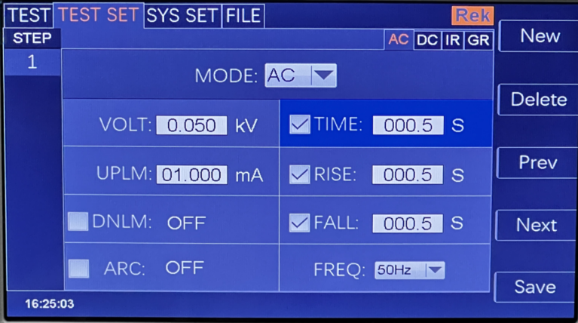

In this interface, press the "ENTER" key to edit the time in the range of (0.1-999.9) s. To change the time value, just enter the number keys.
Just do it. For example, to ENTER 101.2, just press "1", "0", "1", "2" and "Enter".
Rise time: press the "↓" key or code dial to move the cursor to the rise time function item, as shown in the following figure:
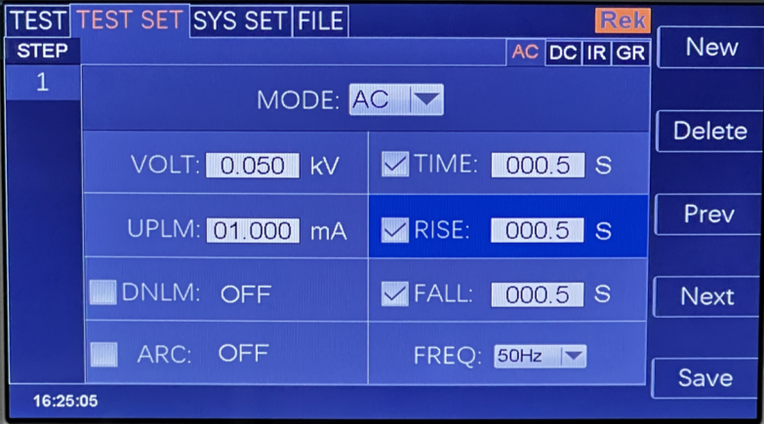

In this interface, press the "ENTER" key to edit the time in the range of (0.1-999.9) s. To change the time value, just enter the number keys.
Just do it. For example, to ENTER 15, just press "0", "0", "1", "5" and "Enter".
Descent time: press the "↓" key or code dial to move the cursor to the function item of descent time, as shown in the following figure:
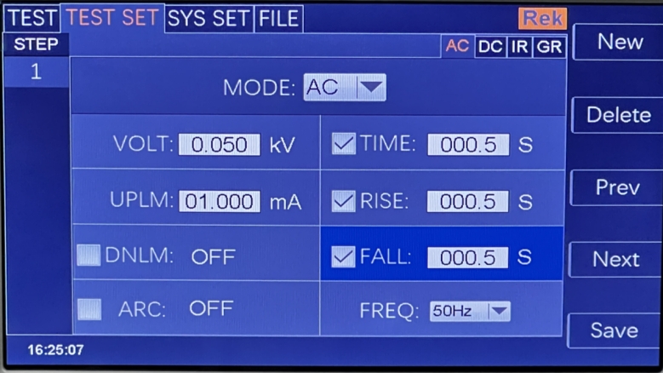

In this interface, press the "ENTER" key to edit the time in the range of (0.1-999.9) s. To change the time value, just enter the number keys.
Just do it. For example, to ENTER 15, just press "0", "0", "1", "5" and "Enter".
Frequency: press the "↓" key or code dial to move the cursor to the frequency function item, as shown in the following figure:

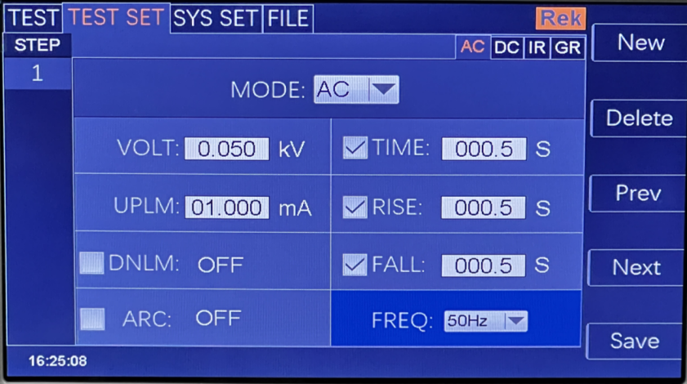

In this interface, press the "ENTER" key to edit the frequency in the range of (50/60)Hz. Press "↓" "↑" or rotate the coded potential.

Device to change the frequency value.
New step: Press "F1" key "New" on the panel in the test interface to create a new test step, and a total of 20 tests can be created.
Steps. A new test step is established after the current step, which adopts the default test mode-AC voltage.
Delete step: press "F2" key "Delete" on the panel in the test interface to delete the test step, and the tester deletes the current step.
The following steps are moved to the current step.
Previous page: (Step Forward) In the test interface, press the "F3" key "Previous Page" on the panel to move forward the current step, that is, the contents of the current test step and the previous test step are exchanged, which can conveniently realize the sorting function of test steps, but when the current step is the first test step, move forward.
Invalid.
Next Page: (Step Backward) Press the "F4" key "Next Page" on the panel in the test interface to move back the current step, that is, the contents of the current test step and the next test step are exchanged, which can conveniently realize the function of sorting test steps, but when the current step is the last test step, move back.
Invalid.
Save as file: press the F5 key on the panel in the test interface to save the current test steps in the form of a file.
Save, convenient access to use. Press Save as File to open the storage interface, as shown below:
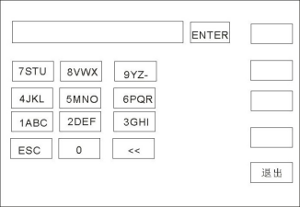

After entering the interface shown above, press the number keys on the panel, and the screen will be displayed as follows:
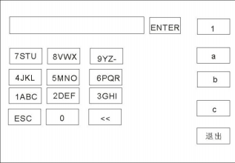

Type the relevant characters on the screen, press the ENTER key, and the file will be saved in the tester memory.
6.2.4 DCW withstand voltage parameter setting of DCW
Select "DC" withstand voltage test mode under the parameter panel setting, and the test parameter setting will enter "DC" withstand voltage mode, as shown below:

Set the parameters as follows:
Test mode: after the cursor moves to the test mode, press "ENTER" to enter the test mode editing, and press "→" or "←" to change the test mode.
Type, set DC withstand voltage tester to select DC, and then press the "ENTER" key to save. In this way, all the following parameters are changed to DC withstand voltage parameters.
Output voltage: press the "↓" key or code dial to move the cursor to the value after the output voltage, as shown in the following figure:

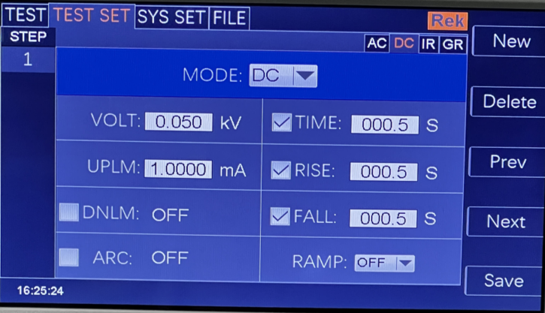
In this interface, press the "ENTER" key to edit the output voltage value, and the output voltage range is (0.050-5.000)KV. To change the output voltage value, just enter the number keys. For example, to input a voltage of 2.000KV, just press the number keys 2 "and" ENTER ". To input 4.750KV,
"
Just press "4", "7", "5", "0" and "ENTER".

Current upper limit: press the "↓" key or code dial to move the cursor to the value after the current upper limit, as shown in the following figure:

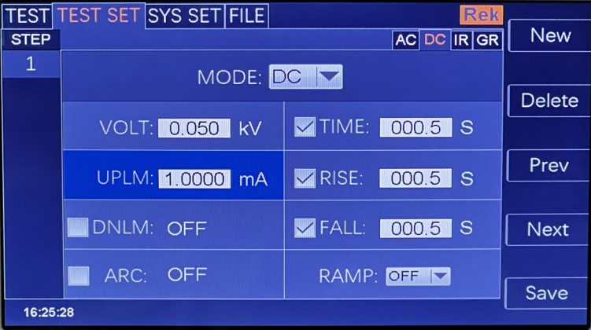

In this interface, press the "ENTER" key to edit the upper limit value of current, with the range of (0.001-10.00)mA. To change the current upper limit,
Just enter the number keys. For example, to ENTER 0.515mA, just press "0", "5", "1", "5" and "Enter".

Lower current limit: press the "↓" key or code dial to move the cursor to the value after the lower current limit, as shown in the following figure:
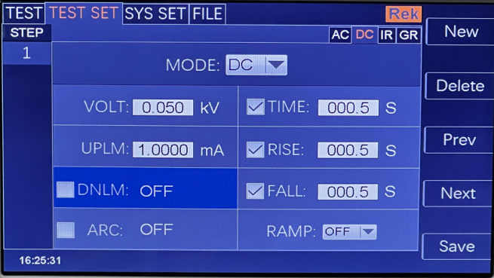

Note: Turn on or off the lower limit function with the "ENTER" key. The lower limit range is (0.001-10)mA.
After the lower limit function is turned on, the lower limit setting function can be operated by lightly pressing the coded potentiometer. To change the current lower limit value, just enter the number keys. for example
To ENTER 0.515mA, just press "0", "5", "1", "5" and "Enter".
Arc function: press the "↓" key or code dial to move the cursor to the arc function item, as shown in the following figure:

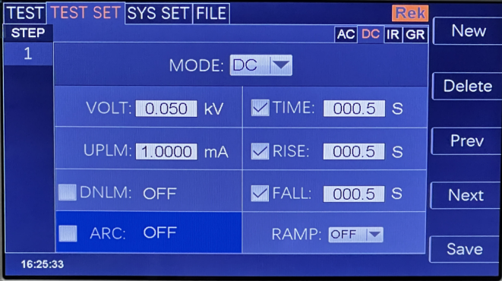

Note: Turn on or off the arc function with the "ENTER" key, and the arc range is (0.1-10 )mA.
After the arc function is turned on, the arc setting function can be operated by lightly pressing the coded potentiometer. To change the arc value, just enter the number keys. Like losing.
ENTER 0.515mA, and press "0", "5", "1", "5" and "Enter".
The smaller the arc value is set, the lighter or flashover phenomenon of the measured object will not be detected by the tester during the test.
Test time: press the "↓" key or code dial to move the cursor to the time function item, as shown in the following figure:

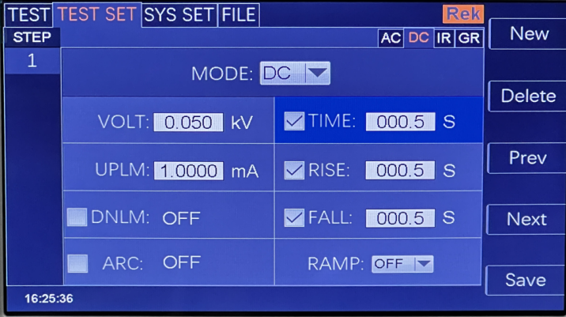

In this interface, press the "ENTER" key to edit the time in the range of (0.1-999.9) s. To change the time value, just enter the number keys.
Just do it. For example, to ENTER 101.2, just press "1", "0", "1", "2" and "Enter".
Rise time: press the "↓" key or code dial to move the cursor to the rise time function item, as shown in the following figure:
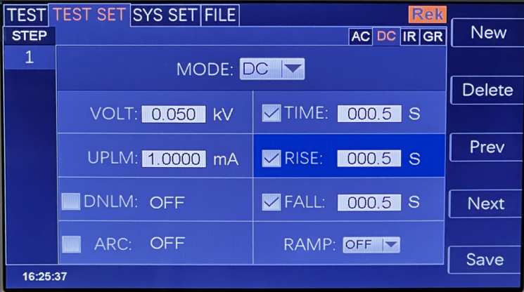

In this interface, press the "ENTER" key to edit the time in the range of (0.1-999.9) s. To change the time value, just enter the number keys.
Just do it. For example, to ENTER 15, just press "0", "0", "1", "5" and "Enter".
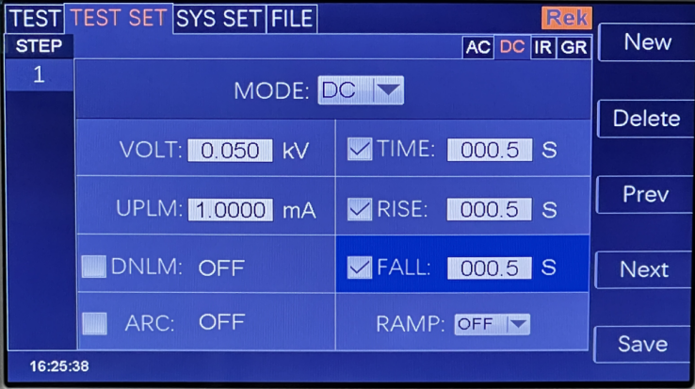
Descent time: press the "↓" key or code dial to move the cursor to the function item of descent time, as shown in the following figure:

In this interface, press the "ENTER" key to edit the time in the range of (0.1-999.9) s. To change the time value, just enter the number keys.
To change the time value, just enter the number keys. For example, to ENTER 15, just press "0", "0", "1", "5" and "Enter".

Ascending judgment: press the "↓" key or code dial to move the cursor to the ascending judgment function item, as shown in the following figure:
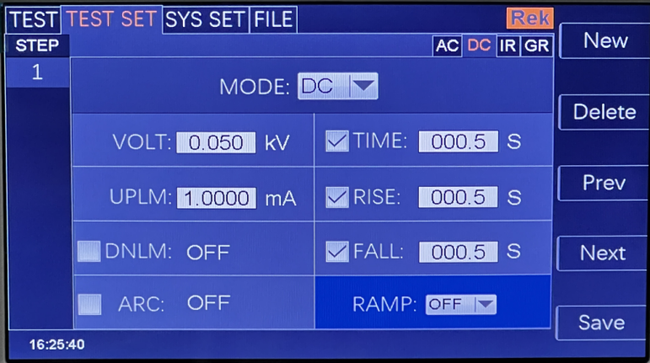

In this interface, press the "ENTER" key to edit the rising judgment in the range of (ON/OFF). Press "↓" "↑" or rotate the code.

Potentiometer
New step: press the "F1" key "New" on the panel in the test interface to create a new test step, and a total of 20 tests can be created.
Steps. A new test step is established after the current step, which adopts the default test mode-AC voltage.
Delete step: press "F2" key "Delete" on the panel in the test interface to delete the test step, and the tester deletes the current step.
The following steps are moved to the current step.
Previous page: (Step Forward) In the test interface, press the "F3" key "Previous Page" on the panel to move forward the current step, that is, the contents of the current test step and the previous test step are exchanged, which can conveniently realize the sorting function of test steps, but when the current step is the first test step, move forward.
Invalid.
Next Page: (Step Backward) Press the "F4" key "Next Page" on the panel in the test interface to move back the current step, that is, the contents of the current test step and the next test step are exchanged, which can conveniently realize the function of sorting test steps, but when the current step is the last test step, move back.
Invalid.
Save as file: press the F5 key on the panel in the test interface to save the current test steps in the form of a file.
Save, convenient access to use. Press Save as File to open the storage interface, as shown below:
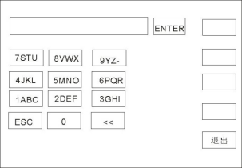

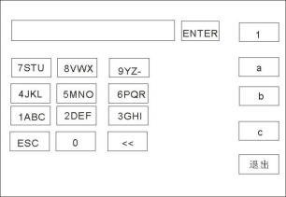
After entering the interface shown above, press the number keys on the panel, and the screen will be displayed as follows:

Type the relevant characters on the screen, press the "ENTER" key, and the file will be saved in the tester memory.

6.2.5 IR insulation resistance parameter setting
Select "IR" insulation test mode under the parameter panel setting, and the test parameter setting will enter "IR" withstand voltage mode, as shown below:
Set the parameters as follows:
Test mode: after the cursor moves to the test mode, press "ENTER" to enter the test mode editing, and press "→" or "←" to change the test mode.
Type, set the IR insulation test, and then press the "ENTER" key to save. In this way, all the following parameters are changed to the parameters of insulation resistance.
Output voltage: press the "↓" key or code dial to move the cursor to the value after the output voltage, as shown in the following figure:
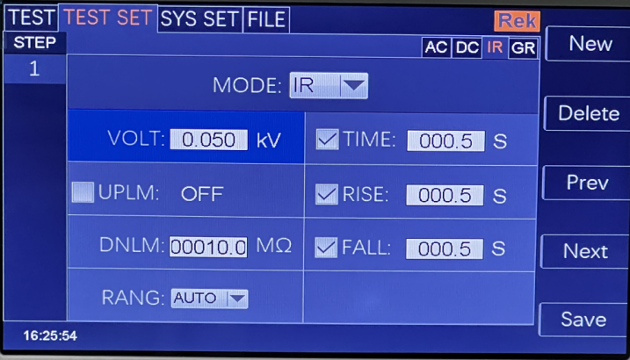

In this interface, press the "ENTER" key to edit the output voltage value, and the output voltage range is (0.050-1.000)KV. To change the output power
Pressure value, just enter the number keys. For example, to input 1.000KV, just press "1", "0", "0" and "ENTER".
Upper limit of resistance: press the "↓" key or code dial to move the cursor to the value after the upper limit of resistance, as shown in the following figure:
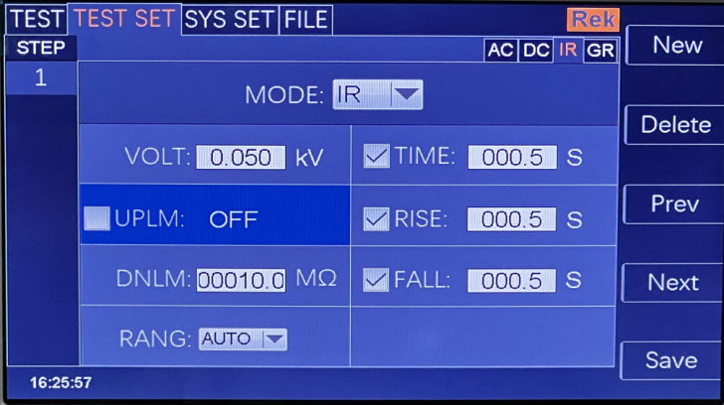
In this interface, press the "ENTER" key to edit the upper limit value of current, and the range is (0.1-9999.9) mω. To change the current upper limit, just enter the number keys. For example, to ENTER 0.515mA, just press "0", "5", "1", "5" and "Enter".
Lower resistance limit: press the "↓" key or code dial to move the cursor to the value after the lower current limit, as shown in the following figure:
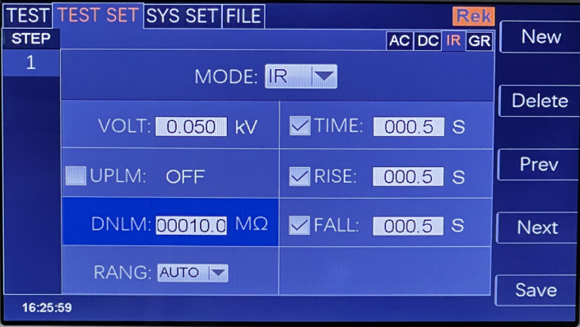

Note: Use the "ENTER" key to turn on or off the lower limit function. The lower limit range is (0.1-9999.9) mω.
After the lower limit function is turned on, the lower limit setting function can be operated by lightly pressing the coded potentiometer. To change the current lower limit value, just enter the number keys. for example
To ENTER 1000 mω, just press "1", "0", "0", "0" and "Enter".
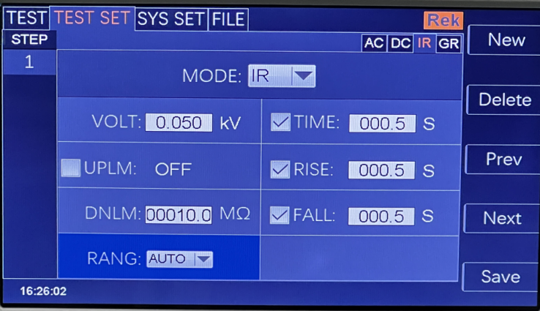
Range function: press the "↓" key or code dial to move the cursor to the range function item, as shown in the following figure:

The measuring range is divided into: AUTO, 1MΩ, 10MΩ, 100MΩ, 1GΩ and 50G(RK9966B/C).
AUTO 、1MΩ 、10MΩ 、100MΩ 、1GΩ、 100G(RK9966A）
AUTO 、1MΩ 、10MΩ 、100MΩ 、1GΩ、 500G(RK9966）
Test time: press the "↓" key or code dial to move the cursor to the time function item, as shown in the following figure:
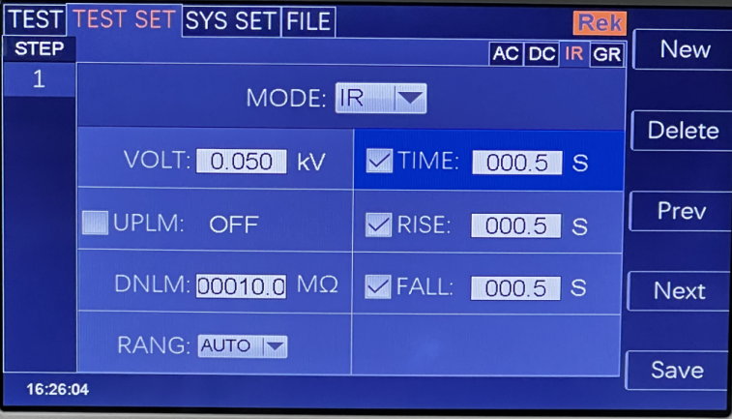

In this interface, press the "ENTER" key to edit the time in the range of (0.1-999.9) s. To change the time value, just enter the number keys.
Just do it. For example, to ENTER 101.2, just press "1", "0", "1", "2" and "Enter".
Rise time: press the "↓" key or code dial to move the cursor to the rise time function item, as shown in the following figure:
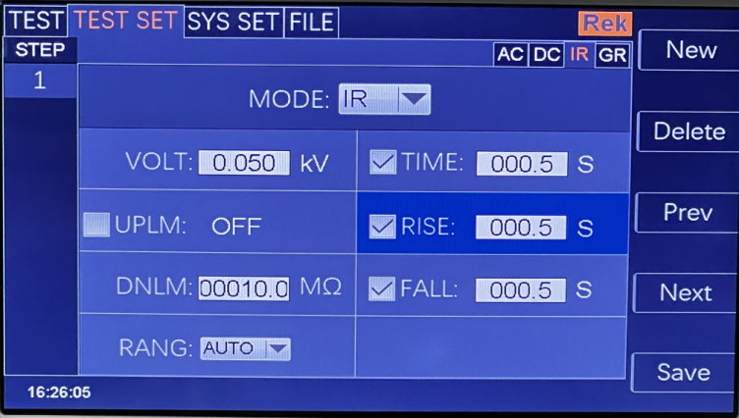

In this interface, press the "ENTER" key to edit the time in the range of (0.1-999.9) s. To change the time value, just enter the number keys.
Just do it. For example, to ENTER 101.2, just press "1", "0", "1", "2" and "Enter".

Descent time: press the "↓" key or code dial to move the cursor to the function item of descent time, as shown in the following figure:

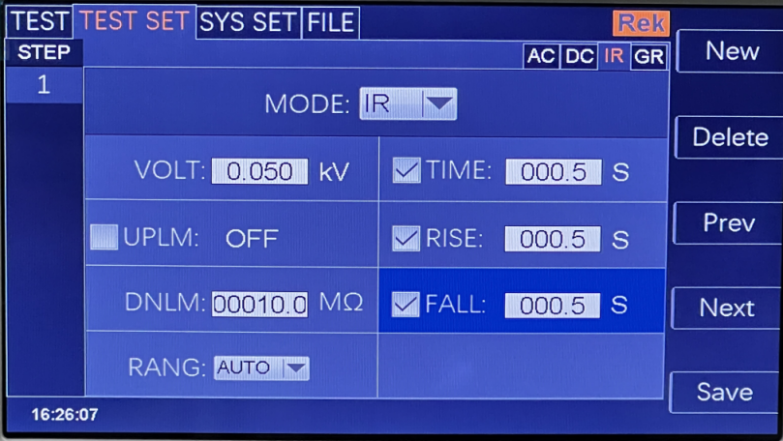

In this interface, press the "ENTER" key to edit the time in the range of (0.1-999.9) s. To change the time value, just enter the number keys.
Just do it. For example, to ENTER 101.2, just press "1", "0", "1", "2" and "Enter".

New step: press the "F1" key "New" on the panel in the test interface to create a new test step, and a total of 20 tests can be created.
Steps. A new test step is established after the current step, which adopts the default test mode-AC voltage.
Delete step: press "F2" key "Delete" on the panel in the test interface to delete the test step, and the tester deletes the current step.
The following steps are moved to the current step.
Previous page: (Step Forward) In the test interface, press the "F3" key "Previous Page" on the panel to move forward the current step, that is, the contents of the current test step and the previous test step are exchanged, which can conveniently realize the sorting function of test steps, but when the current step is the first test step, move forward.
Invalid.
Next Page: (Step Backward) Press the "F4" key "Next Page" on the panel in the test interface to move back the current step, that is, the contents of the current test step and the next test step are exchanged, which can conveniently realize the function of sorting test steps, but when the current step is the last test step, move back.
Invalid.
Save as file: press the F5 key on the panel in the test interface to save the current test steps in the form of a file.
Save, convenient access to use. Press Save as File to open the storage interface, as shown below:
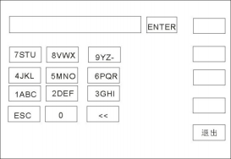

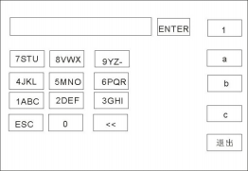
After entering the interface shown above, press the number keys on the panel, and the screen will be displayed as follows:

Type the relevant characters on the screen, press the "ENTER" key, and the file will be saved in the tester memory.

6.2.6 GR Grounding Resistance Parameter Setting
Select "GR" grounding resistance test mode under the parameter panel setting, and the test parameter setting will enter "GR" withstand voltage mode, as shown below:

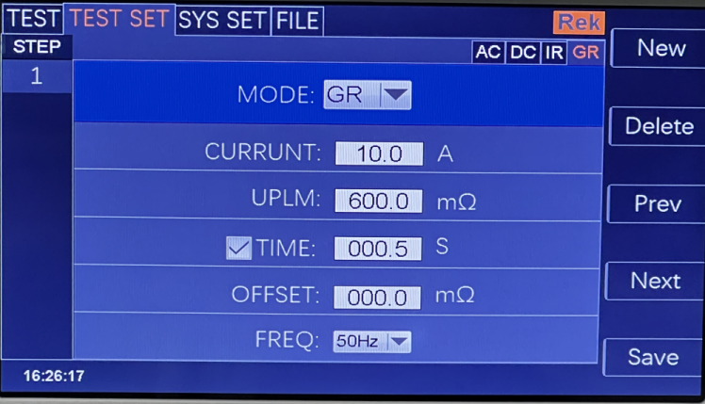

Set the parameters as follows:
Test mode: after the cursor moves to the test mode, press "ENTER" to enter the test mode editing, and press "→" or "←" to change the test mode.
Type, set the GR insulation test, and then press the "ENTER" key to save. In this way, all the following parameters are changed to the parameters of grounding resistance.

Output current: press the "↓" key or code dial to move the cursor to the value after the output current, as shown in the following figure:
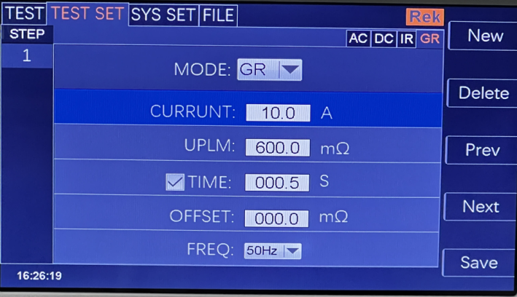

In this interface, press the "ENTER" key to edit the output voltage value, and the output voltage range is (1-30.0) A. To change the output current value,
Just enter the number keys. For example, to ENTER 10.0A, just press "1", "0", "0" and "Enter".
Upper limit of resistance test: press the "↓" key or code dial to move the cursor to the value after the upper limit of resistance test, as shown in the following figure:

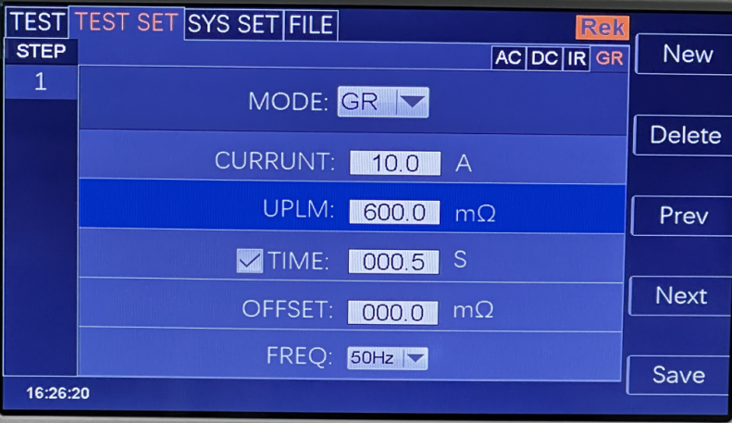

In this interface, press the "ENTER" key to edit the upper limit value of the test, and the range is (0.1-10) mω. To change the current upper limit, just enter the number key. For example, to ENTER 100 mω, just press "1", "0", "0" and "Enter".
Test time: press the "↓" key or code dial to move the cursor to the time function item, as shown in the following figure:
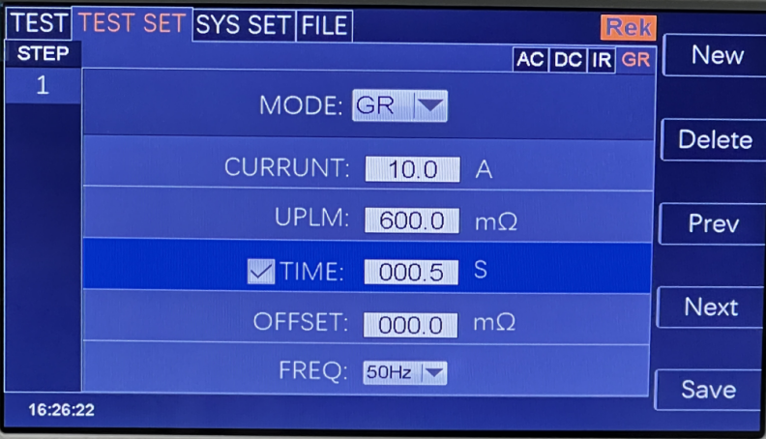

Note: Use the "ENTER" key to turn on or off the time function. The range is (0.1-999.9) s.
After turning on the time function, you can operate the time setting function by lightly pressing the coding potentiometer. To change the time value, just enter the number keys. Like losing.
ENTER 100S and press "1", "0", "0" and "Enter".
Zero compensation: press the "↓" key or code dial to move the cursor to the zero compensation function item, as shown in the following figure:

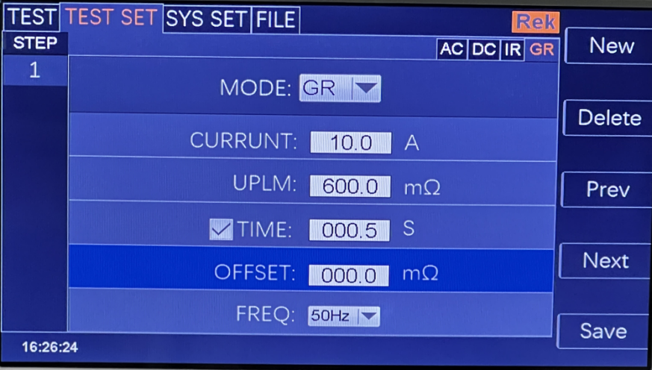

Zero compensation is divided into: AUTO and manual. In the automatic compensation state, the compensation value is automatically recorded in the tester after two test lines are shorted; Manual state
To measure the compensation value of line loss in advance, just input the corresponding digital value.
Test frequency: press the "↓" key or code dial to move the cursor to the test frequency function item, as shown in the following figure:

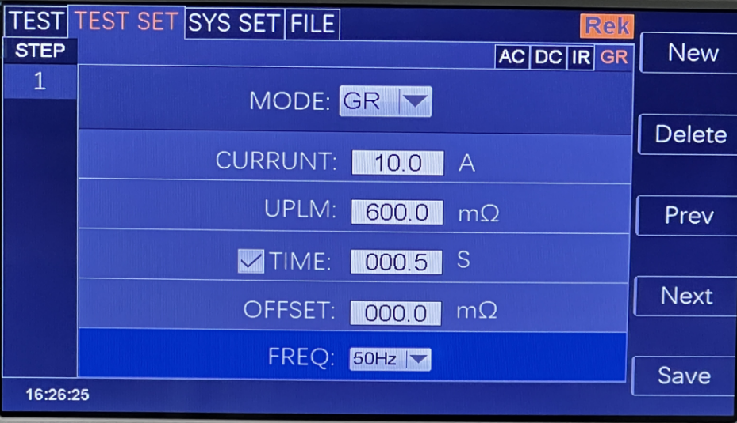

In this interface, press the "ENTER" key to edit the frequency in the range of (50/60)Hz.

New step: press the "F1" key "New" on the panel in the test interface to create a new test step, and a total of 20 tests can be created.
Steps. A new test step is established after the current step, which adopts the default test mode-AC voltage.
Delete step: press "F2" key "Delete" on the panel in the test interface to delete the test step, and the tester deletes the current step.

The following steps are moved to the current step.
Previous page: (Step Forward) In the test interface, press the "F3" key "Previous Page" on the panel to move forward the current step, that is, the contents of the current test step and the previous test step are exchanged, which can conveniently realize the sorting function of test steps, but when the current step is the first test step, move forward.
Invalid.
Next Page: (Step Backward) Press the "F4" key "Next Page" on the panel in the test interface to move back the current step, that is, the contents of the current test step and the next test step are exchanged, which can conveniently realize the function of sorting test steps, but when the current step is the last test step, move back.
Invalid.

Save as file: press the F5 key on the panel in the test interface to save the current test steps in the form of a file.
Save, convenient access to use. Press Save as File to open the storage interface, as shown below:

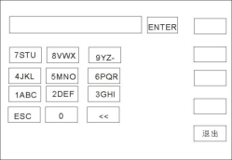

After entering the interface shown above, press the number keys on the panel, and the screen will be displayed as follows:
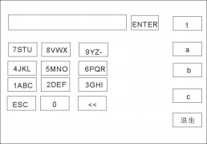

Type the relevant characters on the screen, press the "ENTER" key, and the file will be saved in the tester memory.

6.3 System Setup Mode
6.3.1 Description of system setting parameters

6.3.1.1Failure mode
This option has two functions, namely, CONTINUE, STOP, RESTART and NEXT, and can be selected by using the [write] [↓] [←] [→] cursor.
Select the setting item, and adjust the coding potentiometer to select the function item to be set.

6.3.1.2Qualified sound
This optiON has two functions, on and OFF. You can use the [write] [↓] [←] [→] cursor to select the setting item and adjust the selection of the coding potentiometer.
The function item to be set.
6.3.1.3Keystroke
This optiON has two functions, on and OFF. You can use the [write] [↓] [←] [→] cursor to select the setting item, and adjust the selected coding potentiometer.
The function item to be set.
6.3.1.4screen intensity
You can use the cursor [←] [↓] [→] to select the setting item, and adjust the coding potentiometer to select the value to be set.
6.3.1.5System language
There are two languages in this program, Chinese and English. Use the [write] [↓] [←] [→] cursor to select the setting item and adjust the coding potential.

The device selects the item to be set.
6.3.1.6Baud rate
This item has four baud rates: 9600, 38400, 19200 and 115200. You can use the [write] [↓] [←] [→] cursor to select a setting item and adjust it.
Section coding potentiometer selects the item to be set.
6.3.1.7System date
This item can set the current time of the instrument. Once the system time is set, the time function will remain regardless of the power-on and power-off state, unless the internal battery.
Failure. You can use the [write] [↓] [←] [→] cursor to select the setting item, and adjust the coding potentiometer to select the one to be set.
6.3.1.8Electric shock protection
This optiON has two functions, on and OFF. You can use the [write] [↓] [←] [→] cursor to select the setting item and adjust the selection of the coded potentiometer.
Function items to be set in.

6.3.1.9Failure sound
This optiON has two functions, on and OFF. You can use the [write] [↓] [←] [→] cursor to select the setting item and adjust the selection of the coding potentiometer.
The function item to be set.

6.3.1.10Short circuit protection
This option has two functions, HIGH and LOW. Use the [write] [↓] [←] [→] cursor to select the setting item and adjust the coding potential.
Select the function item to be set.
6.3.1.11Key brightness
You can use the cursor [←] [↓] [→] to select the setting item, and adjust the coding potentiometer to select the value to be set.
6.3.1.12Bus mode
There are two bus modes, RS232 and RS485. Use the [write] [↓] [←] [→] cursor to select the setting item and adjust the coding potential.
The device selects the item to be set.
6.3.1.13System time
This item can set the current time of the instrument. Once the system time is set, the time function will remain regardless of the power-on and power-off state, unless the internal battery.
Failure. You can use the cursor [←] [↓] [→] to select the setting item, and adjust the coding potentiometer to select the value to be set.
6.3.1.14Restore default
This function is to restore system settings, parameter settings and factory settings, and all settings will be reset. Available [←] [↓] [→] light
Select a setting item, press [ENTER] to pop up [OK] and [Cancel] interface, and press [OK] to confirm. Press [Cancel] to cancel.

6.4 Description of file parameters
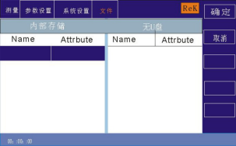

6.4.1 Internal storage: the storage capacity is 16M.
6.4.2 USB flash drive function: This item has external USB flash drive storage function.

Chapter VII Remote Control

7.1 RS232C Interface Description
At present, the widely used serial communication standard is RS-232, which can also be called asynchronous serial communication standard. RS is the abbreviation of Recommended Standard, and 232 is the standard number. This standard was officially published by the American Electronics Industry Association (IEA) in 1969, and it stipulates that one bit at a time is transmitted through a data line. Like most serial ports in the world, the serial interface of this instrument is not strictly based on RS-232 standard, but
Only a minimal subset is provided. The following table:

signal | abbreviate | Connector pin number
TXD | TXD | 2
receive data | RXD | 3
landing | GND | 5

Instrument RS232 signal and pin comparison
The reason is that the operation of three lines is much cheaper than that of five lines or six lines, which is the biggest advantage of using serial port communication. Instrument and computer connection, such as
As shown in the figure:

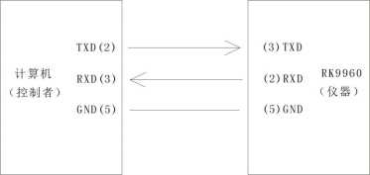

Schematic diagram of computer and instrument connection
As can be seen from the figure, the pin definition of the instrument is different from that of the 9-core connector serial interface used by the computer. The baud rate of RS232 interface can
Choose from 9600~115200, no parity, 8 data bits and 1 stop bit. Instrument command conforms to SCPI standard, when the command string is sent
After being sent to the instrument, LF (hexadecimal: 0AH) should be sent as the ending character. The maximum number of bytes of SPCI command string that the instrument can accept at one time is
2kByte。 For the format of the result data sent by the instrument to the computer, please refer to the command reference section.

7.2 description of RS485/232c interface
The communication interface of the tester can provide RS232C and RS485 serial communication interfaces for users to choose from. The interfaces are defined as follows:

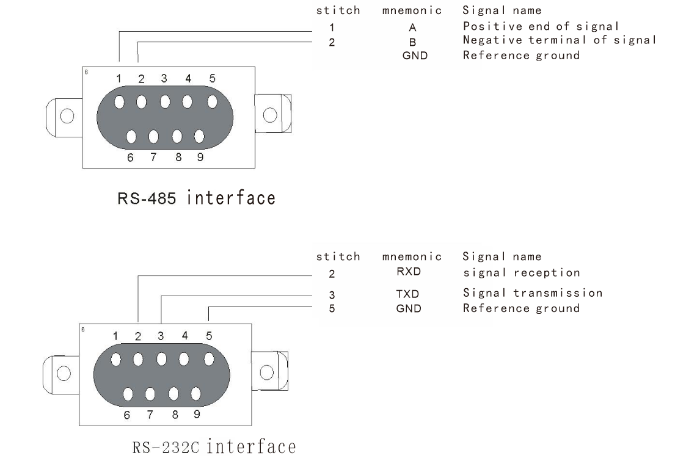

7.3 Instrument Communication Protocol (modbus)
This instrument uses RS-232c and RS-485 standard asynchronous serial communication bus interface to communicate with external control equipment, and the transmission baud rate can be preset in the instrument (9600,19200,38400 and 115200 are optional). 8 data bits, 1 stop bit, no check bit.
The logic level of the signal is ±12V, and the maximum transmission distance is 15m.
The serial interface adopts direct communication, using only three signal lines of TXD (transmission), RXD (reception) and GND (ground), and using a nine-core calibration interface socket.
1. Read instruction (function code is 03H)
Send format (7 bits of data in total):

address | function code | Address high position | Low address | High data volume | Low data volume | CRC low | CRC high

Return format:

address | function code | Data volume (byte) | Data byte | CRC low | CRC high

RK9966 series photovoltaic safety regulations comprehensive test instruction manual

Meiruike instrument (Guangdong) zhi 00000704 Hao

Data Byte: When the data type is U16, the data byte is 2 bytes, with the lower bit first.
When the data type is float, the data 4byte is 4 bytes, and the lower bit comes first.
When the data type is double, the data 8byte is 8 bytes, and the lower bit comes first.
Example: Send 01031010002910b to inquire about the current selection steps of No.01 instrument.
Return to 01 03 02 01 00 B9 D4
Different address bits return different data.
Register list

serial number | Register address | Register name | data type | byte | explain | scope of data | Read-write type | serviceable range
1 | 1001H | Sel Step | U16 | 2 | Current steps/  Selected steps |  | RW
2 | 1002H | To l Step | U16 | 2 | Total steps |  | R
3 | 1003H | New Step | U16 | 2 | New steps |  | W
4 | 1004H | Del Step | U16 | 2 | Delete steps |  | W
5 | 1005H | Mode | U16 | 2 | model | 1-7 | RW | complete
6 | 1006H | Volt | float | 4 | voltage | AC :0. 1- 10.0（RK9966)  0.05-5.0 (RK9966A/B/C)  DC :0. 1- 10.0 (RK9966)  0.05-6.0 (RK9966A/B/C)  IR :0. 1- 10.0 (RK9966)  0.05-5.0 (RK9966A)  0.05-2.5 (RK9966B/C) | RW | ACDCIR
7 | 1007H | Cur rUp lim | float | 4 | Current upper limit | AC 0.00 1-20  DC 0.00 1- 10 | RW | A CDC
8 | 1008H | Cur rUp lim | float | 4 | Current lower limit | AC 0.0- 19.999  DC 0.00 1-9.999 | RW | A CDC
9 | 1009H | Arc | float | 4 | Arc setting | 0-20 | RW | A CDC
10 | 100AH | Time | float | 4 | timeset | 0. 1-999.9 0  (unlimited) | RW | A C DC IR GR  PW ST
11 | 100BH | Rise Time | float | 4 | Rise time setting | 0-999.9 | RW | ACDCIR
12 | 100CH | Fall Time | float | 4 | Descent time setting | 0-999.9 | RW | ACDCIR
13 | 100DH | Fr eq | U16 | 2 | Frequency setting | 50 60  Only for RK9966A. | RW | AC
14 | 100EH | Ramp | U16 | 2 | Ascending judgment | 01 | RW | DC
15 | 100FH | Res Up lim | float | 4 | Upper resistance limit | 0. 1M-499.9GΩ RK9966  0. 1M-99.99GΩ RK9966A0. 1M-49.99GΩ RK9966B0. 1M- 199.99GΩ RK9966C | RW | IR
16 | 1010H | Res Dn lim | float | 4 | Lower resistance limit | 0. 1M-499.9GΩ RK9966  0. 1M-99.98GΩ RK9966A 0. 1M-49.98GΩ RK9966B  0. 1M- 199.98GΩ RK9966C | RW | IR
17 | 1011H | Range | U16 | 2 | measuring range | 0 1 2 3 4 5 | RW | IR
18 | 1012H | GR Test Cur r | float | 4 | Test current | 3-60A (DC) (RK9966)  3-40A (AC) (RK9966A)  3-60A (DC) (RK9966B) | RW | GR
19 | 1013H | GR Test Up lim | float | 4 | Test upper limit | 10-600 | RW | GR

RK9966 series photovoltaic safety regulations comprehensive test instruction manual

Meiruike instrument (Guangdong) zhi 00000704 Hao

20 | 1014H | GROFF SET | float | 4 | Zero compensation |  | RW | GR
2 1 | 1015H | GROFF SET AUTO | U16 | 2 | Automatic zeroing compensation |  | W | GR
22 | 1016H | GR Fr eq | U16 | 2 | Gr frequency | 5060 | RW | GR (only applicable to RK9966A)
23 | 1022H | MD Net | U16 | 2 | MD network | 0-7 | RW | LC
24 | 1060H | Star t | U16 | 2 | Start test |  | W
25 | 1061H | Stop | U16 | 2 | Stop testing |  | W
26 | 1062 | fetch on e | U8 | 1 | Mode of the current step |  | R | A C DC IR GR
 |  |  | U8 | 1 | Test results of the current step
 |  |  | float | 4 | Test voltage of current step
 |  |  | float | 4 | Test current of current step
Description of return value:
Mode mode: 1 AC withstand voltage 2 DC withstand voltage 3 insulation resistance 4 grounding resistance 5 power 6 low voltage start 7 leakage
Range range: AUTO, 1MΩ, 10MΩ, 100MΩ, 1GΩ, 50G(RK9966B/C).
AUTO 、1MΩ 、10MΩ 、100MΩ 、1GΩ、 100G(RK9966A）
AUTO 、1MΩ 、10MΩ 、100MΩ 、1GΩ、 500G(RK9966）

Fetch one

model | Data byte
Communication (AC)  Direct current (DC) | State (byte) voltage (float) current (float)
Insulation (IR) | State (byte) voltage (float) electrical resistance (float)
Grounding (GR) | State (byte) current (float) resistance (float)

Status:
00H Untested 0 1H Test 02H Test Qualified 03H Exceeded Upper Limit 04H Below Lower Limit 05H Exceeded GR Voltage 06H GR Open Circuit 07H Short Circuit Failure 08H Arc Failure.
09H human body protection failed. OAH GR bias O BH contact inspection failed.

2. Write instruction (function code is 10H)
The sending format is:

address | function code | address  high position | address  low post | High data volume  Bit (word) | Low data volume  Bit (word) | Amount of data  (Byte) | data word  Section 1-n | CRC low | CRC high

The return format is:

address | function code | address  high position | address  low post | Data volume high bit (word) | Low data volume (word) | CRC low | CRC high

The following explains the meaning of each parameter in detail for you:
2.1 address
Mailing address. The range is decimal 1-247. If the local address in the instrument system settings is 99, this bit is 63H.

2.2 function code
Write one or more bytes of data to the instrument. The function code is 10H.

2.3 high address+low address
Storage addresses of various parameters of the instrument. See Table 6-1 for details.
2.4. Data volume (word)
How many groups of data are written to the storage address of instrument parameters. It is fixed at 0001H.

2.5 data volume (Byte)
How many bytes of data to write to the instrument parameter storage address.

RK9966 series photovoltaic safety regulations comprehensive test instruction manual

Meiruike instrument (Guangdong) zhi 00000704 Hao

2.6 data bytes 1-n.
See the table below for details.

serial number | Register address | Register name | byte | data type | explain | Data range | Read-write type | serviceable range
1 | 1001H | Sel Step | 2 | U16 | Current Steps/Selected Steps |  | RW
2 | 1002H | To l Step | 2 | U16 | Total steps |  | R
3 | 1003H | New Step | 2 | U16 | New steps |  | W
4 | 1004H | Del Step | 2 | U16 | Delete steps |  | W
5 | 1005H | Mode | 2 | U16 | model | 1-7 | RW | complete
6 | 1006H | Volt | 4 | float | voltage | AC :0. 1- 10.0（RK9966)  0.05-5.0 (RK9966A/B/C)  DC :0. 1- 10.0 (RK9966)  0.05-6.0 (RK9966A/B/C)  IR :0. 1- 10.0 (RK9966)  0.05-5.0 (RK9966A)  0.05-2.5 (RK9966B/C) | RW | ACDC IR
7 | 1007H | Cur rUp lim | 4 | float | Current upper limit | AC 0.00 1-20  DC 0.00 1- 10 | RW | AC DC
8 | 1008H | Cur rUp lim | 4 | float | Current lower limit | AC 0.0- 19.999  DC 0.00 1-9.999 | RW | AC DC
9 | 1009H | Arc | 4 | float | Arc setting | 0-20 | RW | AC DC
10 | 100AH | Time | 4 | float | timeset | 0. 1-999.9 0  (unlimited) | RW | A C DC IR GR  PW ST
11 | 100BH | Rise Time | 4 | float | Rise time setting | 0-999.9 | RW | AC DC IR
12 | 100CH | Fall Time | 4 | float | Descent time setting | 0-999.9 | RW | AC DC IR
13 | 100DH | Fr eq | 2 | U16 | Frequency setting | 5060 | RW | AC
14 | 100EH | Ramp | 2 | U16 | Ascending judgment | 01 | RW | DC
15 | 100FH | Res Up lim | 4 | float | Upper resistance limit | 0. 1M-499.9GΩ Rk9966  0. 1M-99.99GΩ Rk9966A0. 1M-49.99GΩ Rk9966B0. 1M- 199.99GΩ Rk9966C | RW | IR
16 | 1010H | Res Dn lim | 4 | float | Lower resistance limit | 0. 1M-499.9GΩ Rk9966  0. 1M-99.98GΩ Rk9966A0. 1M-49.98GΩ Rk9966B0. 1M- 199.98GΩ Rk9966C | RW | IR
17 | 1011H | Range | 2 | U16 | measuring range | 0 1 2 3 4 5 | RW | IR
18 | 1012H | GR Test Cur r | 4 | float | Test current | 3-60A (DC) (RK9966)  3-40A (AC) (RK9966A)  3-60A (DC) (RK9966B) | RW | GR
19 | 1013H | GR Test Up lim | 4 | float | Test upper limit | 10-600 | RW | GR
20 | 1014H | GROFF SET | 4 | float | Zero compensation |  | RW | GR
2 1 | 1015H | GROFF SET AUTO | 2 | U16 | Automatic zeroing compensation |  | W | GR
22 | 1016H | GR Fr eq | 2 | U16 | Gr frequency | 5060  Only for RK9966A. | RW | GR
23 | 1060H | Star t | 2 | U16 | Start test | AC 0.0-49.999  DC 0.00 1- 19.999 | W
24 | 1061H | Stop | 2 | U16 | Stop testing |  | W
25 | 1062 | fetch one | 1 | U8 | Mode of the current step |  | R | A C DC IR GR S T LC
 |  |  | 1 | U8 | Test results of the current step
 |  |  | 4 | float | Test voltage of current step
 |  |  | 4 | float | Test current of current step
26 | 1060H | Start | 2 | U16 | Start test | AC 0.0-49.999  DC 0.00 1- 19.999 | W
27 | 1061H | Stop | 2 | U16 | Stop testing |  | W
28 | 1062 | fetch on e | 1 | U8 | Mode of the current step |  | R | A C DC IR GR S T LC
 |  |  | 1 | U8 | Test results of the current step
 |  |  | 4 | float | Test voltage of current step
 |  |  | 4 | float | Test current of current step

RK9966C has no GR function, and the GR register is invalid.
For example, send 01h, 10h, 10h, 10h, 06h, 01h, 04h, 00h, 00h, 40h BFH, 86h.
Represents setting the voltage value of Unit 01 to 2KV.
Sending 01h, 10h, 10h, 06h, 00h, 01h, E5h08h represents setting the response of No.01 machine as unqualified.

2.716 bit CRC check
1. First, define two 256-byte check tables.
const BYTE chCRCHTalbe[]
= // CRC high byte
Value table
{
0x00, 0xC1, 0x81, 0x40, 0x01, 0xC0, 0x80, 0x41, 0x01, 0xC0, 0x80, 0x41,
0x00, 0xC1, 0x81, 0x40, 0x01, 0xC0, 0x80, 0x41, 0x00, 0xC1, 0x81, 0x40,
0x00, 0xC1, 0x81, 0x40, 0x01, 0xC0, 0x80, 0x41, 0x01, 0xC0, 0x80, 0x41,
0x00, 0xC1, 0x81, 0x40, 0x00, 0xC1, 0x81, 0x40, 0x01, 0xC0, 0x80, 0x41,
0x00, 0xC1, 0x81, 0x40, 0x01, 0xC0, 0x80, 0x41, 0x01, 0xC0, 0x80, 0x41,
0x00, 0xC1, 0x81, 0x40, 0x01, 0xC0, 0x80, 0x41, 0x00, 0xC1, 0x81, 0x40,
0x00, 0xC1, 0x81, 0x40, 0x01, 0xC0, 0x80, 0x41, 0x00, 0xC1, 0x81, 0x40,
0x01, 0xC0, 0x80, 0x41, 0x01, 0xC0, 0x80, 0x41, 0x00, 0xC1, 0x81, 0x40,
0x00, 0xC1, 0x81, 0x40, 0x01, 0xC0, 0x80, 0x41, 0x01, 0xC0, 0x80, 0x41,
0x00, 0xC1, 0x81, 0x40, 0x01, 0xC0, 0x80, 0x41, 0x00, 0xC1, 0x81, 0x40,
0x00, 0xC1, 0x81, 0x40, 0x01, 0xC0, 0x80, 0x41, 0x01, 0xC0, 0x80, 0x41,
0x00, 0xC1, 0x81, 0x40, 0x00, 0xC1, 0x81, 0x40, 0x01, 0xC0, 0x80, 0x41,
0x00, 0xC1, 0x81, 0x40, 0x01, 0xC0, 0x80, 0x41, 0x01, 0xC0, 0x80, 0x41,
0x00, 0xC1, 0x81, 0x40, 0x00, 0xC1, 0x81, 0x40, 0x01, 0xC0, 0x80, 0x41,
0x01, 0xC0, 0x80, 0x41, 0x00, 0xC1, 0x81, 0x40, 0x01, 0xC0, 0x80, 0x41,
0x00, 0xC1, 0x81, 0x40, 0x00, 0xC1, 0x81, 0x40, 0x01, 0xC0, 0x80, 0x41,
0x00, 0xC1, 0x81, 0x40, 0x01, 0xC0, 0x80, 0x41, 0x01, 0xC0, 0x80, 0x41,
0x00, 0xC1, 0x81, 0x40, 0x01, 0xC0, 0x80, 0x41, 0x00, 0xC1, 0x81, 0x40,
0x00, 0xC1, 0x81, 0x40, 0x01, 0xC0, 0x80, 0x41, 0x01, 0xC0, 0x80, 0x41,
0x00, 0xC1, 0x81, 0x40, 0x00, 0xC1, 0x81, 0x40, 0x01, 0xC0, 0x80, 0x41,
0x00, 0xC1, 0x81, 0x40, 0x01, 0xC0, 0x80, 0x41, 0x01, 0xC0, 0x80, 0x41,
0x00, 0xC1, 0x81, 0x40
};

//CRC low byte value table
const BYTE chCRCLTalbe[]
=
{
0x00, 0xC0, 0xC1, 0x01, 0xC3, 0x03, 0x02, 0xC2, 0xC6, 0x06, 0x07, 0xC7,
0x05, 0xC5, 0xC4, 0x04, 0xCC, 0x0C, 0x0D, 0xCD, 0x0F, 0xCF, 0xCE, 0x0E,
0x0A, 0xCA, 0xCB, 0x0B, 0xC9, 0x09, 0x08, 0xC8, 0xD8, 0x18, 0x19, 0xD9,
0x1B, 0xDB, 0xDA, 0x1A, 0x1E, 0xDE, 0xDF, 0x1F, 0xDD, 0x1D, 0x1C, 0xDC,
0x14, 0xD4, 0xD5, 0x15, 0xD7, 0x17, 0x16, 0xD6, 0xD2, 0x12, 0x13, 0xD3,
0x11, 0xD1, 0xD0, 0x10, 0xF0, 0x30, 0x31, 0xF1, 0x33, 0xF3, 0xF2, 0x32,
0x36, 0xF6, 0xF7, 0x37, 0xF5, 0x35, 0x34, 0xF4, 0x3C, 0xFC, 0xFD, 0x3D,
0xFF, 0x3F, 0x3E, 0xFE, 0xFA, 0x3A, 0x3B, 0xFB, 0x39, 0xF9, 0xF8, 0x38,
0x28, 0xE8, 0xE9, 0x29, 0xEB, 0x2B, 0x2A, 0xEA, 0xEE, 0x2E, 0x2F, 0xEF,
0x2D, 0xED, 0xEC, 0x2C, 0xE4, 0x24, 0x25, 0xE5, 0x27, 0xE7, 0xE6, 0x26,
0x22, 0xE2, 0xE3, 0x23, 0xE1, 0x21, 0x20, 0xE0, 0xA0, 0x60, 0x61, 0xA1,
0x63, 0xA3, 0xA2, 0x62, 0x66, 0xA6, 0xA7, 0x67, 0xA5, 0x65, 0x64, 0xA4,
0x6C, 0xAC, 0xAD, 0x6D, 0xAF, 0x6F, 0x6E, 0xAE, 0xAA, 0x6A, 0x6B, 0xAB,
0x69, 0xA9, 0xA8, 0x68, 0x78, 0xB8, 0xB9, 0x79, 0xBB, 0x7B, 0x7A, 0xBA,
0xBE, 0x7E, 0x7F, 0xBF, 0x7D, 0xBD, 0xBC, 0x7C, 0xB4, 0x74, 0x75, 0xB5,

0x77, 0xB7, 0xB6, 0x76, 0x72, 0xB2, 0xB3, 0x73, 0xB1, 0x71, 0x70, 0xB0,
0x50, 0x90, 0x91, 0x51, 0x93, 0x53, 0x52, 0x92, 0x96, 0x56, 0x57, 0x97,
0x55, 0x95, 0x94, 0x54, 0x9C, 0x5C, 0x5D, 0x9D, 0x5F, 0x9F, 0x9E, 0x5E,
0x5A, 0x9A, 0x9B, 0x5B, 0x99, 0x59, 0x58, 0x98, 0x88, 0x48, 0x49, 0x89,
0x4B, 0x8B, 0x8A, 0x4A, 0x4E, 0x8E, 0x8F, 0x4F, 0x8D, 0x4D, 0x4C, 0x8C,
0x44, 0x84, 0x85, 0x45, 0x87, 0x47, 0x46, 0x86, 0x82, 0x42, 0x43, 0x83,
0x41, 0x81, 0x80, 0x40
};
2. Then calculate.
WORD CRC16(BYTE* pchMsg, WORD wDataLen)
{
BYTE chCRCHi = 0xFF; //high CRC byte initialization
BYTE chCRCLo = 0xFF; //low CRC byte initialization
WORD wIndex; //Index in CRC loop
while (wDataLen--)
{
//Calculate CRC
wIndex = chCRCLo ^ *pchMsg++ ;
chCRCLo = chCRCHi ^ chCRCHTalbe[wIndex];
chCRCHi = chCRCLTalbe[wIndex] ;
}
return ((chCRCHi << 8) | chCRCLo) ;

Chapter 8 SCPI serial port instruction reference

8.1 Brief description of instruction format:
8.1.1. The instrument instruction set only describes the actual characters accepted or sent by the instrument.
8.1.2. Instruction characters are all ASCII characters.
8.1.3. Data of instruction "<? ? ? > "are all ASCII strings. The default format of the system is integer or floating-point number, and the unit of data is the default value, which does not appear in the instruction.
8.1.4 At the end of an instruction, there must be an instruction end mark: an identifier for the end of an instruction, without which the instrument will not parse the instruction.
8.1.5 The default closing marks are: carriage return (NL), print control character (\n), decimal number (10) and hexadecimal number (0 ×0A). End marks of IEEE-488 bus: keyword (end), signal (EOI).
An example in which multiple instructions can simplify sending is as follows: Note: The "_" in the example is marked with a space.
FUNC：SOUR：STEP_1： I ：I_10.00；
FUNC：SOUR：STEP_INS (NL^END)
FUNC：SOUR：TEP_2： I ：I_10.00；

8.2 SCPI instruction set
RK9966 Series Instrument Subsystem Command
● DISPlay
● SYSTem
● FUNCtion
●MMEM
●FETC
8.3DISPLAY subsystem command set
The command set of DISPlay subsystem is mainly used to set the display page and characters of the instrument. You can query the current page.
DISPLay:PAGE
Command syntax:
DISPlay：PAGE <pagename>
< pagename > details are as follows:
TEST
TESTSET
SYSSet
FLIE
Set display page to: Measurement display page
Set the display page to: Measurement Settings page.

Set Display Page to: System Settings Page
Set the display page to: (internal) document list
Characters? You can query the current page.
-example:
Set display page to: Measurement display page.
Setting instruction: DISPLay：PAGE
Query instruction: DISPlay：PAGE?
Return value:
TEST32
8.4 FUNCtion subsystem command set
8.4.1 FUNCtion subsystem command set is mainly used to set the test parameters of instrument test function. Command tree:
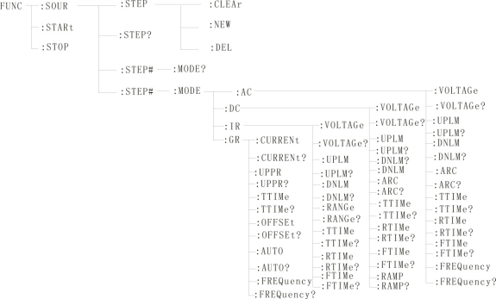
8.4.2PROG function command set
FUNC:STARt the test when the instrument is testing the interface.
FUNC:STOP the test when the instrument is testing the interface.
Func: soul: step: clear clear a new test ITEM in the existing test item.
Func: soul: step: del Delete the current test ITEM within the existing test item.
Func: soul: step: new Create an empty test plan to write a brand-new test plan.
FUNC:SOUR:STEP? : Query the current test scheme.
8.4.3 STEP# function command set

8.4.3.1AC SETUP function command set
Func: source: step #: mode: AC: voltage Set/query the voltage of AC.
-format
Setting format: function: step #: mode: AC: voltage < voltage value >
Query format: function: step #: mode: AC: voltage?
-data < voltage value >:
Data type: floating-point number setting format: func: step: < num >: AC: volt < voltage value >
Data range: 0.050-5.000
Data accuracy: 0.001
Data unit: KV
Example: Set the voltage value of AC in STEP1 to 1000V in this way.
Setting command: function: step 1: mode: AC: voltage 1.000.
Query command: function: step 1: mode: AC: voltage?
Func: source: step #: mode: AC: uplm Set/query the upper limit current of AC.
-format
Setting format: function: step #: mode: AC: uplm < current value >
Query format: function: step #: mode: AC: uplm?
-data < current value >
Data type: floating point number
Data range: 0.001-20.00mA
Data accuracy: 0.001
Data unit: mA
Example: set the current value of AC in STEP1 to 1mA.
Setting command: function: step 1: mode: AC: uplm1.000.
Query command: function: step 1: mode: AC: uplm?
Return value: 1
Func: source: step #: mode: AC: dnlm Set/query the lower limit current of AC.
-format
Setting format: function: step #: mode: AC: dnlm < current value >
Query format: function: step #: mode: AC: dnlm?
-data < current value >
Data type: floating point number
Data range: 0.001-20.00mA
Data accuracy: 0.001
Data unit: mA

Example: set the current value of AC in STEP1 to 1mA.
Setting command: function: step 1: mode: AC: uplm1.000.
Query command: function: step 1: mode: AC: uplm?
Return value: 1
Func: source: step #: mode: AC: arc set/query arc value.
-format
Setting format: function: step #: mode: AC: arc < arc value >
Query format: function: step #: mode: AC: arc?
-data < arc value >:
Data type: floating point number
Data range: 0.001-20.00mA
Data accuracy: 0.001
Data unit: mA
Example: set the current value of AC in STEP1 to 1mA.
Setting command: function: step 1: mode: AC: arc1.000.
Query command: function: step 1: mode: AC: arc?
Return value: 1
Func: source: step #: mode: AC: ttime Set/query the test time of AC.
-format
Set the format: function: step #: mode: AC: ttime < time >
Query format: function: step #: mode: AC: ttime?
-data < time value >
Data type: Integer
Data range: 0-999.9
Data accuracy: 0.1
Data unit: s
Example: Set the time value of AC in STEP1 to 1S.
Setting command: function: step 1: mode: AC: ttime1.
Query command: function: step 1: mode: AC: ttime?
Return value: 1
Func: source: step #: mode: AC: rtime Set/query the rising time of AC.
-format
Set the format: function: step #: mode: AC: rtime < time >
Query format: function: step #: mode: AC: rtime?

-data < time value >
Data type: Integer
Data range: 0-999.9
Data accuracy: 0.1
Data unit: s
Example: Set the time value of AC in STEP1 to 1S.
Setting command: function: step 1: mode: AC: rtime1.
Query command: function: step 1: mode: AC: rtime?
Return value: 1
Func: source: step #: mode: AC: ftime Set/query the falling time of AC.
-format
Set the format: function: step #: mode: AC: ftime < time >
Query format: function: step #: mode: AC: ftime?
-data < time value >
Data type: Integer
Data range: 0-999.9
Data accuracy: 0.1
Data unit: s
Example: Set the time value of AC in STEP1 to 1S.
Setting command: function: step 1: mode: AC: ftime1.
Query command: function: step 1: mode: AC: ftime?
Return value: 1
Func: source: step #: mode: AC: frequency Set/query the test frequency of AC.
-format
Set the format: function: step #: mode: AC: frequency < frequency >.
Query format: function: step #: mode: AC: frequency?
-data < frequency value >
Data type: Integer
Data range: 50/60
Data accuracy: 0.1
Data unit: Hz
Example: set the frequency value of AC in STEP1 to 50Hz.
Setting command: function: step 1: mode: AC: frequency 50.
Query command: function: step 1: mode: AC: frequency?
Return value: 50

8.4.3.2DC SETUP function command set
Func: source: step #: mode: DC: voltage Set/query DC voltage.
-format
Setting format: function: step #: mode: DC: voltage < voltage value >
Query format: function: step #: mode: DC: voltage?
-data < voltage value >:
Data type: floating point number
Data range: 0.050-6.000
Data accuracy: 0.001
Data unit: KV
Example: Set the voltage value of DC in STEP1 to 1000V in this way.
Setting command: function: step 1: mode: DC: voltage 1.000.
Query command: function: step 1: mode: DC: voltage?
Func: source: step #: mode: DC: uplm Set/query the upper limit current of DC.
-format
Setting format: function: step #: mode: DC: uplm < current value >
Query format: function: step #: mode: DC: uplm?
-data < current value >
Data type: floating point number
Data range: 0.001-10.00mA
Data accuracy: 0.001
Data unit: mA
Example: set the current value of DC in STEP1 to 1mA.
Setting command: function: step 1: mode: DC: uplm1.000.
Query command: function: step 1: mode: DC: uplm?
Return value: 1
Func: source: step #: mode: DC: dnlm Set/query the lower limit current of DW.
-format
Setting format: function: step #: mode: DC: dnlm < current value >
Query format: function: step #: mode: DC: dnlm?
-data < current value >
Data type: floating point number
Data range: 0.001-10.00mA
Data accuracy: 0.001
Data unit: mA

Example: set the current value of DC in STEP1 to 1mA.
Setting command: function: step 1: mode: DC: uplm1.000.
Query command: function: step 1: mode: DC: uplm?
Return value: 1
Func: source: step #: mode: DC: arc set/query arc value.
-format
Setting format: function: step #: mode: DC: arc < arc value >
Query format: function: step #: mode: DC: arc?
-data < arc value >:
Data type: floating point number
Data range: 0.001-10.00mA
Data accuracy: 0.001
Data unit: mA
Example: set the current value of DC in STEP1 to 1mA.
Setting command: function: step 1: mode: DC: arc1.000.
Query command: function: step 1: mode: DC: arc?
Return value: 1
Func: source: step #: mode: DC: ttime Set/query the test time of DC.
-format
Set the format: function: step #: mode: DC: ttime < time >
Query format: function: step #: mode: DC: ttime?
-data < time value >
Data type: Integer
Data range: 0-999.9
Data accuracy: 0.1
Data unit: s
Example: Set the time value of DC in STEP1 to 1S.
Setting command: function: step 1: mode: AC: ttime1.
Query command: function: step 1: mode: AC: ttime?
Return value: 1

Func: source: step #: mode: DC: rtime Set/query the rising time of DC.
-format
Set the format: function: step #: mode: DC: rtime < time >
Query format: function: step #: mode: DC: rtime?
-data < time value >
Data type: Integer
Data range: 0-999.9
Data accuracy: 0.1
Data unit: s
Example: Set the time value of DC in STEP1 to 1S.
Setting command: function: step 1: mode: DC: rtime1.
Query command: function: step 1: mode: DC: rtime?
Return value: 1
Func: source: step #: mode: AC: ftime Set/query the falling time of DC.
-format
Set the format: function: step #: mode: DC: ftime < time >
Query format: function: step #: mode: DC: ftime?
-data < time value >
Data type: Integer
Data range: 0-999.9
Data accuracy: 0.1
Data unit: s
Example: Set the time value of DC in STEP1 to 1S.
Setting command: function: step 1: mode: DC: ftime1.
Query command: function: step 1: mode: DC: ftime?
Return value: 1
Func: source: step #: mode: AC: ramp Set/query DC boost status.
-format
Setting format: function: step #: mode: DC: ramp < boost judgment >
Query format: function: step #: mode: DC: ramp?
-data < boost judgment >
Data type: Integer
Data range: 0/1(OFF/ON)
Data accuracy: none
Data unit: None

Example: set the frequency value of DC in STEP1 to 0(OFF) in this way.
Setting command: function: step 1: mode: DC: ramp 0.
Query command: function: step 1: mode: DC: ramp?
Return value: 0(OFF)
8.4.3.3IR SETUP function command set
Func: source: step #: mode: IR: voltage Set/query the voltage of IR.
-format
Setting format: function: step #: mode: IR: voltage < voltage value >
Query format: function: step #: mode: IR: voltage?
-data < voltage value >:
Data type: floating point number
Data range: 0.050-1.000
Data accuracy: 0.001
Data unit: KV
Example: Set the voltage value of IR in STEP1 to 1000V in this way.
Setting command: function: step 1: mode: IR: voltage 1.000.
Query command: function: step 1: mode: IR: voltage?
Return value: 1
Func: source: step #: mode: IR: uplm Set/query the upper limit of IR.
-format
Setting format: function: step #: mode: IR: uplm < resistance value >
Query format: function: step #: mode: IR: uplm?
-data < current value >
Data type: floating point number
Data range: 0-1E4(0 is off) mω.
Data accuracy: 0.1MΩ
Data unit: mω
Example: Set the upper resistance limit of IR in STEP1 to 100 mω.
Setting command: function: step 1: mode: IR: uplm100.
Query command: function: step 1: mode: IR: uplm?
Return value: 100

Func: source: step #: mode: IR: dnlm Set/query the lower limit of IR.
-format
Setting format: function: step #: mode: IR: dnlm < resistance value >
Query format: function: step #: mode: IR: dnlm?
-data < current value >
Data type: floating point number
Data range: 0-1e4mω
Data accuracy: 0.1MΩ
Data unit: 0.1MΩ
Example: Set the resistance value of IR in STEP1 to 10MΩ.
Setting command: function: step 1: mode: IR: uplm10.
Query command: function: step 1: mode: IR: uplm?
Return value: 10
Func: source: step #: mode: IR: range Set/query the resistance range.
-format
Set the format: function: step #: mode: IR: range < range value >
Query format: function: step #: mode: IR: range?
-data < a range value >:
Data type: integer
Data range: 1, 10, 100
Data accuracy: none
Data unit: mω
Example: Set the resistance range of IR in STEP1 to 100 mω.
Setting command: function: step 1: mode: IR: range 100.
Query command: function: step 1: mode: IR: range?
Return value: 100
Func: source: step #: mode: IR: ttime Set/query the test time of IR.
-format
Set the format: function: step #: mode: IR: ttime < time >
Query format: function: step #: mode: IR: ttime?
-data < time value >
Data type: Integer
Data range: 0-999.9
Data accuracy: 0.1
Data unit: s

Example: Set the time value of IR in STEP1 to 1S.
Setting command: function: step 1: mode: IR: ttime1.
Query command: function: step 1: mode: IR: ttime?
Return value: 1
Func: source: step #: mode: IR: rtime Set/query the rising time of IR.
-format
Set the format: function: step #: mode: IR: rtime < time >
Query format: function: step #: mode: IR: rtime?
-data < time value >
Data type: Integer
Data range: 0-999.9
Data accuracy: 0.1
Data unit: s
Example: Set the time value of IR in STEP1 to 1S.
Setting command: function: step #: mode: IR: rtime1.
Query command: function: step #: mode: IR: rtime?
Return value: 1
Func: source: step #: mode: IR: ftime Set/query the falling time of IR.
-format
Set the format: function: step #: mode: IR: ftime < time >
Query format: function: step #: mode: IR: ftime?
-data < time value >
Data type: Integer
Data range: 0-999.9
Data accuracy: 0.1
Data unit: s
Example: Set the time value of IR in STEP1 to 1S.
Setting command: function: step 1: mode: IR: ftime1.
Query command: function: step 1: mode: IR: ftime?
Return value: 1

8.4.3.4GR SETUP function command set
Func: source: step #: mode: gr: current sets the query current.
-format
Set the format: FUNC:SOUR:STEP#:MODE:GR:CRREnt.
Query format: FUNC:SOUR:STEP#:MODE:GR:CRREnt?

-data < sn >
Data type: Integer
Data range: 1-20
Data accuracy: 1
-data < current value >:
Data type: floating point number
Data range: 3-30
Data accuracy: 0.1
Data unit: a
Example:
Set the CURREnt value to: 10.00A
Setting format: func: sour: step #: mode: gr: crrent: < 10.00 >
Query format: FUNC:SOUR:STEP#:MODE:GR:CRREnt:?
Near return value: 10.00

Func: source: step #: modem: gr: uppr sets the upper limit of query resistance.
-format
Setting format: func: source: step #: modem: gr: uppr < resistance value >
Query format: func: source: step #: modem: gr: uppr?
-data < resistance value >
Data type: floating point number
Data range: 0-510mΩ
Data accuracy: 0.1
Data unit mω:
Example:
Set the upper limit of resistance to: 100.0 mω.
Set the format func: source: step #: modem: gr: uppr: 100.00.
Query format: func: source: step #: modem: gr: uppr?
Recent value: 100.0

Func: source: step #: modem: gr: time sets the inquiry current test time.
-format
Set the format: func: source: step #: modem: gr: time < time value >
Query format: func: source: step #: modem: gr: time?
-data < time value >
Data type: floating point number
Data range: 0-999.9 (where 0 is continuous test)
Data accuracy: 0.1
Data unit: s
Example:
Set the test time to: 1S
Setting format: func: source: step #: modem: gr: time: 1.
Query format: func: source: step #: modem: gr: time?
Near return value: 1

Func: source: ste #: modem: gr: offset sets the compensation value for query return to zero.
-format
Setting format: func: source: step #: modem: gr: offset < compensation value >
Query format: func: source: step #: modem: gr: offset?
-data < compensation value >
Data type: floating point number
Data range: 0-100
Data accuracy: 0.1
Data unit: mω

Example:
Set the OFFSET value to: 100 mω.
Setting format: func: source: step #: modem: gr: offset100.
Query format: func: source: step #: modem: gr: offset?
Recent value: 100

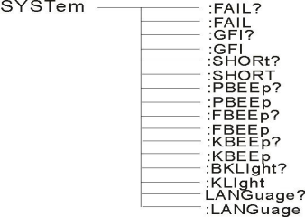

Func: source: step #: modem: gr: frequency Set the test frequency of inquiry current.
-format
Setting format: func: source: step #: modem: gr: frequency < frequency >.
Query format: func: source: step #: modem: gr: frequency?
-data < frequency >
Data type: character
Data range: 50/60
Data accuracy: 0.1
Data unit: Hz
Example:
Set the test frequency to 50Hz.
Set the format: func: source: step #: modem: gr: frequency 50.
Query format: func: source: step #: modem: gr: frequency?
Recent value: 50

8.4.3SYSTEM Function Command Set
Command tree

SYSTem ：PBEE/FBEE/KBEE
Set/query test pass/fail/button buzzer status
-format
Setting format: syst: pbee < on/off > or < 1/0 >
Query format: SYST ：PBEE?
-data: < ON/OFF >
Data type: character
Data range: 0(OFF),1(ON)

Example:
Set BEEP to 1.
Setup command: SYST:BEEP 1

-return information
Query command: SYST:BEEP? , return value: buzzer status, such as 1.
SYSTem ：REset restores all default states.
-format:
Set format: SYST ：RES
8.4.5 MMEM subsystem command set
MMEM：SAVE Saves the current file to the file number.
-format:
Set format: MMEM：SAVE < file name >
-data < file name >
Data type: string
MMEM LOAD exports the file specified by the file number to the current
-format:
Set the format: MMEM：LOAD < file name >
-data < file name >
Data type: string
8.4.6 FETCH subsystem command set
FETCH is used to obtain the measurement results of the instrument.
-format:
Set the format: FETCh：AUTO
Query format: FETCh:AUTO?
-data < ON/OFF>or <1/0 >
Data type: character
Data range: 0(OFF), 1(ON)
-example:
Automatically return the test data to ON.
Command: FETCh：AUTO ON or fetch: auto 1.
-return information
Query command: FETCh? , returns the current measurement result of the instrument.
Command syntax: FETCh?
After receiving this command, the instrument will automatically send out the test results until the test is over.

Return format:
Steps: test items: test current (a) test resistance (mω) sorting results.
1. The separator between steps and test items, test items and data is (:).
2. The separator between test data is (,) and the separator between different unit data is (; )
3. The separator between steps is (:+space), and the data terminator uyly(0X0A).
Note: 1. All data are in integer or floating-point format and ASCII strings.
2. The data unit is the same as FCUN set instruction set by default.
The test results are:
STEP1: I :30A, test resistance 100mΩ, result PASS.
Return data format:
STEP1I :30,100,PASS； （SPACE）
8.4.7 Other control command sets
*IDN query instrument model, version information
The query returns: < manufacturer >, < model >, < firmware > < nl end >
Here: < manufacturer > gives the name of the manufacturer (i.e. ReK).

<model> | Give the machine model (such as RK9966).
<firmware> | Give the software version number (such as Version 1.0.0).
For example: "*IDN?"

Chapter 9 Maintenance Guidelines
9.1 Daily maintenance
9.1.1 The use environment of the tester should be well ventilated, dry and free from dust and electromagnetic interference.
9.1.2 If the tester is not used for a long time, it should be powered on regularly, usually once a month, and the power-on time should be less than 30 minutes.
9.1.3 After the tester works for a long time, such as about 8 hours, it should be turned off for more than 10 minutes to keep the tester in good working condition.
9.1.4 The tester may have poor contact or open circuit after long-term use, so it should be overhauled regularly.

9.2 Simple fault handling

Fault phenomenon | processing method
After the boot, there is no display button and no response. | Please check whether the power supply is normal and whether the fuse is blown. If it is blown, please  Replace fuse
After start-up, the test light is off but there is current output. | Test light is broken.
After starting, the test lamp does not flash and there is no current output. | The start button is not in good contact
After starting, there is no current or resistance display. | Please check whether the test line is open, the testedobject is not in good contact or is damaged.  The measured object has been opened.
After the test fails, the unqualified light does not light up. | The unqualified lamp is broken.

If the fault cannot be eliminated in time, please contact our company or distributor as soon as possible, and we will provide you with services in time.
9.3 Instructions for upgrading instrument system software
9.3.1 Connect the USB interface on the back panel of the instrument to the computer, the power resource manager displays the U disk, copy the upgrade file to the instrument target disk, and restart the instrument to complete the system software upgrade. If you encounter technical problems in upgrading, please contact our company in time.
9.3.2 Press and hold the STOP+START key to restart the power supply, clear the data error caused by version change, and restore the setting data to the default factory setting.

Chapter X Warranties and Accessories
10.1 Warranty
If the user purchases instruments from the company, it shall be counted from the delivery date of the company, and if the user purchases instruments from the distribution department, it shall be counted from the delivery date of the distribution unit.
Calculation, the host is guaranteed for 1 year. The warranty card of the instrument should be presented when the warranty is issued. The company provides lifelong maintenance service for all outgoing instruments. During the warranty period,
If the instrument is damaged due to improper operation by the user, the maintenance cost shall be borne by the user.
10.2 Accessories
1. power line 1 Article
2. High pressure test line 1 Article
3. private wire 1 Article
4. private wire 1 Pay

- U Disk(instructions /modbus test tools 1
- certificate a sheet
- calibration certificate a part
- High Voltage Probe 1 Article
- The RS232 communication cable 1 Article
10.RS-232 turns to USB line 1 Article
11.USB transfer line 1 Article
12.wiring terminal(With card positionRed / Black 60A) a set

After receiving the instrument, the user should unpack and check the above contents. If there is a shortage, please contact our company or distributor.

Instructions for user manual:
The company reserves the right to change the specifications of the user manual without prior notice.
With the improvement of the tester and the upgrade of software and hardware, the user manual will be constantly updated and improved. Please pay attention to the version of the tester and instructions.
If there is anything unknown in the manual, please contact us directly. Merrick's products are protected by China patents that have been approved and are under examination.

Use your browser to scan
Pay attention Shenzhen Merrick Electronic Technology Co., Ltd. official website to experience more concessions and more services

SHENZHEN MEIRUIKE ELECTRONIC TECHNOLOGY CO.,LTD
Address: 31 Blan Road, Nanwan Street, Longgang District, Shenzhen
City 12 / F West, Building B7, Li Lang International Jewelry Industrial
Park (special Ladder No. 7 west)
Technical Department: (0) 13924600220
Tel: 0755-28604516 (after-sales line)
0755-83806889
Http://www.chinaareekcom Global service hotline 400-876-9388

