Meiruike Instruction Manual

RK7305
Ground Bond tester

SHENZHEN MEIRUIKE ELECTRONIC TECHNOLOGY CO.,LTD

Verification and calibration statement

Meiruike Electronic Technology Co., Ltd. specifically declares that the instruments and equipment listed in this manual fully comply with the nominal specifications and characteristics listed in the company's general description.The instrument has passed the factory calibration of the company before leaving the factory. All the instruments and equipment used by the company have invited the inspection center approved by the National Administration of Standards for regular calibration. The calibration procedures and steps are in line with the specifications and standards of the electronic inspection center.

Product quality assurance

Meiruike Electronic Technology Co., Ltd. guarantees that the new instruments manufactured have passed strict quality confirmation, and ensures that if there are any construction defects or parts faults found within one year from the factory, the company is responsible for free repair.However, if the user changes the circuit, function or repairs the instrument and parts or the outer box is damaged, the company does not provide free warranty services, and the maintenance fees are charged according to the actual conditions.Failure to operate the equipment in accordance with the safety specifications.

This guarantee does not include accessories such as ancillary equipment of this instrument.

During the one-year guarantee period, please return the faulty unit to the maintenance center or the dealer designated by the company, and the company will properly repair it.

If the unit is faulty under abnormal use or human negligence or not human control, such as earthquake, flood, riot or fire and other not human control factors, the company will not provide free warranty services.

Contents
Chapter 1: Safety regulations 1
Chapter 2: Installation key points 5
Chapter 3:, Technical parameters 7
Chapter 4: Introduction of safety regulations 12
Chapter 5: Panels and backplane 15
Chapter 6: Test the parameter setting procedure 19
Chapter 7: Display message 26
Chapter 8 Operating Procedures and Steps 28
Chapter 9 Correction of the procedures and steps 31
Chapter 10 Remote control Input and output signal 36

Chapter 1: Safety regulations

Provisions and matters that you should pay attention to before the test!!!

general provisions
- Before using this AC ground resistance tester, please understand the use and related safety signs to ensure safety.
The safety specification cited in this instrument is the Safety Class I (the body has protective ground terminals).
- Select the correct input voltage (115V or 230V input) specification before opening the local input power switch.

High-voltage warning symbol.Refer to the warning and attention instructions listed in the manual to avoid damage to personnel or equipment.Hazard sign, possibly high voltage presence, please avoid contact.
The body ground symbol

WARNING

CAUTION
It should be noted that the procedures, applications or conditions performed are of high risk and may lead to injury or even death.

Note that the procedures, applications or conditions performed may cause damage or lose all stored data in the instrument.

To prevent accidental injury or death, observe and use the instrument.

Maintenance and maintenance

  - 1 Maintenance as used

To prevent the induction process, please do not remove the lid of the instrument.All parts inside the instrument shall absolutely not require maintenance by the user.If the instrument occurs, seek maintenance from Meiruike Electronics or its designated dealer.The attached lines and block drawings are provided for reference purposes only.
1.2.2 Regular maintenance
The AC ground resistance tester, input power cord, test line, and related accessories shall be carefully checked and verified at least once a year to protect the user's safety and the accuracy of the instrument.
1. 2. 3 User Modification
Users shall not change the wiring or parts of the instrument, and the instrument will automatically fail and the Company shall not take any responsibility.Use of parts or accessories not approved by Meiruike is not guaranteed.If the instrument is found to be changed, Meiruike will repair the circuit or parts of the instrument back to the original design state, and charge the maintenance fee.

Test workstation
1. 3. 1 Working location
The location of the workstation must be selected in the non-staff away from the workstation.If impossible because of the production line arrangement, the workstation must be isolated from other facilities and specifically marked "test workstation".If the workstation is very close to other work stations, special attention must be paid to safety issues.When testing, it must be marked as " dangerous!Do not approach to non-staff members ".
- 3. 2 Input power supply
The AC ground resistance tester must be well ground, and the ground wire must be connected before operation to ensure personnel safety.The power supply of the test station must have a separate switch, and the device is specially marked at the entrance of the test station, so that everyone can distinguish that it is the power switch of the test station.Once an emergency occurs, you can immediately turn off the power supply, and then enter the accident processing.
  - 3 Workplace
Use as far as possible with non-conductive material bench, operators and objects to be measured shall not use any metal, the position of the operator shall not be across the object to operate or adjust the ac grounding resistance test instrument, if the volume to be measured is very small, as far as possible to be placed in the non-conductive box, such as acrylic box, etc.
The test site must be kept neat and clean at any time, and not chaotic. The unused instruments and test lines should be placed in a fixed position, so that all personnel can immediately identify the objects to be tested, and the tested objects.
The air in and around the test station shall not contain combustible gas or use an AC ground resistance tester next to flammable substances.

Operators regulations
  - 1 Personnel qualification

The voltage and current output by the AC ground resistance tester are sufficient to cause personnel injury or lethality, and must be used and operated by qualified personnel.
1.4. 2 Safety Code
Operators must be educated and trained at any time to understand the importance of various operating rules and to operate the AC ground resistance tester according to the safety rules.
1.4. 2 Clothing regulations
Operators should not wear clothes with metal decoration or metal hands and watches, which can easily cause unexpected electrical electricity.When accidental sensing, the consequences will be more serious.

Chapter 2: Installation key points

1 Installation profile
This chapter mainly introduces the rules of unpacking, inspection, preparation and storage of Murray rick electronic products.

2. 2 Unseal and check
The Murray electronic products are packaged in a packaging box with foam protection. If the packaging box is damaged, please check the appearance of the machine for deformation, scratches, or panel damage.If there is any damage, please notify Meiruike Electronics or its dealers immediately.Please keep the box and foam to understand why.Our service center will help you repair or replace a new machine.Do not return products immediately until notice to Murray Electronics or its distributor.

Preparation before use
2. 3. 1 Demand and selection of input voltage
The AC ground resistance tester for the 7305 uses a 115V AC or 230V AC ± 1 5% 47-63 Hz single-phase power supply.Before turning on the power selector switch for the machine, verify that the voltage selector on the backplane is placed in the correct position.The correct specification of the fuse must also be used, which must be marked on the back plane of the instrument.Before replacing the fuse, you must first turn off the input power supply to avoid danger.

pay attention to!！！The fuse used in this machine is of the 5A slow speed fuse type.
2. 3. 2 Requirements for input power supply
W A R N IN G Before connecting to the input power supply, you must first confirm that the ground wire on the power wire has been received, and also connect the ground wire to the ground terminal on the body.The power plug on the machine can only be plugged into a power socket with a ground wire.If an extension line is used, attention must be taken that the extension line has a ground wire.The AC ground resistance tester is made using a three-core cable.When the cable is inserted into the socket with the ground cable, the body grounding has been completed.
2. 3. 3 Surrounding ambient conditions used
Temperature: 0°C- -45°C (32- -104 F).
Relative humidity: between 20-80%.
Height: below an altitude of 2000 feet (6500 feet).

Storage and transportation
2. 4. 1 Surrounding Environment
7305 The AC ground resistance tester can be stored and transported under the following conditions:
Surrounding temperature is 0°C.......................................〜4...5°C......................
altitude...................................3..7.6.2.0 Meter (.......2.5.0.0.0.Foot) This machine must avoid the temperature.....................The drastic change of, the temperature of the temperature
Sharp changes in degrees may cause water to condense inside the body.
2. 4. 2 Packaging method
2. 4. 2. 1 Original packaging:
Please keep all original packaging materials, if the machine must return to repair, use the original packaging material.Please contact the repair center of Murray Electronics first.When sending repair, please send back all the accessories such as the power cord and test line together, please indicate the fault phenomenon and cause.Also, please indicate "fragile" on the package and please carry it carefully.
2. 4. 2. 2 Other packaging:

If the original packaging material cannot be found for packaging, follow the following instructions:

- Bag the machine with a bubble cloth or Paulilon first.
- Put the machine at 150KG (350ib.) Multi-layer carton packaging.
- The periphery of the machine must be filled with shockproof material, approximately 70-100mm (3 to 4inch) thick, and the machine panels must first be protected with thick cardboard.
- Seal the box body properly.
- make a footnote“fragile cargo"Please be careful to move

Chapter 3:, Technical parameters

input specification

Electricity, pressure | Single-phase 115 / 230 VAC is switchable, with the input range ± 15%, and a 5A slow fuse
Frequency, rate | Input range: 47- -63 Hz

Output specifications
Meiruike Electronics's 73
The AC ground resistance tester of 05 does not require other ancillary field installation procedures.

Item, eye | instrument for drawing circles | rattle
Electricity, flow | Set range: AC 3- -30Amps resolution: 0. lAmp / step  Accuracy: ± (2% set point + 0.02A)
Electricity, pressure | Range: AC 6V Maxo (open-circuit voltage)
Frequency, rate | 50 / 60Hz optional accuracy: ±I00PPM
Wave, shape | sinusoidal wave
ammeter | Measurement range: 3- -30A Resolution: 0. lA / step  Accuracy: ± (2% reading + 0. 1A)
ohmmeter | Measurement range: 0- -510mQ, 0- -120m when the output current is 10A, and when the output current is 10- -30A  Resolution: lm Ω / step  Accuracy: ± (2% reading + l m Ω)
calculagraph | Timing range: 0- -999.9 seconds resolution: 0. lS / step  Accuracy: ± 50 ms
 | Offset mode: automatic or manual
Milliohmoffset | Maximum Offset range: 100 mΩ Max.
setting | Resolution: lm Ω / step
 | Accuracy: ± (2% Setpoint + M Q)
Determining value setting | Upper limit of resistance setting range: 0-510mQ resolution: lm Ω / step accuracy: ± (2% setting + lm)
Test time setting | Set range: 0. 5- -999.9 seconds resolution: 0. 1S / step  Accuracy: ± (0. 01% + 50m s)

3.3. General specification description
Item, eye | instruction
Remote control input function | TEST, RESET, and Withstand Process controls
Remote control output function | Pass, Fail, and Test — in a Process  Special connection interface for withstand test: Start Out and Reset Out
Test failure alarm | Warning unit, LCD display display "FAIL" and test readings
memory unit | There are 5 groups of memorisable current, frequency, mΩ OFFSET, upper resistance value and test time
LCD | The 16X2 point matrix type has a backlight device
instrument calibration | Using the software correction method, the correction data is stored in the E2PR0M and will not disappear
P-wire | Four-end test line, red and black line is 1.2 meters long
service environment | Operating temperature: 0。一 45。  humidity: 20- -80%RH  Height: below 2,000 meters above sea level
Box structure | Dimensions: 280L X 370W X 89Hmm  Net weight: 8.7Kg

5

9

Medical regulations
The pressure tester must never be operated by someone with a heart disease or a rhythm regulator.

Test safety procedures provisions
The grounding wire of the AC grounding resistance tester must be completed according to the regulations.When connecting the test line, you must first connect the return route on the AC ground resistance tester to the object to be tested.The operator must determine the control switch and remote control switch of the AC grounding resistance tester. If the remote control switch should be placed and positioned, not arbitrary.

W A R N IN G Do not touch the test item or any connection to the object under test.

Safety points

- Unqualified operators and unrelated personnel shall be kept away from the test area.
- Keep the test area safe and orderly state at all times.
- Do not touch the test item or any item connected to the item under test.
- Should any problems occur, please turn off the power supply immediately.

10

Chapter 4: Introduction of safety regulations

The importance of testing.... user safety
In today's world with high consumer awareness, every manufacturer of new electrical and electronic products must do its best to ensure the safety of the product. The design of each product must do its best to not let the user have the opportunity to be electrified.Even if the user uses it incorrectly, there should be no inductive opportunity.To meet the generally accepted safety requirements, the AC ground resistance tester must be used.Current safety regulation enforcement units such as UL CSA IEC BSI VDE TUV and JSI require manufacturers to use an AC ground resistance tester as a safety test in the design and production of electronic or electrical products.

AC ground resistance test (The AC Ground Cont i nu i ty Test)......
The grounding resistance test is mainly in measuring the resistance of the contact point between the grounding wire and the casing of the appliance. The measurement method is to follow the principle of Ohm's law, a current flows through the contact point, and then measure the current and the voltage value of the contact point respectively, and then calculate the resistance value according to Ohm's law.Usually flows through a large current, the analog device is abnormal when the condition of the abnormal current, as the standard of testing.If the contact resistance of the grounding wire on the appliance can pass the test of this harsh environment, the appliance should be relatively safe under normal use conditions.Measure the contact resistance of the ground wire using the AC Ground Resistance Tester.

- Functional tests at design..
- Specification test during production...
- Confirmation test for quality insurance...
- Safety test after repair...
Determine that the designed product can meet the required conditions.Confirm that the products produced can meet the required conditions.Confirm that the quality of the product can meet the requirements of the safety regulations.Verify that the repaired products can meet the standards of the safety regulations.

Different products have different technical specifications, and basically the safety gauge specification requires a constant current flowing at the contact point, which must be maintained for a specified period of time.If be inside prescribed time, the resistance of contact point keeps inside prescribed specification, can determine to operate in the state of normal condition, appliance should be relatively safe.Proper design and proper construction can protect the user from accidental sensing.

Although measuring contact resistance can be measured with a general resistance meter, but the current output of the resistance meter is usually small, does not meet the requirements of the safety specification, cannot be recognized by the safety inspection agency, must be measured using the ground resistance tester.General users will often touch the appliance, its grounding resistance test specifications in addition to the CSA specification requirements of 30 amps, most security institutions (such as UL, BSI, TUV, VDE, etc.) require 25 amps, and the resistance value of the contact point must be less than 100m Ω, and the current must last for 60 seconds, and the resistance value must be maintained below 100m.The specifications of the appliances that are not accessible to the user are generally relatively loose, generally requiring a current of 10 amps, and the resistance value of the contact point should be less than 500 mΩ, but the time is still 60 seconds.There are still some international specifications above the above standard, and the test standard is 5 times the rated input current of the appliance, while the resistance value of the contact point is still lOOmΩ, and the test time is 60 seconds.Most of these are motor appliances, their danger is higher, so the specification requirements will be higher than the general appliances.

In the current world's safety specifications, some special requirements are to measure the contact resistance of the grounding wire, the resistance of the contact points must meet the requirements before the "voltage / insulation test".This is mainly to prevent the grounding wire is not received, and mistakenly for voltage or good insulation.Meiruike Electronics also produces such "voltage tester", but the ground resistance test specification usually requires only 0.1 amps, and the resistance value is only less than 1 Ω, without the formal ground resistance test specifications.

The ground resistance tester has two types of output: AC and DC. Both types can correctly measure the resistance value of the contact, but the two types are significantly different for the destruction of the bad contact points.Because the calculation value of resistance is the effective value of voltage and current, and the effective value of DC and the wave peak are the same, but the wave peak of AC is 1.414 times that of the effective value, so the current value is also 1.414 times that of DC.When the energy generated by the contact point is compared between the two, according to the power theorem (power = the square resistance of the current), the energy generated by the AC peak instantly for the contact point is 2 times that of the DC.

At present, although the security check mechanism allows both types of ground tester to be used, the main reason for the use of AC ground tester is particularly recommended in the selection of grounding resistance tester specifications.Secondly, the general appliances are mostly commercial power supply (mains) as power supply, and commercial power supply itself is AC, so with AC grounding tester as a test standard, fully in line with the actual use conditions.

Chapter 5: Panels and backplane
5 .1 Panel description

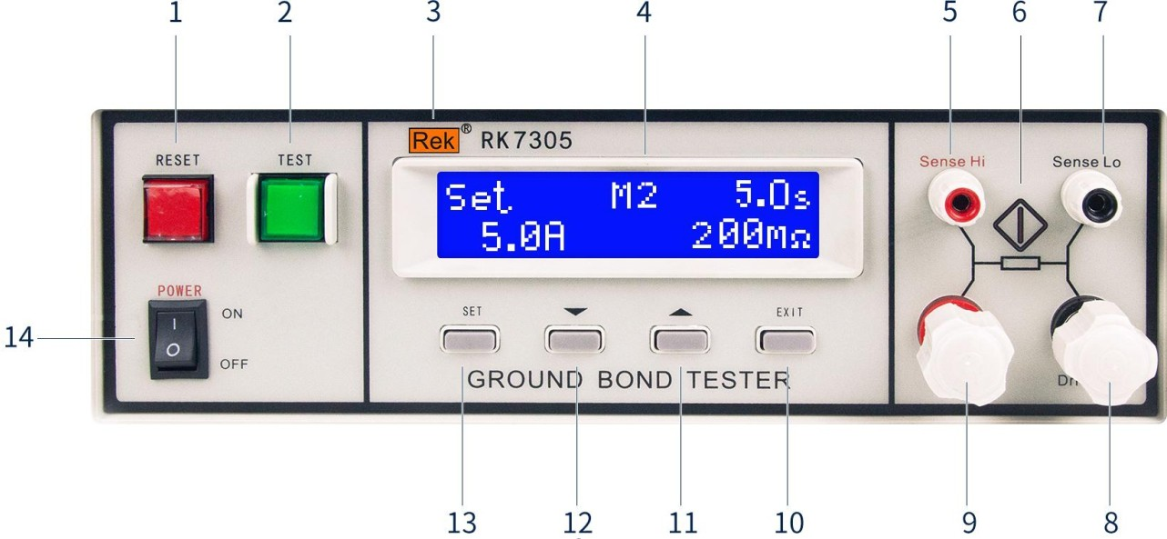

RESET switch
The instantaneous contact switch in red, while containing an indicator light for FAIL.When the test is conducted, act as the switch to turn off the alarm sound to the next state under test.It can also be used as a switch for interrupt testing as the test is conducted.This red indicator is on when the object fails to pass the test.

TEST switch
The green instantaneous contact switch also contains the PASS indicator lamp, serving as the starting switch for the test.This green indicator lights on when passing the test.

Rek logo flag 4.LCD display
A 16-line backlight LCD serves as a display of setting data or test results.

The Sense Hi voltage detection end

Check the voltage on the ground resistance of the tested piece

- Test the indicator lamp, the TEST ON
The TEST key is green when the indicator is on and the RESET key is red when the indicator is on

The Sense Lo voltage detection end

Check the voltage on the ground resistance of the tested piece

- The Drive Lo current output end

Special output can withstand large current above 30A as the current output of the measured object.As the loop test end of the subject piece.

The Drive Hi circuit loop end

Special output can withstand large current above 30A as the current output of the measured object.As the loop test end of the subject piece.

EXIT key
A function key to save the set parameter and exit the set mode.

11. The '' (+) UP key
Function key entered as the value of each test parameter when setting the mode.

“ "(-) DOWN key is used
Function key entered as the value of each test parameter when setting the mode.

SET key

As the operation key to select enter setting mode and select memory group and AC ground resistance test parameter setting.

Enter the power switch
Switches marked with international standards "I" (ON) and "O" (OFF) symbols, used as power switches for input.

15

5.2 Description of the backplane
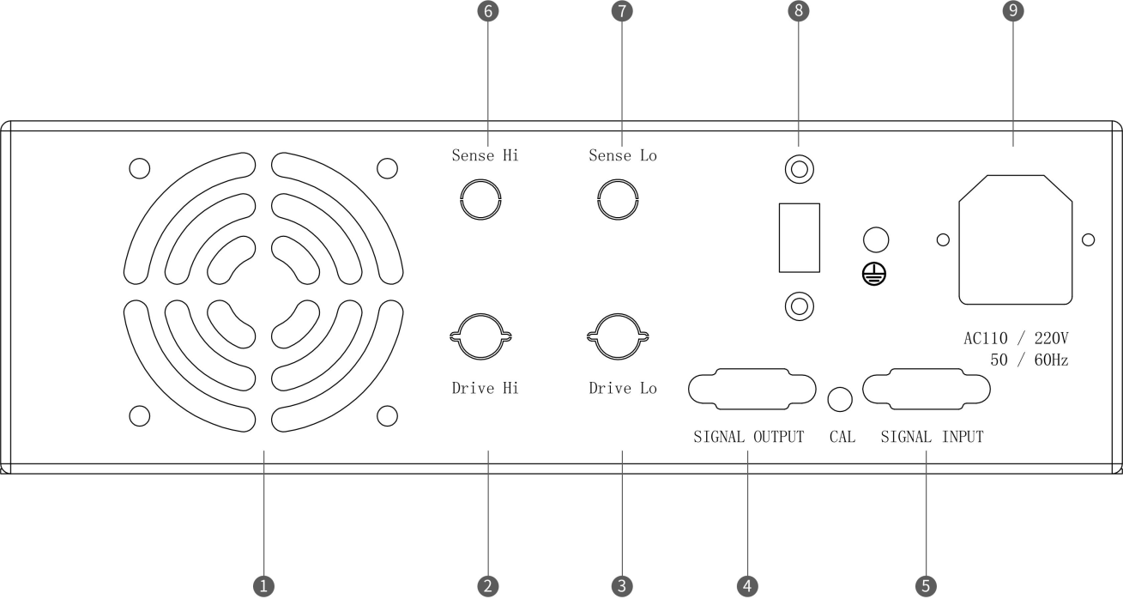

radiator fan
Must be kept at a distance of over 15cm from other items.

The Drive Hi circuit loop end
Special output can withstand large current above 30A as the current output of the measured object.As the loop test end of the subject piece.
- The Drive Lo current output end
Special output can withstand large current above 30A as the current output of the measured object.As the loop test end of the subject piece.

SIGNAL OUTPUT
This interface has the STOP, START, and WINTHSTANDPROCESSING functions.

SIGNAL INPUT
A standard 9-core D-type male terminal seat, providing remote control monitoring and control signal interface.

The Sense Hi voltage detection end
Check the voltage on the ground resistance of the tested piece

The Sense Lo voltage detection end
Check the voltage on the ground resistance of the tested piece

8.115V / 230V power conversion

9. Power socket
Standard input power outlet, providing working power for the tester.Close the input power switch before replacing the fuse, and replace the standard specification fuse (AC110 / 220V) 50/60HZ）。

Chapter 6: Test the parameter setting procedure

The AC ground resistance tester of 7305 is equipped with a keyboard lock function. Before entering the parameter setting, if you press the SET key, if the keyboard is locked, and the monitor will also display:

The SET key is the operation key for entering the parameters and mode settings.When entering the parameter setting pending test mode, press "SET" key, the program will automatically change into the parameter item and turn a memory program set setting, output current value setting, ground resistance limit setting, test time setting, output frequency selection and zero (MiLLohm Offset) setting in the following order.With each SET press, the parameter setting will be turned to the next set item, and the set test parameter or mode will be automatically stored into the memory body, and the last test parameter setting item will automatically return to the original first parameter setting item.Test parameters or patterns stored in memory are still retained after turning off the input power supply and are not cleared, unless manually reset.

In the mode set by the test parameters, the "" and "" keys are the input keys for the action keys and parameter values selected as the mode selection.The "" key, the number goes down, and the reverse turn key goes up.

Each press "" and "" When Key, the far most digit on the display increases "1" or decreases "1". For example, the original number "5" becomes "6" or "4". If pressed for more than 0. 3 seconds, the second digit on the right (excluding decimal point) on the display increases "1" or decreases "1" every 0. 3 seconds and the rightmost digit will automatically return to "0".For example, the original number is "55", which becomes "60" or "50", and then changes at the rate of increasing or decreasing "10" every 0. 3 seconds.If you press continuously for more than 3 seconds, the rate will increase or decrease "10" every 0. 1 seconds, and the button will return to the original rate state.

Under the test parameter setting and selection mode, the "EXIT" key is used as a function key that leaves the test parameter setting and selection mode.In the process of setting the test parameters, if you do not have to reset all, you can press the "EXIT" key to leave the test parameter setting mode, the program will automatically enter the pending test mode, and put the set test parameters in the memory.

The program does not accept the unreasonable setting and input, if there is an unreasonable setting or input, will issue two short "beep" warning sound and return to the original setting."X" in the following parameter setting description represents any number between 0-9.

Preparation for test parameter setting

Open the input power switch and the LCD display will display:
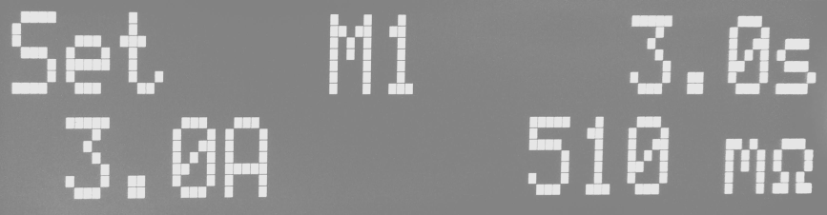
At the moment, the program automatically enters the parameters set during the last test before the last shutdown, and the LCD display will display

MX: Programmed Memory Group 1-5
XXX.Xs： Test time value setting
XX.X A: Output current value setting
XXX mΩ: Upper limit of the ground resistance value is set

At this time, the program has entered the parameter setting mode, please set and select the tested parameters and modes by following the instructions of the following procedures and steps.

Test the parameter setting program

6. 2. 1 Memory group setting
Press the SET key on the panel, the program will automatically enter the memory group set mode, and the LCD display will display:

Please use" "And" "keys set the number input parameter of the" program memory group 1-5.

6. 2. 2 Output current setting
After the program memory group is set and the SET key is pressed, the program will enter the output current setting mode, and the LCD display will display:
Use the " " on the panel The and keys enter the output current value to be set in "A" o

6. 2. 3 Limit of ground resistance (Hl-Limit) setting
After the output current setting is completed and the SET key is pressed, the program will enter the ground resistance upper limit setting mode, and the LCD will display:

Use the ' ' and '' on the panel "Key input to set the ground resistance limit in" mΩ ".

6.2.4 Test time setting
After the ground resistance limit is set and the SET key is pressed, the program enters the test time setting mode, and the LCD displays:

Use the keys and keys on the panel to enter the set test time value in S.

6.2. 5 Output frequency selection
After the test time is set and the SET key is pressed, the program will enter the output frequency selection mode, and the LCD will display:

Use the '' and '' keys on the panel to select the output frequencies of '50' or '60' Hz.

2. 6 Test line and cure resistance zero (mΩ Offset)
After the output frequency selection is completed and the SET key is pressed, the program will enter the setting mode of zero treatment resistance, and the LCD will display:
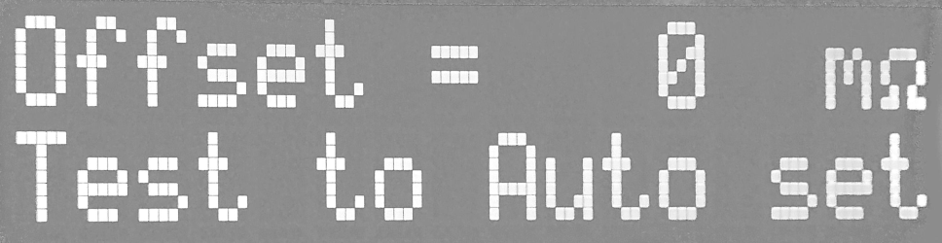

There are two ways to test line and zero resistance, one is automatic zero for the application internal program, the other is artificial input zero (OFFSET) data.

Before the test line and the treatment resistance are automatically zero, the power cord or cable on the test wire, the harness and the subject must be connected in series (if the power cable is OFFSET together), and the circuit to the Sense Hi and Sense Lo terminals of the machine.Then press the "TEST" switch on the panel, the program will automatically output the output current value of the memory program group on the LCD display, and automatically measure the resistance value on the circuit.After the resistance value measurement is completed, the program will issue two "beep" and "beep" sounds to confirm that the zero work has been completed.
And pressing EXIT to save the Offsetsh data LCD displays:
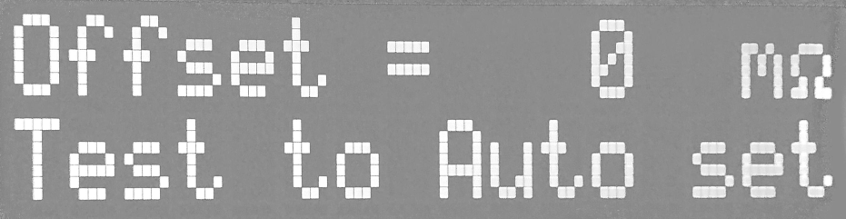
If you want to use artificial zero parameter settings, directly use the "" and "" keys on the panel
In the zero parameter input program, after the input is completed, the program will automatically deposit the return zero parameters of the test line and the test device into the test line and the test device zero setting program of the memory program group.
The zero parameter of each memory program group is set as an independent parameter, and must be set separately.
This is the last step of test parameter setting. If you want to check the set parameters, please press "SET" on the panel, the program will automatically return to the first parameter setting mode, the LCD will display:
If you want to leave the parameter setting mode, directly press the "EXIT" key on the panel, the program will automatically leave the parameter setting mode and enter the pending mode, the LCD display will display:
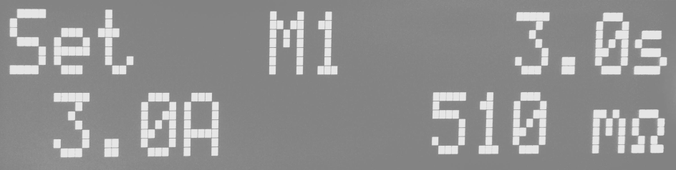

Chapter 7: Display message
This chapter provides various information about the LCD display during the test of the tester.

1 Boot-on screen display
After the input power switch of the tester, the LCD displays:
After a short period, the program automatically enters the tested and setting mode described in the next section 7.2.

7. 2 Ttest and parameter setting mode
The following display message indicates that the instrument has entered the pending test and parameter setting mode of the AC ground resistance test:
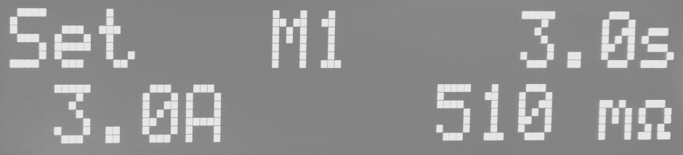

When pressing the "TEST" switch, the instrument starts to perform the AC ground resistance test; when pressing the "SET" key, the instrument immediately enters the parameter setting mode of the AC ground resistance test, and can set the test parameters.

7. 3 AC ground resistance test
7. 3. 1 When the AC ground resistance test is performed, the test results will be constantly updated, and the LCD display will display:

7. 4 Test suspension (Abort)
If the output voltage of the instrument is over 6V, the program will automatically stop the output and test, and the LCD display will display three phenomena:

    - overvoltage

    - Super upper limit

    - open a way

7. 7 Test Pass (Pass)
If the whole process of the AC ground resistance test occurs, it is deemed to pass the test, the LCD will display:
URL_5200cff371e6943303996876a749944c

Chapter 8 Operating Procedures and Steps
The 7305 AC grounding resistance tester is mainly designed for the general production line or quality inspection to use, and its operation and setting are very simple.Unreasonable setting and operation will give two short "beep" warnings, while returning to the original set state.
Run the instrument following the following procedures and procedures.
- Before connecting the input power cord plug of the instrument to the mains power supply, please close the input "power switch", and switch the "voltage selection" switch on the back plane to the correct input voltage position, and check whether the specification of the fuse wire is correct.Then connect the ground wire to the ground terminal on the backplane of the instrument.
- Connect the input power cord to the instrument and the power outlet respectively. Do not connect the test wire to the output terminal of the instrument first.
- Connect all the test lines of the test object or its test cure end, and then connect the various test lines to the output terminal of the instrument, and check whether all the test lines are all connected.
- Turning on the input "power switch" display for this instrument will appear immediately:
When the indicator is fully on, immediately check whether the indicator is normal.Then the program will automatically appear the memory group and test parameters at the last time of the last test of the instrument, and enter the pending test and setting mode, when the display will appear:
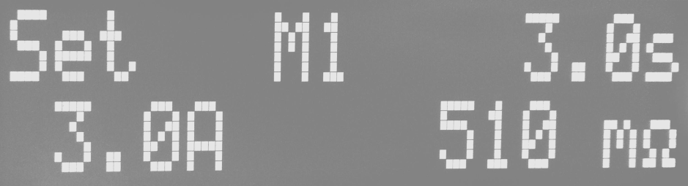
- If you want to reset the test parameters, press SET to set the parameters. For details, refer to the setting methods, procedures and steps.
- If you want to call the test parameters in the memory group for test, press SET and the program enters the setting mode of the memory group and the LCD display:
Please use" "And" Within the key will select, the program memory group is 1-5.
After the memory group is selected, press "EXIT" to leave the parameter setting mode and return to the pending test and setting mode. The program will automatically call out the test parameters of the memory group and wait for the test. The LCD display will display the test parameters of the memory group.

- If you want to test, press the TEST switch, when the green TEST indicator on the panel comes on and the timer starts timing.Do not touch the items to be tested to ensure safety.The display displays the following message for the test:

Dwell MX XXX.X s
XX.X A XXX mΩ
After the test, the instrument will automatically turn off the output, the green indicator light on the TEST switch will light on, and make a "beep" sound, indicating that the test item passes the test, and the display will appear "PASS" and the value of the test results.
To continue with the test, press the TEST switch again.To see the original setting, press the RESET switch, and the program will immediately clear the test results and display the original setting.
- If the test is being aborted, press the RESET switch, the instrument will immediately stop the test, and the display retains the test value at the time.To continue with the testing, press the TEST switch on the panel.
- If the object to test fails, the instrument will immediately stop the test and the display will display its status and failure value, when the indicator in the red "RESET" switch is on and the "beep" warning sound occurs.Press the RESET switch to close the alarm sound and keep the test reading. To continue the test, press the TEST switch again.For information about the various displays, refer to the Display Message description.
- If operating this AC ground resistance tester using an external remote control device, connect the remote control to the remote control input terminal on the backplane.The function and function of TEST and RESET switches on remote control are exactly the same as the switches on this instrument.
Since the TEST and RESET switches of the instrument and the remote control can be operated simultaneously, the remote control must be properly kept and allowed to contact the remote control to avoid accidents.
- The AC ground resistance tester is equipped with the output of "PASS, FAIL and PROCESSING" remote monitoring signals that can be connected to the control center for monitoring, completely consistent with the signals of the instrument.
- This AC ground resistance tester is equipped with "StartOut", "Reset Out" and "HIPOT LINK" signal interfaces for our resistance
Pressure tester for linkage test, detailed instructions and wiring, please refer to chapter 6 remote control output and input instructions.

Chapter 9 Correction of the procedures and steps
This instrument before the factory, according to the national standard correction procedures, correction on the instrument, the accuracy of the instrument is fully in line with the Meiruike electronic record specifications, even more accurate, and this manual attached "test report".Meiruike Electronics recommends that the instrument be corrected at least once a year, with a standard instrument and its accuracy must be within 0. 5% to ensure the accuracy of the instrument.

Instrument and equipment used for calibration:
The following instruments and equipment are sufficient to correct the instruments on this machine, please confirm that these standard instruments and equipment are within 0.5% accuracy.Voltmeter specification: 0-10V AC.
Ammeter specification: 0-35A AC above.
Resistance specification: over 100 mΩlOO WATT, as a current shunt, read the standard current value.

Enter the correction mode
    - After startup, press the CALI button to enter the main calibration interface, as shown in the figure below
- . Connect the instruments and the load

This instrument uses a 100m Ω standard resistance of 1% accuracy.The measurement end adopts a four-end network, separating the driver end Drive and the sampling end sense, to improve the measurement accuracy.
  - Connect the instrument

Thick red line to DriverHI, thin red line to Sense HI, thick black line to DriverLo end and thin black line to SenseLo end of the instrument.
  - Connect standard resistance

The connection line to the standard resistance is shown in the figure below.

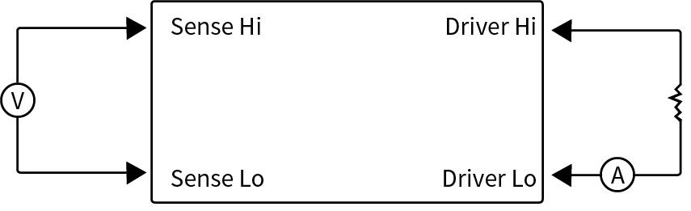

- DAC current calibration
  - DAC Point 1 for calibration

Press [Set] to pop the following figure

Measure the output current with the current clamp meter, press the upper and lower key input to measure the current value.
  - DAC Point 2 calibration

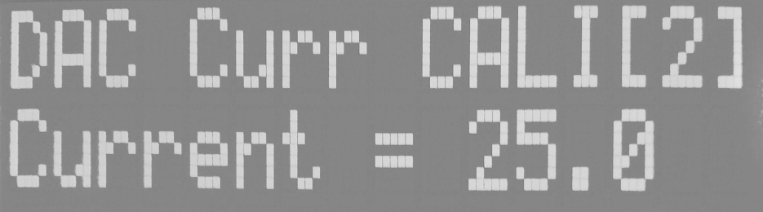
Press [Set] to pop the following figure.

Input the current clamp meter measurement value.
- ADC current calibration
  - ADC Point 1 current calibration

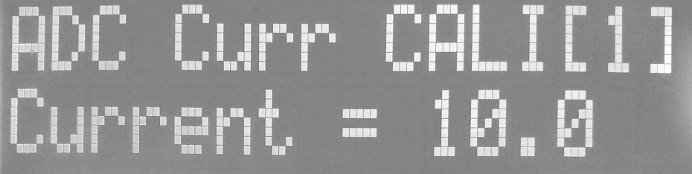
Press [Set] to pop the following figure
Input the current clamp meter measurement value.
  - ADC Point 2 current calibration

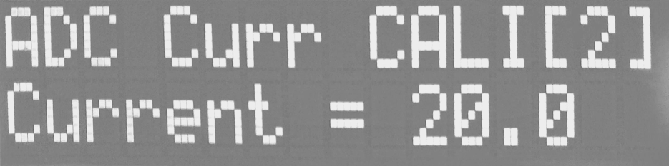
Press [Set] to pop the following figure

Input the current clamp meter measurement value.

- ADC voltage calibration
  - ADC point 1 voltage calibration

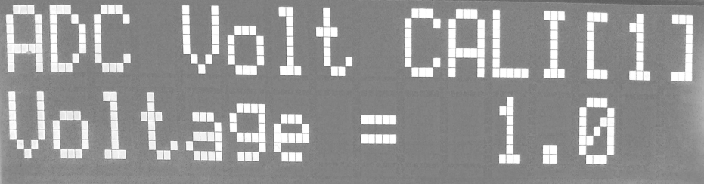
Press [Set] to pop the following figure

The Sense + and Sense-end voltages were measured with the Fluk Multimeter AC gear, with the input voltage values.

  - ADC point 2 voltage calibration

Press [Set] to pop the following figure
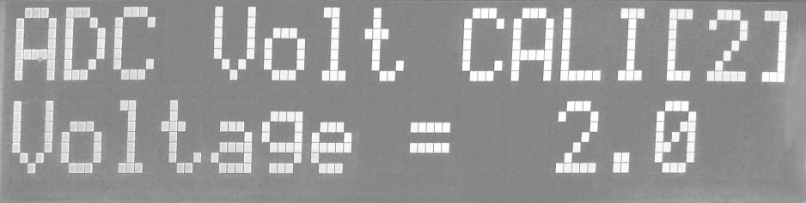

Enter the multimeter voltage value

- End calibration

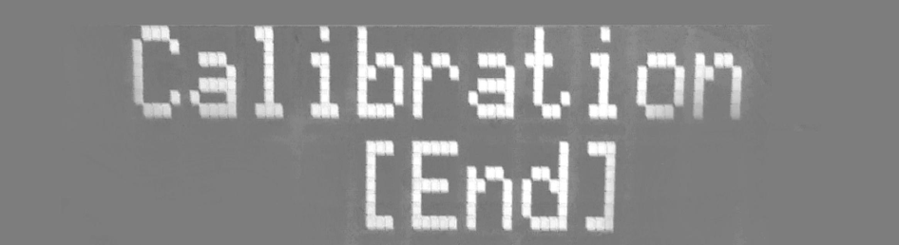
Press [Set] to pop the following figure.

Automatically save the calibration coefficient, and restart it.

    - After the machine is corrected, it must first switch off the input power switch before restart to bring the machine back to the test and set mode, otherwise The machine cannot enter the test and setting mode.
- The correction data stored will not change or disappear unless changed.

- The recommended correction cycle is at least once a year.

Chapter 10 Remote control Input and output signal

Remote command signal output

10.1. 1 Description of remote control signal output
On the backplane of this machine, there is a signal output terminal (as shown in the backplane Figure # 2), which monitors the execution of the machine to the monitoring center, and connects the START and RESET OUT signals to the Murray pressure tester into a set of safety gauge automatic test equipment.The remote terminal is a standard type 9 PIN D terminal with three monitoring signals to output PASS (pass test), FAIL (test failure)
And PROCESSING (in test execution) and two connection signals outputs STARTOUT (test start for withstand tester

Number) and RESET OUT (reset signal for pressure tester).
- START OUT signal:
After the instrument is executed and the object is tested, the START OUT terminal of the instrument will automatically output a pulse signal.If this signal is connected to the remote control TEST input terminal on the backplane of the company withstand pressure tester, the signal will automatically start the withstand voltage test and continue the withstand voltage test.

RESET OUT signal:
When pressing the RESET switch on the panel or using a remote control reset (RESET), the RESET OUT terminal of the instrument will automatically output a ripple signal.If this signal is connected to the remote control RESET input terminal on the backplane of the company voltage tester, the voltage tester can be reset together.
The machine provides "regular open (NO)" contacts without power to the above five signals, the parameters of the contacts are 250VAC / 1.0 A, 250VDC / 0. 5AOThese junctions have no positive and negative polarity limits, and each signal is an independent wiring, with no common ground wire (COMMON) o

10.1.2 Instructions of remote control output signal
The tester provides three "normally open" contact signals provided by three relays inside the tester with AC 250V 1.0A / DC 250V 0.5A capacity with no positive and negative polarity limits, and each signal has independent wiring with no common ground wires.
The pin number mark is attached to the terminal seat, and the output signal wiring is as follows;

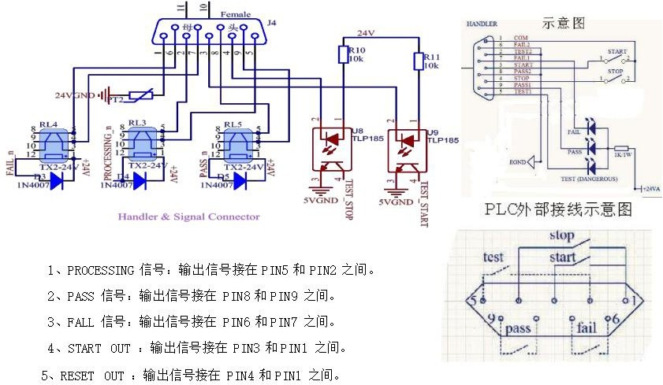

Remote command signal input

10.2. 1 Input description of the remote control signal
On the backplane of this instrument is a remote control input terminal (as shown in the backplane Figure # 4), which can operate the machine and the execution signal of the WITHSTAND PROCESSING into the working signal), TEST (test switch function) and RESET (reset switch function).
The remote control signal input terminal is a standard 9 PIN D terminal seat with controlling power supply on the terminal. TEST and RESET switches must be controlled using "instant contact" (MOMENTARY) switches.

Please pay special attention, absolutely do not connect to any other power supply, if input other power supply, will cause misaction or damage to the internal circuit of the machine.
The function of WITHSTAND PROCESSING input signal is used for interface signal with our voltage tester.If the PROCESSING signal on the remote output terminal of the backvoltage tester is connected to the input terminal of this signal, the LCD display on the AC ground resistance tester displays "W-ON" when the voltage tester is performing the test.If the test of the AC ground resistance tester is being performed and the voltage tester is activated, the AC ground resistance tester immediately stops performing the test and the LCD displays "W-ON".As long as the link signal is connected between the two instruments, only one instrument can be allowed to perform the test at a time, and the withstand pressure tester has the priority to perform the test.

10.2.2 Remote control input signal wiring instructions
The tester is equipped with a remote control contact, which can operate the TEST (start) and RESET (reset) functions of the instrument by the external remote control device, and input the execution signal of the following three functions: WITHSTAND PROCESSING (Enter the working signal of the voltage tester), TEST (test switch function).The instant contact switch must be used as the controller.Please note that no other power supply can be connected. If any other power supply is connected, it will cause damage or misoperation of the internal circuit.
WITHSTAND PROCESSING The function of input signal is used for the dynamic test interface signal.if
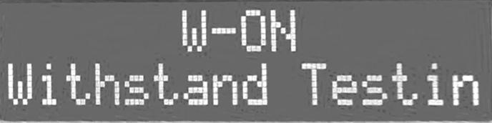
Connect the PROCESS signal on the PLC remote control output terminal of the company to the input terminal of the signal. When the voltage regulator performs the test, the LCD display of the AC ground resistance test will display "W-ON". If the AC ground resistance test is executing, the AC ground resistance test will immediately stop performing the test and display "W-ON" on the LCD display.As long as the link signal is connected between two instruments, only one instrument is allowed to perform the test at a time, while the pressure regulator has the priority to perform the test.
Input the wiring instructions for the remote control signal
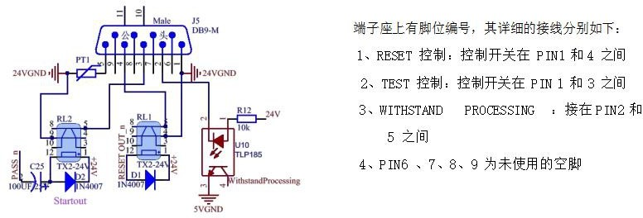

37

AC ground resistance tester and voltage resistance tester dynamic test way
The AC grounding resistance tester and the voltage resistance tester have the following three test methods:
    - AC ground resistance test and voltage withstand test after passing AC ground resistance test.
    - Conduct the withstand voltage test first, and then perform the AC ground resistance test.
    - The AC ground resistance test and the voltage resistance test are performed simultaneously.
Most of the safety regulations and safety regulations enforcement units stipulate that the first test method, only a few use the second method.The third way mostly manufacturers in order to shorten the manufacturing hours, and the two tests at the same time, in theory two tests at the same time will not cause any problems or danger, but if one of the instruments have abnormal condition, is likely to cause operator danger or injury, also may make another instrument follow
Abnormal condition occurred.

The Company does not recommend the use of the third test method. If the third test method must be used, it must be checked at any time and confirm that the instrument is free from any abnormal conditions.
Since the company has two series of 70 and 71, the foot position of the signal interface on the backplane of the two series of instruments is not the same, but the language is consistent, and the foot position must be confirmed when connecting.

10.4 Wiring and description of connection test of AC grounding resistance tester and withstand voltage resistance tester

10.4. 1 Wiring and description of AC grounding resistance test
AC ground resistance test and voltage withstand test after passing AC ground resistance test.

1. 1 Wiring for linkage testing with the 70 series

    - Connect the START OUT output signal (PIN 6 and PIN 8) in the SIGNAL OUTPUT terminal of the 7305 to the TEST input terminal and the PIN 3 and PIN 5).

    - Connect the RESET OUT output signal (PIN 7 and PIN 8) in the SIGNAL OUTPUT terminal of the 7305 back to the RESET signal input terminal (PIN 2 and PIN 5) in the SIGNAL INPUT terminal of the 70 series backplane.

    - Connect the PROCESSING output signal (PIN 5 and PIN 6) in the SIGNAL OUTPUT terminal of the 70 series backplane to the WITHSTAND PROCESSING signal input terminal in the [J7305 backplane SIGNAL INPUT terminal (PIN 6 and PIN 7).

    - If connecting the AC ground resistance tester and the voltage tester must have a common ground (COMMON GROUND), connect the HIPOT LINK on the 7305 panel to the output RETURN terminal.

    - Set the PLC REMOTE mode for series 70 to "0N".

Wiring with Series 71
        - Use the connecting line to connect the START OUT output signals (PIN 6 and PIN 8) in the 7305 back SIGNAL, OUTPUT terminals to the TEST signal input terminals (PIN 3 and PIN 5) in the SIGNAL I / O terminal of the 71 series back panel.
        - Use the connecting line to connect the RESET OUT output signal (PIN 7 and PIN 8) in the 7305 backplane SIGNAL, OUTPUT terminal to the 71 series
On the RESET signal input terminal (PIN 2 and PIN 5) in the SIGNAL I / O terminal of the backplane.
        - Connect the PROCESSING output signal (PIN 1 and PIN 4) in the 71 series backplane SIGNAL I / O terminal to the WITHSTAND PROCESSING signal input terminal in the 7305 SIGNAL INPUT terminal (PIN 6 and PIN 7).
        - If connecting the AC ground resistance tester and the voltage tester must have a common ground (COMMON GROUND), connect the 7305 sides
The HIPOT LINK on the board is connected to the output RETURN terminal.

Operation and action description of AC ground resistance test for continuous voltage resistance test
        - This wiring method is to conduct the AC ground resistance test before the AC ground resistance test is completed and passed.
        - Press the TEST switch of 7305 for the test of AC ground resistance. After the test, the test of 7305 will output a ripple signal to the TEST input terminal of the voltage tester
The withstand pressure test begins immediately upon receipt of the TEST signal.
        - During the withstand pressure tester test, the LCD of the 7305 displays:
        - If the AC ground resistance test fails, the 7305 program will not output the signal to the TEST input terminal of the withstand tester, which will not perform the withstand test.
        - During the AC ground resistance test, if the TEST switch of the voltage tester is pressed, 7305 will immediately stop performing the test, instead of the voltage resistance test, and the LCD display of 7305 will display:
        - For the RESET AC ground resistance test and voltage tester, use only the 7305 RESET switch.

10.4.2 Wiring and description of continuous AC ground resistance test
Conduct the withstand test first, and then perform the AC ground resistance test.

4. 2. 1 Wiring for linkage testing with the 70 series
  - Connect the PASS output signal (PIN 1 and PIN 2) in the 70 series panel SIGNAL OUTPUT terminal to the TEST input terminal (PIN 3 and PIN 5) in the 7305 SIGNAL INPUT terminal.
  - Connect the PROCESSING output signal (PIN 5 and PIN 6) in the SIGNAL OUTPUT terminal of the 70 series backplane to the WITHSTAND PROCESSING signal input terminal in the SIGNAL INPUT terminal of the 7305 backplane (PIN 6 and PIN 7).
  - If connecting the AC ground resistance tester and the voltage tester must have a common ground (COMMON GROUND), connect the HIPOT LINK on the 7305 panel to the output RETURN terminal.

4. 2. 2 Wiring for linkage testing with series 71
  - Connect the PASS output signal (PIN 6 and PIN 7) in the 71 series terminal to the TEST signal input terminal in the 7305 terminal at the SIGNAL INPUT terminal (PIN 3 and PIN 5).
  - Connect the PROCESSING output signal (PIN 1 and PIN 4) in the 71-series backplane SIGNAL I / O terminal to the 7305 backplane SIGNAL
On the WITHSTAND PROCESSING signal input terminal within the INPUT terminal (PIN 6 and PIN 7)
  - If connecting the AC ground resistance tester and the voltage tester must have a common ground (COMMON GROUND), connect the HIPOT LINK on the 7305 panel to the output RETURN terminal.
- 4. 2. 3 Operation and action description of continuous AC voltage test ground resistance test
  - The wiring mode is for withstand voltage test and then for AC ground resistance test.
  - Press the TEST switch of the withstand tester for the withstand test. After the withstand test is completed and the test is passed, the program outputs a signal from the A S S to the TEST input terminal via the PASS. The AC ground resistance tester receives the TEST
Ground resistance test starts immediately after the signal.
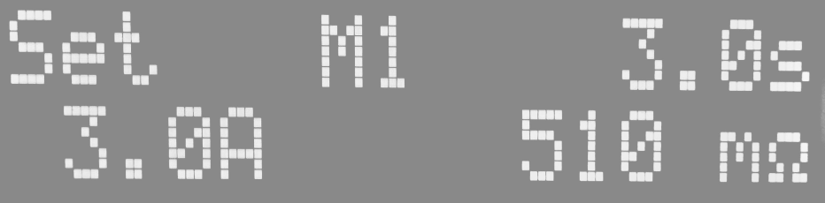
  - During the withstand pressure tester test, the LCD of the 7305 displays:
  - If the withstand test fails, the withstand test program will not output the signal to the TEST input terminal of the AC ground resistance tester, which will not perform the AC ground resistance test.

42

Shenzhen Meiruike Electronic Technology Co., LTD

packing list

Machine model: RK7305

The following is the packing list, please carefully check and check, in case of defect or damage, please timely contact the Murray dealer or our company.

name | specifications and models | unit | quantity
Programme-controlled ground resistance tester | RK7305 | short for Taizhou | 1
instructions | RK7305 | portion | 1
Calibration report | / | portion | 1
power line | RK00001 | root | 1
certificate | / | portion | 1
P-wire | RK00005 | Pay | 1
The RS232 cable | RK00002 | twig | 1

examination clerk:

43

Scan the code with a browser
Vsit our website for more product information.
SHENZHEN MEIRUIKE ELECTRONIC TECHNOLOGY.,LTD

