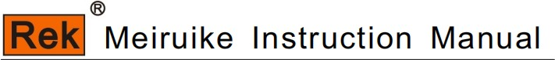
RK9970
Program-controlled safety comprehensive tester

SHENZHEN MEIRUIKE ELECTRONIC TECHNOLOGY CO.,LTD

Safety warning:

Instrument grounding

This instrument is a Class I safety instrument. When connecting the power supply, please make sure that the power socket contains grounding wire. If it is not grounded, static electricity or induced electricity on the casing may cause personal injury!

Danger of electric shock

Electric shock damage

Beware of electric shock during operation, testing and instrument maintenance. Non-professionals are not allowed to open the chassis without authorization. If professionals need to change the fuse or carry out other maintenance, they must unplug the power plug first and be accompanied by others. Even if the power plug has been unplugged, there may still be dangerous voltage on the capacitor, so it should be operated after discharge.

Any incorrect removal or addition of the tested part during the test will cause abnormal damage to people, property or instruments! ! ! If the instrument is damaged due to abnormal operation, the maintenance cost shall be borne by the customer.

Please use the power supply according to the power supply parameters specified in this instrument, and the power supply input that does not meet the specifications may damage this instrument.

Stay away from explosive gas environment

Other safety

item

Electronic instruments should not be used in flammable and explosive gas environment or environment containing corrosive gas or smoke, because it may bring danger.

Please do not apply any voltage source or current source to the test terminal of this instrument.

An important supplement or reminder to the content elaborated.

Instructions for use:
* Please read and understand the contents described in the instruction carefully before operating the tester. After reading, please put the instructions near the operator for reading when necessary. When moving the tester from one workplace to another, please carry the manual with the instrument to avoid losing it.
* With the improvement of instrument function and the upgrade of software, the instruction manual will be improved and upgraded continuously. Please pay attention to the software and instructions of the tester.
Version.

MEIRUIKEINSTRUMENT 错误！未定义书签。
Chapter I Safety Rules 1
1.1 General provisions 1
1.2 Maintenance and maintenance 1
1.3 test environment 1
1.4 operator regulations 2
1.5 Safety grounding regulations 2
1.6 fuse replacement regulations 3
1.7 test safety regulations 3
1.8 test exception regulations 3
1.9 safety points 3
Chapter 2 Overview 4
Chapter 3 Panel Description 9
Chapter 4 Explains the operation 21
Ch a p t er 5 HANDLER Interface and SINGAL Interface 23
Chapter6 24
Chapter 7 Remote Control 50
Chapter 8 SCPI serial port instruction reference 60
Chapter 9 83
Chapter 10 Warranty 84

Chapter I Safety Rules
The contents of the user manual are subject to change without prior notice.
If there is anything unclear in the user manual, please contact us directly.

Rules and matters needing attention before testing!
Warning: To prevent malfunction or damage to the tester, please use the tester within the specified voltage range.

1.1 General provisions
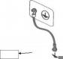
■ Before using the tester, please read the manual carefully to understand the operating procedures and related safety signs to ensure safety.
■ Please select the correct input voltage specification before turning on the input power switch.
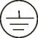

Chassis grounding symbol
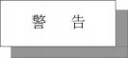
Warning: It should be noted that the operations, applications or conditions performed are very dangerous, which may lead to personal injury or death.

The current generated by the tester is enough to cause casualties. In order to prevent accidental injury or death, please be sure to observe clearly before moving and using the tester.

1.2 Maintenance and maintenance
1.2.1 In order to prevent electric shock, non-professionals should not open the cover of the tester, and all parts inside the tester should not be replaced without permission. If there is any abnormality in the tester, please seek the help of our company or the designated dealer.
1.2.2 Regular maintenance
Testers, power cords, test lines and related accessories should be carefully inspected and calibrated at least once a year to ensure the safety of operators and the accuracy of testers.
1.2.3 user's modification
Users are not allowed to change the circuit or parts of the tester by themselves, otherwise our guarantee will be invalid and we will not be responsible for the consequences.

1.3 test environment
1.3.1 Working position
When operating the tester, you must ensure that the tester is placed in a place that ordinary people can't touch at will. If it cannot be done because of the arrangement of the production line, the test area must be isolated from other facilities and specially marked as "test work area".

1.3.2 input power supply
The tester uses 220V 50Hz/60Hz single-phase power supply. Before turning on the power switch, please ensure that the power supply voltage meets the requirements. The power supply in the test area must have a separate switch, which is installed at the entrance of the test area to ensure that all personnel can identify it. Once there is an emergency, you can turn off the power immediately.

To prevent the tester from malfunction, please use it within the specified voltage range.

1.3.3 Workplace
Use a workbench made of non-conductive materials as much as possible. The test site must be kept neat and clean at all times, and must not be chaotic. Please put the unused tester and test line in a fixed position, and make sure that all personnel can immediately separate the tested object, the tested object and the tested object.
The air in the test area and the surrounding area must not contain flammable gas, nor can the tester be used next to flammable items.

1.4 operator regulations
1.4.1 Qualification of operators
The current output by the tester is enough to cause personal injury or death when it is electrocuted by wrong operation, so it must be used and operated by trained and qualified personnel. 1.4.2 Safety Code
Operators must be educated and trained at any time to understand the importance of various operating rules and operate the tester according to safety rules. In order to prevent electric shock accidents, please wear insulating gloves before using the tester.
1.4.3 dress code
Operators are not allowed to wear clothes decorated with metal or wear metal ornaments and watches, which can easily cause accidental electric shock. When you get an electric shock, the consequences will be more serious.
1.4.4 Medical regulations
The tester must not be operated by people who have heart disease or wear a pacemaker.
Incorrect grounding or ungrounded grounding may lead to electric shock accidents.

1.5 Safety grounding regulations
The tester must have a good grounding, and the ground wire must be connected well before the test to ensure the safety of the operator. If the ground wire on the power plug is connected
Unreliable, an additional protective grounding terminal is provided on the back panel of the tester for connecting to a safe ground.
Incorrect grounding or ungrounded grounding may lead to electric shock accidents.

1.6 fuse replacement regulations
Please turn off the input power switch and disconnect the power plug before replacing the fuse, and replace the standard fuse (200V-240V 47Hz-63Hz 5A).

In order to avoid electric shock, be sure to disconnect the power cord before replacing the fuse.

1.7 test safety regulations
After connecting the test line to the object to be tested, make sure the connection is reliable. Operators must ensure that they can operate completely independently, and the switch and remote control switch cannot be controlled by other personnel. The remote control switch should be placed in a fixed position when not in use, and should not be placed at will.
Never use the tester on a live circuit board or equipment! Do not touch the test object or the object connected with the test object during the test!

1.8 test exception regulations
Under certain conditions, the tester will not respond to the reset key, the test time value will not move, and the black screen will be displayed, which is very dangerous. When these situations occur, please turn off the power switch and disconnect the power plug. Do not use it again, please contact our company.

Turn off the power switch and unplug the power plug immediately when the test is abnormal!

1.9 safety points
■ Unqualified operators and irrelevant personnel should stay away from the test area.
■ The test area must be kept in a safe and orderly state at all times.
■ Never touch the test object or anything connected with the test object during the test.
■ In case of any problems, please turn off the output and input power immediately.

Chapter 2 Overview
2.1 introduction

Thank you for purchasing RK9970 comprehensive safety tester.
RK9970 comprehensive safety tester is controlled by high-performance ARM microprocessor, which has excellent speed and performance. It provides eight test functions: DC insulation resistance test, DC withstand voltage test, AC withstand voltage test, grounding impedance test, leakage current test, AC power test, starting current test and comprehensive test.
You can use the built-in file editor of the instrument or RS232 interface to edit the comprehensive test list and complete the efficient test.

2.2 main specifications

RK9970 series technical specifications include the basic technical indicators of the instrument and the allowable range of instrument testing. These specifications can be achieved when the instrument leaves the factory.

Grounding resistance test
Grounding resistance test mode | four-wire system
No load output voltage | < 12V
Output current setting range | AC:3.00~32.00 A Continuous adjustable constant current output 50/60 Hz dual frequency optional.
Output current resolution | 0.1A
Output current accuracy | 3.00 ~ 9.99a: (1.5% set value +0.20A)
 | 10.00 ~ 32.00a: (1.5% set value)
Setting range of grounding resistance | Upper limit: 0 ~ 600 mω
Measuring range of grounding resistance | 3.00A ≥ output current ≤10.00A, 0 ~ 600 mω.
 | 10.00A≥ output current ≤20.00A, 0~300mΩ.
 | 20.00A≥ Output current ≤32.00A, 0~180mΩ
Resolution of grounding resistance measurement | 0.1mΩ
Resistance return to zero compensation | 0~600mΩ
Measurement accuracy of grounding resistance | (1.5% reading value +3mΩ)
Test time setting range | 0.5~999.9sOFF= continuous output
Test time resolution | 0.1s
Test time accuracy | (0.1% set value +0.05 s)

Insulation resistance test
Rated output load/current | 3VA(3000/1mA)1mA
Output voltage ripple | Resistive load, 3000 V/1mA, < 5%
Output voltage setting range | D C: 50~ 30 00V continuously adjustable.
Output voltage resolution | 0.1V
Output voltage accuracy | (1.5% set value+3V)
Insulation resistance setting range | Upper limit: 10.1 mω ~ 99999.9 mω 0 = off.
 | Lower limit: 0.1~99999.9MΩ 0FF= = off.
Measuring range of insulation resistance | 0.1~99999.9MΩ
Resolution of insulation resistance measurement | 0.01MΩ/0.1MΩ/1MΩ
Measurement accuracy of insulation resistance | 0.1MΩ~1GΩ±10%
 | 10~100GΩ±20%
Delay time | 0.5~999.9s
Test time setting range | 0.1~999.9sOFF= continuous output
Test time resolution | 0.1s
Test time accuracy | (0.1% set value +0.05 s)

Ac withstand voltage test
Rated output load | 250VA(AC ：5000V/50mA)
Output voltage regulation rate | < 2% (no load to full load)
Output voltage setting range | Ac: 50 ~ 5000 v, 50/60 Hz dual-band optional.
Output voltage resolution | 1V
Output voltage accuracy | (1.5% set value+3V)
Measurement range of breakdown current | 0.005~9.999~50.00mA
Breakdown current setting range | Upper limit: 0.001~50.00mA
 | Lower limit: 0.001~50.00mA OFF= off.
Resolution of breakdown current measurement | 0.00 1mA /0.01mA
Measurement accuracy of breakdown current | (1.5% reading value+0.005m A)
Boost time | 0.1~999.9s
Slow rise time | 0.0~999.9s
Test time setting range | 0.0,0.1~999.9sOFF= continuous output
Test time resolution | 0.1s
Test time accuracy | (0.1% set value +0.05 s)

Dc withstand voltage test
Rated output load | 120VA(DC ：6000V/ 20mA )
Output voltage regulation rate | < 2% (no load to full load)
Output voltage setting range | DC ：50 ~ 6000V
Output voltage resolution | 1V
Output voltage accuracy | (1.5% set value+3V)

11

Measurement range of breakdown current | 0.005~9.999~ 20.00mA
Breakdown current setting range | Upper limit: 0.0001~9.999~ 20.00mA
 | Lower limit: 0.0001~9.999~ 20.00mA OFF= off.
Resolution of breakdown current measurement | 0.00 1mA /0.01mA
Measurement accuracy of breakdown current | (1.5% reading value+0.005m A)
Boost time | 0.1~999.9s
Slow rise time | 0.0~999.9s
Test time setting range | 0.1~999.9sOFF= continuous output
Test time resolution | 0.1s
Test time accuracy | (0.1% set value +0.05 s)

Leakage current test
Rated load power range | Determined by the power of external isolation transformer/external variable frequency power supply.
Leakage type setting | Static leakage, dynamic leakage
Analog impedance type | GB/T12113( idtIEC60990) | 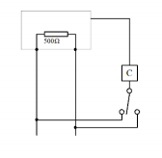  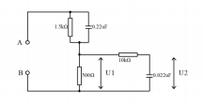
Leakage current measuring circuit | GB/T12113( idtIEC60990 )
Output voltage ratio | Determined by the external input voltage.
Output voltage setting range | AC ：0.1~300.0V
Output voltage measuring range | AC ：5.0~300.0V
Output voltage measurement resolution | 0.1V
Output voltage measurement accuracy | ± (1.5%+3V)
Leakage current setting range | Upper limit: 0.001~20.00mA
 | Lower limit: 0.000~19.999mA
Leakage current measurement resolution | 0.001mA
Measurement accuracy of leakage current | 0.005 ~ 9.999 Ma: (1.5% reading value+0.005mA)
 | 10.00 ~ 20.00 Ma: (1.5% reading value +0.05mA)
Test time setting range | 0.1~999.9sOFF= continuous output
Test time resolution | 0.1s
Test time accuracy | (0.1% set value +0.05 s)

Ac power test
Output voltage ratio | Determined by the external input voltage.
Output voltage setting range | AC ：0.0~300.0V
Output voltage measuring range | AC ：0.0~300.0V
Output voltage measurement resolution | 0.1V
Output voltage measurement accuracy | (0.25% reading value+0.25% range value)
Power setting range | RK9970/9970A-6: upper limit: 0.001~6000W w. | 9970A-3: upper limit: 0.001~3000W W.
 | Lower limit: 0.001~6000W W. | Lower limit: 0.001~3000W W.
Power measurement range | 5.0~6000W | 5.0~3000W
Power measurement resolution | 0.1W/1W
Power measurement accuracy | (0.25% reading value +0.25% range value)
Current setting range | RK9970/9970A-6: upper limit: 0.001~30.000A | 9970A-3: upper limit: 0.001~15.000A
 | Lower limit: 0.001~30.000A | Lower limit: 0.001~15.000A
Current measuring range | 0.000~30.000A | 0.000~15.000A
Current measurement resolution | 0.001A ~0.01A
Current measurement accuracy | (0.25% reading value +0.25% range value)
Delay time | 1.0~99.9s
Power factor measurement range | 0.100~1.000
Power factor measurement resolution | 0.01
Accuracy of power factor measurement | +/-(0.5% reading value +0.01)
Test time setting range | 0.1~999.9s0FF= continuous output
Test time resolution | 0.1s
Test time accuracy | (0.1% set value +0.05 s)

Low voltage start-up test
Output voltage ratio | Determined by the external input voltage.
Output voltage setting range | AC ：0.2~300.0V
Output voltage measuring range | AC ：0.0~300.0V
Output voltage measurement resolution | 0.1V
Output voltage measurement accuracy | (0.25% reading value+0.25% range value)
Current setting range | RK9970/9970A-6: upper limit: 0.001~30.000A | 9970A-3: upper limit: 0.001~15.000A
 | Lower limit: 0.001~30.000A | Lower limit: 0.001~15.000A
Current measuring range | 0.000~30.000A | 0.000~15.000A
Current measurement resolution | 0.001A ~0.01A
Current measurement accuracy | (0.25% reading value +0.25% range value)
Test time setting range | 0.5~999.9s 0FF= continuous output
Test time resolution | 0.1s
Test time accuracy | (0.1% set value +0.05 s)

human body network: there are 8 kinds of simulated human body networks (MD-A, MD-B, MD-B1, MD-C, MD-D, MD-E, MD-F and MD-G) built into the instrument.

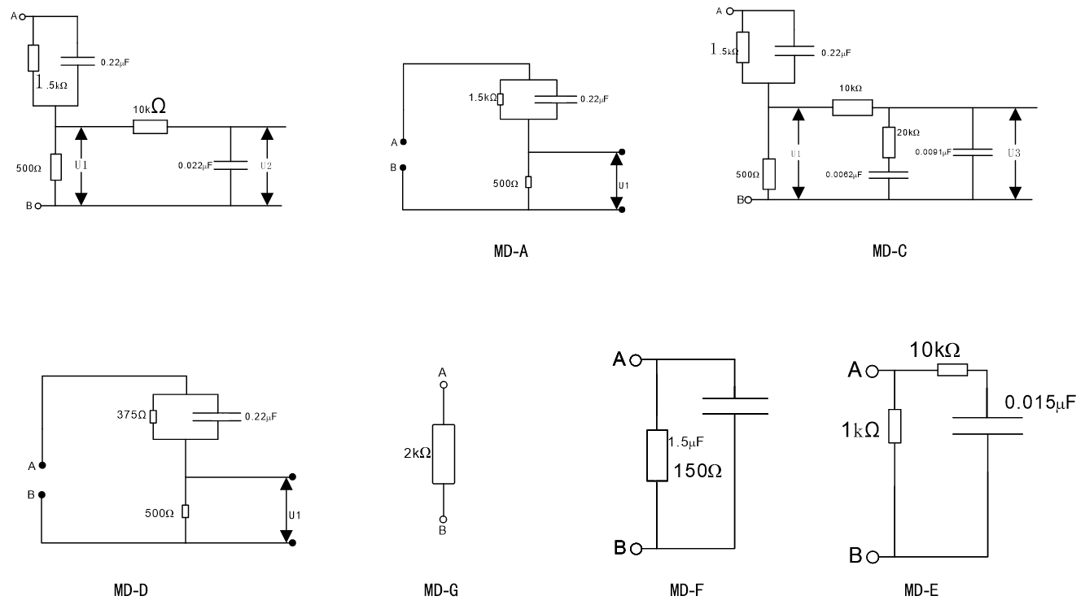

MD-A: GB/T 12113-2003 (IEC 60990: 1999) Contact current measurement; Gb 4793.1-2007 (iec 61010-1: 2001) electrical equipment for measurement, control and laboratory MD-b/B1: GB/t12113-2003 (iec 60990: 1999) contact current measurement, GB 4793.1-2007 (iec 61010-2007)
Gb4706.1-2005 (IEC 60335-1: 2004) household and similar appliances, Gb4943.1-2011 (IEC 60950-1: 2005) information technology equipment,
Gb 8898-2011 (iec 60065: 2005) audio, video and similar electronic equipment, IEC60335-1-2010, GB 7000.1-2015 (iec 60598-1: 2014) lamps MD-c: GB/t12113-2003.
MD-D: GB 4793.1-2007 (IEC 61010-1: 2001) Electrical Equipment for Measurement, Control and Laboratory
MD-E: GB 9706.1-2007/IEC 60601-1-1988 Medical electrical equipment, UL2601 -2022 Medical electrical equipment.
MD-F: GB 9706.1-2007/IEC 60601-1-1988 Medical electrical equipment, UL2601 -2022 Medical electrical equipment.

note:
1. The above technical parameters are standard parameters, and the measurement should meet the measurement environment and other conditions without auxiliary accessories such as test boxes, so as to reduce the influence of external factors on the measurement accuracy.
2. When using the instrument to test, it is recommended to test in the order of grounding, insulation, withstand voltage, leakage and power. Users can also change the measurement sequence according to the actual requirements of the products on the side.

Product volume and weight

model | RK9970 | RK9970A-3 | RK9970A-6
Volume (W*D*H) | 700*440*230 | 500*550*1270 | 500*550*1270
Weight (KG) | 43.25 | 108.8 | 125.8

Chapter 3 Panel Description
3.1 RK9970/RK9970A-3/RK9970A-6 Front Panel Description

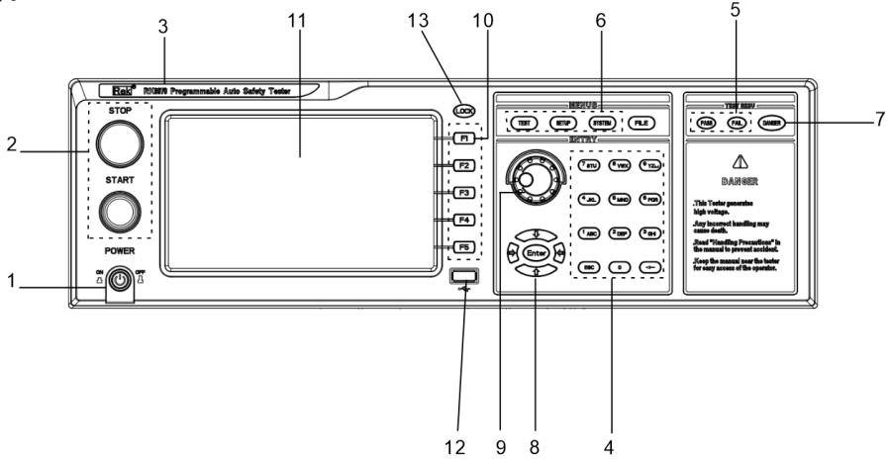

3.1.1 POWER switch (power)
Power switch. Before starting the machine for the first time, the operator should pay attention to check whether the instrument power supply type and test line connection are normal.
3.1.2 START key and STOP key
START key (green circle): used to start the test. Once the test starts, the HV indicator will light up.
STOP key (red circle): stop key, used to stop the test; It can also be used to cancel prompt states such as PASS and FAIL.
3.1.3 Trademark and model
Trademark and model of instrument
3.1.4 Numeric keypad
Used for digital value input.
3.1.5 Indicator light area
● FAIL
In the test, there are test data beyond the set, the instrument judges that the test is unqualified, and the FAIL judgment light is on.
● PASS
After the test, no test data beyond the initial setting was found, the instrument judged that the test was qualified, and the PASS judgment light was on. When the test timing function is off (TIM E OFF), the test can only be ended with' ‘STOP' without PASS judgment.
3.1.6 FUNCTION area (function)
Select test mode setting, system setting and document operation interface.
● TEST
Press this key to light up, and the instrument will be ready for testing. Only in this state can the instrument start the high voltage test.
● SETUP
Press this key to light up, and the instrument will enter the parameter setting interface; Only in this state can the instrument modify the test parameters.
● SYSTEM
This button is lit, and the display SYSTEM setting interface (system) is used to configure parameters related to the test system, such as display, communication and so on, which have nothing to do with the test.
● FILE
This button lights up to display the FILE operation interface (file).

3.1.7 DANGER
! ! As long as the test is in progress, this light will light up, indicating that the test is in progress.
3.1.8 Move key
Used for cursor movement on the screen and parameter selection.
3.1.9 rotary coding potentiometer
Used to adjust and confirm parameters.
3.1.10 shortcut function keys
F1-F5 correspond to the functional operation area on the right side of the LCD to realize quick operation.
3.1.11 800*480TFT dot matrix LCD screen, display setting interface, measurement interface, etc.
Usb interface.
Realize parameter setting copy storage.
3.1.13 LOCK key
Press this key to lock all keys on the operation panel except the START key and the STOP key to prevent misoperation.

RK9970 rear panel
Figure 3-2

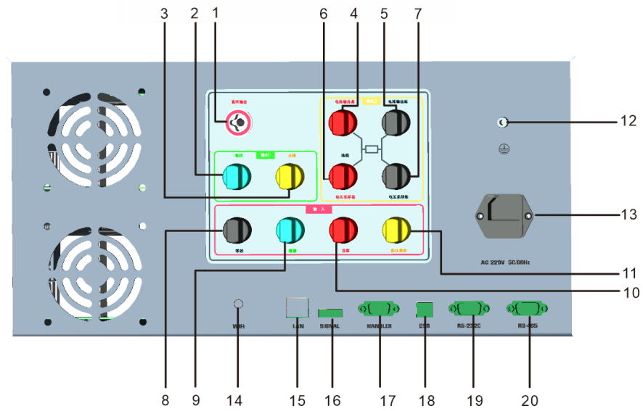

3.2.1 High voltage output terminal
High voltage output of high voltage test interface.
3.2.2 Zero line
Integrated output interface, the output is high voltage in AC DC IR mode and zero line in PW ST LC mode.
3.2.3 Firewire
Integrated output interface, the output is high voltage in AC DC IR mode and live wire in PW ST LC mode.
3.2.4 Current output high end
Special output terminal, which can bear large current of more than 30 years, is used as the current output terminal of the measured object. As the loop test end of the DUT.
3.2.5 Current output low end
Special output terminal, which can bear large current of more than 30 years, is used as the current output terminal of the measured object. As the loop test end of the DUT.
3.2.6 High-end voltage sampling
Detect the voltage on the ground resistance of the DUT (integrated output interface, high voltage loop interface in AC DC IR mode, ground wire in PW ST mode, high voltage sampling terminal in GR mode and sampling terminal in LC mode).

3.2.7 Voltage sampling low end
Detecting the voltage on the grounding resistance of the tested part
3.2.8 Zero line
Input, usually connected to the neutral line of the isolation voltage device
3.2.9 Leakage
Input, usually connected to isolated voltage leakage input live wire.
3.2.10 Power
3.2.11 Start up
3.2.12 Protective ground terminal
When the three-pin power socket plugged into the instrument power supply cannot ensure reliable connection to the earth, it must be connected to a reliable grounding bar from now on. 3.2.13 Power socket: self-contained fuse box.
For inputting AC power, please use the voltage within the specified input voltage range of the instrument, and use the power cord that comes with the instrument.

3.2.14 WIFI antenna interface (optional)
3.2.15 LAN interface
Interface for LAN communication to realize communication with computer.
3.2.16 SIGNAL interface
An interface for outputting special signals is used to connect the multi-channel scanning controller.
3.2.17 HANDLER interface
The instrument is connected with the control and output of external control equipment.

3.2.18 USB serial communication interface
Realize the connection with the computer and upgrade the instrument.
3.2.19 RS232C serial interface
Serial communication interface, realization, communication with computer.
3.2.20 RS485 serial interface
Serial communication interface to realize communication with computer.

Figure 3 -3 RK9970A-3/RK9970A-6 Description of Back Panel

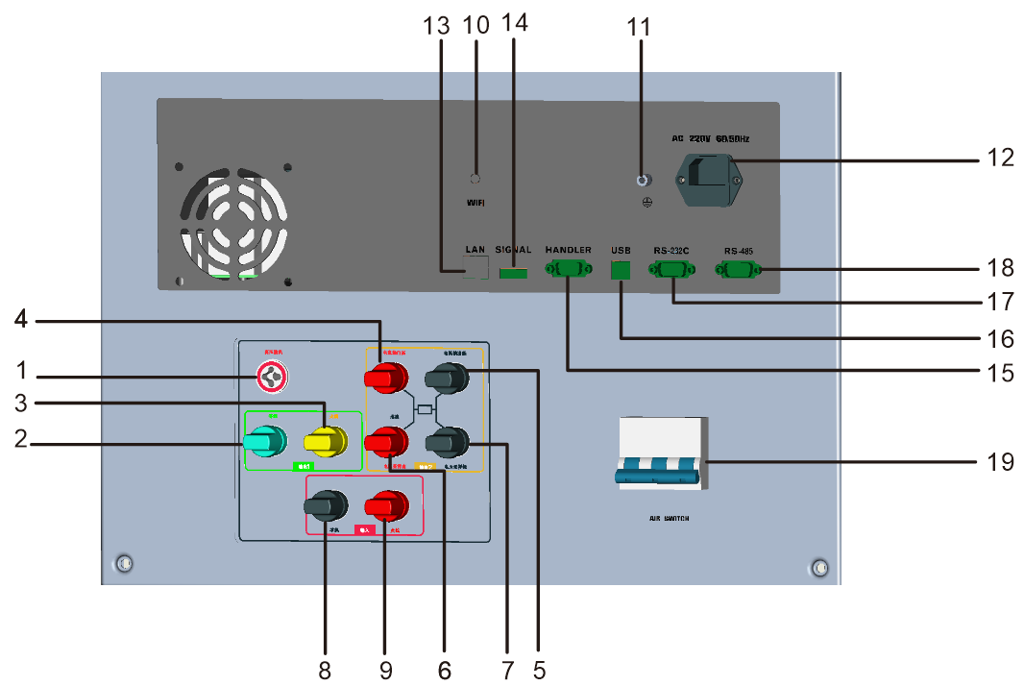

3.3.1 High voltage output terminal
High voltage output of high voltage test interface.
3.3.2 Zero line
Integrated output interface, the output is high voltage in AC DC IR mode and zero line in PW ST LC mode.
3.3.3 Firewire
Integrated output interface, the output is high voltage in AC DC IR mode and live wire in PW ST LC mode.
3.3.4 Current output high end
Special output terminal, which can bear large current of more than 30 years, is used as the current output terminal of the measured object. As the loop test end of the DUT.
3.3.5 Current output low end
Special output terminal, which can bear large current of more than 30 years, is used as the current output terminal of the measured object. As the loop test end of the DUT.
3.3.6 High-end voltage sampling
Detect the voltage on the ground resistance of the DUT (integrated output interface, high voltage loop interface in AC DC IR mode, ground wire in PW ST mode, high voltage sampling terminal in GR mode and sampling terminal in LC mode).
3.3.7 Voltage sampling low end
Detecting the voltage on the grounding resistance of the tested part
3.3.8 Zero line
Input, usually connected to the neutral line of the isolation voltage device
3.3.9 Firewire
Input, usually connected to the live wire of the isolation voltage device
3.3.10 WIFI antenna interface (optional)
3.3.11 Protective ground terminal
When the three-pin power socket plugged into the instrument power supply cannot ensure reliable connection to the earth, it must be connected to a reliable grounding bar from now on. 3.3.12 Power socket: self-contained fuse box.
For inputting AC power, please use the voltage within the specified input voltage range of the instrument, and use the power cord that comes with the instrument. 3.3.13LAN interface

Interface for LAN communication to realize communication with computer.
3.3.14SIGNAL interface
An interface for outputting special signals is used to connect the multi-channel scanning controller.

3.3.15HANDLER interface
The instrument is connected with the control and output of external control equipment.
3.3.16 USB serial communication interface
Realize the connection with the computer and upgrade the instrument.
3.3.17 RS232C serial interface
Serial communication interface to realize communication with computer.
3.3.18 RS485 serial interface
Serial communication interface to realize communication with computer.
3.3.19 Air switch
The blue switch is turned on when pushed up, and turned off when pushed down.

3.4 Preparation before test

3.4.1 Safety inspection
Since the AC voltage output by the instrument after starting the test will endanger personal safety, please be sure to observe the safety operation of electrical appliances and do a good job of safety inspection before starting the instrument.

1. The testing station should be separated from other stations and insulated mats should be laid, and non-testing personnel are strictly prohibited from entering the station.
2. Testers should do protective tests and wear insulating gloves.
3. The instrument is well grounded.
4. Testers should receive relevant safety knowledge training.
5. All connection operations must be carried out under the condition that the instrument has no output, and it is forbidden to plug and unplug the test wire and the tested electrical appliance during the test.
6. The test box and the tooling used in the test should be inspected and maintained frequently to ensure the normal test.

3.4.2 External wiring diagram for connecting the tested equipment.

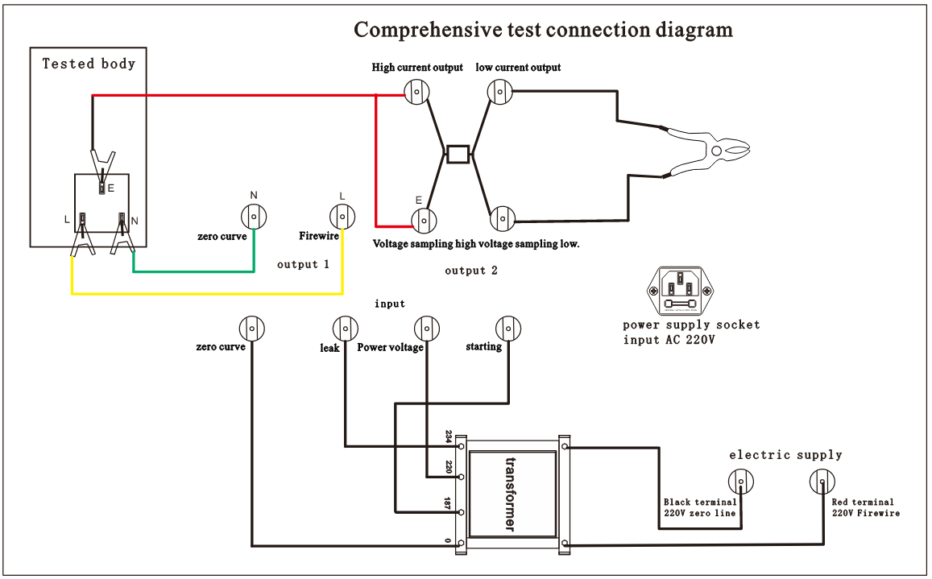

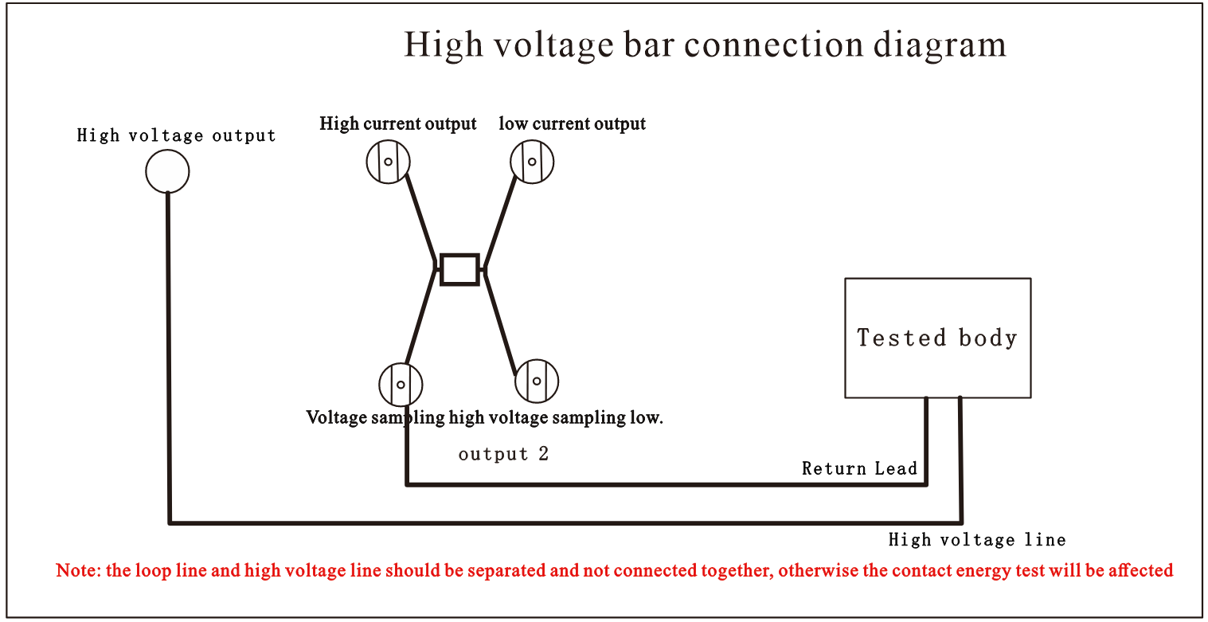

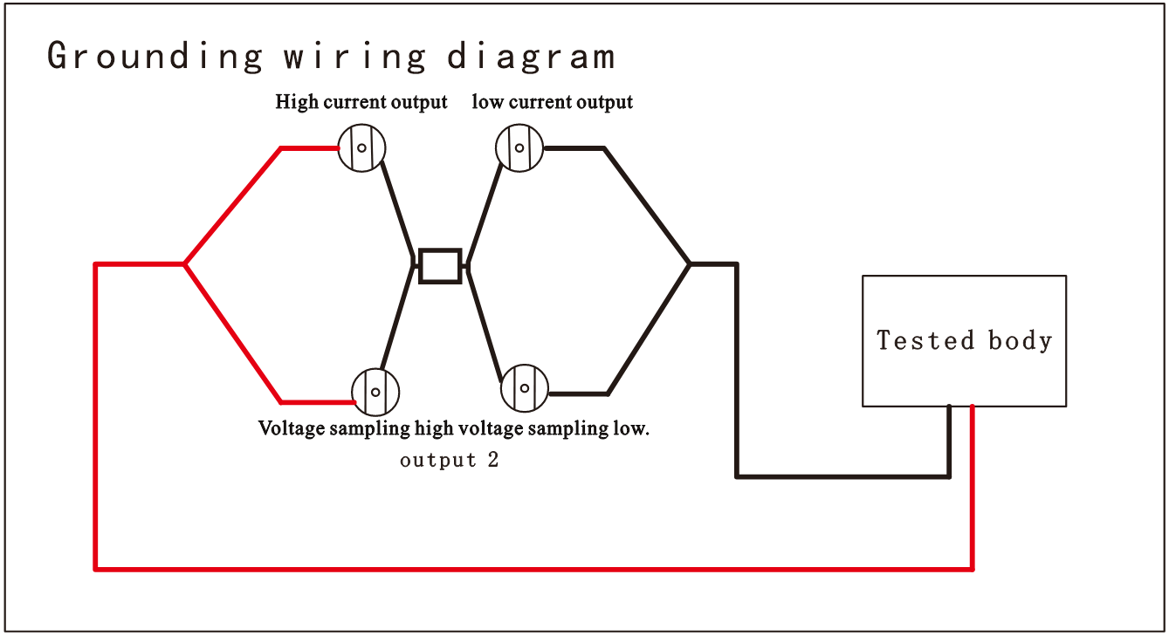

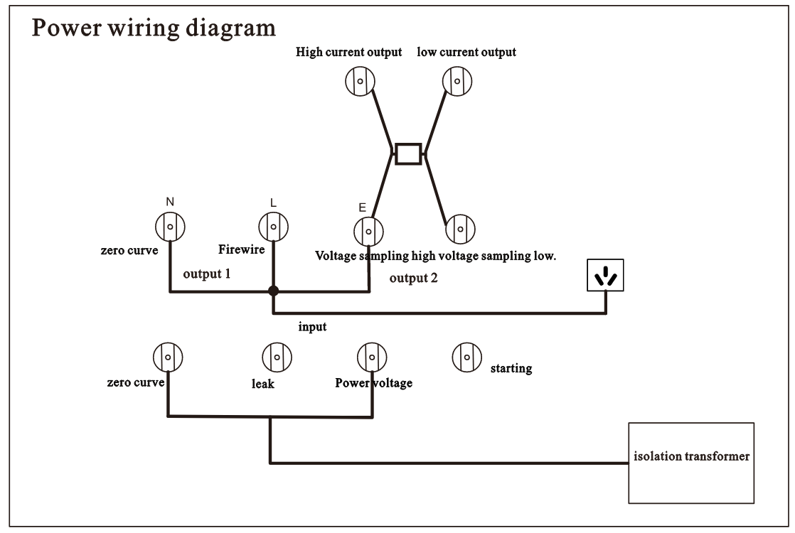

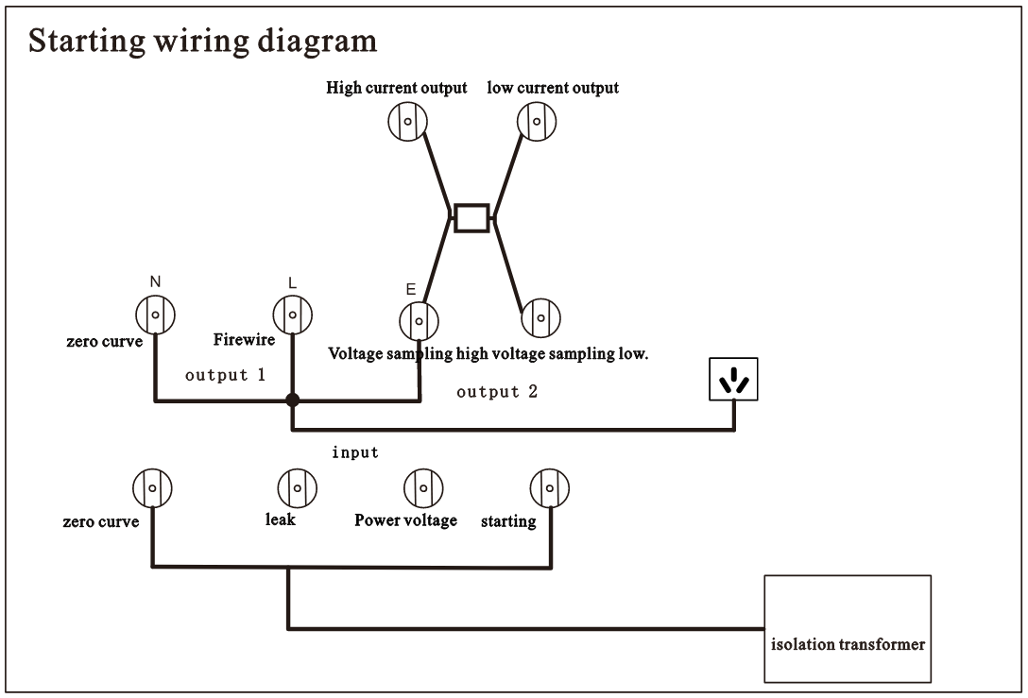

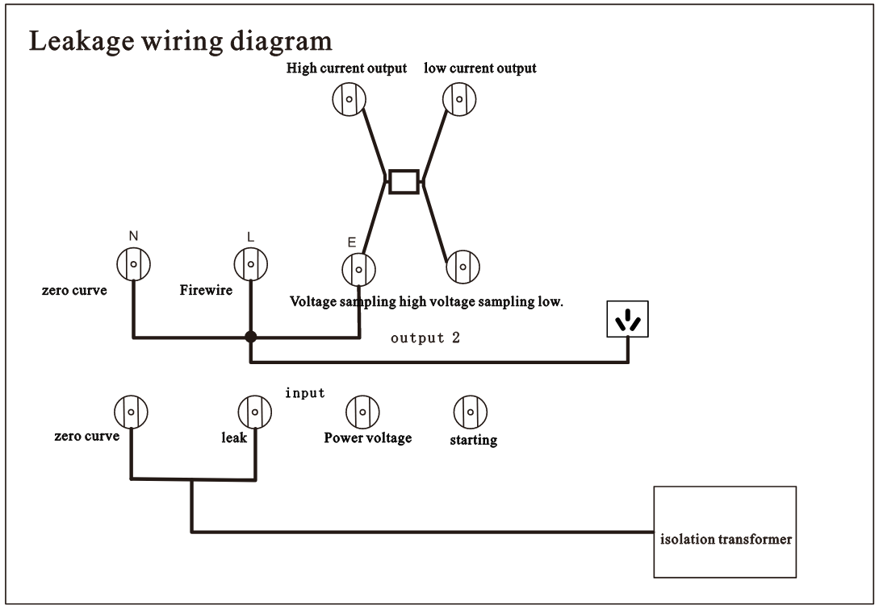

Note: In case of power failure, follow the following steps to connect external lines.
(1) Connect the test box circuit according to the corresponding color.
(2) Connect the grounding resistance test pliers.
(3) If equipped with high voltage test stick, connect high voltage test stick.
(4) Connect the isolated power supply input line: power input voltage AC 220V, leakage input voltage AC2 20V, and input frequency 50H z/60Hz. When connecting or removing the isolated power supply line, make sure that the posts and terminals are not charged.
(5) Connect the working power line AC220 V/50Hz of the comprehensive tester.

3.5 Definition of screen display area
RK9970 adopts an 800×480 LCD 7-inch display screen, and the contents displayed on the display screen are divided into the following display areas, as shown below:
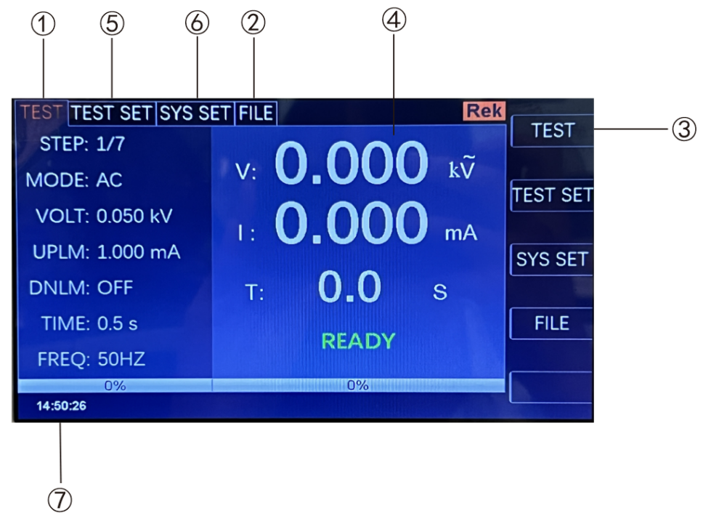
3.5.1 Measure the display page area.
The area indicates the measurement parameter name of the current page.
3.5.2 file domain
Move the cursor to this area for file management. File management includes: loading, saving and deleting.
3.5.3 Soft key area
This area is used to display the function definition of soft keys. The definition of soft keys has different function definitions depending on the location of the cursor area.
3.5.4 Measurement result display area
This area displays test result information and current test conditions.
3.5.5 Parameter Setting Area
This area displays various parameter settings.
3.5.6 System Settings
This area displays the system parameter settings.
3.5.7 Time display area
This area displays the current working time.
3.6 Main menu buttons and corresponding displayed pages
3.6.1 Measurement Display Main Menu Keys
Display home page for various measurements. The function pages in this part are (use the "soft key" to select the following page functions, the same below):

< measurement display >
< measurement settings >
< system settings >
"document management"

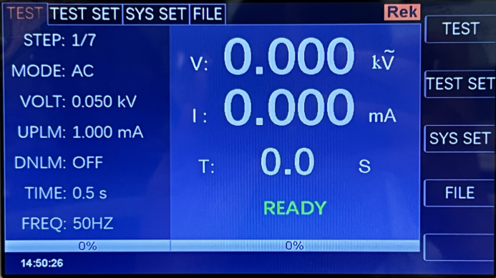

3.6.2 Parameter Setting Main Menu Button
It is mainly used to enter the measurement setting interface corresponding to the measurement display. The main interfaces are as follows:

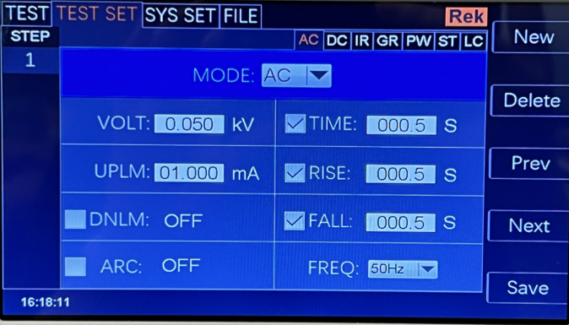
AC

3.6.3 System Settings Main Menu Button
Used to enter the system settings home page. Mainly about the system settings, this part of the function page are:

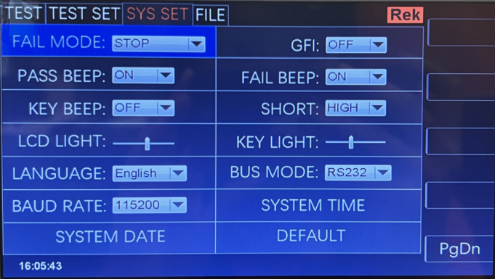

3.6.4 File Management Main Menu Button
Used for file management settings.

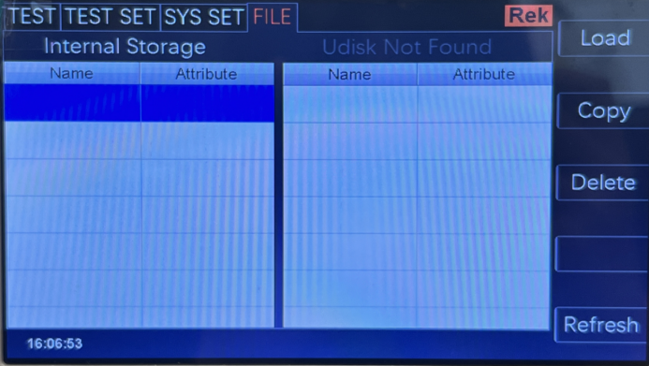

Chapter 4 Explains the operation
4.1 boot instructions and boot screen
Before the power cord plug is connected to the mains supply, please turn off the input "power switch", check whether the safety specification is correct, and connect the safety grounding wire to the "grounding terminal" on the back panel of the tester.
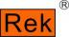
ShenzhenMeiruike ElectronicTechnology Co.,Ltd.

RK9970
Programmable Auto Safety Tester
VERSION：0.0.0Copyright(c)2022

http://www.chinarek.com
The basic operation is as follows:
■ Use the menu button ([TEST ][SETUP ][SYSTEM][FILE]) and soft keys to select the page you want to display.
■ Use the cursor ([→] [←] [↑] [↓]) to move the cursor to the field you want to set. When the cursor moves to a field, the field will turn blue. A domain is an area where the cursor can be set.
■ The domain where the current cursor is located can be used to set the parameter value by coding potentiometer or numeric keys. When the data input is finished, you can use the [ENTER] key or lightly press the coding potentiometer to confirm.
4.2 operation steps
4.2.1 Setting tester parameters
Please refer to the chapter "Parameter Settings" to set various parameters.
4.2.2 Connect the tester with the tested object and plug in the three-wire power plug.
Note: The power supply voltage should be kept at 198-242V AC (50Hz).
The power input phase line L, neutral line N and ground line E should be the same as those on the power plug of this instrument.
Turn on the power, press the power switch in the lower left corner of the front panel, and the instrument will be turned on, displaying the boot screen. As shown above.

Please press the "Reset" button once, and make sure that the test indicator light is off, the monitor works normally and there is no output, then connect the test wires, and check whether all the wires are reliable.

4.2.3 Press the "Start" key to start the test.
After pressing the "Start" key, the tester outputs. At this time, the test indicator light on the front panel will light up, the display will display "Being Tested" and the test value will be displayed at the same time. The timer will also start working and the data will be updated continuously.
4.2.4 Determination of qualified products
After the test is completed, the tester will automatically turn off the output, the qualified indicator light on the front panel will light up and make a sound at the same time, and the display will display "PASS" and test data, indicating that the tester determines that the tested object is qualified.
If you want to continue the test, you can press the "Start" button again and the tester will start the test again.
If you want to stop the test, you can press the "Reset" key, and the tester will stop the test immediately, and the display will keep the current test value.
4.2.5 Determination of nonconforming products
If the test fails, the tester will immediately turn off the output, the unqualified light on the front panel will turn on, and a warning sound will be issued at the same time. The display will display the test failure prompt and test data, indicating that the tester determines that the tested object is unqualified. Test failure tips include: upper limit failure and over-current protection.
If you want to turn off the alarm sound, you can press the "Reset" key.
4.2.6 START and STOP operation instructions
START key is the key to start the test. Press this key to start the test. STOP key is the reset STO P key. In the test state, press STO P key once to interrupt the test of the instrument. The running light DANGER turns off and the LOCK light turns on. Press STOP to enter the reset state of the secondary instrument, and the DANGER and LOC K lights go out.
Two ends of the red and black terminal of the instrument are connected with the four-terminal test wire provided by the instrument. When the tested object is not connected, press the START key to start the instrument. At this time, the instrument appears "open circuit failure" and gives an alarm sound (when the grounding resistance function option is selected).

Chapter 5 HANDLER Interface and SINGAL Interface
5.1 Circuit structure and use of Handler interface and SINGAL interface
The principle of the control interface is shown in the following figure. This terminal is a standard 9PIN D terminal holder, which contains three monitoring signal outputs, namely, PROCESSING (under TEST), PSASS (test passed) and FALL (test failed), and two remote control input signals, namely, Test (start) and STOP (reset).

5.2 Description of output signals
HANDLER interface: START, STOP and COM signals constitute remote input control, and the switch input is closed effectively.
HANDLER interface: remote output control is composed of TEST, PASS and FAIL signals. The switch is closed effectively. TEST can be used as a high-voltage starting signal or a pulse signal that the instrument works normally.
SINGAL interface is mainly used to provide an instrument selection signal (INTLOCK) for multi-instrument online testing. This signal is short-circuited by default on a single machine, and it is forbidden to start high-voltage output when the instrument is open.
SINGAL interface provides about +24V power supply, and the output current is less than 0.5A With the control signal of HANDLER interface, it can drive indicator light, photoelectric switch, low-power solenoid valve and so on. This interface is generally used for remote control and test synchronization or indication.

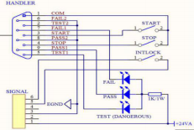

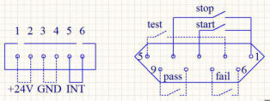

1. PROCESSING signal: the output signal is connected between PIN5 and PIN2.
2. PASS signal: The output signal is connected between PIN8 and PIN9.
3. FALL signal: The output signal is connected between PIN6 and PIN7.
4. START OUT: the output signal is connected between PIN3 and PIN1.
5. RESET OUT: the output signal is connected between PIN4 and PIN1.

Chapter6
6.1 instrument self-check.
6.1.1 Instrument power-on self-check items
When the tester runs POST, the screen displays as follows

Parameter setting

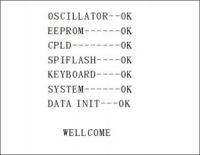

The self-inspection items are as follows:
1. Detection of internal crystal oscillator working state: If it is normal, it will display OK; if it is abnormal, it will give an alarm sound and cannot enter the self-inspection of the next project.
2. I/O memory status detection: If it is normal, OK will be displayed; if it is abnormal, an alarm sound will be given, and the next self-check cannot be entered.
3. State detection of complex programmable logic: If it is normal, OK will be displayed; if it is abnormal, an alarm sound will be given, and the self-check of the next project cannot be entered.
4. State detection of serial peripheral interface: If it is normal, OK will be displayed; if it is abnormal, an alarm sound will be given, and the self-check of the next item will not be entered.
5. Keyboard status detection: If it is normal, OK will be displayed; if it is abnormal, an alarm sound will be given, and the next item cannot be self-checked.
6. System status detection: If it is normal, OK will be displayed; if it is abnormal, an alarm sound will be given, and the self-inspection of the next project cannot be entered.
7. Data initialization status detection: If it is normal, OK will be displayed; if it is abnormal, an alarm sound will be given, and the next self-check cannot be entered.
If there are no errors in the above self-inspection, the instrument self-inspection is successful. Enter the test interface, as shown below:

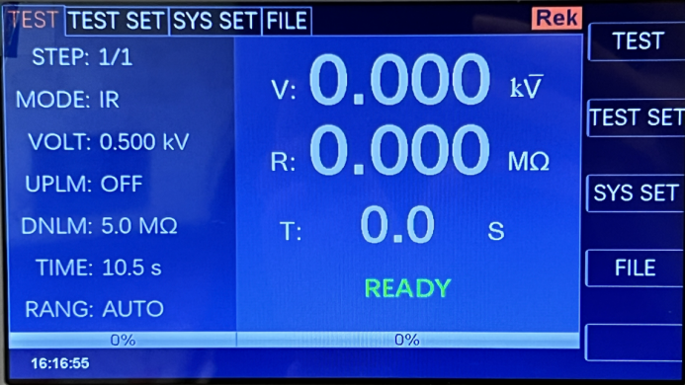

6.2 parameter setting mode
Press the "SETUP" or "F2" key on the instrument panel in the measurement interface to enter the parameter setting page.
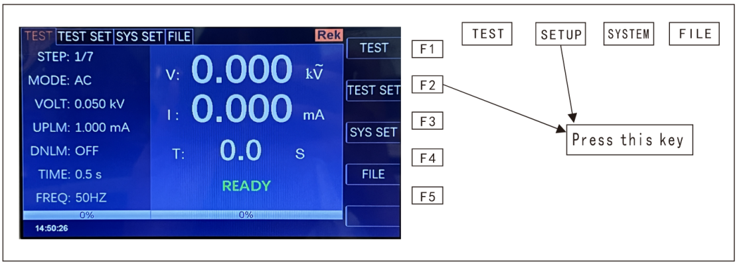

The parameter setting interface is as follows:
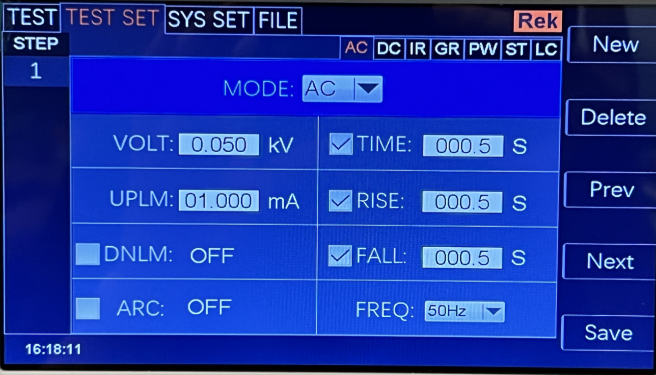

Note: It varies according to the test mode of the test steps.
6.2.1 Description of parameter setting
Test mode: a parameter in the step details panel is always a test mode parameter. Editing this parameter can change the test mode of the test step. Scope: Test modes supported by the instrument. After pressing the "Enter" key on this parameter, modify the test mode control value according to the selection box control modification method, and then press the "Enter" key again to save the modification. If the test mode of the test step changes, the parameter panel corresponding to the new test mode is automatically updated. In the process of revision, you can press the "ESC" key to cancel all current operations.
6.2.2 Description of test modes supported by step
The test mode supported by the test step is determined by the following factors: the test mode supported by the tester and the file working mode.
For example, suppose that the tester supports ACW, DCW, IR, GR, PW, ST, LC test modes, and when the file working mode is GR, it is a GR test condition. 6.2.3 ACW AC withstand voltage parameter setting
Select "AC" withstand voltage test mode under the parameter panel setting, and the test parameter setting will enter "AC" withstand voltage mode, as shown below.

Set the parameters as follows:
Test mode: after the cursor moves to the test mode, press "ENTER" to ENTER the test mode editing, press "→" or "←" to change the test mode, set the AC withstand voltage tester, select AC, and then press "Enter" to save. In this way, all the following parameters are changed to AC withstand voltage parameters.
Output voltage: press the "↓" key or code dial to move the cursor to the value after the output voltage, as shown in the following figure:

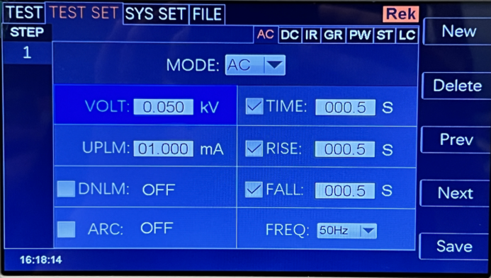

In this interface, press the "ENTER" key to edit the output voltage value, and the output voltage range is (0.050-5.000) KV. To change the output voltage value, just enter the number keys. For example, to input a voltage of 2.000KV, just press the number keys 2 "and" ENTER ". To input 4.750KV, just press "4", "7", "5", "0" and "ENTER".
"
Current upper limit: press the "↓" key or code dial to move the cursor to the value after the current upper limit, as shown in the following figure:
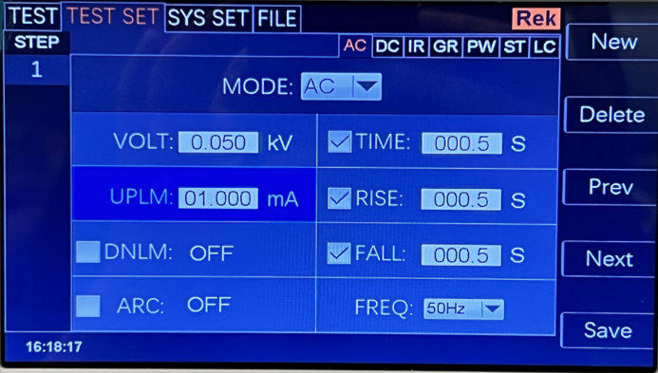

In this interface, press the "ENTER" key to edit the upper limit value of current, with the range of (0.001-50.00) mA. To change the current upper limit,

Just enter the number keys. For example, to ENTER 0.515mA, just press "0", "5", "1", "5" and "Enter". Lower current limit: press the "↓" key or code dial to move the cursor to the value after the lower current limit, as shown in the following figure:
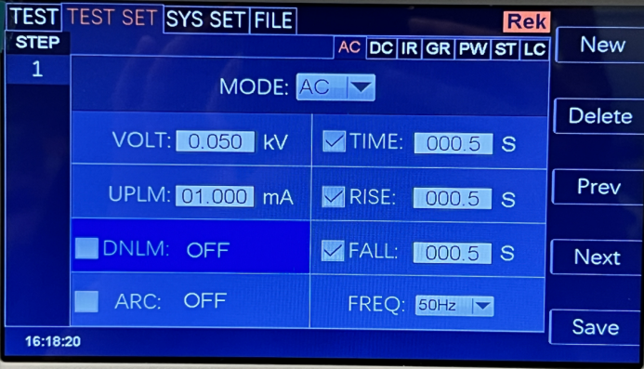

Note: Turn on or off the lower limit function with the "ENTER" key. The lower limit range is (0.001-10) mA.
After the lower limit function is turned on, the lower limit setting function can be operated by lightly pressing the coded potentiometer. To change the current lower limit value, just enter the number keys. For example, to ENTER 0.515mA, just press "0", "5", "1", "5" and "Enter".
Arc function: press the "↓" key or code dial to move the cursor to the arc function item, as shown in the following figure:

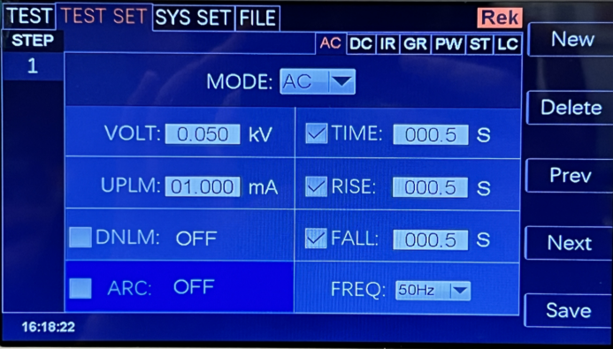

Note: Turn on or off the arc function with the "ENTER" key, and the arc range is (0.1-50) mA.
After the arc function is turned on, the arc setting function can be operated by lightly pressing the coded potentiometer. To change the arc value, just enter the number keys. For example, to ENTER 0.515mA, just press "0", "5", "1", "5" and "Enter".
The smaller the arc value is set, the lighter or flashover phenomenon of the measured object will not be detected by the tester during the test.
Test time: press the "↓" key or code dial to move the cursor to the time function item, as shown in the following figure:

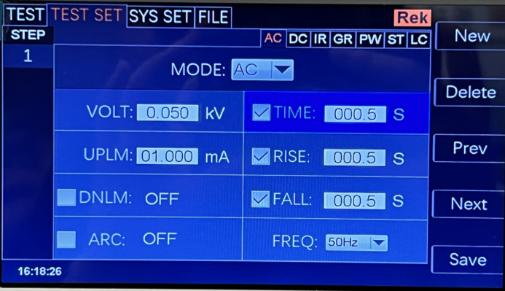
A

In this interface, press the "ENTER" key to edit the time in the range of (0.1-999.9) s. To change the time value, just enter the number keys. For example, to ENTER 101.2, just press "1", "0", "1", "2" and "Enter".
Rise time: press the "↓" key or code dial to move the cursor to the rise time function item, as shown in the following figure:

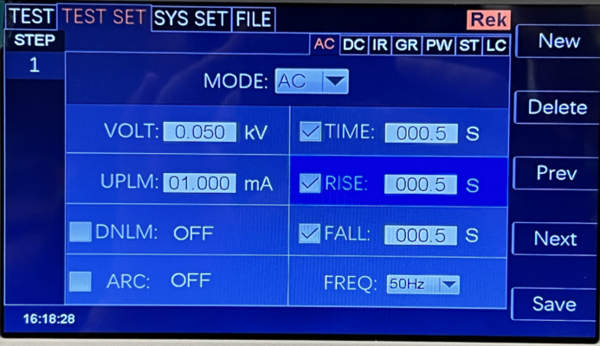

In this interface, press the "ENTER" key to edit the time in the range of (0.1-999.9) s. To change the time value, just enter the number keys. For example, to ENTER 101.2, just press "1", "0", "1", "2" and "Enter".
Descent time: press the "↓" key or code dial to move the cursor to the function item of descent time, as shown in the following figure:

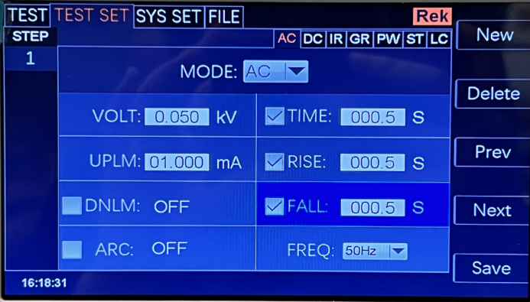

In this interface, press the "ENTER" key to edit the time in the range of (0.1-999.9) s. To change the time value, just enter the number keys. For example, to ENTER 101.2, just press "1", "0", "1", "2" and "Enter".
Frequency: press the "↓" key or code dial to move the cursor to the frequency function item, as shown in the following figure:

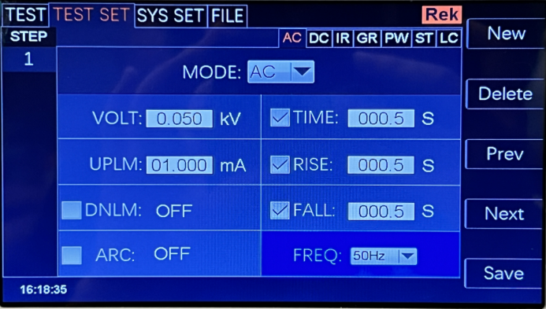

In this interface, press the "ENTER" key to edit the frequency in the range of (50/60) Hz. Press "↓" "↑" or rotate the coded potentiometer to change the frequency value.
New step: Press "F1" key "New" on the panel in the test interface to create a new test step, and a total of 20 test steps can be created. A new test step is established after the current step, which adopts the default test mode-AC voltage.
Delete step: Press "F2" key "Delete" on the panel in the test interface to delete the test step. The tester deletes the current step, and the subsequent steps move to the current step.
Previous Page: (Step Forward) Press the "F3" key "Previous Page" on the panel in the test interface to move forward the current step, that is, the contents of the current test step and the previous test step are exchanged, which can conveniently realize the sorting function of test steps, but when the current step is the first test step, the moving forward operation is invalid.
Next Page: (Step Backwards) Press the "F4" key "Next Page" on the panel in the test interface to move back the current step, that is, the contents of the current test step and the next test step are exchanged, which can conveniently realize the sorting function of test steps, but when the current step is the last test step, the backward operation is invalid.
Save as a file: press the F5 key on the panel in the test interface to save the current test steps, and save them in the form of a file for easy retrieval and use. Press Save as File to open the storage interface, as shown below:

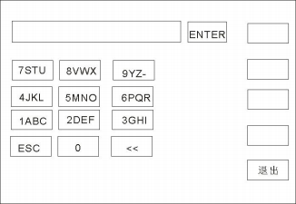

After entering the interface shown above, press the number keys on the panel, and the screen will be displayed as follows:
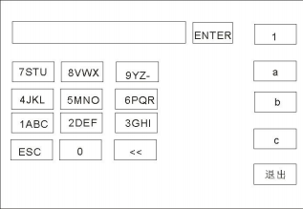

Type the relevant characters on the screen, press the "ENTER" key, and the file will be saved in the tester memory.
6.2.4 DCW withstand voltage parameter setting of DCW
Select "DC" withstand voltage test mode under the parameter panel setting, and the test parameter setting will enter "DC" withstand voltage mode, as shown below:

Set the parameters as follows:
Test mode: after the cursor moves to the test mode, press "ENTER" to ENTER the test mode editing, press "→" or "←" to change the test mode, set DC withstand voltage tester to select DC, and then press "Enter" to save. In this way, all the following parameters are changed to DC withstand voltage parameters.
Output voltage: press the "↓" key or code dial to move the cursor to the value after the output voltage, as shown in the following figure:

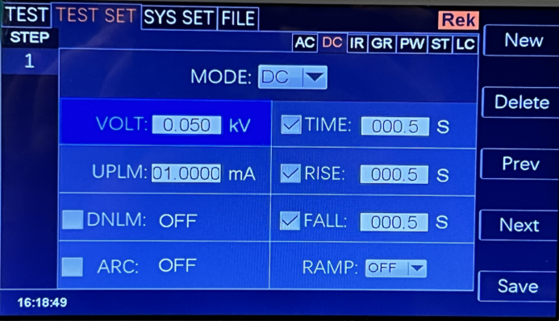

In this interface, press the "ENTER" key to edit the output voltage value, and the output voltage range is (0.050-6.000) KV. To change the output voltage value, just enter the number keys. For example, to input a voltage of 2.000KV, just press the number keys 2 "and" ENTER ". To input 4.750KV, just press "4", "7", "5", "0" and "ENTER".
"

Current upper limit: press the "↓" key or code dial to move the cursor to the value after the current upper limit, as shown in the following figure:

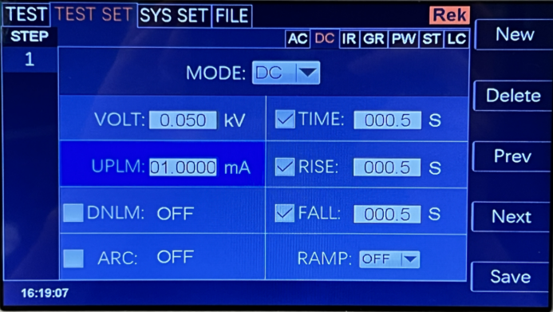

In this interface, press the "ENTER" key to edit the upper limit value of current, with the range of (0.001-20.00) mA. To change the current upper limit, just enter the number keys. For example, to ENTER 0.515mA, just press "0", "5", "1", "5" and "Enter".

Lower current limit: press the "↓" key or code dial to move the cursor to the value after the lower current limit, as shown in the following figure:

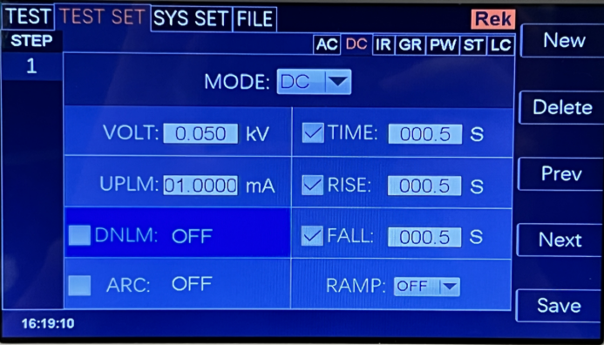

Note: Turn on or off the lower limit function with the "ENTER" key. The lower limit range is (0.001-20) mA.
After the lower limit function is turned on, the lower limit setting function can be operated by lightly pressing the coded potentiometer. To change the current lower limit value, just enter the number keys. For example, to ENTER 0.515mA, just press "0", "5", "1", "5" and "Enter".
Arc function: press the "↓" key or code dial to move the cursor to the arc function item, as shown in the following figure:

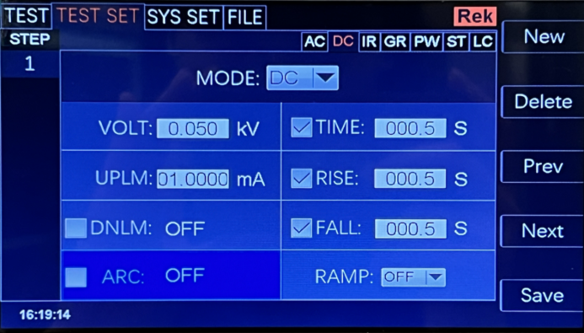

Note: Turn on or off the arc function with the "ENTER" key, and the arc range is (0.1-20) mA.
After the arc function is turned on, the arc setting function can be operated by lightly pressing the coded potentiometer. To change the arc value, just enter the number keys. For example, to ENTER 0.515mA, just press "0", "5", "1", "5" and "Enter".
The smaller the arc value is set, the lighter or flashover phenomenon of the measured object will not be detected by the tester during the test.
Test time: press the "↓" key or code dial to move the cursor to the time function item, as shown in the following figure:

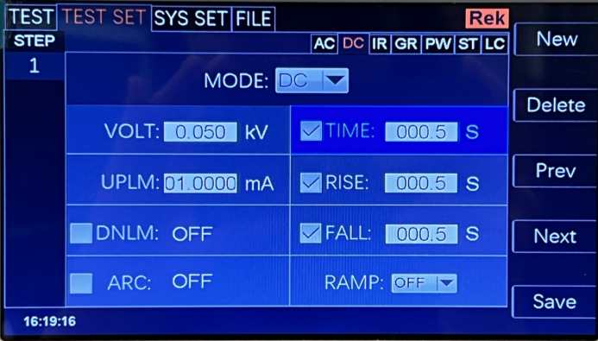

In this interface, press the "ENTER" key to edit the time in the range of (0.1-999.9) s. To change the time value, just enter the number keys. For example, to ENTER 101.2, just press "1", "0", "1", "2" and "Enter".
Rise time: press the "↓" key or code dial to move the cursor to the rise time function item, as shown in the following figure:

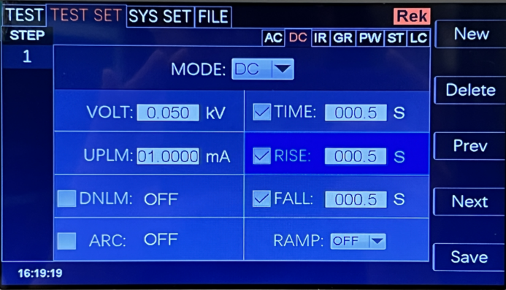

In this interface, press the "ENTER" key to edit the time in the range of (0.1-999.9) s. To change the time value, just enter the number keys. For example, to ENTER 101.2, just press "1", "0", "1", "2" and "Enter".
Descent time: press the "↓" key or code dial to move the cursor to the function item of descent time, as shown in the following figure:

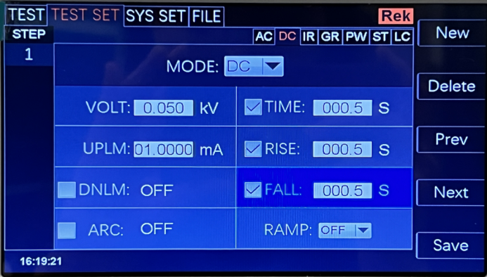

In this interface, press the "ENTER" key to edit the time in the range of (0.1-999.9) s. To change the time value, just enter the number keys. To change the time value, just enter the number keys. For example, to ENTER 101.2, just press "1", "0", "1", "2" and "Enter".
Ascending judgment: press the "↓" key or code dial to move the cursor to the ascending judgment function item, as shown in the following figure:

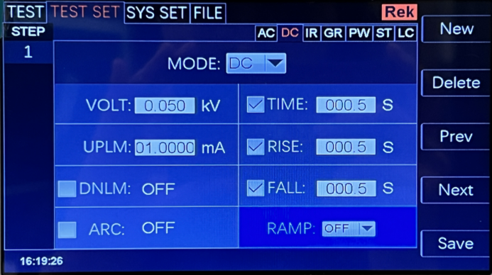

In this interface, press the "ENTER" key to edit the rising judgment in the range of (ON/OFF). Press "↓" "↑" or rotate the coded potentiometer.
New step: Press "F1" key "New" on the panel in the test interface to create a new test step, and a total of 20 test steps can be created. A new test step is established after the current step, which adopts the default test mode-AC voltage.
Delete step: Press "F2" key "Delete" on the panel in the test interface to delete the test step. The tester deletes the current step, and the subsequent steps move to the current step.
Previous Page: (Step Forward) Press the "F3" key "Previous Page" on the panel in the test interface to move forward the current step, that is, the contents of the current test step and the previous test step are exchanged, which can conveniently realize the sorting function of test steps, but when the current step is the first test step, the moving forward operation is invalid.
Next Page: (Step Backwards) Press the "F4" key "Next Page" on the panel in the test interface to move back the current step, that is, the contents of the current test step and the next test step are exchanged, which can conveniently realize the sorting function of test steps, but when the current step is the last test step, the backward operation is invalid.
Save as a file: press the F5 key on the panel in the test interface to save the current test steps, and save them in the form of a file for easy retrieval and use. Press Save as File to open the storage interface, as shown below:
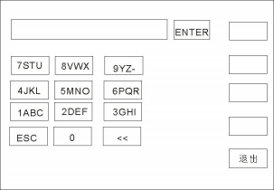
After entering the interface shown above, press the number keys on the panel, and the screen will be displayed as follows:
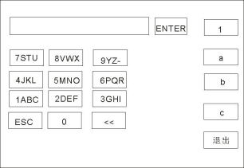

Type the relevant characters on the screen, press the "ENTER" key, and the file will be saved in the tester memory.

6.2.5 IR insulation resistance parameter setting
Select "IR" insulation test mode under the parameter panel setting, and the test parameter setting will enter "IR" withstand voltage mode, as shown below: The setting parameters are as follows:
Test mode: after the cursor moves to the test mode, press "ENTER" to ENTER the test mode editing, press "→" or "←" to change the test mode, set the IR insulation test, and then press "Enter" to save. In this way, all the following parameters are changed to the parameters of insulation resistance.
Output voltage: press the "↓" key or code dial to move the cursor to the value after the output voltage, as shown in the following figure:

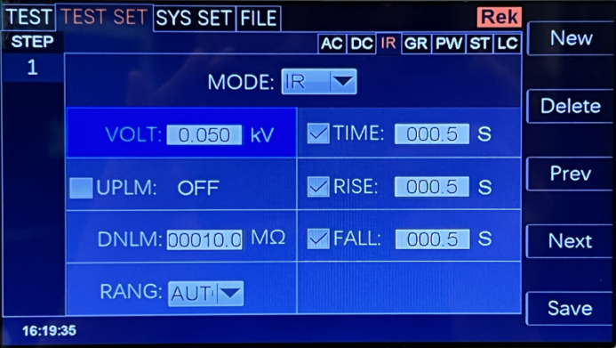

In this interface, press the "ENTER" key to edit the output voltage value, and the output voltage range is (0.050-3.000) KV. To change the output voltage value, just enter the number keys. For example, to input 1.000KV, just press "1", "0", "0" and "ENTER".
Upper limit of resistance: press the "↓" key or code dial to move the cursor to the value after the upper limit of resistance, as shown in the following figure:

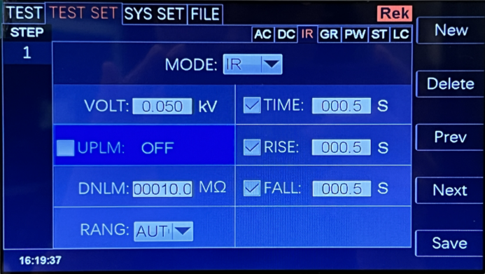

In this interface, press the "ENTER" key to edit the upper limit value of current, and the range is (0.1-99999.9) mω. To change the upper limit of resistance, just enter the number keys. For example, to ENTER 0.515mA, just press "0", "5", "1", "5" and "Enter".
Lower resistance limit: press the "↓" key or code dial to move the cursor to the value after the lower resistance limit, as shown in the following figure:

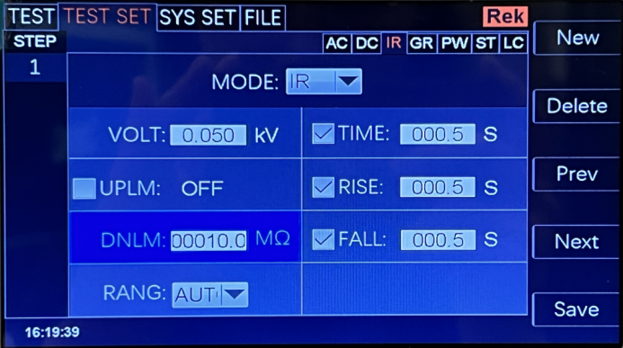

Note: Turn on or off the lower limit function with the "ENTER" key. The lower limit range is (0.1-99999.9) MΩ.
After the lower limit function is turned on, the lower limit setting function can be operated by lightly pressing the coded potentiometer. To change the lower limit value of resistance, just enter the number keys. For example, to ENTER 1000 mω, just press "1", "0", "0" and "Enter".
Range function: press the "↓" key or code dial to move the cursor to the range function item, as shown in the following figure:

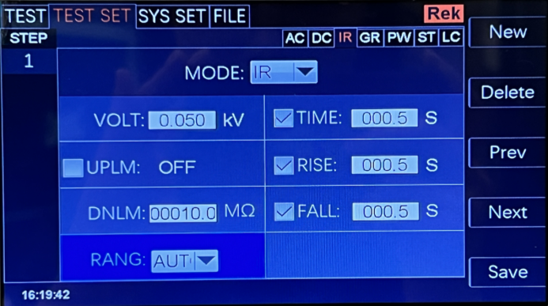

The measuring range is divided into: AUTO, 400K 4M 40M 400M 100G.
Test time: press the "↓" key or code dial to move the cursor to the time function item, as shown in the following figure:

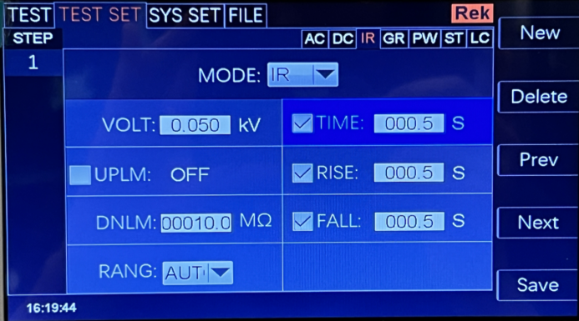

In this interface, press the "ENTER" key to edit the time in the range of (0.1-999.9) s. To change the time value, just enter the number keys. For example, to ENTER 101.2, just press "1", "0", "1", "2" and "Enter".
Rise time: press the "↓" key or code dial to move the cursor to the rise time function item, as shown in the following figure:

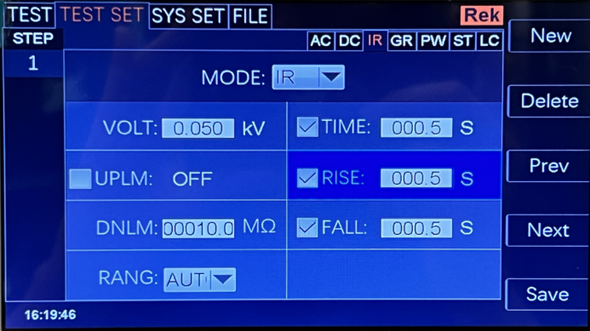

In this interface, press the "ENTER" key to edit the time in the range of (0.1-999.9) s. To change the time value, just enter the number keys. For example, to ENTER 101.2, just press "1", "0", "1", "2" and "Enter".

Descent time: press the "↓" key or code dial to move the cursor to the function item of descent time, as shown in the following figure:

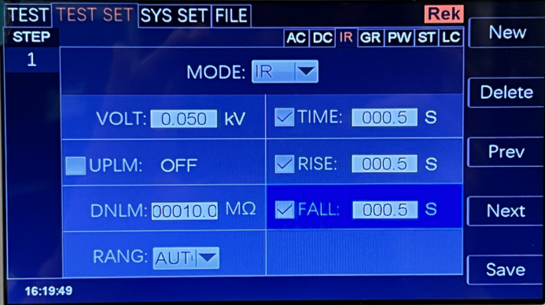

In this interface, press the "ENTER" key to edit the time in the range of (0.1-999.9) s. To change the time value, just enter the number keys. For example, to ENTER 101.2, just press "1", "0", "1", "2" and "Enter".

New step: Press "F1" key "New" on the panel in the test interface to create a new test step, and a total of 20 test steps can be created. A new test step is established after the current step, which adopts the default test mode-AC voltage.
Delete step: Press "F2" key "Delete" on the panel in the test interface to delete the test step. The tester deletes the current step, and the subsequent steps move to the current step.
Previous Page: (Step Forward) Press the "F3" key "Previous Page" on the panel in the test interface to move forward the current step, that is, the contents of the current test step and the previous test step are exchanged, which can conveniently realize the sorting function of test steps, but when the current step is the first test step, the moving forward operation is invalid.
Next Page: (Step Backwards) Press the "F4" key "Next Page" on the panel in the test interface to move back the current step, that is, the contents of the current test step and the next test step are exchanged, which can conveniently realize the sorting function of test steps, but when the current step is the last test step, the backward operation is invalid.
Save as a file: press the F5 key on the panel in the test interface to save the current test steps, and save them in the form of a file for easy retrieval and use. Press Save as File to open the storage interface, as shown below:
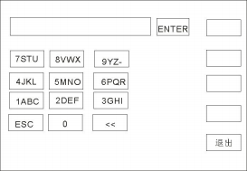

After entering the interface shown above, press the number keys on the panel, and the screen will be displayed as follows:
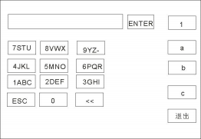

Type the relevant characters on the screen, press the "ENTER" key, and the file will be saved in the tester memory.

6.2.6 GR Grounding Resistance Parameter Setting
Select "GR" grounding resistance test mode under the parameter panel setting, and the test parameter setting will enter "GR" grounding resistance test mode, as shown below:
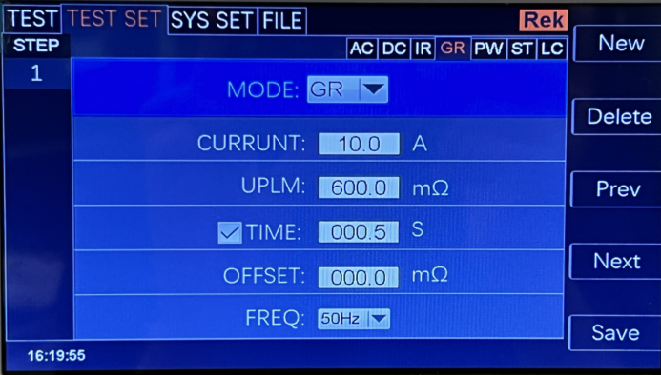

Set the parameters as follows:
Test mode: after the cursor moves to the test mode, press "ENTER" to ENTER the test mode editing, press "→" or "←" to change the test mode, set GR grounding test, and then press "Enter" to save. In this way, all the following parameters are changed to the parameters of grounding resistance.
Output current: press the "↓" key or code dial to move the cursor to the value after the output current, as shown in the following figure:

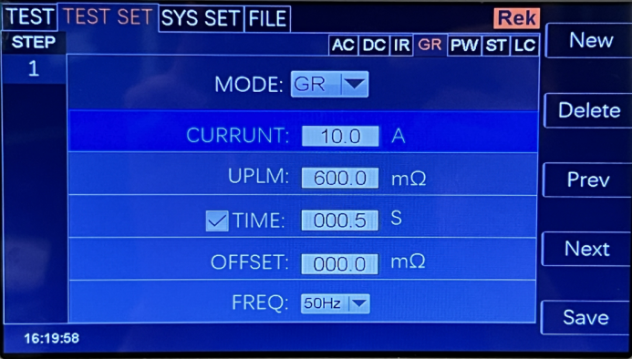

In this interface, press the "ENTER" key to edit the output voltage value, and the output voltage range is (3-32.0) A. To change the output current value, just enter the number keys. For example, to ENTER 10.0A, just press "1", "0", "0" and "Enter".
Upper limit of resistance test: press the "↓" key or code dial to move the cursor to the value after the upper limit of resistance test, as shown in the following figure:

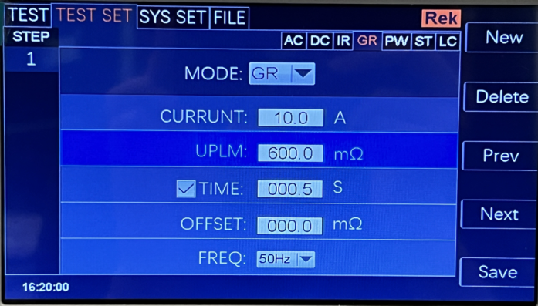
AC

In this interface, press the "ENTER" key to edit the upper limit value of the test, and the range is (0.1-600) mω. To change the upper limit value of resistance, just enter the digital key. For example, to ENTER 100 mω, just press "1", "0", "0" and "Enter".
Test time: press the "↓" key or code dial to move the cursor to the time function item, as shown in the following figure:

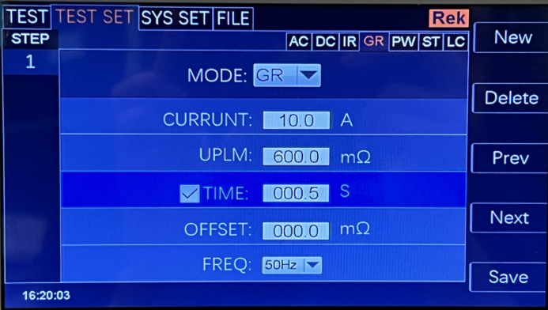

Note: Use the "ENTER" key to turn on or off the time function. The range is (0.1-999.9) s.
After turning on the time function, you can operate the time setting function by lightly pressing the coding potentiometer. To change the time value, just enter the number keys. For example, to ENTER 100S, just press "1", "0", "0" and "Enter".
Zero compensation: press the "↓" key or code dial to move the cursor to the zero compensation function item, as shown in the following figure:

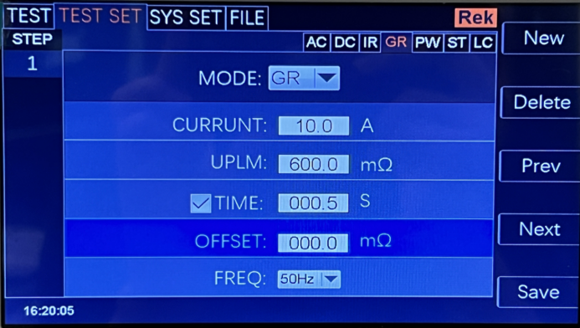

Zero compensation is divided into: AUTO and manual. In the automatic compensation state, the compensation value is automatically recorded in the tester after two test lines are shorted; In manual mode, the compensation value of line loss should be measured in advance, and the corresponding digital value can be input.
Test frequency: press the "↓" key or code dial to move the cursor to the test frequency function item, as shown in the following figure:

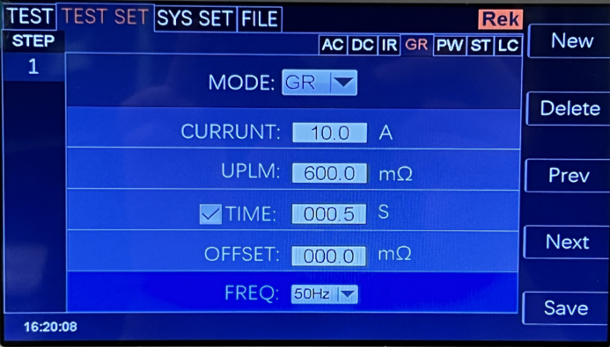
In this interface, press the "ENTER" key to edit the frequency in the range of (50/60) Hz.

New step: Press "F1" key "New" on the panel in the test interface to create a new test step, and a total of 20 test steps can be created. A new test step is established after the current step, which adopts the default test mode-AC voltage.
Delete step: Press "F2" key "Delete" on the panel in the test interface to delete the test step. The tester deletes the current step, and the subsequent steps move to the current step.
Previous Page: (Step Forward) Press the "F3" key "Previous Page" on the panel in the test interface to move forward the current step, that is, the contents of the current test step and the previous test step are exchanged, which can conveniently realize the sorting function of test steps, but when the current step is the first test step, the moving forward operation is invalid.
Next Page: (Step Backwards) Press the "F4" key "Next Page" on the panel in the test interface to move back the current step, that is, the contents of the current test step and the next test step are exchanged, which can conveniently realize the sorting function of test steps, but when the current step is the last test step, the backward operation is invalid.

Save as a file: press the F5 key on the panel in the test interface to save the current test steps, and save them in the form of a file for easy retrieval and use. Press Save as File to open the storage interface, as shown below:

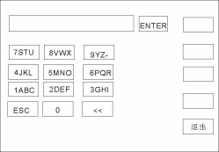

After entering the interface shown above, press the number keys on the panel, and the screen will be displayed as follows:
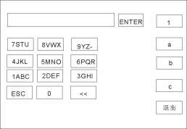

Type the relevant characters on the screen, press the "ENTER" key, and the file will be saved in the tester memory.

6.2.7 PW power parameter setting
Select "PW" power test mode under the parameter panel setting, and the test parameter setting will enter "PW" power mode, as shown below:

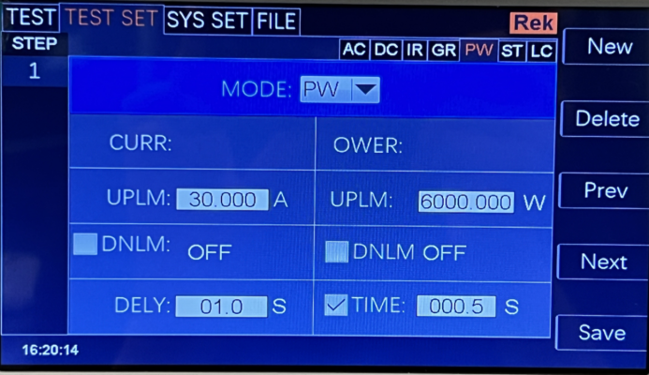
Set the parameters as follows:
Test mode: after the cursor moves to the test mode, press "ENTER" to enter the test mode editing, and press "→" or "←" to change the test mode.
Type, set the PW power test, and then press the "ENTER" key to save. In this way, all the following parameters are changed to power parameters.
Upper limit of power test: press the "↓" key or code dial to move the cursor to the value after the output current, as shown in the following figure:

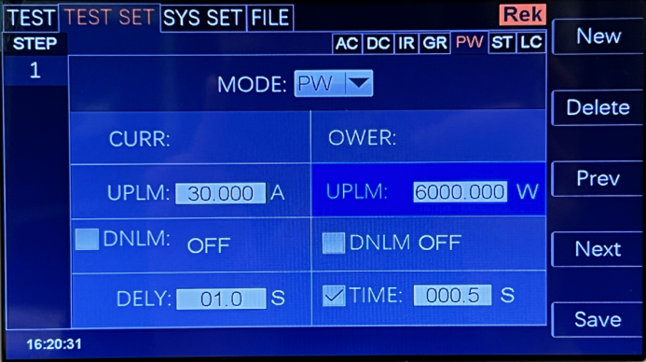
W

In this interface, press the "ENTER" key to edit the upper power limit, and the power setting range is (0.200~6000 )W W. To change the power value, just enter the number keys. For example, to ENTER 10.0W, just press "1", "0", "0" and "Enter".
Upper limit of resistance test: press the "↓" key or code dial to move the cursor to the value after the upper limit of resistance test, as shown in the following figure:

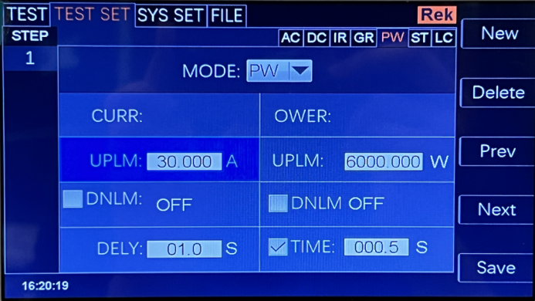
:

In this interface, press the "ENTER" key to edit the current upper limit value, and the range is (0.02-30.0) a. To change the current upper limit, just enter the number key. For example, to ENTER 10.0A, just press "1", "0" and "Enter".
Test time: press the "↓" key or code dial to move the cursor to the time function item, as shown in the following figure:

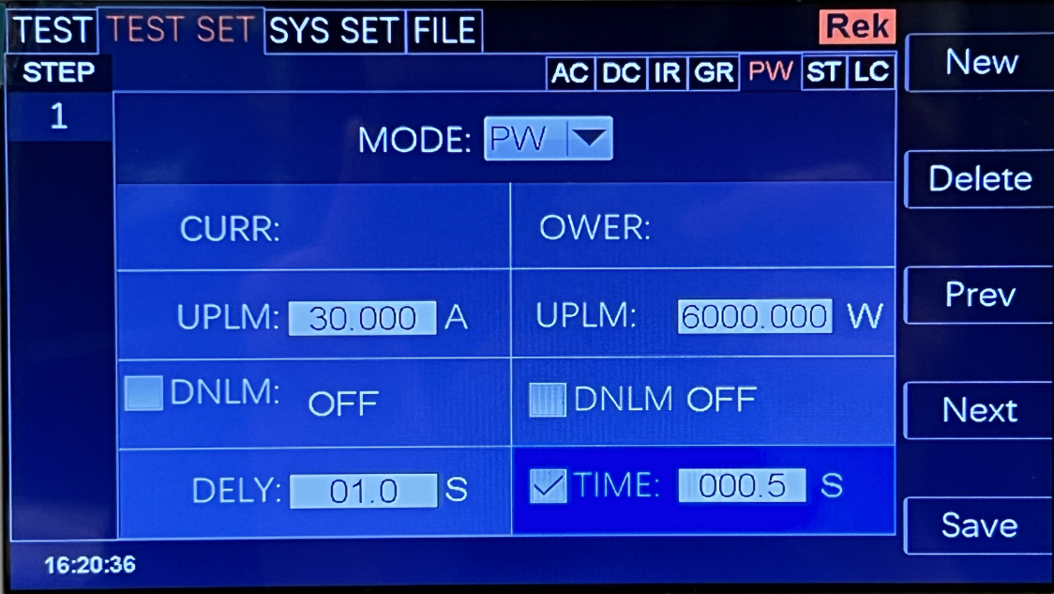

Note: Use the "ENTER" key to turn on or off the time function. The range is (0.1-999.9) s.
After turning on the time function, you can operate the time setting function by lightly pressing the coding potentiometer. To change the time value, just enter the number keys. For example, to ENTER 100S, just press "1", "0", "0" and "Enter".

New step: Press "F1" key "New" on the panel in the test interface to create a new test step, and a total of 20 test steps can be created. A new test step is established after the current step, which adopts the default test mode-AC voltage.
Delete step: Press "F2" key "Delete" on the panel in the test interface to delete the test step. The tester deletes the current step, and the subsequent steps move to the current step.
Previous Page: (Step Forward) Press the "F3" key "Previous Page" on the panel in the test interface to move forward the current step, that is, the contents of the current test step and the previous test step are exchanged, which can conveniently realize the sorting function of test steps, but when the current step is the first test step, the moving forward operation is invalid.
Next Page: (Step Backwards) Press the "F4" key "Next Page" on the panel in the test interface to move back the current step, that is, the contents of the current test step and the next test step are exchanged, which can conveniently realize the sorting function of test steps, but when the current step is the last test step, the backward operation is invalid.

Save as a file: press the F5 key on the panel in the test interface to save the current test steps, and save them in the form of a file for easy retrieval and use. Press Save as File to open the storage interface, as shown below:

After entering the interface shown above, press the number keys on the panel, and the screen will be displayed as follows:

Type the relevant characters on the screen, press the "ENTER" key, and the file will be saved in the tester memory.

6.2.8 ST startup parameter setting
Select "ST" under the parameter panel settings to start the test mode, and the test parameter settings will enter the "ST" start mode, as shown below:

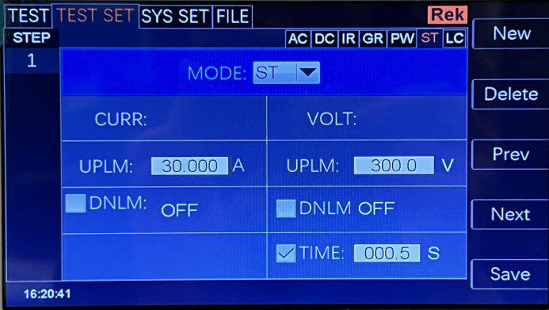
Set the parameters as follows:
Test mode: after the cursor moves to the test mode, press "ENTER" to ENTER the test mode editing, press "→" or "←" to change the test mode, set ST to start the test, and then press "Enter" to save. In this way, all the following parameters are changed to startup parameters.
Upper limit of voltage test: press the "↓" key or code dial to move the cursor to the value of upper limit of voltage, as shown in the following figure:

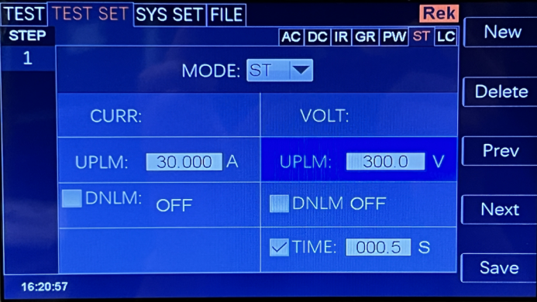

In this interface, press the "ENTER" key to edit the output voltage value, and the output voltage range is (0.2 ~ 300) V. To change the upper voltage limit, just enter the number keys. For example, to input 100V, just press "1", "0", "0" and "ENTER".
Upper limit of resistance test: press the "↓" key or code dial to move the cursor to the value after the upper limit of resistance test, as shown in the following figure:

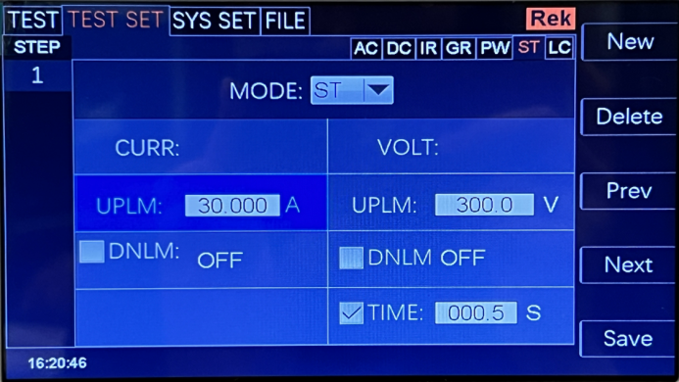

In this interface, press the "ENTER" key to edit the upper limit value of the test, and the range is (0.2 ~ 30) a.. To change the current upper limit, just enter the number key. For example, to ENTER 10.0A, just press "1", "0", "0" and "Enter".

Test time: press the "↓" key or code dial to move the cursor to the time function item, as shown in the following figure:

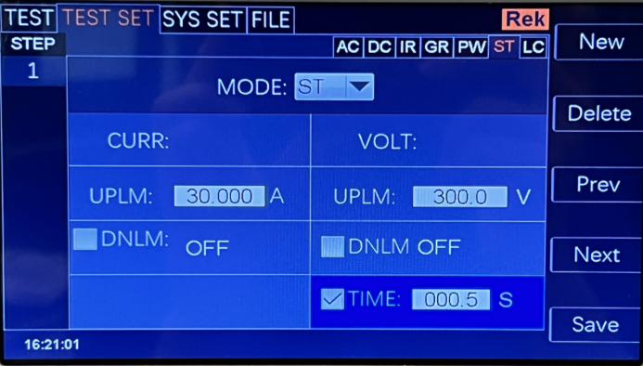
V

Note: Use the "ENTER" key to turn on or off the time function. The range is (0.1-999.9) s.
After turning on the time function, you can operate the time setting function by lightly pressing the coding potentiometer. To change the time value, just enter the number keys. For example, to ENTER 100S, just press "1", "0", "0" and "Enter".
New step: Press "F1" key "New" on the panel in the test interface to create a new test step, and a total of 20 test steps can be created. A new test step is established after the current step, which adopts the default test mode-AC voltage.
Delete step: Press "F2" key "Delete" on the panel in the test interface to delete the test step. The tester deletes the current step, and the subsequent steps move to the current step.
Previous Page: (Step Forward) Press the "F3" key "Previous Page" on the panel in the test interface to move forward the current step, that is, the contents of the current test step and the previous test step are exchanged, which can conveniently realize the sorting function of test steps, but when the current step is the first test step, the moving forward operation is invalid.
Next Page: (Step Backwards) Press the "F4" key "Next Page" on the panel in the test interface to move back the current step, that is, the contents of the current test step and the next test step are exchanged, which can conveniently realize the sorting function of test steps, but when the current step is the last test step, the backward operation is invalid.

Save as a file: press the F5 key on the panel in the test interface to save the current test steps, and save them in the form of a file for easy retrieval and use. Press Save as File to open the storage interface, as shown below:

After entering the interface shown above, press the number keys on the panel, and the screen will be displayed as follows:

Type the relevant characters on the screen, press the "ENTER" key, and the file will be saved in the tester memory.

6.2.9 LC leakage parameter setting
Select "LC" leak test mode under the parameter panel setting, and the test parameter setting will enter "LC" leak test mode, as shown below.
:

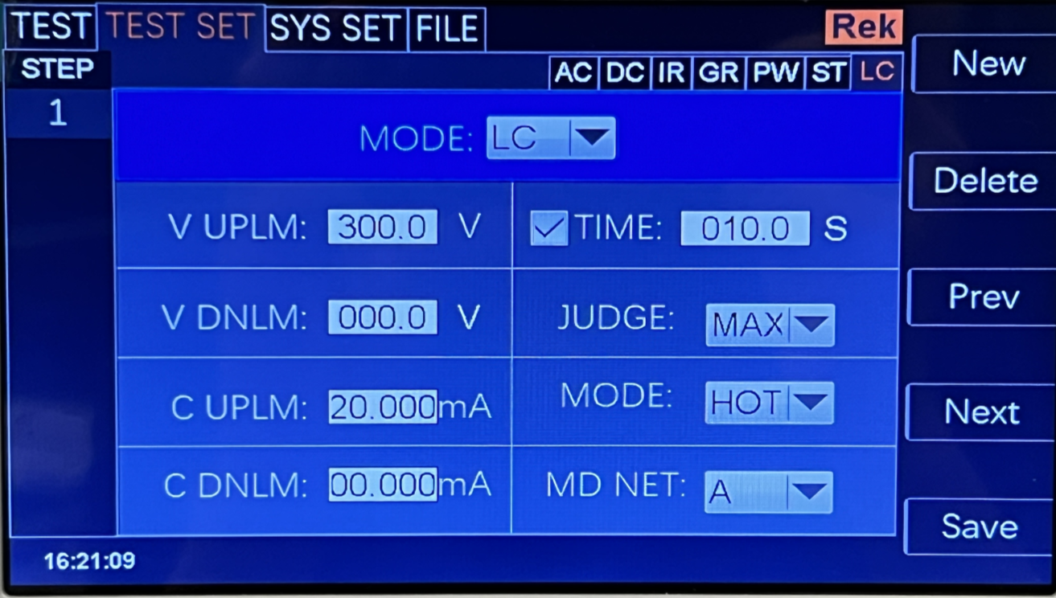

Set the parameters as follows:
Test mode: after the cursor moves to the test mode, press "ENTER" to ENTER the test mode editing, press "→" or "←" to change the test mode, set the LC leak test, and then press "Enter" to save. In this way, all the following parameters are changed to leaked parameters.
Upper voltage limit: press the "↓" key or code dial to move the cursor to the value of the upper voltage limit, as shown in the following figure:

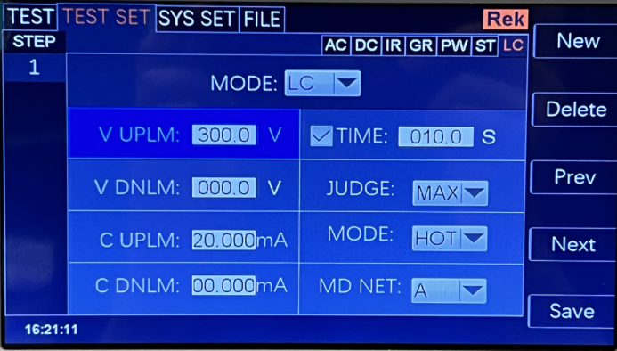
V

In this interface, press the "ENTER" key to edit the voltage value, and the voltage range is (0.1 ~ 300) V. To change the voltage value, just enter the number keys. For example, to input 100V, just press "1", "0", "0" and "ENTER".
Current test upper limit: press the "↓" key or code dial to move the cursor to the value after the test upper limit, as shown in the following figure:

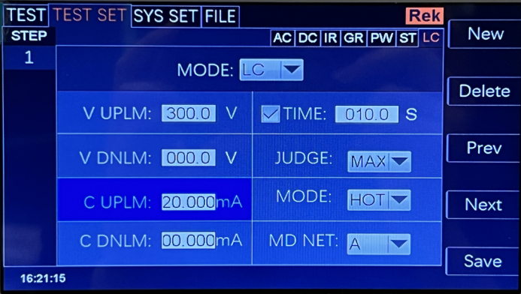
√ 0 10.0

In this interface, press the "ENTER" key to edit the upper limit value of the test, and the range is (0.001~20 )mA. To change the current upper limit, just enter the number key. For example, to ENTER 10.0mA, just press the keys "1", "0", "0" and "Enter".
Test time: press the "↓" key or code dial to move the cursor to the time function item, as shown in the following figure:

Note: Use the "ENTER" key to turn on or off the time function. The range is (0.1-999.9) s.
After turning on the time function, you can operate the time setting function by lightly pressing the coding potentiometer. To change the time value, just enter the number keys. For example, to ENTER 100S, just press "1", "0", "0" and "Enter".

New step: Press "F1" key "New" on the panel in the test interface to create a new test step, and a total of 20 test steps can be created. A new test step is established after the current step, which adopts the default test mode-AC voltage.
Delete step: Press "F2" key "Delete" on the panel in the test interface to delete the test step. The tester deletes the current step, and the subsequent steps move to the current step.
Previous Page: (Step Forward) Press the "F3" key "Previous Page" on the panel in the test interface to move forward the current step, that is, the contents of the current test step and the previous test step are exchanged, which can conveniently realize the sorting function of test steps, but when the current step is the first test step, the moving forward operation is invalid.
Next Page: (Step Backwards) Press the "F4" key "Next Page" on the panel in the test interface to move back the current step, that is, the contents of the current test step and the next test step are exchanged, which can conveniently realize the sorting function of test steps, but when the current step is the last test step, the backward operation is invalid.

Save as a file: press the F5 key on the panel in the test interface to save the current test steps, and save them in the form of a file for easy retrieval and use. Press Save as File to open the storage interface, as shown below:

After entering the interface shown above, press the number keys on the panel, and the screen will be displayed as follows:

Type the relevant characters on the screen, press the "ENTER" key, and the file will be saved in the tester memory.

6.3 System Setup Mode
6.3.1 Description of system setting parameters

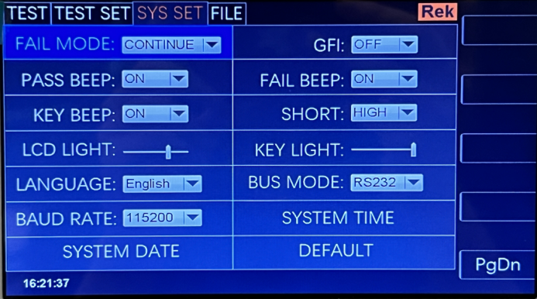

6.3.1.1 failure mode
This option has two functions, namely, CONTINUE, STOP, RESTART and NEXT. You can use the [↑] [←] [→] cursor to select the setting item, and adjust the coded potentiometer to select the function item to be set.

6.3.1.2 qualified voice
This optiON has two functions, on and OFF. You can use the [write] [↓] [←] [→] cursor to select the setting item and adjust the selection of the coding potentiometer.
The function item to be set.
6.3.1.3 keystrokes
This optiON has two functions, on and OFF. You can use the cursor [←] [↓] [→] to select the setting item, and adjust the coding potentiometer to select the function item to be set.
6.3.1.4 screen brightness
You can use the cursor [←] [↓] [→] to select the setting item, and adjust the coding potentiometer to select the value to be set.
6.3.1.5 system language
There are two languages in this program, Chinese and English. You can use the [↑] [↓] [←] [→] cursor to select the setting item, and adjust the coded potentiometer to select the item to be set.
6.3.1.6 baud rate
This item has four baud rates: 9600, 38400, 19200 and 115200. You can use the cursor [↑] [↓] [←] →】 to select the setting item, and the adjustable coding potentiometer selects the item to be set.
6.3.1.7 system date
This item can set the current time of the instrument. Once the system time is set, the time function will continue regardless of the power-on and power-off state, unless the internal battery fails. You can use the [write] [↓] [←] [→] cursor to select the setting item, and adjust the coding potentiometer to select the one to be set.
6.3.1.8 electric shock protection
This optiON has two functions, on and OFF. You can use the cursor [←] [↓] [→] to select the setting item and adjust the function item to be set in the selection of coded potentiometer.
6.3.1.9 failed.
This optiON has two functions, on and OFF. You can use the cursor [←] [↓] [→] to select the setting item, and adjust the coding potentiometer to select the function item to be set.
6.3.1.10 short circuit protection
This option has two functions, HIGH and LOW. Use the [write] [↓] [←] [→] cursor to select the setting item and adjust the coding potential.
Select the function item to be set.
6.3.1.11 key brightness
You can use the cursor [←] [↓] [→] to select the setting item, and adjust the coding potentiometer to select the value to be set.
6.3.1.12 bus mode
There are two bus modes, RS232 and RS485. You can use the [↑] [↓] [←] [→] cursor to select a setting item, and adjust the coded potentiometer to select the item to be set.

6.3.1.13 system time
This item can set the current time of the instrument. Once the system time is set, the time function will continue regardless of the power-on and power-off state, unless the internal battery fails. You can use the cursor [←] [↓] [→] to select the setting item, and adjust the coding potentiometer to select the value to be set.
6.3.1.14 returned to default.
This function is to restore system settings, parameter settings and factory settings, and all settings will be reset. Use the cursor [←] [↓] [→] to select a setting item, press [ENTER] to open the [OK] [Cancel] interface, and press [OK] to confirm. Press [Cancel] to cancel.

6.4 Description of file parameters
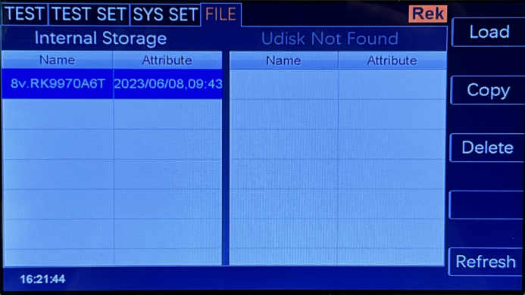

6.4.1 Internal storage: the storage capacity is 16M.
6.4.2 USB flash drive function: This item has external USB flash drive storage function.

6.5 Description of contact inspection function
Contact inspection is conducted by a high voltage of 1kV to determine whether it contacts the equipment under test, which is usually used for testing equipment under 100G.
Contact inspection suggests that the high-voltage rod should be used when it is output for testing.

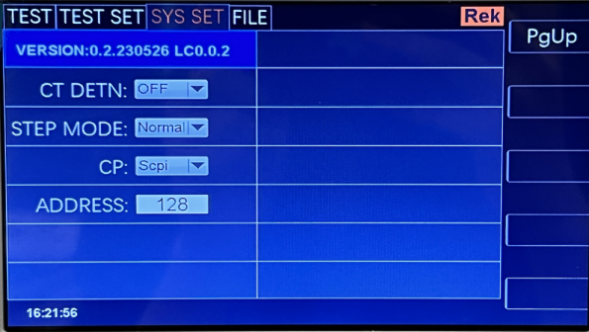

6.6 Communication Protocol Selection
SCPI Modbus → Description, SCPI and Modbus are supported, and Modbus address position can be set.

Chapter 7 Remote Control

7.1 RS232C Interface Description
At present, the widely used serial communication standard is RS-232 standard, which can also be called asynchronous serial communication standard, and RS is "Recommended Standard" The English abbreviation of (Recommended Standard), 232 is the standard number. This standard was officially published by the American Electronics Industry Association (IEA) in 1969, and it stipulated that it should be transmitted one bit at a time via a data line. Like most serial ports in the world, the serial interface of this instrument is not strictly based on RS-232 standard, but only provides a minimal subset. The following table:

signal | abbreviate | Connector pin number
TXD | TXD | 2
receive data | RXD | three
landing | GND | five

Instrument RS232 signal and pin comparison
The reason is that the operation of three lines is much cheaper than that of five lines or six lines, which is the biggest advantage of using serial port communication. Instrument and computer connection, such as
As shown in the figure:

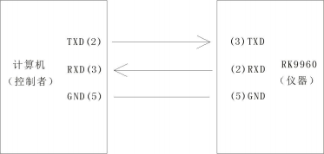
RK9970

Schematic diagram of computer and instrument connection
As can be seen from the figure, the pin definition of the instrument is different from that of the 9-core connector serial interface used by the computer. The baud rate of RS232 interface can be selected from 9600 to 115200, with no parity, 8 data bits and 1 stop bit. The instrument command conforms to SCPI standard. When the command string is sent to the instrument, LF (hexadecimal: 0AH) should be sent as the ending character. The maximum number of bytes of SPCI command string that the instrument can accept at one time is 2kByte. For the format of the result data sent by the instrument to the computer, please refer to the command reference section.

7.2 description of RS485/232c interface
The communication interface of the tester can provide RS232C and RS485 serial communication interfaces for users to choose from. The interfaces are defined as follows:

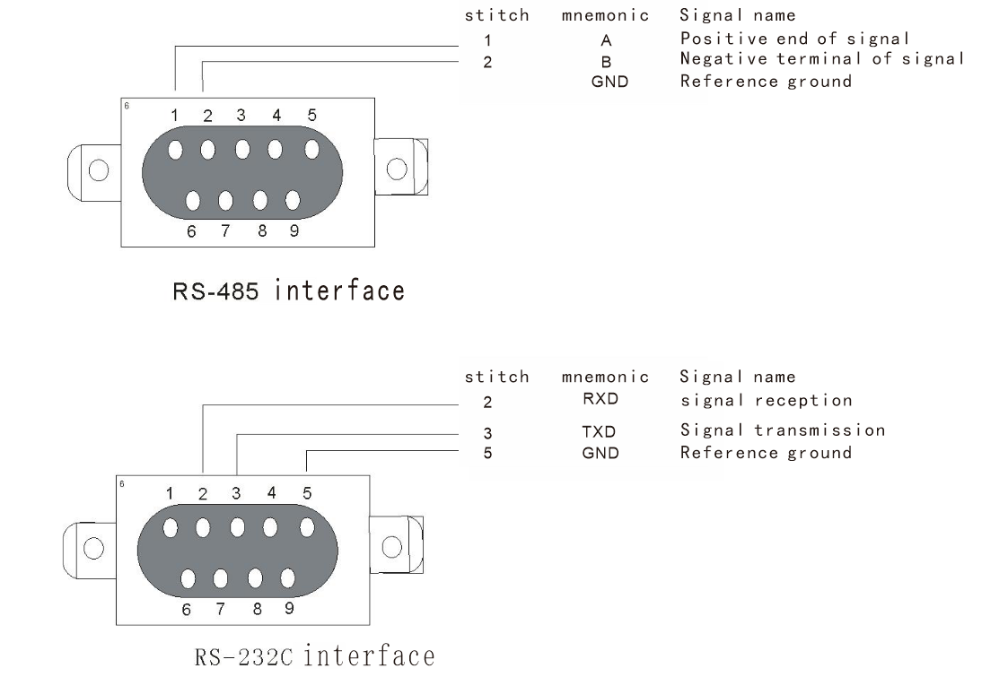

7.3 USBTMC remote control system
USB (universal serial bus) remote control is to control equipment through USB interface. The connection conforms to the USB2.0 protocol. Connect the USB interface on the back panel of RK9970 with the USB interface on the host through USB cable.

7.4 instrument communication protocol (modbus)
This instrument uses RS-232c RS-485 standard asynchronous serial communication bus interface to communicate with external control equipment, and the transmission baud rate can be preset in the instrument (9600, 19200, 38400 and 115200 are optional). 8 data bits, 1 stop bit, no check bit.
The logic level of the signal is ±12V, and the maximum transmission distance is 15m.
The serial interface adopts direct communication, using only three signal lines of TXD (transmission), RXD (reception) and GND (ground), and using a nine-core calibration interface socket.

1. Read instruction (function code is 03H)
Send format (7 bits of data in total):

address | function code | Address high position | Low address | High data volume | Low data volume | CRC low | CRC high
Return format:

address | function code | Address high position | Low address | High data volume | Low data volume | Data byte | CRC low | CRC high
Data Byte: When the data type is U16, the data byte is 2 bytes, with the lower bit first.
When the data type is float, the data 4byte is 4 bytes, and the lower bit comes first.
When the data type is double, the data 8byte is 8 bytes, and the lower bit comes first.
Example: Send 01031010002910b to inquire about the current selection steps of No.01 instrument.
Return to 01 03 10 01 00 02 01 00 2D C7
Different address bits return different data.
: register list

serial number | Register address | Register name | data type | byte | explain | scope of data | Read-write type | serviceable range
1 | 1001H | Se l Step | U16 | 2 | Current steps/  Step number of selection |  | RW
2 | 1002H | To l Step | U16 | 2 | Total steps |  | R
3 | 1003H | New Step | U16 | 2 | New steps |  | W
4 | 1004H | De l Step | U16 | 2 | Delete steps |  | W
5 | 1005H | Mode | U16 | 2 | Mode | 1-7 | RW | complete
6 | 1006H | Vo lt | f loat | 4 | voltage | AC 0.05-5.0  DC 0.05-6.0  IR 0.05-3.0 | RW | AC DCIR
7 | 1007H | Cu r rUp l im | f loat | 4 | Current upper limit | AC 0.001-50  DC 0.001-20 | RW | ACDC
8 | 1008H | Cu r rUp l im | f loat | 4 | Current lower limit | AC 0.0-49.999  DC 0.001-19.999 | RW | ACDC
9 | 1009H | Arc | f loat | 4 | Arc setting | 0-20 | RW | ACDC
10 | 100AH | T ime | f loat | 4 | timeset | 0.1-999.9 0 (unlimited) | RW | AC DC IR GR  PW ST
11 | 100BH | R iseT ime | f loat | 4 | Rise time setting | 0-999.9 | RW | AC DCIR
12 | 100CH | Fa l lT ime | f loat | 4 | Setting of descending time interval | 0-999.9 | RW | AC DCIR
13 | 100DH | F req | U16 | 2 | Frequency setting | 5060 | RW | AC
14 | 100EH | Ramp | U16 | 2 | Ascending judgment | 01 | RW | DC
15 | 100FH | ResUp l im | f loat | 4 | Upper limit of electrical resistance | 0.1-99999.9 | RW | IR
16 | 1010H | ResDn l im | f loat | 4 | Lower limit of electrical resistance | 0.1-99999.8 0 (no lower limit) | RW | IR
17 | 1011H | Range | U16 | 2 | measuring range | 0 1 2 3 4 5 | RW | IR
18 | 1012H | GRTestCurr | f loat | 4 | Test current | 3-32A | RW | GR
19 | 1013H | GRTestUp l im | f loat | 4 | Test upper limit | 10-600 | RW | GR
20 | 1014H | GROFFSET | f loat | 4 | Zero compensation |  | RW | GR
21 | 1015H | GROFFSETAUTO | U16 | 2 | Automatic zeroing compensation |  | W | GR
22 | 1016H | GRFreq | U16 | 2 | G r frequency | 5060 | RW | GR
23 | 1017H | PWSTCurrUp l im | f loat | 4 | Upper limit of power ST current | 0.001-30 | RW | PW ST
24 | 1018H | PWSTCurrDn l im | f loat | 4 | Power ST current lower limit | 0-29.999 | RW | PW ST
25 | 1019H | Pw rUp l im | doub le | 8 | Power upper limit setting | 0.001-6000 | RW | PW
26 | 101AH | Pw rDn l im | doub le | 8 | Power lower limit setting | 0-5999.999 | RW | PW
27 | 101BH | PWDe layT ime | f loat | 4 | Power delay time | 1-999.9 | RW | PW
28 | 101CH | Vo ltUp l im | f loat | 4 | Upper voltage limit | 0.1-300 | RW | ST LC
29 | 101DH | Vo ltDn l im | f loat | 4 | Lower voltage limit | 0-299.9 | RW | ST LC
30 | 101EH | LCCu r rUp l im | f loat | 4 | Upper limit of LC current | 0.001-30 | RW | LC
31 | 101FH | LCCu r rDn l im | f loat | 4 | LC current lower limit | 0-29.999 | RW | LC
32 | 1020H | JudgeMode | U16 | 2 | Decision mode | 01 | RW | LC
33 | 1021H | TestMode | U16 | 2 | Test setup | 01 | RW | LC
34 | 1022H | MDNet | U16 | 2 | MD network | 0-7 | RW | LC
35 | 1060H | Sta rt | U16 | 2 | Start test |  | W
36 | 1061H | Stop | U16 | 2 | Stop testing |  | W

serial number | Register address | Register name | data type | byte | explain | scope of data | Read-write type | serviceable range
37 | 1062 | fetch one | U8 | 1 | Mode of the current step |  | R | AC DC IR GR ST LC
 |  |  | U8 | 1 | Test results of the current step
 |  |  | f loat | 4 | Test voltage of current step
 |  |  | f loat | 4 | Test current of current step
 |  |  | U8 | 1 | Mode of the current step |  | R | PW
 |  |  | U8 | 1 | Test results of the current step
 |  |  | f loat | 4 | Test voltage of current step
 |  |  | f loat | 4 | Test current of current step
 |  |  | f loat | 4 | Test power of current step

Description of return value:
Mode mode: 1 AC withstand voltage 2 DC withstand voltage 3 insulation resistance 4 grounding resistance 5 power 6 low voltage start 7 leakage
Range range: AUTO 400K 4M 40M 400M 100G
Judge decision mode: 0 Judge End 1 Judge Max
TestMode test mode: 0 Cold 1 Hot
MDNet MD network: 0MD A, 1MD B, 2MD B1, 3MD C, 4MD D, 5MD E, 6MD F, 7MD G.

Fetch one

Mode | Data byte
Communication (AC)  Direct current (DC) | State (byte) voltage (f loat) current (f loat)
Insulation(IR) | Byte voltage (f loat) electrical resistance (f loat)
Grounding (GR) | Byte current (f loat) resistance (f loat)
Low voltage start (ST) | State (byte) voltage (f loat) current (f loat)
Leakage (PW) | State (byte) voltage (f loat) current (f loat) power (f loat)
Form:
00H Untested 01H Test 02H Test Qualified 03H Exceeded Upper Limit 04H Below Lower Limit 05H Exceeded GR Voltage 06HGR Open Circuit 07H Short Circuit Failure 08H Arc Failure 09H Human Protection Failure OAHGR Biased OBH Contact Check Failure OCH Current Exceeded Upper Limit ODH Current Below Lower Limit OEH Power Exceeded Upper Limit.
OFH power is lower than the lower limit for 10H, voltage exceeds the upper limit for 11H, voltage is lower than the lower limit for 12H, leakage voltage exceeds the limit for 13H, and leakage current exceeds the limit.

2. Write instruction (function code is 10H)
The sending format is:

address | function code | address  high position | address  low post | Data volume high bit (word) | Low data volume (word) | Data volume (Byte) | Data words 1-n | CRC low | CRC high

The return format is:

address | function code | address  high position | address  low post | Data volume high bit (word) | Low data volume (word) | CRC low | CRC high
The following explains the meaning of each parameter in detail for you:
2.1 address
Mailing address. The range is decimal 1-247. If the local address in the instrument system settings is 99, this bit is 63H.

2.2 function code
Write one or more bytes of data to the instrument. The function code is 10H.

2.3 high address+low address
Storage addresses of various parameters of the instrument. See Table 6-1 for details.

2.4. Data volume (word)
How many groups of data are written to the storage address of instrument parameters. It is fixed at 0001H.

2.5 data volume (Byte)
How many bytes of data to write to the instrument parameter storage address.

2.6 data bytes 1-n.
See the table below for details.

serial number | Register address | Register name | byte | data type | explain | Data range | Read-write type | serviceable range
1 | 1001H | Se l Step | 2 | U16 | Current Steps/Selected Steps |  | RW
2 | 1002H | To l Step | 2 | U16 | Total steps |  | R
3 | 1003H | New Step | 2 | U16 | New steps |  | W
4 | 1004H | De l Step | 2 | U16 | Delete steps |  | W
5 | 1005H | Mode | 2 | U16 | Mode | 1-7 | RW | complete
6 | 1006H | Vo lt | 4 | f loat | voltage | AC 0.05-5.0  DC 0.05-6.0  IR 0.05-3.0 | RW | ACDCIR
7 | 1007H | Cu r rUp l im | 4 | f loat | Current upper limit | AC 0.001-50  DC 0.001-20 | RW | ACDC
8 | 1008H | Cu r rUp l im | 4 | f loat | Current lower limit |  | RW | ACDC
9 | 1009H | Arc | 4 | f loat | Arc setting | 0-20 | RW | ACDC
10 | 100AH | T ime | 4 | f loat | timeset | 0. 1-999.9 0 (unlimited) | RW | AC DC IR GR  PW ST
11 | 100BH | R iseT ime | 4 | f loat | Rise time setting | 0-999.9 | RW | ACDCIR
12 | 100CH | Fa l lT ime | 4 | f loat | Setting of descending time interval | 0-999.9 | RW | ACDCIR
13 | 100DH | F req | 2 | U16 | Frequency setting | 5060 | RW | AC
14 | 100EH | Ramp | 2 | U16 | Ascending judgment | 01 | RW | DC
15 | 100FH | ResUp l im | 4 | f loat | Upper limit of electrical resistance | 0.1-99999.9 | RW | IR
16 | 1010H | ResDn l im | 4 | f loat | Lower limit of electrical resistance | 0. 1-99999.8 0 (no lower limit) | RW | IR
17 | 1011H | Range | 2 | U16 | measuring range | 0 1 2 3 4 5 | RW | IR
18 | 1012H | GRTestCurr | 4 | f loat | Test current | 3-32A | RW | GR
19 | 1013H | GRTestUp l im | 4 | f loat | Test upper limit | 10-600 | RW | GR
20 | 1014H | GROFFSET | 4 | f loat | Zero compensation |  | RW | GR
21 | 1015H | GROFFSETAUTO | 2 | U16 | Automatic zeroing compensation |  | W | GR
22 | 1016H | GRFreq | 2 | U16 | G r frequency | 5060 | RW | GR
23 | 1017H | PWSTCurrUp l im | 4 | f loat | Upper limit of power ST current | 0.001-30 | RW | PW ST
24 | 1018H | PWSTCurrDn l im | 4 | f loat | Power ST current lower limit | 0-29.999 | RW | PW ST
25 | 1019H | Pw rUp l im | 8 | doub le | Power upper limit setting | 0.001-6000 | RW | PW
26 | 101AH | Pw rDn l im | 8 | doub le | Power lower limit setting | 0-5999.999 | RW | PW
27 | 101BH | PWDe layT ime | 4 | f loat | Power delay time | 1-999.9 | RW | PW
28 | 101CH | Vo ltUp l im | 4 | f loat | Upper voltage limit | 0.1-300 | RW | ST LC
29 | 101DH | Vo ltDn l im | 4 | f loat | Lower voltage limit | 0-299.9 | RW | ST LC
30 | 101EH | LCCu r rUp l im | 4 | f loat | Upper limit of LC current | 0.001-30 | RW | LC
31 | 101FH | LCCu r rDn l im | 4 | f loat | LC current lower limit | 0-29.999 | RW | LC
32 | 1020H | JudgeMode | 2 | U16 | Judgment mode | 01 | RW | LC
33 | 1021H | TestMode | 2 | U16 | Test setup | 01 | RW | LC
34 | 1022H | MDNet | 2 | U16 | MD network | 0-7 | RW | LC
35 | 1060H | Sta rt | 2 | U16 | Start test | AC 0.0-49.999  DC 0.00 1- 19.999 | W
36 | 1061H | Stop | 2 | U16 | Stop testing |  | W
37 | 1062 | fetch one | 1 | U8 | Mode of the current step |  | R | AC DC IR GR ST LC
 |  |  | 1 | U8 | Test results of the current step
 |  |  | 4 | f loat | Test voltage of current step
 |  |  | 4 | f loat | Test current of current step
 |  |  | 1 | U8 | Mode of the current step |  | R | PW
 |  |  | 1 | U8 | Test results of the current step
 |  |  | 4 | f loat | Test voltage of current step
 |  |  | 4 | f loat | Test current of current step
 |  |  | 4 | f loat | Test power of current step

For example, send 01h, 10h, 10h, 10h, 06h, 01h, 04h, 00h, 00h, 40h BFH, 86h.
Represents setting the voltage value of Unit 01 to 2KV
Sending 01h, 10h, 10h, 06h, 00h, 01h, E5h08h represents setting the response of No.01 machine as unqualified.
2.716 bit CRC check
1. First, define two 256-byte check tables.
const BYTE chCRCHTalbe[]
= // CRC high byte
Value table
{
0x00, 0xC1, 0x81, 0x40, 0x01, 0xC0, 0x80, 0x41, 0x01, 0xC0, 0x80, 0x41,
0x00, 0xC1, 0x81, 0x40, 0x01, 0xC0, 0x80, 0x41, 0x00, 0xC1, 0x81, 0x40,
0x00, 0xC1, 0x81, 0x40, 0x01, 0xC0, 0x80, 0x41, 0x01, 0xC0, 0x80, 0x41,
0x00, 0xC1, 0x81, 0x40, 0x00, 0xC1, 0x81, 0x40, 0x01, 0xC0, 0x80, 0x41,
0x00, 0xC1, 0x81, 0x40, 0x01, 0xC0, 0x80, 0x41, 0x01, 0xC0, 0x80, 0x41,
0x00, 0xC1, 0x81, 0x40, 0x01, 0xC0, 0x80, 0x41, 0x00, 0xC1, 0x81, 0x40,
0x00, 0xC1, 0x81, 0x40, 0x01, 0xC0, 0x80, 0x41, 0x00, 0xC1, 0x81, 0x40,
0x01, 0xC0, 0x80, 0x41, 0x01, 0xC0, 0x80, 0x41, 0x00, 0xC1, 0x81, 0x40,
0x00, 0xC1, 0x81, 0x40, 0x01, 0xC0, 0x80, 0x41, 0x01, 0xC0, 0x80, 0x41,
0x00, 0xC1, 0x81, 0x40, 0x01, 0xC0, 0x80, 0x41, 0x00, 0xC1, 0x81, 0x40,
0x00, 0xC1, 0x81, 0x40, 0x01, 0xC0, 0x80, 0x41, 0x01, 0xC0, 0x80, 0x41,
0x00, 0xC1, 0x81, 0x40, 0x00, 0xC1, 0x81, 0x40, 0x01, 0xC0, 0x80, 0x41,
0x00, 0xC1, 0x81, 0x40, 0x01, 0xC0, 0x80, 0x41, 0x01, 0xC0, 0x80, 0x41,
0x00, 0xC1, 0x81, 0x40, 0x00, 0xC1, 0x81, 0x40, 0x01, 0xC0, 0x80, 0x41,
0x01, 0xC0, 0x80, 0x41, 0x00, 0xC1, 0x81, 0x40, 0x01, 0xC0, 0x80, 0x41,
0x00, 0xC1, 0x81, 0x40, 0x00, 0xC1, 0x81, 0x40, 0x01, 0xC0, 0x80, 0x41,
0x00, 0xC1, 0x81, 0x40, 0x01, 0xC0, 0x80, 0x41, 0x01, 0xC0, 0x80, 0x41,
0x00, 0xC1, 0x81, 0x40, 0x01, 0xC0, 0x80, 0x41, 0x00, 0xC1, 0x81, 0x40,
0x00, 0xC1, 0x81, 0x40, 0x01, 0xC0, 0x80, 0x41, 0x01, 0xC0, 0x80, 0x41,
0x00, 0xC1, 0x81, 0x40, 0x00, 0xC1, 0x81, 0x40, 0x01, 0xC0, 0x80, 0x41,
0x00, 0xC1, 0x81, 0x40, 0x01, 0xC0, 0x80, 0x41, 0x01, 0xC0, 0x80, 0x41,
0x00, 0xC1, 0x81, 0x40
};

//CRC low byte value table
const BYTE chCRCLTalbe[]
=
{
0x00, 0xC0, 0xC1, 0x01, 0xC3, 0x03, 0x02, 0xC2, 0xC6, 0x06, 0x07, 0xC7,
0x05, 0xC5, 0xC4, 0x04, 0xCC, 0x0C, 0x0D, 0xCD, 0x0F, 0xCF, 0xCE, 0x0E,
0x0A, 0xCA, 0xCB, 0x0B, 0xC9, 0x09, 0x08, 0xC8, 0xD8, 0x18, 0x19, 0xD9,
0x1B, 0xDB, 0xDA, 0x1A, 0x1E, 0xDE, 0xDF, 0x1F, 0xDD, 0x1D, 0x1C, 0xDC,
0x14, 0xD4, 0xD5, 0x15, 0xD7, 0x17, 0x16, 0xD6, 0xD2, 0x12, 0x13, 0xD3,
0x11, 0xD1, 0xD0, 0x10, 0xF0, 0x30, 0x31, 0xF1, 0x33, 0xF3, 0xF2, 0x32,
0x36, 0xF6, 0xF7, 0x37, 0xF5, 0x35, 0x34, 0xF4, 0x3C, 0xFC, 0xFD, 0x3D,
0xFF, 0x3F, 0x3E, 0xFE, 0xFA, 0x3A, 0x3B, 0xFB, 0x39, 0xF9, 0xF8, 0x38,
0x28, 0xE8, 0xE9, 0x29, 0xEB, 0x2B, 0x2A, 0xEA, 0xEE, 0x2E, 0x2F, 0xEF,
0x2D, 0xED, 0xEC, 0x2C, 0xE4, 0x24, 0x25, 0xE5, 0x27, 0xE7, 0xE6, 0x26,
0x22, 0xE2, 0xE3, 0x23, 0xE1, 0x21, 0x20, 0xE0, 0xA0, 0x60, 0x61, 0xA1,
0x63, 0xA3, 0xA2, 0x62, 0x66, 0xA6, 0xA7, 0x67, 0xA5, 0x65, 0x64, 0xA4,
0x6C, 0xAC, 0xAD, 0x6D, 0xAF, 0x6F, 0x6E, 0xAE, 0xAA, 0x6A, 0x6B, 0xAB,
0x69, 0xA9, 0xA8, 0x68, 0x78, 0xB8, 0xB9, 0x79, 0xBB, 0x7B, 0x7A, 0xBA,
0xBE, 0x7E, 0x7F, 0xBF, 0x7D, 0xBD, 0xBC, 0x7C, 0xB4, 0x74, 0x75, 0xB5,

0x77, 0xB7, 0xB6, 0x76, 0x72, 0xB2, 0xB3, 0x73, 0xB1, 0x71, 0x70, 0xB0,
0x50, 0x90, 0x91, 0x51, 0x93, 0x53, 0x52, 0x92, 0x96, 0x56, 0x57, 0x97,
0x55, 0x95, 0x94, 0x54, 0x9C, 0x5C, 0x5D, 0x9D, 0x5F, 0x9F, 0x9E, 0x5E,
0x5A, 0x9A, 0x9B, 0x5B, 0x99, 0x59, 0x58, 0x98, 0x88, 0x48, 0x49, 0x89,
0x4B, 0x8B, 0x8A, 0x4A, 0x4E, 0x8E, 0x8F, 0x4F, 0x8D, 0x4D, 0x4C, 0x8C,
0x44, 0x84, 0x85, 0x45, 0x87, 0x47, 0x46, 0x86, 0x82, 0x42, 0x43, 0x83,
0x41, 0x81, 0x80, 0x40
};
2. Then calculate.
WORD CRC16(BYTE* pchMsg, WORD wDataLen)
{
BYTE chCRCHi = 0xFF; //high CRC byte initialization
BYTE chCRCLo = 0xFF; //low CRC byte initialization
WORD wIndex; //Index in CRC loop
while (wDataLen--)
{
//Calculate CRC
wIndex = chCRCLo ^ *pchMsg++ ;
chCRCLo = chCRCHi ^ chCRCHTalbe[wIndex];
chCRCHi = chCRCLTalbe[wIndex] ;
}
return ((chCRCHi << 8) | chCRCLo) ;

Chapter 8 SCPI serial port instruction reference
8.1 Brief description of instruction format:
8.1.1. The instrument instruction set only describes the actual characters accepted or sent by the instrument.
8.1.2. Instruction characters are all ASCII characters.
8.1.3. Data of instruction "<? ? ? > "are all ASCII strings. The default format of the system is integer or floating-point number, and the unit of data is the default value, which does not appear in the instruction.
8.1.4 At the end of an instruction, there must be an instruction end mark: an identifier for the end of an instruction, without which the instrument will not parse the instruction.
8.1.5 The default closing marks are: carriage return (NL), print control character (\n), decimal number (10) and hexadecimal number (0 ×0A). End marks of IEEE-488 bus: keyword (end), signal (EOI).
An example in which multiple instructions can simplify sending is as follows: Note: The "_" in the example is marked with a space.
FUNC：SOUR：STEP_1：I ： I_10.00；
FUNC：SOUR：STEP_ INS (NL^END)
FUNC：SOUR：TEP_2：I ： I_10.00；

8.2 SCPI instruction set RK9970 series instrument subsystem commands
● DISPlay
● SYSTem

● FUNCtion ●MMEM ●FETC

8.3DISPLAY subsystem command set
The command set of DISPlay subsystem is mainly used to set the display page and characters of the instrument. You can query the current page.
DISPLay:PAGE
Command syntax:
DISPlay：PAGE <page name>
< page name > details are as follows:
TEST
TESTSET
SYSSet

FLIE
Set display page to: Measurement display page
Set the display page to: Measurement Settings page.

Set Display Page to: System Settings Page
Set the display page to: (internal) document list
Characters? You can query the current page.
-example:
Set display page to: Measurement display page.
Setting instruction: display: page
Query instruction: DISPlay：PAGE?
Return value:
TEST32

8.4 FUNCtion subsystem command set
8.4.1 FUNCtion subsystem command set is mainly used to set the test parameters of instrument test function.
Command tree:
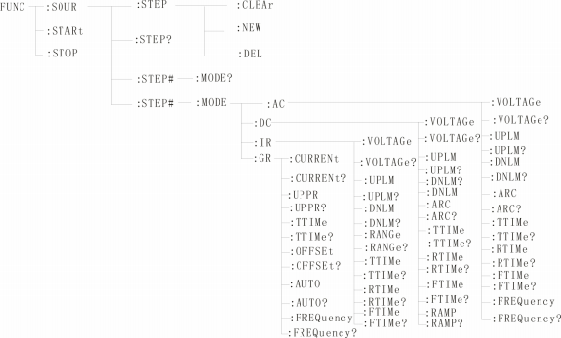
8.4.2PROG function command set
FUNC:STARt the test when the instrument is testing the interface.
FUNC:STOP the test when the instrument is testing the interface.
Func: soul: step: clear clear a new test ITEM in the existing test item.
Func: soul: step: del Delete the current test ITEM within the existing test item.
Func: soul: step: new Create an empty test plan to write a brand-new test plan.
FUNC:SOUR:STEP? : Query the current test scheme.

8.4.3 STEP# function command set
8.4.3.1 acsetup function command set
Func: source: step #: mode: AC: voltage Set/query the voltage of AC.
-format
Setting format: function: step #: mode: AC: voltage < voltage value >
Query format: function: step #: mode: AC: voltage?
-data < voltage value >:
Data type: floating-point number setting format: func: step: < num >: AC: volt < voltage value >
Data range: 0.050-5.000
Data accuracy: 0.001
Data unit: KV
Example: Set the voltage value of AC in STEP1 to 1000V in this way.
Setting command: function: step 1: mode: AC: voltage 1.000.
Query command: function: step 1: mode: AC: voltage?
Func: source: step #: mode: AC: uplm Set/query the upper limit current of AC.
-format
Setting format: function: step #: mode: AC: uplm < current value >
Query format: function: step #: mode: AC: uplm?
-data < current value >
Data type: floating point number
Data range: 0.001-20.00mA
Data accuracy: 0.001
Data unit: mA
Example: set the current value of AC in STEP1 to 1mA.
Setting command: function: step 1: mode: AC: uplm1.000.
Query command: function: step 1: mode: AC: uplm?
Return value: 1
Func: source: step #: mode: AC: dnlm Set/query the lower limit current of AC.
-format
Setting format: function: step #: mode: AC: dnlm < current value >
Query format: function: step #: mode: AC: dnlm?
-data < current value >
Data type: floating point number
Data range: 0.001-20.00mA

Data accuracy: 0.001
Data unit: mA
Example: set the current value of AC in STEP1 to 1mA.
Setting command: function: step 1: mode: AC: uplm1.000.
Query command: function: step 1: mode: AC: uplm?
Return value: 1
Func: source: step #: mode: AC: arc set/query arc value.
-format
Setting format: function: step #: mode: AC: arc < arc value >
Query format: function: step #: mode: AC: arc?
-data < arc value >:
Data type: floating point number
Data range: 0.001-20.00mA
Data accuracy: 0.001
Data unit: mA
Example: set the current value of AC in STEP1 to 1mA.
Setting command: function: step 1: mode: AC: arc1.000.
Query command: function: step 1: mode: AC: arc?
Return value: 1
Func: source: step #: mode: AC: ttime Set/query the test time of AC.
-format
Set the format: function: step #: mode: AC: ttime < time >
Query format: function: step #: mode: AC: ttime?
-data < time value >
Data type: Integer
Data range: 0-999.9
Data accuracy: 0.1
Data unit: s
Example: Set the time value of AC in STEP1 to 1S.
Setting command: function: step 1: mode: AC: ttime1.
Query command: function: step 1: mode: AC: ttime?
Return value: 1
Func: source: step #: mode: AC: rtime Set/query the rising time of AC.

-format
Set the format: function: step #: mode: AC: rtime < time >
Query format: function: step #: mode: AC: rtime?
-data < time value >
Data type: Integer
Data range: 0-999.9
Data accuracy: 0.1
Data unit: s
Example: Set the time value of AC in STEP1 to 1S.
Setting command: function: step 1: mode: AC: rtime1.
Query command: function: step 1: mode: AC: rtime?
Return value: 1
Func: source: step #: mode: AC: ftime Set/query the falling time of AC.
-format
Set the format: function: step #: mode: AC: ftime < time >
Query format: function: step #: mode: AC: ftime?
-data < time value >
Data type: Integer
Data range: 0-999.9
Data accuracy: 0.1
Data unit: s
Example: Set the time value of AC in STEP1 to 1S.
Setting command: function: step 1: mode: AC: ftime1.
Query command: function: step 1: mode: AC: ftime?
Return value: 1
Func: source: step #: mode: AC: frequency Set/query the test frequency of AC.
-format
Set the format: function: step #: mode: AC: frequency < frequency >.
Query format: function: step #: mode: AC: frequency?
-data < frequency value >
Data type: Integer
Data range: 50/60
Data accuracy: 0.1

Data unit: Hz
Example: set the frequency value of AC in STEP1 to 50Hz.
Setting command: function: step 1: mode: AC: frequency 50.
Query command: function: step 1: mode: AC: frequency?
Return value: 50

8.4.3.2 DC Setup Function Command Set
Func: source: step #: mode: DC: voltage Set/query DC voltage.
-format
Setting format: function: step #: mode: DC: voltage < voltage value >
Query format: function: step #: mode: DC: voltage?
-data < voltage value >:
Data type: floating point number
Data range: 0.050-6.000
Data accuracy: 0.001
Data unit: KV
Example: Set the voltage value of DC in STEP1 to 1000V in this way.
Setting command: function: step 1: mode: DC: voltage 1.000.
Query command: function: step 1: mode: DC: voltage?
Func: source: step #: mode: DC: uplm Set/query the upper limit current of DC.
-format
Setting format: function: step #: mode: DC: uplm < current value >
Query format: function: step #: mode: DC: uplm?
-data < current value >
Data type: floating point number
Data range: 0.001-10.00mA
Data accuracy: 0.001
Data unit: mA
Example: set the current value of DC in STEP1 to 1mA.
Setting command: function: step 1: mode: DC: uplm1.000.
Query command: function: step 1: mode: DC: uplm?
Return value: 1
Func: source: step #: mode: DC: dnlm Set/query the lower limit current of DW.
-format

Setting format: function: step #: mode: DC: dnlm < current value >
Query format: function: step #: mode: DC: dnlm?
-data < current value >
Data type: floating point number
Data range: 0.001-10.00mA
Data accuracy: 0.001
Data unit: mA
Example: set the current value of DC in STEP1 to 1mA.
Setting command: function: step 1: mode: DC: uplm1.000.
Query command: function: step 1: mode: DC: uplm?
Return value: 1
Func: source: step #: mode: DC: arc set/query arc value.
-format
Setting format: function: step #: mode: DC: arc < arc value >
Query format: function: step #: mode: DC: arc?
-data < arc value >:
Data type: floating point number
Data range: 0.001-10.00mA
Data accuracy: 0.001
Data unit: mA
Example: set the current value of DC in STEP1 to 1mA.
Setting command: function: step 1: mode: DC: arc1.000.
Query command: function: step 1: mode: DC: arc?
Return value: 1
Func: source: step #: mode: DC: ttime Set/query the test time of DC.
-format
Set the format: function: step #: mode: DC: ttime < time >
Query format: function: step #: mode: DC: ttime?
-data < time value >
Data type: Integer
Data range: 0-999.9
Data accuracy: 0.1
Data unit: s

Example: Set the time value of DC in STEP1 to 1S.
Setting command: function: step 1: mode: AC: ttime1.
Query command: function: step 1: mode: AC: ttime?
Return value: 1
Func: source: step #: mode: DC: rtime Set/query the rising time of DC.
-format
Set the format: function: step #: mode: DC: rtime < time >
Query format: function: step #: mode: DC: rtime?
-data < time value >
Data type: Integer
Data range: 0-999.9
Data accuracy: 0.1
Data unit: s
Example: Set the time value of DC in STEP1 to 1S.
Setting command: function: step 1: mode: DC: rtime1.
Query command: function: step 1: mode: DC: rtime?
Return value: 1
Func: source: step #: mode: AC: ftime Set/query the falling time of DC.
-format
Set the format: function: step #: mode: DC: ftime < time >
Query format: function: step #: mode: DC: ftime?
-data < time value >
Data type: Integer
Data range: 0-999.9
Data accuracy: 0.1
Data unit: s
Example: Set the time value of DC in STEP1 to 1S.
Setting command: function: step 1: mode: DC: ftime1.
Query command: function: step 1: mode: DC: ftime?
Return value: 1
Func: source: step #: mode: AC: ramp Set/query DC boost status.
-format
Setting format: function: step #: mode: DC: ramp < boost judgment >

Query format: function: step #: mode: DC: ramp?
-data < boost judgment >
Data type: Integer
Data range: 0/1(OFF/ON)
Data accuracy: none
Data unit: None
Example: set the frequency value of DC in STEP1 to 0 (OFF) in this way.
Setting command: function: step 1: mode: DC: ramp 0.
Query command: function: step 1: mode: DC: ramp?
Return value: 0 (OFF)

8.4.3.3 irsetup function command set
Func: source: step #: mode: IR: voltage Set/query the voltage of IR.
-format
Setting format: function: step #: mode: IR: voltage < voltage value >
Query format: function: step #: mode: IR: voltage?
-data < voltage value >:
Data type: floating point number
Data range: 0.050-1.000
Data accuracy: 0.001
Data unit: KV
Example: Set the voltage value of IR in STEP1 to 1000V in this way.
Setting command: function: step 1: mode: IR: voltage 1.000.
Query command: function: step 1: mode: IR: voltage?
Return value: 1
Func: source: step #: mode: IR: uplm Set/query the upper limit of IR.
-format
Setting format: function: step #: mode: IR: uplm < resistance value >
Query format: function: step #: mode: IR: uplm?
-data < current value >
Data type: floating point number
Data range: 0-1E4(0 is off) mω.
Data accuracy: 0.1MΩ
Data unit: mω

Example: Set the upper resistance limit of IR in STEP1 to 100 mω.
Setting command: function: step 1: mode: IR: uplm100.
Query command: function: step 1: mode: IR: uplm?
Return value: 100
Func: source: step #: mode: IR: dnlm Set/query the lower limit of IR.
-format
Setting format: function: step #: mode: IR: dnlm < resistance value >
Query format: function: step #: mode: IR: dnlm?
-data < current value >
Data type: floating point number
Data range: 0-1e4mω
Data accuracy: 0.1MΩ
Data unit: 0.1MΩ
Example: Set the resistance value of IR in STEP1 to 10MΩ.
Setting command: function: step 1: mode: IR: uplm10.
Query command: function: step 1: mode: IR: uplm?
Return value: 10
Func: source: step #: mode: IR: range Set/query the resistance range.
-format
Set the format: function: step #: mode: IR: range < range value >
Query format: function: step #: mode: IR: range?
-data < a range value >:
Data type: integer
Data range: 1, 10, 100
Data accuracy: none
Data unit: mω
Example: Set the resistance range of IR in STEP1 to 100 mω.
Setting command: function: step 1: mode: IR: range 100.
Query command: function: step 1: mode: IR: range?
Return value: 100
Func: source: step #: mode: IR: ttime Set/query the test time of IR.
-format
Set the format: function: step #: mode: IR: ttime < time >

Query format: function: step #: mode: IR: ttime?
-data < time value >
Data type: Integer
Data range: 0-999.9
Data accuracy: 0.1
Data unit: s
Example: Set the time value of IR in STEP1 to 1S.
Setting command: function: step 1: mode: IR: ttime1.
Query command: function: step 1: mode: IR: ttime?
Return value: 1
Func: source: step #: mode: IR: rtime Set/query the rising time of IR.
-format
Set the format: function: step #: mode: IR: rtime < time >
Query format: function: step #: mode: IR: rtime?
-data < time value >
Data type: Integer
Data range: 0-999.9
Data accuracy: 0.1
Data unit: s
Example: Set the time value of IR in STEP1 to 1S.
Setting command: function: step #: mode: IR: rtime1.
Query command: function: step #: mode: IR: rtime?
Return value: 1
Func: source: step #: mode: IR: ftime Set/query the falling time of IR.
-format
Set the format: function: step #: mode: IR: ftime < time >
Query format: function: step #: mode: IR: ftime?
-data < time value >
Data type: Integer
Data range: 0-999.9
Data accuracy: 0.1
Data unit: s
Example: Set the time value of IR in STEP1 to 1S.

Setting command: function: step 1: mode: IR: ftime1.
Query command: function: step 1: mode: IR: ftime?
Return value: 1

8.4.3.4 GRSetup function command set

Func: source: step #: mode: gr: current sets the query current.
-format
Set the format: FUNC:SOUR:STEP#:MODE:GR:CRREnt.
Query format: FUNC:SOUR:STEP#:MODE:GR:CRREnt?

-data < sn >
Data type: Integer
Data range: 1-20
Data accuracy: 1
-data < current value >:
Data type: floating point number
Data range: 3-30
Data accuracy: 0.1
Data unit: a
Example:
Set the CURREnt value to: 10.00A
Setting format: func: sour: step #: mode: gr: crrent: < 10.00 >
Query format: FUNC:SOUR:STEP#:MODE:GR:CRREnt:?
Near return value: 10.00

Func: source: step #: modem: gr: uppr sets the upper limit of query resistance.
-format
Setting format: func: source: step #: modem: gr: uppr < resistance value >
Query format: func: source: step #: modem: gr: uppr?
-data < resistance value >
Data type: floating point number
Data range: 0-510mΩ
Data accuracy: 0.1

Data unit mω:
Example:
Set the upper limit of resistance to: 100.0 mω.
Set the format func: source: step #: modem: gr: uppr: 100.00.
Query format: func: source: step #: modem: gr: uppr?
Recent value: 100.0
Func: source: step #: modem: gr: time sets the inquiry current test time.
-format
Set the format: func: source: step #: modem: gr: time < time value >
Query format: func: source: step #: modem: gr: time?
-data < time value >
Data type: floating point number
Data range: 0-999.9 (where 0 is continuous test)
Data accuracy: 0.1
Data unit: s
Example:
Set the test time to: 1S
Setting format: func: source: step #: modem: gr: time: 1.
Query format: func: source: step #: modem: gr: time?
Near return value: 1

Func: source: ste #: modem: gr: offset sets the compensation value for query return to zero.
-format
Setting format: func: source: step #: modem: gr: offset < compensation value >
Query format: func: source: step #: modem: gr: offset?
-data < compensation value >
Data type: floating point number
Data range: 0-100
Data accuracy: 0.1
Data unit: mω

Example:
Set the OFFSET value to: 100 mω.

Setting format: func: source: step #: modem: gr: offset100.
Query format: func: source: step #: modem: gr: offset?
Recent value: 100
Func: source: step #: modem: gr: frequency Set the test frequency of inquiry current.
-format
Setting format: func: source: step #: modem: gr: frequency < frequency >.
Query format: func: source: step #: modem: gr: frequency?
-data < frequency >
Data type: character
Data range: 50/60
Data accuracy: 0.1
Data unit: Hz
Example:
Set the test frequency to 50Hz.
Set the format: func: source: step #: modem: gr: frequency 50.
Query format: func: source: step #: modem: gr: frequency?
Recent value: 50

8.4.3.5 pwsetup function command set
-format
Set the format: function: source: step #: mode: pw: pwruplm.
Query format: function: source: step #: mode: pw: pwruplm?
Set/query the upper power limit in PW mode.
-data < data value >
Data type: double
Data range: 0.001-6000.000
Example:
Query/set the upper power limit of PW mode in STEP1 to 6000.000W W.

Setting command: FUNCtion:SOURce:STEP
Query command: FUNCtion:SOURce:STEP
Return value: 6000.00

1 :MODE:PW:PWRUPLM?
1 :MODE:PW:PWRUPLM 6000.0

FUNCtion:SOURce:STEP#:MODE:PW:PWRDNLM?
FUNCtion:SOURce:STEP#:MODE:PW:PWRDNLM
Set/query the lower power limit in PW mode.
-data < data value >
Data type: double
Data range: 0.000-5999.999
Example: Example: Query/set the lower power limit of PW mode in STEP1 as 1.000W W.

FUNCtion:SOURce:STEP 1 :MODE:PW:PWRDNLM?
FUNCtion:SOURce:STEP 1 :MODE:PW:PWRDNLM1.0
Return 1.000w

FUNCtion:SOURce:STEP#:MODE:PW:DELAYTIME?
FUNCtion:SOURce:STEP#:MODE:PW:DELAYTIME
Set/query the delay check time in PW mode
-data < data value >
Data type: float
Data range: 1.0-999.9
Example: Example: Query/set the lower power limit of PW mode in STEP1 as 1.000W W.

FUNCtion:SOURce:STEP
FUNCtion:SOURce:STEP
Return to 2.0

1 :MODE:PW:DELAYTIME?
1 :MODE:PW:DELAYTIME 2.0

FUNCtion:SOURce:STEP#:MODE:PW:TTIMe?
FUNCtion:SOURce:STEP#:MODE:PW:TTIMe
Set/query the test time in PW mode
-data < data value >
Data type: float
Data range: 0.1-999.9 0(OFF)
Example: Example: The test time for querying/setting PW mode in STEP1 is 10s.

FUNCtion:SOURce:STEP 1 :MODE:PW:TTIMe?
FUNCtion:SOURce:STEP 1 :MODE:PW:TTIMe
Return to 10.0

FUNCtion:SOURce:STEP#:MODE:PW:CURRUPLM?
FUNCtion:SOURce:STEP#:MODE:PW:CURRUPLM
Set/query the current upper limit in PW mode.
-data < data value >
Data type: float
Data range: 0.001-30.000
Example: Example: Query/set the current limit of PW mode in STEP1 to 30.000A A.

FUNCtion:SOURce:STEP 1 :MODE:PW:CURRUPLM?
FUNCtion:SOURce:STEP 1 :MODE:PW:CURRUPLM 30.0
Return to 30.0

FUNCtion:SOURce:STEP#:MODE:PW:CURRDNLM?
FUNCtion:SOURce:STEP#:MODE:PW:CURRDNLM

-data < data value >
Data type: float
Data range: 0.000-29.999
Set/query the current lower limit in PW mode.
Example: Example: Query/set the current lower limit of PW mode in STEP1 as 1.0A

FUNCtion:SOURce:STEP 1 :MODE:PW:CURRUPLM?
FUNCtion:SOURce:STEP 1 :MODE:PW:CURRUPLM 1.0
Return to 1.0

8.4.3.6 stsetup function command set
FUNCtion:SOURce:STEP#:MODE:ST:CURRUPLM?
FUNCtion:SOURce:STEP#:MODE:ST:CURRUPLM?
-data < data value >
Data type: float
Data range: 0.001-30.000
Set/query the current upper limit in ST mode
Example: Example: Query/set the upper current limit of ST mode in STEP1 to 30.0A

FUNCtion:SOURce:STEP1:MODE:ST:CURRUPLM?
FUNCtion:SOURce:STEP1:MODE:ST:CURRUPLM 30.0
Return to 30.0

FUNCtion:SOURce:STEP#:MODE:ST:CURRDNLM?
FUNCtion:SOURce:STEP#:MODE:ST:CURRDNLM?
-data < data value >
Data type: float
Data range: 0.000-29.999
Set/query the current lower limit in ST mode
Example: Example: Query/set the current lower limit of ST mode in STEP1 as 1.0A

FUNCtion:SOURce:STEP1:MODE:ST:CURRDNLM?
FUNCtion:SOURce:STEP1:MODE:ST:CURRDNLM 1.0
Return to 1.0

FUNCtion:SOURce:STEP#:MODE:ST:VOLTUPLM?
FUNCtion:SOURce:STEP#:MODE:ST:VOLTUPLM
-data < data value >
Data type: float
Data range: 0.1-300.0
Set/query the upper voltage limit in ST mode
Example: Example: Query/set the upper voltage limit of ST mode in STEP1 to 300V V.

FUNCtion:SOURce:STEP 1 :MODE:ST:VOLTUPLM?
FUNCtion:SOURce:STEP 1 :MODE:ST:VOLTUPLM 300.0
Return to 300.0

FUNCtion:SOURce:STEP#:MODE:ST:VOLTDNLM?
FUNCtion:SOURce:STEP#:MODE:ST:VOLTDNLM

-data < data value >
Data type: float
Data range: 0.0-299.9
Set/query the lower voltage limit in ST mode
Example: Example: Query/set the lower voltage limit of ST mode in STEP1 as 100V V.

FUNCtion:SOURce:STEP 1 :MODE:ST:VOLT DNLM?
FUNCtion:SOURce:STEP 1 :MODE:ST:VOLT DNLM100.0
Return to 100.0

FUNCtion:SOURce:STEP#:MODE:ST :TTIMe?
FUNCtion:SOURce:STEP#:MODE:ST :TTIMe
Set/query the test time in ST mode
-data < data value >
Data type: float
Data range: 0.5-999.9 0(OFF)
Example: Example: The test time for querying/setting ST mode in STEP1 is 10s.

FUNCtion:SOURce:STEP1 :MODE:ST :TTIMe?
FUNCtion:SOURce:STEP1 :MODE:ST:TTIMe 10
Return to 10.0

8.4.3.7 lcsetup function command set
FUNCtion:SOURce:STEP#:MODE:LC:CURRUPLM?
FUNCtion:SOURce:STEP#:MODE:LC:CURRUPLM
Set/query the current upper limit (mA) in LC mode.
-data < data value >
Data type: float
Data range: 0.001-20.000
Example: Example: Query/set the upper limit current of LC mode in STEP1 to 20mA.

FUNCtion:SOURce:STEP 1 :MODE:LC:CURRUPLM?
FUNCtion:SOURce:STEP 1 :MODE:LC:CURRUPLM 20
Return to 20.0

FUNCtion:SOURce:STEP#:MODE:LC:CURRDNLM?
FUNCtion:SOURce:STEP#:MODE:LC:CURRDNLM
Set/query the lower current limit (mA) in LC mode.
-data < data value >

Data type:
Data range:

float
0.000-19.999

Example: Example: Query/set the lower limit current of LC mode in STEP1 as 1mA.

FUNCtion:SOURce:STEP 1 :MODE:LC:CURRDNLM?
FUNCtion:SOURce:STEP 1 :MODE:LC:CURRDNLM 1.0
Return to 1.0

FUNCtion:SOURce:STEP#:MODE:LC:VOLTUPLM?
FUNCtion:SOURce:STEP#:MODE:LC:VOLTUPLM
Set/query the upper voltage limit in LC mode.
-data < data value >
Data type: float
Data range: 0.1-300.0
Example: Example: Query/set the upper voltage limit of LC mode in STEP1 to 300V V.

FUNCtion:SOURce:STEP 1 :MODE:LC:VOLTUPLM?
FUNCtion:SOURce:STEP 1 :MODE:LC:VOLTUPLM 300.0
Return to 300.0

FUNCtion:SOURce:STEP#:MODE:LC:VOLTDNLM?
FUNCtion:SOURce:STEP#:MODE:LC:VOLTDNLM
Set/query the lower voltage limit in LC mode.
-data < data value >
Data type: float
Data range: 0.0-299.9
Example: Example: Query/set the lower voltage limit of LC mode in STEP1 as 100V V.

FUNCtion:SOURce:STEP 1 :MODE:LC:VOLTDNLM?
FUNCtion:SOURce:STEP 1 :MODE:LC:VOLTDNLM 100.0
Return to 100.0

FUNCtion:SOURce:STEP#:MODE:LC:TTIMe?
FUNCtion:SOURce:STEP#:MODE:LC:TTIMe
Set/query the test time in LC mode
-data < data value >
Data type: float
Data range: 1.0-999.9
Example: Example: The test time for querying/setting LC mode in STEP1 is 10s.

FUNCtion:SOURce:STEP 1 :MODE:LC:TTIMe?
FUNCtion:SOURce:STEP 1 :MODE:LC:TTIMe 10.0
Return to 10.0

FUNCtion:SOURce:STEP#:MODE:LC:JUDGEMODE?
FUNCtion:SOURce:STEP#:MODE:LC:JUDGEMODE
Set/query decision mode in LC mode
-data < data value >
Data type: byte
Data range: 0 1
Example: Example: Query/set the judgment mode of LC mode in STEP1 as Judge_End.

FUNCtion:SOURce:STEP 1 :MODE:LC:JUDGEMODE?
FUNCtion:SOURce:STEP 1 :MODE:LC:JUDGEMODE 0
Return 0

FUNCtion:SOURce:STEP#:MODE:LC:TESTMODE?
FUNCtion:SOURce:STEP#:MODE:LC:TESTMODE
Set/query the test mode in LC mode
-data < data value >
Data type: byte
Data range: 0 1
Example: Example: Query/set the test mode of LC mode in STEP1 as COLD.

FUNCtion:SOURce:STEP1 :MODE:LC:TESTMODE?
FUNCtion:SOURce:STEP1 :MODE:LC:TESTMODE 0
Return 0

FUNCtion:SOURce:STEP#:MODE:LC:MDNET?
FUNCtion:SOURce:STEP#:MODE:LC:MDNET
Set/query MD network in LC mode
-data < data value >
Data type: byte
Data range: 0 1 2 3 4 5 6 7 (corresponding to MD_A MD_B MD_B1 MD_C MD_E MD_FMD_G respectively) Example: Query/set MD channel of LC mode in STEP1 as MD_A.

FUNCtion:SOURce:STEP
FUNCtion:SOURce:STEP

1 :MODE:LC:MDNET?
1 :MODE:LC:MDNET

Return 0

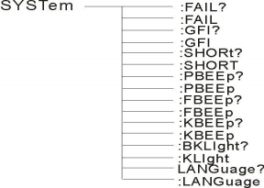
8.4.4SYSTEM Function Command Set
Command tree

SYSTem ：PBEE/FBEE/KBEE
Set/query test pass/fail/button buzzer status
-format
Setting format: syst: pbee < on/off > or < 1/0 >
Query format: SYST ：PBEE?
-data: < ON/OFF >
Data type: character
Data range: 0 (OFF) ,1 (ON)
Example:
Set BEEP to 1.
Setup command: SYST:BEEP 1
-return information
Query command: SYST:BEEP? , return value: buzzer status, such as 1.
SYSTem ：REset restores all default states.
-format:
Set format: SYST ：RES
8.4.5 MMEM subsystem command set
MMEM ：SAVE Saves the current file to the file number.
-format:
Set format: MMEM：SAVE < file name >
-data < file name >
Data type: string

MMEM LOAD exports the file specified by the file number to the current
-format:
Set the format: MMEM：LOAD < file name >
-data < file name >
Data type: string

8.4.6 FETCH subsystem command set
FETCH is used to obtain the measurement results of the instrument.
-format:
Set the format: FETCh：AUTO
Query format: FETCh:AUTO?
-data < ON/OFF>or <1/0 >
Data type: character
Data range: 0 (OFF), 1 (ON)
-example:
Automatically return the test data to ON.
Command: FETCh：AUTO ON or fetch: auto 1.

-return information
Query command: FETCh? , returns the current measurement result of the instrument.
Command syntax: FETCh?
After receiving this command, the instrument will automatically send out the test results until the test is over.
Return format:
Steps: test items: test current (a) test resistance (mω) sorting results.
1. The separator between steps and test items, test items and data is (:).
2. The separator between test data is (,) and the separator between different unit data is (; )
3. The separator between steps is (:+space), and the data terminator is uyly (0X0A). Note: 1. All data are in integer or floating-point format and ASCII strings.
2. The data unit is the same as FCUN set instruction set by default. The test results are:
STEP1: I :30A, test resistance 100mΩ, result PASS.
Return data format:
STEP1I :30,100,PASS； (SPACE)

8.4.7 Other control command sets
*IDN query instrument model, version information
The query returns: < manufacturer >, < model >, < firmware > < nl end >
Here: < manufacturer > gives the name of the manufacturer (i.e. ReK).

<model>
<firmware>

Give the machine model (such as RK9970).
Give the software version number (such as Version 1.0.0).

For example: "*IDN?"

-return information
Query command: FETCh? , returns the current measurement result of the instrument.
Command syntax: FETCh?
After receiving this command, the instrument will automatically send out the test results until the test is over.
Return format:
Steps: test items: test current (a) test resistance (mω) sorting results.
1. The separator between steps and test items, test items and data is (:).
2. The separator between test data is (,) and the separator between different unit data is (; )
3. The separator between steps is (:+space), and the data terminator is uyly (0X0A). Note: 1. All data are in integer or floating-point format and ASCII strings.
2. The data unit is the same as FCUN set instruction set by default. The test results are:
STEP1: I :30A, test resistance 100mΩ, result PASS.
Return data format:
STEP1I :30,100,PASS； (SPACE)
8.4.8 Other control command sets
*IDN query instrument model, version information
The query returns: < manufacturer >, < model >, < firmware > < nl end >
Here: < manufacturer > gives the name of the manufacturer (i.e. ReK).

<model>
<firmware>

Give the machine model (such as RK9970).
Give the software version number (such as Version 1.0.0).

For example: "*IDN?"

Chapter 9

9.1 Daily maintenance
9.1.1 The use environment of the tester should be well ventilated, dry and free from dust and electromagnetic interference.
9.1.2 If the tester is not used for a long time, it should be powered on regularly, usually once a month, and the power-on time should be less than 30 minutes.
9.1.3 After the tester works for a long time, such as about 8 hours, it should be turned off for more than 10 minutes to keep the tester in good working condition.
9.1.4 The tester may have poor contact or short circuit after long-term use, so it should be overhauled regularly.

9.2 Simple fault handling

Fault phenomenon | processing method
After the boot, there is no display button and no response. | Please check whether the power supply is normal and whether the fuse is blown. If it is blown, please  Replace fuse
After start-up, the test light is off but there is current output. | Test light is broken.
After starting, the test lamp does not flash and there is no current output. | The start button is not in good contact
After starting, there is no current or resistance display. | Please check whether the test line is open, the tested object is not in good contact or is damaged.  The measured object has been opened.
After the test fails, the unqualified light does not light up. | The unqualified lamp is broken.

If the fault cannot be eliminated in time, please contact our company or distributor as soon as possible, and we will provide you with services in time.

9.3 Instructions for upgrading instrument system software
9.3.1 Connect the USB interface on the back panel of the instrument to the computer, the power resource manager displays the U disk, copy the upgrade file to the instrument target disk, and restart the instrument to complete the system software upgrade. If you encounter technical problems in upgrading, please contact our company in time.
9.3.2 Press and hold the STOP+START key to restart the power supply, clear the data error caused by version change, and restore the setting data to the default factory setting.

Chapter 10 Warranties and Accessories

10.1 Warranty
If the user purchases instruments from our company, it shall be counted from the delivery date of our company, and if the user purchases instruments from the distribution department, it shall be counted from the delivery date of the distribution unit, and the mainframe shall be guaranteed for one year. The warranty card of the instrument should be presented when the warranty is issued. The company provides lifelong maintenance service for all outgoing instruments. During the warranty period, if the instrument is damaged due to improper operation by the user, the maintenance cost shall be borne by the user.

10.2 Accessories

1、Power cord 1PCS
2、Power cord components(RK00063) 1PCS
3、The RS232 cable 1PCS
4、RS232 turn USB drive disc 1PCS
5、RS232转USB 1PCS
6、RS232 turns to USB 1PCS
7、Manual/modbus test tool (U disk) 1PCS
8、certificate 1PCS
9、calibration certificate 1PCS
10、P-wire 3PCS
11、High pressure test line 1PCS
12、High pressure rod 1PCS
13、Quick operation guide 1PCS

After receiving the instrument, the user should unpack and check the above contents. If there is a shortage, please contact our company or distributor.

Instructions for user manual:
The company reserves the right to change the specifications of the user manual without prior notice.
With the improvement of the tester and the upgrade of software and hardware, the user manual will be constantly updated and improved. Please pay attention to the version of the tester and instructions.
If there is anything unknown in the manual, please contact us directly. Merrick's products are protected by China patents that have been approved and are under examination.

Use the browser to scan.
Pay attention to the official website of Shenzhen Meiruike Electronic Technology Co., Ltd. and experience more benefits and services.

