R
MEIRUIKE INSTRUMENT
Rek

Manua l

R K 2 6 7 5 W T
Three-phase passive Leakage current tester

Shenzhen Meiruike Electronic Technology Co.,Ltd

Manual

R K 2 6 7 5 W T
Three-phase passive Leakage current tester

The maximum current of per phase for 20A,the highest voltage of per phase for 450V.

* Any incorrect operation may cause death.
* Please read the second chapter"the use of precautions"before using the tester.
* The operating instruction should be placed next to the operator so that you can read it when you need it.

Instructions for use：

* Please read and understand the content described in the instructions

carefully before operating tester. After reading,please put the manual

near to operator for reading when needed. When the tester was carried

from a workplace to another place.Please carry the instructions with

the instrument to prevent loss.
* If it is found that the page is missing or the Instructions is contaminated.Please contact the dealer of the Meiruike for purchase immediately.
* With the improvement of the function of the instrument, upgrade of the software.The instructions will also continue to be improved,upgraded.
RK2675WT Three-phase passive Leakage current tester manual Ver:1.0 2016.12

In order to ensure safety, please note.

* In the testing process,the operator should not touch the location or area of the following;otherwise it will cause the occurrence of electric shock accident.
（1）voltage output port of test instrument;
（2）The test line connecting with the tester;
（3）Tested product;
（4）Any object that is connected to the output port of the tester.

* In order to prevent the accident of electric shock,please follow the steps below：
（1）In order to prevent the occurrence of electric shock accident,before using the tester, please put on the insulating rubber gloves and then work on the tester;
（2）Grounding connect safely and reliablely:There is a grounding terminal on the rear faceplate of this series of tester,please connect this terminal to the ground.It is likely to cause the electric shock as long as any human contact the shell.So it must ensure the terminal connectted with earth reliablely.

* The following situation is very dangerous:
（1）Don’t touch the tester and tested object during testing;
（2）RK2675WT is a passive leakage tester,need to equipped with voltage regulator and isolation transformer, to ensure that connecting in the power-off state.

CONTENTS
Unpacking and Installation of Tester 5
1.1 Receiving instrument examination 6
1.2 Unpacking inspection of instrument 6
1.3 Packing box and packing material 6
1.4 Safety rules for the use of instruments 6
1.5 Operator requirements 7
1.6 Check voltage of power supply 7
1.7 Check and replace the fuse 7
1.8 Grounding connection 8
Operating considerations 9
2.1 Forbidden operation 10
2.2 Emergency handling 10
2.3 Preventive measures in the testing process 10
Description of faceplate 11
3.1 Description of front faceplate 12
3.2 Description of rear faceplate 14
Summary of instrument function 15
4.1 Summary 15
4.2 Introduction of instrument function 15
Technical Specifications 16
5.1 Technical parameter 16
Setting of instrument parameter 17
6.1 Presetting of test time 18
6.2 Presetting of AC current alarm value 18
6.3 Output voltage regulation 18
Instrument test function 19
7.1 Electrical principle diagram 20
7.2 Operation method 21
Accessories and warranty 22
8.1 Accessories 22
8.2 Warranty 22

1

Unpacking and Installation of Tester

This chapter describes the basic condition of the test and installation of the tester after user received it.

1.1 Receiving instrument examination
After you receive the test instrument of the Meiruike instrument, according to the following steps to check:
1.1.1 Whether the packing box of instrument is intact;if damaged,we recommend that you do not carry out of the box,and connect with the Meiruike company or the distributor of Meiruike.
1.1.2 If the packing box of instrument is well, please check whether the type of the instrument you ordered and the type on the packing box is consistent,if no,please connect with Meiruike company or the distributor of Meiruike.

If after 1.1.1 and 1.1.2 examination,there are no problem,you can check out of the box of the instrument.

1.2 Unpacking inspection of instrument
1.2.1 Please check whether the attachment and the following list in the package you ordered is consistent.The accessories in the RK2675WT packing box are as follows:one power line.

1.3 Packing box and packing material
Please keep the original packing material in order to use it in the transportation.

1.4 Safety rules for the use of instruments
When using the instrument,please follow the safety rules:

1.4.1 Don’t use test equipment in flammable air.
In order to prevent theexplosion or burning accident occurr,do not use the tester in the presence of alcohol,thinner or other combustible materials,and do not use the instrument in the air containing flammable gases.

1.4.2 Don’t use the test instrument in the area of high temperature or direct sunlight.
The components used in the instrument are precision parts,which should be avoided used in the high temperature or direct sunlight place,it will accelerate the aging of the instrument,shorten the life of the tester,it is also possible to damage the tester.
Using temperature range of instrument:0ºC~+40ºC;
Storage temperature range of instrument:-20ºC~+70ºC；
1.4.3 Don't use tester in a high humidity environment.
Don't put the instrument on the boiler,kettle,humidifier or water in high humidity environment.Congealed droplet may cause internal short circuit and damage the tester, seriously may cause fire.If the environment humidity of storage instrument exceeds specified below,the test must be dry completely before use.
Using humidity range:20%～80%RH
Storage humidity range:less than 90%RH

1.4.4 Don’t use the tester in a dusty environment
A dusty environment may cause a short circuit in the instrument to cause a fire.

1.4.5 Don’t put the tester on the inclined surface or use the tester in the shaking of the place
Instruments placed on a sloping or shaking surface will make the tester fall off easily.

1.4.6 Don’t use the tester in the sensitive test equipment or beside the receiving equipment.
If used the tester beside these devices,these devices may be interfered by the tester;in order to reduce the interference of these devices,so that these devices should be away from the tester.

1.4.7 The input power of the tester must have a separate switch control
The input power of the tester must have a separate switch control,once the emergency situation occured should be cut off the power switch to deal with the accident immediately.

1.5 Operator requirements
The output voltage of the tester is sufficient to cause death,so it is necessary to be qualified personnel to operate the test instrument.

1.5.1 Personnel qualification
It must be operated by a skilled person to understand the basic concepts of voltage, current and resistance;the operator must know that during the test,the voltage is output from the voltage output port of tester,through the tested object,inflow the tester by the connecting line of current return port;it will get an electric shock if you touch any thing with the voltage.

1.5.2 Safety rules
Operators must undergo special training,and understand all kinds of safety rules and safety regulations,read the instructions carefully before operating the tester.

1.5.3 Regulations of dress
Operatiors should not wear clothes with metal decorative or wear metal accessories, such as watches and so on.

1.6 Check voltage of power supply

1.6.1 Switching input supply voltage of instrument
This instrument use the 220V AC±10% 50Hz±2Hz single-phase power supply,before opening the power switch on front faceplate of instrument,please ensure that the power supply voltage and fuse is consistent with the voltage of the instrument faceplate which selected by switch.

Warning:in order to prevent failure or damage to the tester,please use the test instrument in the specified voltage range.

1.7 Check and replace the fuse

Warning：
* In order to avoid the accident of electric shock, before the replacement of the fuse, please turn off the power switch and unplug the power plug.
* Make sure that the fuse used is in accordance with the shape, size and characteristics specified in the specification of the tester.Otherwise it may damage the tester.

1.7.1 Fuse specifications

Type | Input voltage range | Frequency range | Fuse specifications
RK2675WT | 200V～240V | 47Hz～63Hz | 5A

1.7.2 Fuse replacement
When replacing the fuse,please follow these steps：
（1）Turn off the power switch on the front faceplate and pull out the power cord;
（2）Use a screwdriver to fix the fuse holder as shown below:

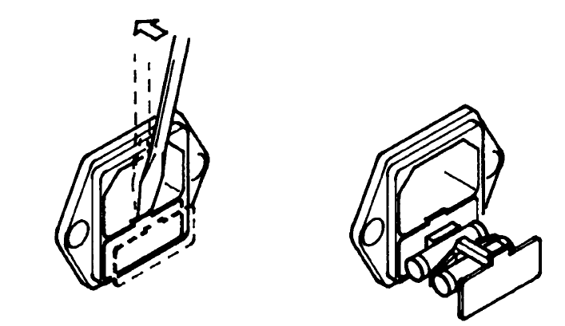
（3）Check fuse specifications and replace the fuse to the same specifications as the fuse listed in 1.7.1;
（4）Put the supporting frame back to the original position.

1.8 Grounding connection

Warning:* There may be an accident of electrical breakdown grounding connection in the wrong place or not connecting.

In order to ensure the safety,we must ensure that the instrument is grounding connection reliablely;There are two ways to ensure reliable grounding connection of the instrument,please select one to connect the instruments with ground the reliablely.
（1）Connect the power cord to a power socket of three-phase grounding;
（2）If the three-phase power supply socket is not grounded,there is a protective grounding terminal on the rear faceplate of the instrument,and connected it to the safety ground.

2

Operating considerations

This chapter describes the norms, measures and precautions must be followed by the operating instruments;please read the contents of this chapter in detail before using the instruments;

Warning:It is necessary to be very careful and follow the warnings given in this chapter,notes and other instructions when operate the instrument.

2.1 Forbidden operation

2.1.1 It is forbidden to continuous and rapid switching the power supply switch
Turn off the power switch on the front panel,if you want to re open the power switch, please ensure that turn off the power switch in time a few seconds or longer.Don’t switch the power switch repeat and frequently,if so,protection apparatus may not be appropriate to implement the protection function;Please do not turn off the power switch when the tester is testing the output voltage,unless it can be executed in an emergency.

2.2 Emergency handling
In case of emergency(the occurrence of an electric shock or the test object combustion),you must take the following actions;you can complete (1) or (2) first,but both must be completed.
（1）Closing the power switch of instrument;
（2）Unplug the power cable from the power socket.

2.3 Preventive measures in the testing process

2.3.1 Prevent electric shock proof with insulated gloves
In order to prevent the electric shock accident,please bring the rubber gloves with insulation and then engage in electrical related work before using this tester.

2.3.2 Connect the test line with the current measuring port
The test line is connected to the current measurement port,when working,you must check the test line whether is connected well,loose or fall off in any time,if you want to connect the tested object with the test line,please connect the test line to the current measuring port.

2.3.3 Replace the measured object
When a test object has been tested and replace another object,please confirm:
（1）The tester is in a "reset" state.
（2）The display digit of voltage display window don’t jitter at all.

2.3.4 Tester is in test condition
When the tester is in the test condition,the test line,the test object,the output port are all equipped with high pressure,please do not touch.

2.3.5 Stop testing
Please turn the power switch placed in the location of OFF when don’t use the tester any more,or you need to leave.

2.3.6 Comfirm after testing
Touch the wire,the measured object or voltage output port by hand at any time,please confirm that:
（1）The power switch is turned off and the display device isn’t bright;
（2）Turn off the external power supply.

3

Description of faceplate

This chapter describes components of the front faceplate and rear faceplate of the tester,please know all the functions on the instrument faceplate before operating the instrument.

3.1 Description of front faceplate

3.2 Description of rear faceplate

3.1 Description of front faceplate

3.1.1 Description of RK2675WT front faceplate

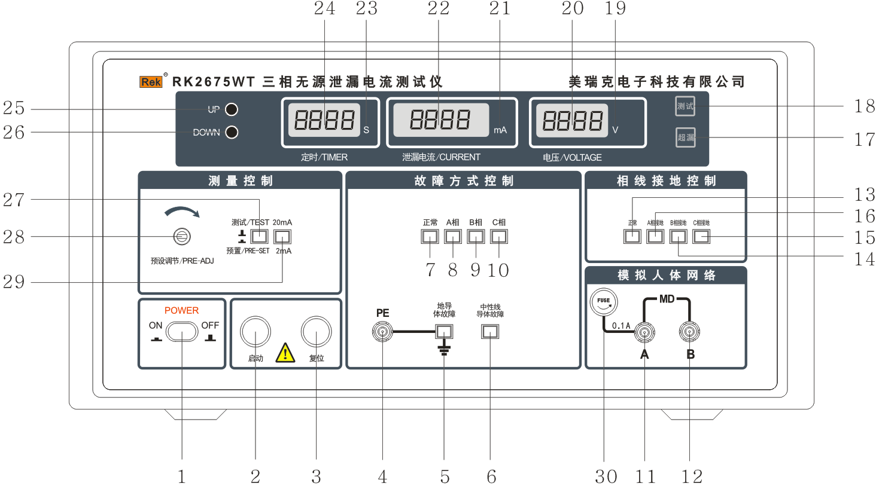

The front faceplate of RK2675WT

1、Power switch
Press for connecting(ON),pop-up for close(OFF).

2、START test button
In the reset and standby state,press this button to start the test.

3、STOP stop button
As the switch of the stop test.When test failure,the superleak lamp(17)light,the buzzer sound,press this button can stop the sound and light alarm,enter next measured state.
4、PE connecting terminal
5、Grounding conductor fault button
Press this button for PE connecting terminal grounding,pop-up for the PE which connecting the tested object didn’t grounding.(This function is useless for three phase leakage current test)

6、Neutral line system fault button
Press for N phase(zero line)output normally,pop-up for N phase(zero line)disconnect.(This function is useless for three phase leakage current test).
7、This button press for normal test
A phase,B phase,C phase output normally.

8、This button press for A phase fault
A phase output disconnect.

9、This button press for B phase fault
B phase output disconnect.

10、This button press for C phase fault
C phase output disconnect.
11、MDA
This terminal is current measuring input port,which is connected with the MD measuring port of the instrument.
12、MDB
This terminal is current measuring input port,which is connected with the MD measuring port of the instrument,this port is connected with the ground of the interior of instrument.
13、This button press for N phase(zero phase) grounding
Pop-up the 14、15、16 button,A,B,C phase can’t test the leakage current.
14、This button press for B phase grounding
B phase grounding,that is test B phase leakage current.
- This button press for C phase grounding
C phase grounding,that is test C phase leakage current.
- This button press for A phase grounding
A phase grounding,that is test A phase leakage current.
17、Super leakage indicator lamp for leakage current
This lamp light indicates that the leakage current is out of range.
18、Test status indicator lamp
This lamp light indicates that the instrument is in the test state.
- Voltage unit
- Voltage display window
- Current unit
- Current display window
- Time unit
- Time display window
- UP button
When setting the time,press this button,the time setting value will increases;
- DOWN button
When setting the time,press this button,the time setting value will decreases;
- Current preset adjusting potentiometer
Press 28,the display value of current display window is AC current alarm value;adjust the potentiometer clockwise,AC current alarm value increases;adjust the potentiometer counterclockwise, AC current alarm value decreases.
- Preset,test button,press this button for preset,pop-up for test
- 2mA/20mA switch button
This button is pressed for the 20mA file,pop-up for the 2mA file.
30、0.1A fuse,it can be replaced
If there isn’t leakage current display,check whether the fuse is burning.

3.2 Description of rear faceplate

3.2.1 Description of RK2675WT rear faceplate

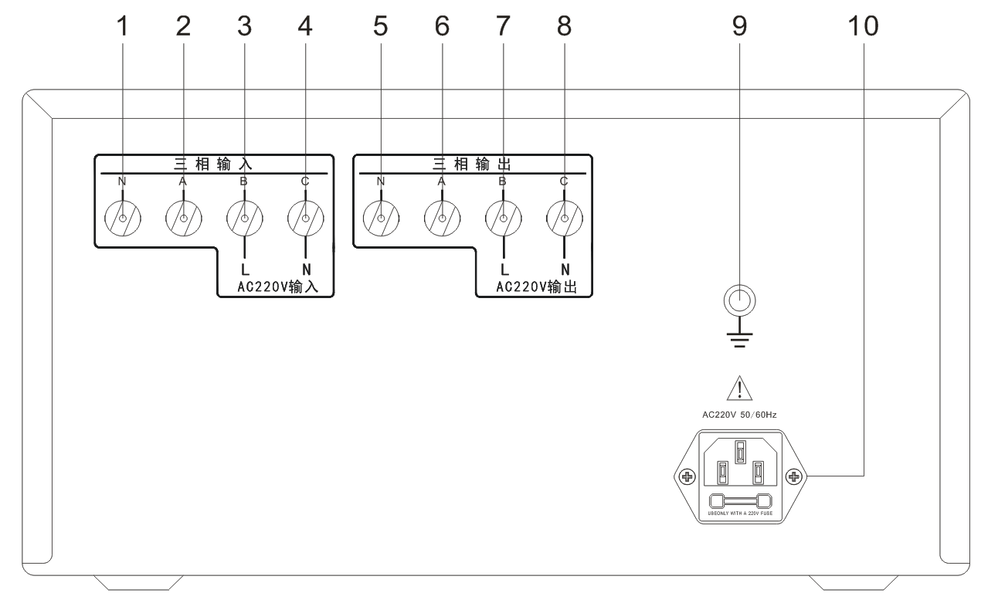

- The port is connected to the N phase of input isolation power supply
- The port is connected to the A phase of input isolation power supply
- The port is connected to the B phase of input isolation power supply（220V L phase）
- The port is connected to the C phase of input isolation power supply（220V N phase）
- This port is the power output port,connected to the N phase of the tested product.
- This port is the power output port,connected to the A phase of the tested product.
- This port is the power output port,connected to the B phase of the tested product.（220V L phase）
- This port is the power output port,connected to the C phase of the tested product（220V N phase）
- Protective grounding port
The protective grounding port should be connected to the protective ground reliably.Otherwise,the outer shell may be filled with high voltage,which can cause the electric shock accident.
- Input power supply socket
Three-core power supply socket,it built-in the fuse;please refer to 1.7. about the selection of the input voltage and the replacement of the fuse.

4

Summary of instrument function

In this chapter, the function of the tester is described in detail. Please read the contents of this chapter before operating the tester.

4.1 Summary

RK2675WT leakage tester is developed,produce according to the national standard GB4706.1-2005,(IEC60335-1),the first part of household and similar electrical appliances security:(General requirements).Use for testing safety leakage current measurement of three-phase household and similar electrical appliances.
RK2675WT three-phase leakage current tester adopt true RMS test circuit,it can convert all kinds of frequency complex wave AC current into the effective value by calculation,and can test a variety of switch combination as the standard required.It is an essential safety testing instrument for household appliance manufacturers and testing departments.

4.2 Introduction of instrument function

4.2.1 With open-phase protection timing control,if the time’s up,the power supply of each phase will be cut off automatically.To prevent the open-phase work of the tested object for long time.

4.2.2 The combination of open-phase switch is interlocked,and only one phase power supply of tested object can be disconnected.
4.2.3 The MD measuring port has a short circuit protection switch to protect the impact of the overcurrent signal on the measuring device.
4.2.4 Each phase switch of the instrument can withstand current below 20A.

5

Technical parameter

The technical parameters of various tester are introduced in detail in this chapter.

5.1 Technical parameter

Type | RK2675WT
Leakage test voltage | AC 50~450V±（5%+1% Full scale value）
Leakage current test range | AC 0.2~2mA/2mA~20mA two files ±（5%+1.5% Full scale value）
Leakage current alarm value | AC 0.1mA~2mA/2mA~20mA±（5%+1.5% Full scale value）  (Can be setted alarm value continuous arbitrarily）
Time range | 0.1~999s,Continuous setting and manual ± 1%
Working conditions | Ambient temperature:0 ~ 40℃
Relative humidity | Not more than 75%
Atmospheric pressure | 101、25kPa
Volume | 443mm*390mm*200mm
Weight | 10.5kg
Power Supply | 220v ± 10% 50Hz ± 2Hz
Accessory | A test manual,a warranty card,a power cord
Standard | GB4706.1-2005 GB4793.1-2007

6

Setting of instrument parameter

The parameter setting of the tester are introduced in detail in this chapter.

6.1 Presetting of test time

6.2 Presetting of test current

6.2 Presetting of test voltage

6.1 Parameter setting of RK2675WT

6.1.1 Presetting of test time
6.1.1.1 The preset conditions of test time
The tester must be in a reset state,that is the tester can’t be in a state of test and alarm.

6.1.1.2 Preset method
（1） Time increases
In the front faceplate has a UP button,click on this button,the time preset value plus 1;if you hold this key,preset time continuous add 1,when added to a certain value,preset time continuous add 10;until 999s.

（2） Time decreases
In the front faceplate has a DOWN button,click on this button,the time preset value minus 1;if you hold this key,preset time continuous minus 1,when reduced to a certain value,preset time continuous minus 10;until 0.0s.

6.1.2 Presetting of AC current alarm value
6.1.2.1 Preset method
Press the "test/preset" button,the current display window shows the current preset value;use the debug driver clockwise to adjust preset adjust potentiometer of current,preset current increased;adjust counterclockwise,preset current is reduced;set the alarm value of current to the required value of the test,pop up the "test / preset" button.

6.1.3 Adjustment of output voltage
This is the passive tester,which needs to by an external three phase adjustable isolated power supply by yourself.
When the voltage regulator knob is in the 0 place,even if start the tester,it has no high voltage output;after starting the tester,Start adjustable isolated power supply,the output voltage increased,and reach the voltage required for testing.

7

Instrument test function

In this chapter, we introduce the testing function of all kinds of testing instruments.

7.1 Electrical principle diagram

7.2 Schematic diagram of test method

7.3 Operation method

7.1 Electrical principle diagram

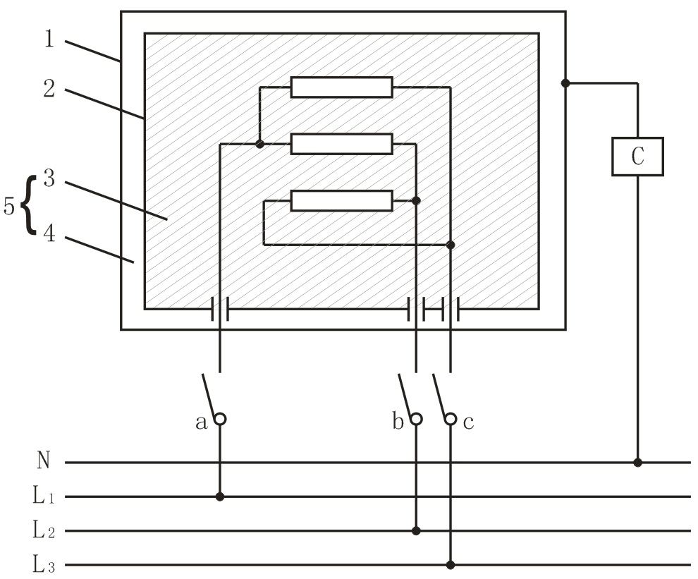

Connection and power supply
L1、L2、L3、N with neutral line and power supply
Key word
C：GB/T 12113（idt IEC 60990)Figure 4 circuit;
1：Easy touch part;
2：Difficult touch metal parts;
3：Basic insulation;
4：Additional insulation;
5：Double insulation.
Figure 3 Leakage current measuring circuit diagram of class II appliances which three-phase connecting in the working temperature

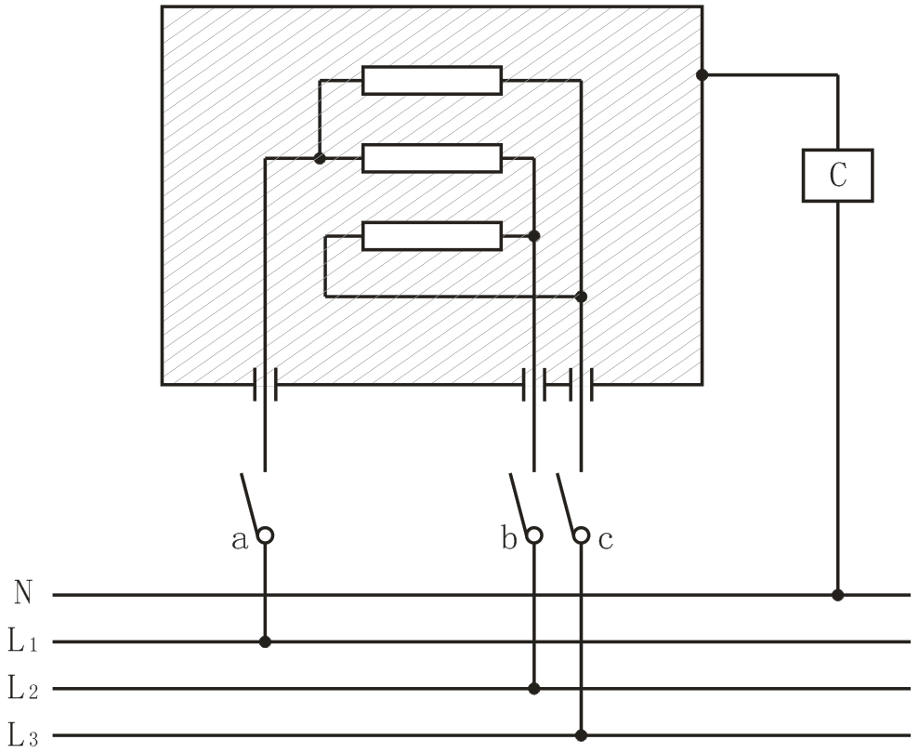

Connection and power supply
L1、L2、L3、N with neutral line and power supply
Key word
C：GB/T 12113（idt IEC 60990)Figure 4 circuit;
Figure 4 Leakage current measuring circuit diagram of non-class II appliances which three-phase connecting in the working temperature

7.2 Operation method

7.2.1 Open the power switch of instrument,time,current,voltage display window light.

7.2.2 Test time presetting

7.2.2.1 Test time preset conditions：The tester must be in a reset state,that is the tester can’t be in a state of test and alarm.
7.2.2.2 Preset method
（1）Time increases:
In the front faceplate has a UP button,click on this button,the time preset value plus 1;if you hold this key,preset time continuous add 1,when added to a certain value,preset time continuous add 10;until 999s.
（2）Time decreases:In the front faceplate has a DOWN button,click on this button,the time preset value minus 1;if you hold this key,preset time continuous minus 1,when reduced to a certain value,preset time continuous minus 10;until 0.0s.

7.2.3 Presetting of AC current alarm value
7.2.3.1 The preset conditions of AC current alarm value:Select the corresponding files,this series tester with 2mA, 20mA two files.
7.2.3.2 Preset method：Press the "test/preset" button,the current display window shows the current preset value;use the debug driver clockwise to adjust preset adjust potentiometer of current,preset current increased;adjust counterclockwise,preset current is reduced;set the alarm value of current to the required value of the test,pop up the "test / preset" button.

7.2.4 According to the requirement to select AC leakage current test, select the appropriate current range.

7.2.5 The measured power supply should be connected to the output port on the rear faceplate of instrument.

7.2.6 The input power supply is connected to the input port on the rear faceplate of the instrument.

7.2.7 According to the test method schematic diagram of the corresponding test items connect into the test device (MD),there are 4 states when testing,there is a normal state,disconnect the A phase, disconnect the B phase,disconnect the C phase.

7.2.8 Check the above steps carefully,if correct,turn on the input power supply switch and confirm, adjust the experimental voltage value.

7.2.9 Press the "start" button,the "TEST" indicator lamp lights,and read the indicated value of the ammeter on the measuring device.

7.2.10 If you need to cancel the test or appear the abnormal situation,you can press the "reset" button,interrupt the test process,"TEST" indicator lamp light off,and cut off the power input on the tested object.
Remark:The test process should not be too long,so as not to damage the tested object.

8

Accessories and warranty

8.1 Accessories
1、Power cord 1 root
2、Instruction manual 1 copy
3、Quality assurance 1 copy
4、Product qualification certificate 1 copy
After the user receives the instrument,should check the contents of the box,if there is a shortage,please contact with our company or distribution unit.

8.2 Warranty
8.2.1 Warranty Period (1)、The use units purchase instrument from the company,calculate since the date of shipment of the company,purchase from the dstribution department,calculate since the date of shipment of the distribution unit,the whole machine warranty period of 12 months.
(2)、The warranty period of perishable products such as accessories is 6 months.
8.2.2 Warranty
It should issue the instrument warranty card when repair.Our company provide the lifelong maintenance services for all external equipment.In the warranty period,due to the improper operation of the user and damage to the instrument,the maintenance costs will assumed by the user.
Meiruike company reserved all rights
The products of Meiruike company have been approved and are being examined and approved by the Chinese patent protection.
The information provided in this instructions replaces all the information that is published in the past.Our company reserves the right of change the specifications and prices.And won’t give any notice further.

Address:Floor 5,Block 1,Qingchangtai Industrial Zone,No 365,Silian Road,Henggang Town,Longgang District,Shenzhen
Technology department:(0)13924600220
Tel:0755-83987768
Fax:0755-82736668
Http/www.chinarek.com
Free service hotline:400-876-9388

