RK9830N Three Phase
Ac Parameter Tester
CONTENTS
One、Abstract 1
Two、Prompt and Warning 4
Three、Introduction of The Front Faceplate layout 6
Four、Introduction of The Rear Faceplate 7
Five、Introduction of The Wiring 9
One、Wiring Diagram of Single-phase Load 9
Two、Wiring Diagram of Three phase Three line load 11
Three、Wiring Diagram of Three phase Four line load 12
Six、Introduction of The Display Screen and Keypad 13
The Display Screen 15
The Indicator Light 19
Introduction of The Keypad 20
Seven、Instructions of the Operation and Setting of the Function
22
The Electrical Work 22
Switch Display Parameters and Reset Energy Value 23
Data maintain and unlocked 23
Switch the Connection Mode（3L/4L） 24
Eight、The Testing Software and Communication Protocol
25
Nine、FAQ 26
Warranty Card 29

One、 Abstract
Welcome to use Three Phase Ac Parameter Testerthe produced by Meiruike Electronic Technology Co.,Ltd.After unpacking, please check whether the items in the carton is the same as the table below first,confirm the product and attachments is correct.If there are any discrepant,please contact our company or retailer.
- A RK9830N Three Phase Ac Parameter Testerthe
- A Three core power cord
- A Specification and a Certificate of Inspection
- A RS232 Communication Cable and a Light Disk(Optional Matching)
RK9830N Three Phase Ac Parameter Testerthe（Sometimes named tester or instrument for short)is used for measuring the common parameters of three-phase alternating current such as voltage,current,power,power factor,work(energy) and frequency.This specification is about the function of the instrument,Settings,connection mode and method of the operation,and the processing method of failure occurs.
RK9830N three-phase ac parameter tester has the following advantages：
- High measurement precision,wide range,high speed.
- Can display the voltage,current and power of certain phase respectively.May also display the voltage, current and power of three-phase at the same time,It is flexible operation.
- Has the work (energy) display function(energy value has autosave function when outage)
- Has communication function,can display all parameters of the three phase through the PC screen at the same time,it will more complete,intuitive.
- Has power off memory function,can save settings and data before power off.
- Has the data remained functions,makes it is more convenient to observe and record.
- Has energy resetted function,it is convenient to meter energy.
- Small and exquisite appearance,easy to carry and operation.
Two form below is about the performance of the tester and error data,for reference to choose.
Form 1：Essential Parameter
Name | Voltage | Electric Current
Input Circuit Type | floating input | floating input
range ability | 0－600V | 0－40A
The maximum continuous input | 800V | 45A
The maximum instantaneous input | 1600V | 60A
Communicating function | Interface of RS232（DB9）
Measuring speed | 2 t/s
Testing frequency | 45Hz － 65Hz（The frequency tester can be detected）
Work environment | 0℃ ——40℃ 20RH —— 85RH
Insulate resistance and voltage withstand | Terminals and the shell：>5MΩ，>1.5KV（simple alternating current）
working power supply | AC 220V ±20%，50/60Hz，<10W

Form 2：The measuring precision and error
Parameter | Range | Error | Resolution displaying
voltage | 0－600V | ±（0.4%（reading  ）+ 0.1%（Range）+ 1 digital） | 0.1V
electric current | 0－40A | ±（0.4%（reading  ）+ 0.1%（Range）+ 1 digital） | 1mA
Power(single phase) | 0－24KW(Record) | ±（0.4%（reading  ）+ 0.1%（Range）+ 1 digital） | 1mW
Power (three-phase) | 0-41.5KW(Record) | ±（0.4%（reading  ）+ 0.1%（Range）+ 1 digital） | 1mW
Work | 0－1000KWh | ±（0.4%（reading  ）+ 0.1%（Range）+ 1 digital） | 0.001KWh
PF | －1 — +1 | ±0.02 | 0.01
Frequency | 45Hz —— 65Hz | 0.05Hz | 0.01Hz

Record：
The data showed on the instrument is the active power,it is apparent power gived here, the data is the voltage multiply by the current namely.In the case of lower power factor,although active power is smaller,but apparent power may have reached or exceed the limit value.
The total power of the three phase is that the three phase current phase difference reach 120°.Voltage is calculated at 600V, if the power source is 380V,the maximum allowable measuring power should be scaled down.

Two、 Prompt and Warning
In order to use the instrument safely,please be sure to comply with the following safety precautions in the operation, otherwise,it may cause the instrument damage,even personal injury.If accident happened since implement without in accordance with announcements,our company will not undertake any responsibility.
Warning：
- The range of instrument power supply is 220V±20%,the frequency is 50Hz±10%,please check whether the power supply voltage is consistent with them before switch on the power supply.
- Don't use this equipment for life supporting system or other equipment or environment of security requirement.
- Guaranteeing the instrument and equipment waited for test are reliable grounding protection.
- To ensure that the input voltage and current shall not exceed the range of instrument afford.
- Do not wiring when the instrument power on(including switching in or wipe off)
- Ensure the measuring the scene clean,no other sundries.
- To ensure that the instrument has good ventilation radiating environment.
- Something common rules are not included,but it is suitable for all instruments.

Prompt
- There are no part can be debugging in this instrument for operator,please don’t unauthorized changes,including hardware and software.
- If there are any problems,please refer to the back of the “common problem”,if it is not able to resolve,please consult our after-sales personnel,if necessary,the instrument must be sent to the maintenance department of our company for testing,please don't repair by yourself.

Warranty
Our company promises that give one year warranty since product sold.If any of the following circumstances,we do not assume warranted responsibility,but we can provide the maintenance paid by yourself:
- The improper operating of product by operator.
- Unauthorized modification of the product on hardware or software.
- Using in unsuitable environment,such as too much acid, alkali,salt composition in the air,high temperature、 humidity,etc.
- The situation mentioned in warning and prompt,but not listed here.

If the contents of this manual change,we won’t prior notice.

Three、 Introduction of The Front Faceplate layout

图1 前面板
显示窗口
电源按钮
指示灯区
按键区
In the upper portion of the front faceplate is the display window,the window is divided into five display area,the four areas above is A、B、C and D respectively,corresponding parameter is used for display the alternating current;Below is indicator light area,used for display the working state of the instrument.
In the bottom of the front faceplate is a keypad area,the power button for instrument on the left,on the right side of the 10 key,is used for switching function or change the settings.

Four、Introduction of The Rear Faceplate

图2 后面板
零线
火线
输出接线柱
输入接线柱
保险丝
电源插座
RS232通讯端口

图2 后面板
零线
火线
输出接线柱
输入接线柱
保险丝
电源插座
RS232通讯端口

图2 后面板
保险丝
电源插座
RS232通讯端口
输出
输入
公共
In the rear faceplate of instrument,there are three group a total of nine binding post on the left(Ⅰ,Ⅱgroups and Ⅲ group,each group has three) ,used for connect the power supply and load to be tested.Each group can be composed of a measuring mechanism,used for measurement of single-phase electric appliance.
At the nine binding post,the following three is the common port for power input of measuring mechanism and connected load.It usual connecting midcourt line(also called a zero line),and three in the center are use to connect power supply wait for test (connected by firing line generally),the three above are used to connect the load( input end for connected load of firing line),the definite connection mode shows in the next chapter.

Communication interface is on upper right,if you need the remote communication,the connector of RS232 DB9(instrument for the main port)can connect to the port,and then link to the other controller,in order to the remote observation,record data,or operating equipment.
The bottom right of rear interface is the power socket of instrument,it is used to provide instrument with working power supply,the specifications of power supply is AC 220V ±20%，50/60Hz.
On the lower end of the socket is the location of the power fuses and backup fuse,if the fuse is damaged,you can use something pry-out the plastic parts with the pattern of fuse, replace the specified specifications of the fuse(capacity of 0.5 A).

Five、Introduction of The Wiring
According to the different of power input and loading types,there are three connecting mode of tester,is the single-phase load,three phase three line and three phase four wire namely.Listing the description respectively.

One、Schematic diagram of wiring for single-phase load
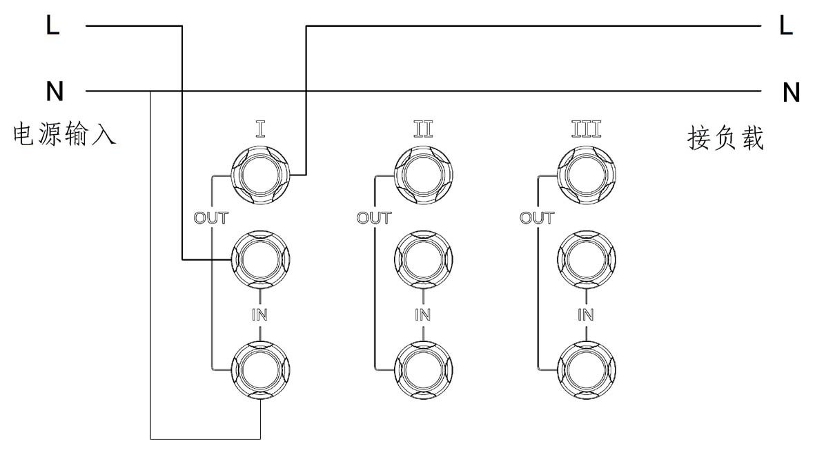
Picture 3 Schematic diagram of wiring for single-phase load testing
Picture 3 is the schematic diagram of wiring for single-phase load testing,according to the way of diagram, using Ⅱ groups and Ⅲ groups can also obtain communication parameters,but the internal frequency detected circuit is connected in the voltage input port of group I,therefore, measuring according to other two connection methods of wiring, there will be no frequency data showed.
L line is for wire in this diagram,N line is the middle line,in the middle line of circuit,the thin indicated as it didn’t through heavy current in the process of measuring.And just use the average thickness wire,the other parts need to choose which according to the load size,also express in the same way in the back of the picture,no longer repeat.
If measure instrument of single-phase load,should be set to three phase four wire connection mode,the method of operation as shown in chapter 7.

Two、Schematic diagram of three phase three line load
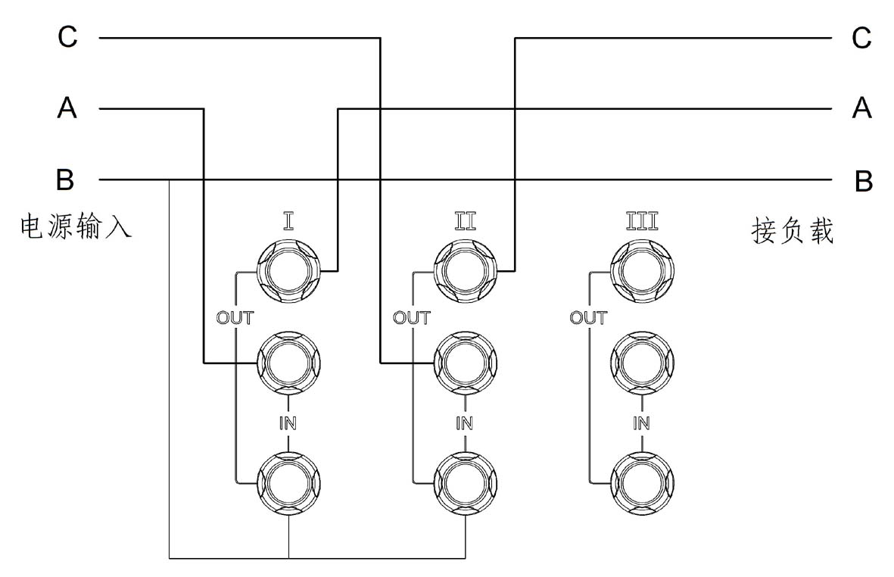
Picture 4 Schematic diagram of wiring for three phase three line load testing
Picture 4 is the connection mode of measure for three phase three line load,it is suitable for the three-phase power supply without center line,or didn’t derivate the three-phase load line,please wiring according to the phase sequence of regulations in the diagram.

Three、Schematic diagram of three phase four line load
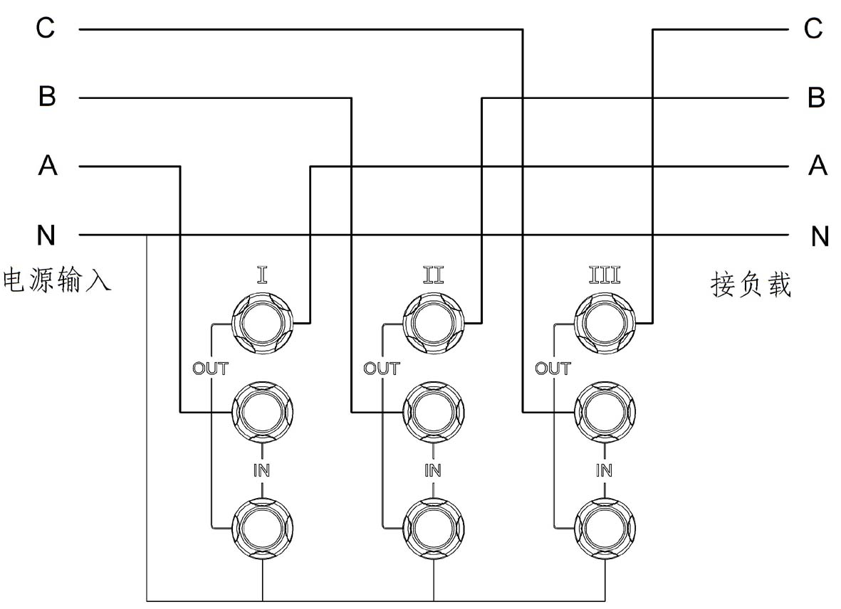
Picture 5 Schematic diagram of wiring for three phase four line load testing

Picture 5 is the connection mode of measure for three phase four wire load(there is the center line in power supply and load),the center line(null line,labeled “N”in the picture) connected to load the null line,at the same time,draw forth a wire,connected to the public terminal of binding post for three phase detection.
Three wire switching in the input end of the three-phase terminal,output end connected to the wire input end of the three-phase load.

Six、Introduction of The Display Screen and Keypad
Display screen is divided into five areas,is A,B,C,D and indicator light area namely,the keypad area is at the bottom of the screen.
Display screen
A,B,C,D this four areas have each four pieces of LED digital screen,each area can display four digits,among them,A,B,C is used to display voltage,current,and power data,D area is used to display the power factor,frequency and energy (power)data.

One、Display area of A、B、C
According to the setting of the service by user,the instrument can be set to three phase three line and three phase four line this two work modes,To cope with the different connection mode of the power and load.Since the screen display content is limited,therefore,it cannot show all the data at the same time,and need to set different display status,it can display the different parameters depending on the different display status,As follows:
- CH_A：Display the parameter of A phase or AB line
- CH_B：Display the parameter of B phase or CB line
- CH_C：Display the parameter of C phase
- ALL_V：Display the three-phase voltage in A,B,C three display area at the same time.
- ALL_A：Display the three-phase electric current in A,B,C three display area at the same time.
- ALL_W：Display the three-phase power in A,B,C three display area at the same time.
- AVER：A area display three-phase average voltage (or two lines),B area shows three phase(or two line), average current,C area display appulsive power.

In order to make it easier to understand in different working mode(three phase three wire or three phase four wire), the content showed in A,B,C area when in different display status,the forms listed below for reference:
Form 3：The content showed in A,B,C area when three phase three wire loading.
Status | A area | B area | C area
CH_A | The voltage of AB line | The electric current of AB line | The power of AB line
CH_B | The voltage of CB line | The electric current of CB line | The power of CB line
CH_C | Do not use this group in the process of measurement circuit,the data showed is meaningless.
ALL_V | The voltage of AB line | The voltage of CB line | The data showed is meaningless.
ALL_A | The electric current of AB line | The electric current of CB line | The data showed is meaningless.
ALL_W | The power of AB line | The power of CB line | The data showed is meaningless.
AVER | （AB+CB）voltage/2 | （AB+CB）electric current/2 | Appulsive power

Form 4：The content of A,B,C area displaied when the three phase four wire loaded.
status | A area | B area | C area
CH_A | The voltage of A phase | The electric current of A phase | The power of A phase
CH_B | The voltage of B phase | The electric current of B phase | The power of B phase
CH_C | The voltage of C phase | The electric current of C phase | The power of C phase
ALL_V | The voltage of A phase | The voltage of B phase | The voltage of C phase
ALL_A | The electric current of A phase | The electric current of B phase | The electric current of C phase
ALL_W | The power of A phase | The power of B phase | The power of C phase
AVER | （A+B+C）voltage/3 | （A+B+C）electric current/3 | Appulsive power

Specific format displayed as shown below when data displaying:
A：voltage
The Ac voltage value displaied is the effective value,range for 0－600V,the format displayed is 0.0V to 600.0V.
If shows “OVER”,it means that the actual voltage is greater than the actual measuring range,shall be disconnected or reduce voltage circuit immediately,otherwise,it will damage the instrument if keep for a long time.
B：electric current
The Ac current value displaied is the effective value,according to the result of actual measurement,format displayed is:
0.00－9.999A Electric current is less than 10A。
10.00－99.99A Electric current is more than 10A。
If the parameters of electric current are shown as “-- -”,it means that the current measurement circuit is in the range during the period of transformation,the measured current value is unreliable;If shows “OVER”,it means that the actual current is greater than the measurable range,it shall be disconnected or reduce voltage circuit immediately, otherwise,it will damage the instrument if keep for a long time.
C： Power
The power of instrument displayed is the active power,when the power factor to 1,it is equal to the apparent power,voltage multiplied by the electric current namely;When the power factor to 1,active power is equal to the apparent power multiplied by the absolute value of power factor.
0.000－9.999W Power is less than 10W
10.00－99.99 Power is less than 100W
100.0－999.9 Power is less than 1000W
1000－9999 Power is less than 10KW
10.00－99.99 Power is greater than or equal to 10KW（character“K”illumed）
Attention：
If is shown as“-- -”,it means that the current measurement circuit is in the range during the period of transformation,the measured current value is unreliable;If shows “OVER”,it means that the actual current is greater than the measurable range,it shall be disconnected or reduce voltage circuit immediately, otherwise,it will damage the instrument if keep for a long time.
D：About AVER
“AVER”is the abbreviation of“average”,it showed the average,in the practical application and the condition of the display,the voltage and electric current displayed is the average of voltage and electric current for second-line(three phase three line)or three-phase(three phase four wire),the power displayed is the appulsive power.

二、Display area of D

According to the different Settings,D area can display the power factor、frequency and energy (work).Press the “FUNC”button can switch between the three kinds of display mode.
A：Power Factor
Power factor is the ratio of active power and apparent power.
The display format of the power factor as below:
－1 ― ―0.01 The power factor change from the negative of the minimum to the maximum.
0.00 － 1.00 The power factor change from zero to positive maximum.
Note 1：
If is shown as“-- -”,it means that the current measurement circuit is in the range during the period of transformation,or the voltage value is 0,or current value is 0,the measured power factor values are not reliable.
Note 2：
The total power factor displayed in the three phase three wire connection mode,the formula as following:
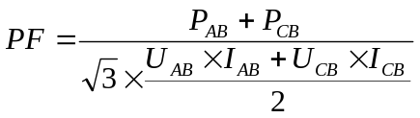

In the“CH_A”,“CH_B”and“CH_C”state,the A, B, C three-phase power factor displayed in three phase four wire connection mode respectively,according to power factor.The total power factor displayed in the“ALL_V”,“ALL_A”,“ALL_W”and“AVER”state,the formula as following:
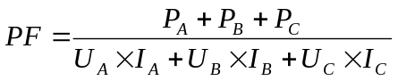

B： Frequency
Ac parameter tester can test the input ac power frequency,range for 45Hz to 65Hz.
The format of display:
45.00－65.00 it means that the frequency values of the measured power
C：Power (energy)
The format of energy displayed:
0.000－9.999 energy is less than 10KWh
10.00－99.99 energy is less than 100KWh
100.0－999.9 energy is less than 1000KWh
Attention:
The metering range of energy is 0 to 999.999999KWh,when it is greater than the maximum,it will measure from 0.Due to the limit of the display data bits(4 bits),can only show the top four effective data,the data behind cannot displayed,but it does not affect the measurement.
If you want to observe the complete data,you can connected to the PC to the instrument through RS232 data cables,and get more detailed data through the PC.

Indicator Light：
Indicator Light is divided into two parts,one is located in the rear of the parameters data displayed A,B,C,D area,is used to represent the project and the units of the current data display,such as V(voltage),A(electric current),W and KW (power).
For D area,the three indicator light in the rear of parameters indicating the significance of the current parameters respectively,such as: PH express the power factor KWh express the frequency,Hz express the energy.
There are a row of indicator light below the display window, according to the different function setting and operating state,provide the corresponding instructions with flashing light.Form 5 is the brief description of this indicator light:

Form 5：Description of indicator light
Indicator Light | Description
SAMPLE | Flashing express collecting the data,normal work
A | A, B, C area shows the parameters of theⅠphase (or AB line).
B | A, B, C area shows the parameters of the Ⅱ phase (or CB line).
C | A, B, C area shows the parameters of the Ⅲ phase
A B C light at the same time | A, B, C area shows the parameters of the three phase(or two line),can distinguish the current displayed specific meaning through “V”“A”and “W”indicator light of three area(or A,B two areas).
AVER | Showing the average voltage and average current and appulsive power.
3L | The current setting is the three phase three line works mode.
4L | The current setting is the three phase four line works mode.
HOLD | Flashing express in the “keep”displayed mode,the screen displayed data is no longer updated,it’s convenient for observing and records,but the measurement of the internal instrument is not stopped,energy accumulation is also in progress.

Description of keypad
There are 10 keypad in key areas,used for instrument operation,works mode translation or display status,and the specific meaning shown in the following table.
Form 6：Description of switches and keypad
 | Normal Condition
POWER | Switch on the 220V power source circuit when press the main power switch.
CH_A | Setting the parameters of theⅠphase(or AC line)displayed.
CH_B | Setting the parameters of theⅡphase(or BC line)displayed.
CH_C | Setting the parameters of theⅢ phase displayed.
HOLD | Lock or unlock the data displayed on screen.
FUNC | Short press to switch the content displayed on screen in section D,is the power factor,frequency and energy(work)respectively.In energy displayed state,long press the keypad(the time is more than 1 second),energy counter reset,and then start measuring.
ALL_V | Setting display three-phase voltage at the same time on A,B,C three areas.
ALL_A | Setting display three-phase current at the same time on A,B,C three areas.
ALL_W | Setting display three-phase power at the same time on A,B,C three areas.
AVER | Setting display the the average voltage of three-phase(or two line)in A area,the average current of three phase(or two line)in B area,the appulsive power in C area.
3L/4L | Switch the work mode of three phase three line or three phase four wire.

Seven、 Instructions of the Operation and Setting of the Function
This chapter explains how to use ac parameter tester correctly.

The Electrical Work
- Turning off the power supply of the instrument,insert three-core cable dispatching with instrument in the rear of the instrument power socket,and connect to the power adapter.
- Depending on the situation of the source and load, access the alternating current power supply and load to the the right terminal according to the instructions in chapter 5.
- Detect is correct,press the power button on the instrument,light up the full screen to check the screen quality,then display the instrument model is RK9830,and the version number in below.
- Connect the power supply of the equipment under test,instrument began to display the measured data.
- According to the key instructions in chapter 6,operate the right keypad in order to display the anticipated parameters data on the LCD screen.
- You can press “FUNC”if you need to look at the frequency value or the energy dissipations of the load, the contents showed in D area can switch between the data of power factor,frequency and energy.
There are data collecting chip in instrument internal, collecting the data of voltage and electric current uninterruptedly,over a period of time,it will operate the data collected,and get the effective value of voltage and electric current,and according to the magnitude of power and power factor value calculated.
When power instrument is outage,can record showing status and record the energy data automatically,after power on again, it can continue to show according to the state before outage,of course,energy data is restored,then accumulate on this basis
The method of switch the status of the display can be reference for an explanation of the keypad in the previous chapter.The instructions about other functional operation as following.
Switch Display Parameters and Reset Energy Value
It will show the options last shutdown on D area of the screen when the electricity on,,you can click the button “FUNC”to switch project displayed,power factor,frequency and energy respectively.
When D area in the display of energy,long pressing the “FUNC”key(the time is more than 1 second)can reset the energy, and then began to measure and cumulate.

Data maintain and unlocked
When load current is kept changing(may be caused by power supply,may also be caused by the load change),the data of electric current and power beating frequently,it is not easy to observe the data,it is more convenient to observe or record a number of parameters at the same time.So set the parameters remain function.
Clicking on the “HOLD”button in normal working state can stop the screen data refresh and the data displayed stay in the moment pressing the button.The operator can observe、record or calculated data leisurely.
In the condition of keeping data,only screen data remains the same,the interior of the instrument of the data acquisition,parameter calculation,energy accumulation is not stop,so it can ensure energy data is always correct.
In the condition of keeping data,other keys is no longer valid,pressing the“HOLD”button again can relieve maintain state,the screen data will refresh again.
Switch the Connection Mode（3L/4L)
According to the different wiring of the three phase power supply and load,three-phase power supply divide into three phase three line and three phase four line,the user wiring must be conducted in accordance with chapter 5,and must be change the working mode to corresponding work style on the instrument, to reflect the variation of wiring,otherwise it will cause measurement and the calculated data does not accord with real data.
The user can press the “3L/4L”key to switch the wiring way,and know the current working way by observing the indicator“3L”and “4L”.

Eight、The Testing Software and Communication Protocol
Ac parameter tester can communicate with PC through RS232 interface,in order to observe data over a long distance or switch settings.
Using PC to observe data has advantages of more comprehensive,more detailed.For example,it can display three-phase voltage,electric current,power and total power, power factor,frequency and energy at the same time,the data of power and energy can be displayede completely and bound by four display data no longer,the data of energy can be more accurate to 0.000001KWh,and the data of instrument faceplate can only showed 0.001KWh,the minimum data displayed will also be bigger with the data largen.
We provide a testing software for comprehensive monitoring the three-phase ac parameters.Testing software is in the accompanying CD,the CD and RS232 communication cable are optional matching,please consult dealers if you need to buy.
If you have any suggestions or comments,also can contact us by email:
chinarek@126.com

Nine、FAQ
- Already add voltage at input end,the electric current also flows through load,why the voltage or electric current value still displayed zero?
Answer:Due to the nonlinear detecting element,when the input voltage is less than 2V,or current value is less than 5mA,the detection error is bigger,so if the detected data is less than this value,it will be displayed as 0,rather than an error.

- Why can show the data of voltage,electric current but no frequency?
Answer: Frequency detection circuit is connect in A phase of the voltage loop,only in A phase has ac voltage input,when the voltage is greater than 2V,the frequency can be displayed,if only impose the electric current in A phase and no voltage or voltage is lower than 2V,or impose the voltage in the other two phase is no frequency data displayed.

- Why a certain data show “-- --”?
Answer:During the electric current gears switching, electric current value and power values become unreliable, so use this symbol to represent.

- Why data no change on the screen?
Answer:Checking whether the“HOLD”indicator light is flashing,confirm whether enter the data maintain state, if it is,press“HOLD”key to exit.
- Why the power factor showed is 1 if connect to the load is resistive?
Answer:When the voltage value or electric current value minuteness extremely,or during the period of rapid change of the voltage and electric current,the power factor value instrument measured is unnormal,and this is a normal phenomenon.
- Why power factor shows negative?
Answer:Depending on the type of load(resistance, sensibility,capacitive),power factor can be positive,can also be negative,which represents the current phase is still pull ahead or lags behind the voltage phase.
If confirm certain a load of power factor should be positive,but showed a negative(or vice versa),it should detect the rear of the binding post of testing instrument whether connect the input line and output line of power supply measured inversely.

- Why the energy data displayed have no change for a long time?
Answer: It may the power of consumed load is too small,and makes the energy accumulation is too slow,due to the limitation of the display precision,low energy data cannot be displayed.But the data is not lost,the energy still be added,only to attain minimum display data,it can be displayed.
What the instrument displayed is the minimum units of energy which is 0.001KWh,the energy consumption for 1W of load work continuous working for an hour namely.
Energy data display as 4 bits digital,when the energy accumulation is more than 10KWh(e.g.,12.345KWh),the screen can only display 12.34,the least significant digit alter from 0.001KWh to 0.01KWh namely,cause the data of screen no change for a long time.
With the data become gather volume,the decimal point move towards the right,the least significant digit represented by the unit even bigger,the data in a longer period of time will not change. In this case,can according to chapter 7 of the instructions,it will be able to reset zero value.
A better approach is use the computer to communicate with Ac parameter tester through the interface of RS232.Making use of the powerful computing and display ability of PC in order to obtain more information,energy data can be fully displayed,is not restricted by tester digital digits.
Using the PC,can observe the minimum units of energy is 0.000001KWh,is 1mWh namely,the electricity energy consumption for 1mW of load for an hour namely.

Warranty Card
―――――――――――――――――――――――――――――
｜
｜
｜
｜
｜
｜
｜
｜
｜
｜
｜
｜
｜
｜
｜
｜
｜
―――――――――――――――――――――――――――――

Shenzhen Meiruike Electronic Technology Co.,Ltd
Warranty Card
Type&Name of Product |  | Factory No.
Date of purchase |  | Using date
Using unit |  | Contact
Code |  | Tel
Address
Fault：
Record of repairs：

Shenzhen Meiruike Electronic Technology Co.,Ltd Presents
Address：Floor 5 ,Block 1 ,Qingchangtai Industrial Zone ,No 365 ,Silian Road ,Henggang Town ,Longgang District ,Shenzhen
Code：51800
Technology department ：（0）13924600220
Tel：0755-82736668 83987768
Fax：0755-82736668
Http//www.chinarek.com

